3GPP TSG-SA3 Meeting #102bis-e draft_S3-210914-r1

e-meeting, 1 – 5 March 2021

Source: Huawei, Hisilicon

Title: New solution to mitigate the SUPI guessing attack

Document for: Approval
Agenda Item: 2.5

1 Decision/action requested
This contribution proposes to add a solution for TR 33.846.

2 References
[1]

3 Rationale
The solution proposes to send the same authentication request message whether SUPI is vaild or invalid. As a result, the attacker cannot ascertain that the guessed SUPI is valid or not with the Authentication Request message sent by the network.

4 Detailed proposal
It is proposed to approve the following changes in TR 33.846.
*** BEGIN OF 1st CHANGE ***

6.X.1 Solution #3.X: Mitigation of SUPI guessing attack

6.X.1.1 Introduction
This solution addresses Key issue #3.2 to mitigate the SUPI guessing attack. The basic idea is to use the same response message for valid and invalid subscriber.

6.X.1.2 Solution details

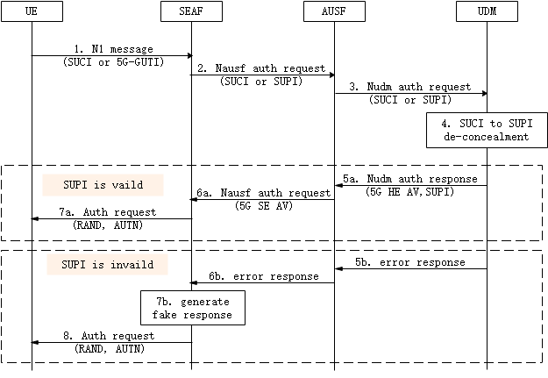
Figure 6.3.1.2-1: Procedure for mitigating SUPI guessing attack
Step 1-4: The initiation of the primary authentication is defined in TS 33.501 [2] clause 6.1.2.
Step 5a-7a: If the SUPI is valid, the authentication procedure is performed as defined in TS 33.501 [2] clause 6.1.3.
Step 5b: If the SUPI is invalid, UDM sends error response to AUSF with failure cause.
Step 6b: AUSF send error response to SEAF with failure cause.
Step 7b: When the error reponse indicating invalid SUPI is received, SEAF generates Auth request message including the RAND and AUTN. RAND and AUTN are randomly generated.
Step 8: SEAF sends the generated Auth request message to UE.
Afterwards, if UE with an invalid SUPI returns a auth response with RES* or sych failure, SEAF responses with authentication failure. If the attacker returns a MAC failure, SEAF may initiate the identification procedure as define in TS 24.501 [6].
With the proposed method, the attacker cannot ascertain that the guessed SUPI is valid or not with the Authentication Request message sent by the network.
6.X.1.3 Evaluation
This solution addresses Key issue #3.2 to mitigate the SUPI guessing attack.
The solution only requires changes on the SEAF. There is no change to any entities if the SUPI is valid.
Editor’s Note: more evaluation is FFS.
*** END OF 1st CHANGE ***

