3GPP TSG-SA3 Meeting #101e S3-203230-r1

e-meeting, 09 - 13 November 2020 Revision of S3-203230

Source: Nokia, Nokia Shanghai Bell

Title: Optimized UAS enabled Authentication

Document for: Approval
Agenda Item: 5.7

1 Decision/action requested
Solution proposal for UAS Authentication and Authorization to address key issue #1 in TR 33.854

2 References
[4] TR 33.854:

3 Rationale
As described in key issue 1 of TR 33.854:
If UAS authentication is not performed, unauthorized UEs/UAVs may access the UAS services provided by 3GPP and consume resources meant for authorized UEs/UAVs. It is notable that the unauthorized UEs may be a regular UE or a UAV with 3GPP ID/credentials. They may be able to access 3GPP networks using 3GPP credentials, but do not have credentials for access UAS services.
If 5GC would not be notified of UAS authentication result, 5GS may allow access UAVs in their system that are not authorized.
The presented solution proposal prevents the attacker or unauthorized UAVs accessing UAS service from 3GPP.

4 Detailed proposal

***** START OF CHANGES

6.x Solution #x: UAS Enabled Authentication

6.x.1 Introduction
This solution addresses the key issue #1 UAS Authentication and Authorization.
When a UAV type UE registers to 5GS, it will after a first successful authentication also register with USS/UTM. The solution proposes to optimize for UAS authentication.

6.x.2 Solution details
When a UAV type UE sends a registration request, it includes in SUCI an indication "UAV type" (step 1) to indicate to the 5GS that additional authentication is needed. After successful authentication, the AUSF provides in its authentication response this UAV type information to AMF (step 2). By this, the AMF knows that the UE is a UAV type UE that also wants to connect to USS/UTM system. I.e. this is to indicate to the serving network the service, for which the UAV enabled UE wants to be authenticated and AMF requests the UAV ID from the UE (step 3).
The 3GPP system is aware of the 'CAA-level UAV ID' and its mapping with 3GPP UAV ID. If the UAV-type UE (UAV/UAV-C) has successfully authenticated to 5GS, it shares within the SMC response its 'CAA level UAV ID' with AMF (step 4). AMF retrieves 3GPP UAV ID from UDM database (step 5). A mapping of SUPI, CAA level UAV ID and 3GPP UAV ID is performed in UDM (step 6) and 3GPP UAV ID is provided back to AMF (step 7). Now UAV/UAV-C authentication and authorization towards UTM/USS can be triggered by AMF (step 8).
Editor's note: Whether the storage of CAA-level UAV Id in UDM is needed in addition to CAA-level UAV Id storage in UAS NF is FFS
Editor's note: Which intermediate functions are involved between AMF and USS/UTM is ffs.

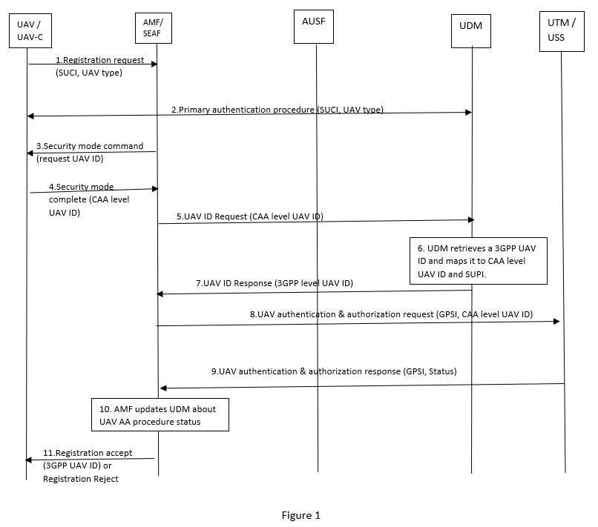

After successful authentication and authorization by UTM/USS, UAV authentication and authorization response is sent to AMF with external identifier (step 9). In case of failure, UAV Authentication & Authorization response is sent to AMF with a failure status. AMF updates UAV authentication and authorization results to UDM (step 10). Also, the UAV/UAV-C is informed with registration accept or reject message (step 11).
If the UDM did not have an entry for the 'CAA-level UAV ID', i.e. it is a non-registered UAV-type UE, then depending on operator policy the UAV/UAV-C may be registered in UDM, the UE becomes a subscriber for a service and a 3GPP UAV ID is provided.

6.x.3 Evaluation
TBD

***** END OF CHANGES

