3GPP TSG SA WG3 Meeting #101e S3-203087

e-meeting, 9 – 20 November 2020 revision S3-20abcd

Source: Huawei, Hisilicon

Title: New Solution on groupcast security and privacy

Document for: Approval
Agenda Item: 5.9

Decision/action requested
This contribution proposes a new solution for groupcast security and privacy

References
[1] 3GPP TR 33.847: "Study on security aspects of enhancement for proximity based services in the 5G System (5GS)".

Rational
The contribution proposes a new solution for groupcast security and privacy.

Detailed proposal
*************** Start of 1st Change ****************

6.Y Solution #Y: Solution on securely creating destination Layer-2 ID in groupcast communication

6.Y.1 Introduction
This solution addresses the KI #13 "Security and privacy of groupcast communication".

6.Y.2 Solution details
The detailed solution is illustrated in Figure.
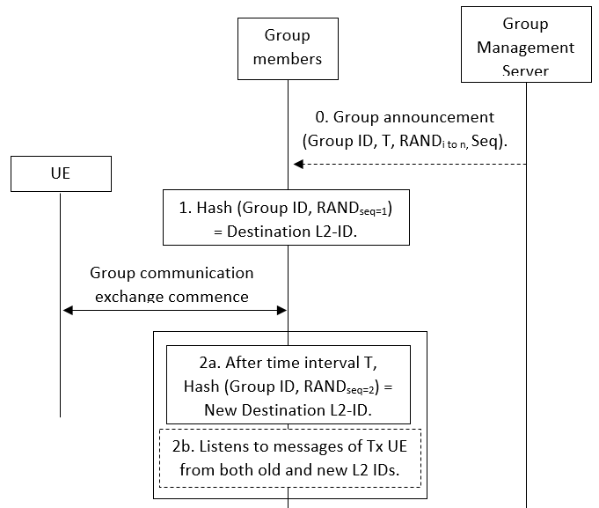
Figure: Procedure for secure conversion of application layer group ID to destination Layer-2 ID
0. Group Setup: Once the group is created, the group management server will send the application layer group ID to the associated UEs and a timer T. It will also send a set of random numbers and a specific sequence in which these random number are to be used. It is assumed that the application layer signalling is protected.
1. ID Conversion: All the UEs use the application layer group ID and the first random number according to the sequence as an input to a hash function to generate the destination Layer-2 ID.
2. ID Update: When the timer T expires, a new destination Layer-2 ID is calculated using the next random number according to the sequence. The UEs can listen to both old a new destination Layer-2 IDs, to avoid any time synchronization issues, for a certain period of time or until receives a message with the new ID.
The destination Layer-2 ID is updated until the ProSe application layer changes the group ID.

The group management server can also send the corresponding materials to generate random numbers rather than sending the random numbers itself.
Editor’s Note: security for group management (including message 0 in the figure) is FFS

Editor’s Note: time synchronization among group members is FFS

6.Y.3 Evaluation
TBA.
*************** End of 1st Change ****************

