3GPP TSG-SA3 Meeting #101-e S3-202918-r1

e-meeting, 9 - 20 November 2020 Revision of S3-20xxxx

Source: ZTE, Huawei

Title: Update solution 14 in TR 33.839

Document for: Approval
Agenda Item: 5.8

1 Decision/action requested
This contribution proposes to update solution 14 in TR 33.839.

2 References
[1] 3GPP TR 33.839 v0.2.0

3 Rationale
In the step 2a-2b, AF and NEF need to generates a Key-ID for the UE and derives a K_{LE}. But it’s not clear how to generates a Key-ID for the UE and derives a K_{LE} in AF and NEF, Some editor note need to be added.
In the step 3-4. in this solution, the Key-ID and K_{LE} is generate in NEF, not receive from AF.

4 Detailed proposal

**** START OF CHANGES ****

6.14 Solution #14: Protection of Network Information Provisioning to Local AF directly

6.14.1 Solution overview
This solution addresses the security requirement for the case that the UPF exposes information to local AF directly in the key issue 7.
Editor’s Note: which interface for UPF and AF communicate over is FFS.

6.14.2 Solution details
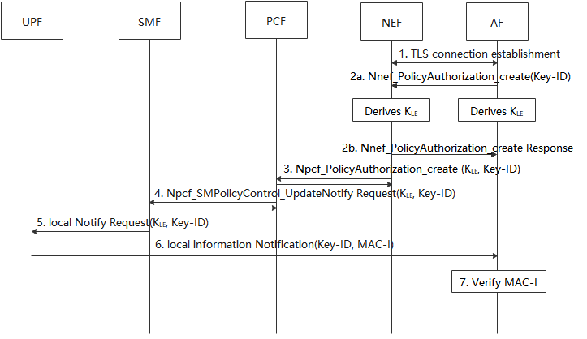
Figure 6.14.2-1 Protection of Network Information Provisioning to Local AF
1. AF establish a TLS session with the NEF, to secure the communication between the AF and NEF.
2a-2b. The AF randomly generates a Key-ID for the UE. And both the AF and NEF derive a K_{LE} based on the shared key negotiated during the TLS establishment. The Key-ID is used to identify the K_{LE}, and the K_{LE} is used to protect the message transmission between UPF and AF. The AF provides the Key-ID to NEF in the request service.

3-4. The NEF initiates the policy authorization with PCF, including the Key-ID and K_{LE} . PCF initiates the PDU session modification procedure as defined in clause 4.3.3.2 of TS 23.502 [3] and provides the Key-ID and K_{LE} to the SMF.
5. SMF sends the notification information with Key-ID and K_{LE} to the UPF.
6. When the QoS monitoring information is received from RAN, the UPF generates MAC-I over the message using the K_{LE} to prove its authenticity. The UPF sends the message including Key-ID and MAC-I to AF.
7. The AF retrieves the K_{LE} based on the received Key-ID and verify the MAC-I.

**** END OF CHANGES ****

