 |  | TO MEMBERS OF 3GPP TSG-SA WG3 ‚SECURITY‘
From | Dr. Stefan Pütz, Systems Technology
Contact | Telephone: +49 228/936-3377, Telefax: +49 228/936-883377
Date | 08.04.1999
Subject | Invitation to the 3GPP TSG-SA WG3 meeting#3 to be held on 11-12 May 1999  in Bonn, Germany
Dear Colleague,
T-Mobil has the pleasure to inform you of the arrangements for the above-mentioned meeting.
The venue of this meeting will be:
AMBER HOTEL
Clemens-August-Straße 32-35
53115 Bonn
Germany
The meeting will start on 11 May 1999 at 10:00 and will end on 12 May 1999 at approximately 16:00.
Registration will take place on the first day of the meeting between 09:00 and 10:00.
Documents for the meeting should be delivered by e-mail to: maurice.pope@etsi.fr by 28 April 1999. After acceptance and number allocation the documents will be uploaded on the server in the FTP directory at:
ftp://ftp.3gpp.org/TSG_SA/WG3_Security/TSGS3_03/Docs
The secretary responsible for this meeting is Nina Paul to whom you should return the registration form (either by e-mail or fax) before 28 April 1999 and should contact concerning any administrative arrangements.
Tel: +49 228 936 3301 Fax: +49 228 936 3309 e-mail: nina.paul@t-mobil.de
Delegates are asked to make their booking directly with the AMBER HOTEL using the attached hotel registration form. Annexed to this invitation you will find hotel and meeting registration forms and traveling details.
I look forward to seeing you in Bonn.
Best regards,
Stefan Pütz

Encl.: Meeting registration form
Hotel information form
Traveling details

MEETING REGISTRATION FORM
For the 3GPP TSG-SA WG3 Meeting #3
to be held on 11-12 May 1999 in Bonn, Germany.
PLEASE FILL IN THIS FORM AND SEND IT BY 28 April 1999 TO:
Nina Paul e-mail: nina.paul@t-mobil.de or Fax: +49 228 936 3309

Title: | Ms Mrs Mr
Last Name:
First Name:
Company:
Mailing address:
Telephone:
Fax:
E-mail:
Date and time of arrival:
Date and time of departure:

Status of Represented Membership (tick one box, either box 1, 2 or 3):
1) Organizational Partner Representative (SDO) | 2) Individual Member(1) Representative **
Representing Partner: (tick one box below)  ARIB | Representing Partner: (tick one box below)  ARIB
ETSI | ETSI
T1 | T1
TTA | TTA
TTC | TTC
Other: ________________________ | Other: _____________________

** Name of Represented 3GPP Individual Member Organization: ______________________________
(for a list of 3GPP Individual Member Organisations see http://www.3gpp.org/Individual_Member.htm )
** I am the Voting Representative for this Individual Member.

3) Market Representation Partner Representative (tick one box below)
UMTS Forum
Other: ________________________________

Category of represented Individual Membership: (tick one box)
Administration
Manufacturer
Public Network Operator
Private Service Provider
Other: ________________________________

(1) You can only represent an Individual Member organization of the 3GPP. Subsidiaries of Individual Member organizations need the authority of the represented Individual Member organization in order to register.

HOTEL RESERVATION FORM
For the 3GPP TSG-SA WG3 #3 Meeting
to be held on 11-12 May 1999 in Bonn, Germany.

Attention of: Sandra Dobbertin
AMBER HOTEL
Clemens-August-Straße 32-35
53115 Bonn, Germany
Tel. + 49 228 7250-0
Fax. + 49 228 7250-72
e-mail: AMBER.HOTEL.Bonn@t-online.de

Please complete ALL sections in BLOCK CAPITALS and send this form as soon as possible
(but before 28 April 1999) to the AMBER HOTEL (either by Fax. + 49 228 7250-72 or by
e-mail AMBER.HOTEL.Bonn@t-online.de).

The special rate of DM 250,- per person per night includes breakfast.

Please indicate your booking with the following reference: 3GPP TSG-SA WG3 ‘Security’.

I will arrive on ____________ at ____________
I will leave on ____________ at ____________

Name: __________________________________________________
Company: __________________________________________________
Address: __________________________________________________
__________________________________________________
Fax*: __________________________________________________
Tel*: __________________________________________________
(* = including country code)

Please guarantee my room for late arrival.

Credit Card no: __________________________________________________

Expiry Date: __________________________________________________

Signature: __________________________________________________

Traveling details

Airport Cologne/Bonn
- Bus Shuttle each 20/30 minutes (30 minutes to Bonn main station)
- 10 minutes walk from Bonn main station to AMBER HOTEL
- or Taxi (30 minutes to AMBER HOTEL, about DM 60)
Airport Düsseldorf
- Subway to Düsseldorf main station (10 minutes) and train to Bonn main station (45 minutes)
- 10 minutes walk from Bonn main station to AMBER HOTEL
Airport Frankfurt
- Train to Bonn main station (1 hour, 40 minutes)
- 10 minutes walk from Bonn main station to AMBER HOTEL

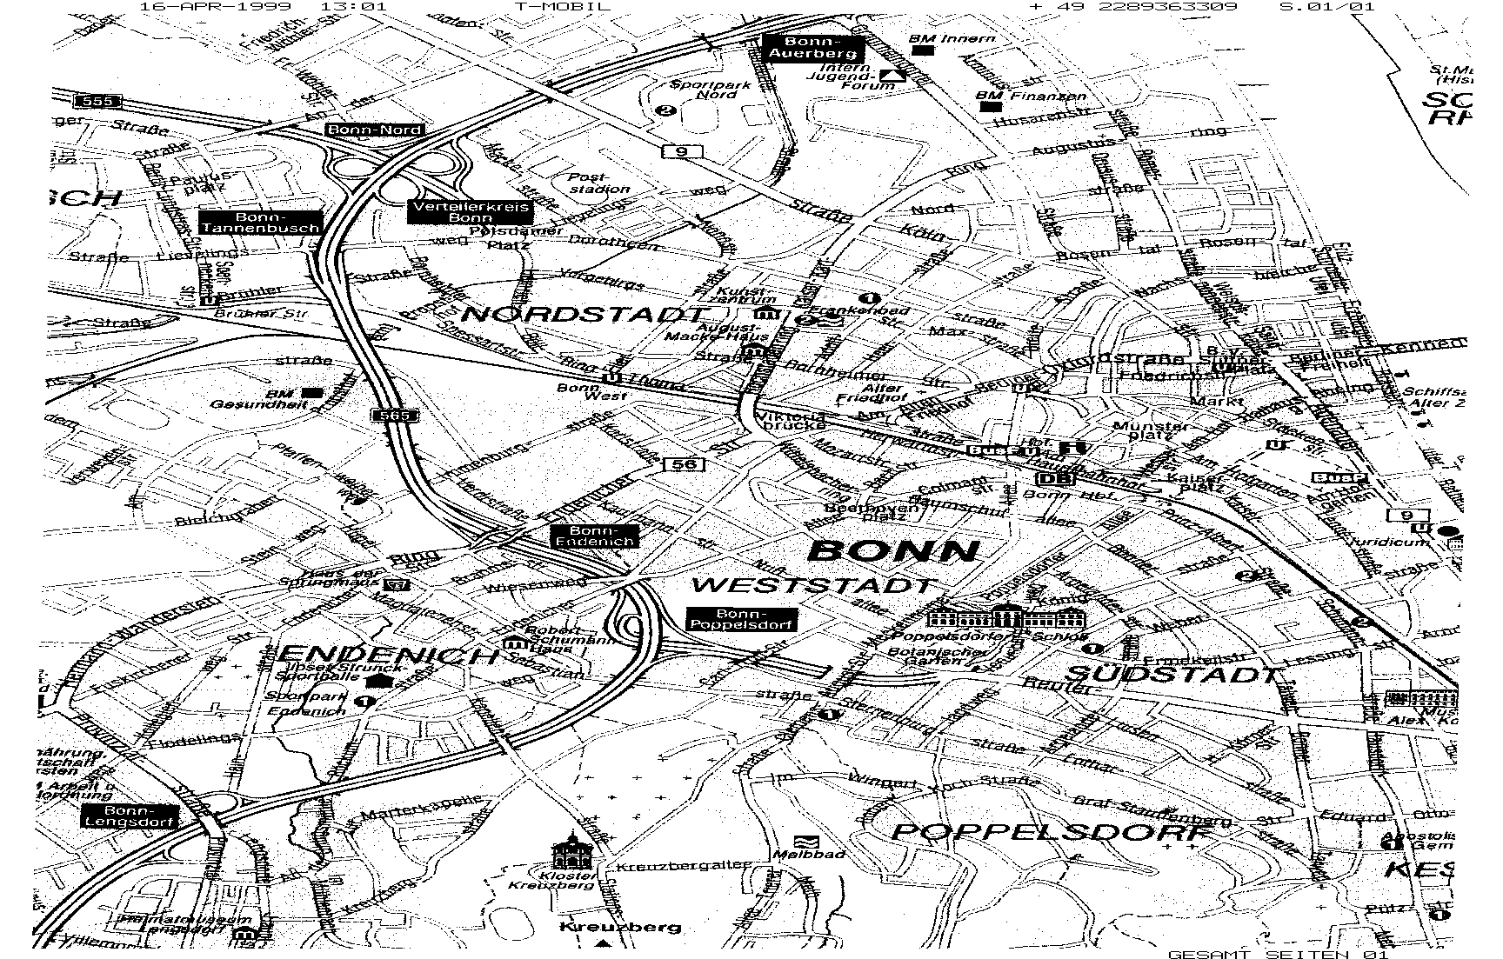
Main
Station
Clemens-
August-
Straße
R
H
E
I
N

