3GPP TSG-SA WG2#160 S2-2313187
Chicago, USA, 13 - 17 Nov 2023 (was S2-23)

Source: Xiaomi
Title: Discussion on RAN/CT alignment issues and the proposed way forward
Document for: Approval
Agenda Item: 9.5.2
Work Item / Release: Ranging_SL/Rel-18
Abstract of the contribution: This contribution includes RAN/CT alignment issues identified during SA2#159 meeting and based on the Editor’s notes from TS 23.586 and TS 23.273 with the proposed way forward.

Discussion

1.1 SLPP messages VS non-SLPP messages
Messages | SLPP | SA2 agreements
LMF - Target UE / SL Reference UE / Located UE | Partially supported | SLPP+LCS SS  (see S2-2311896)
SL Positioning Server UE - Target UE / SL Reference UE / Located UE | TBD | TBD
Target UE - SL Reference UE / Located UE | Partially supported | SLPP  Target UE to trigger Located UE for its absolute location TBD (see S2-2311896)
SL Positioning Client UE - Target UE / SL Reference UE / Located UE | TBD | Non-SLPP over SR5

SA2 agreements (S2-2311896)
SA2 has defined the following information and messages provided from the LMF to the UE:
- list of candidate Located UE(s) identified with Application Layer ID in the SL-MO-LR Procedure defined in clause 6.20.1 of TS 23.273
- SL-MT-LR request, including the application layer IDs of the other UEs 2 to n and the types of required location results in the SL-MT-LR Procedure defined in clause 6.20.3 of TS 23.273
- Application Layer ID of the selected SL Positioning Server UE in the Procedures for Network-assisted SL Positioning for UE with NAS connection defined in clause 6.5.3 of TS 23.586
- Indication of whether it is the LMF or the Target UE that select the Located UE(s).
The following information and messages provided from the UE to the LMF:
- List of candidate Located UE(s) identified with Application Layer ID to the LMF for the selection defined in clause 6.20.3 of TS 23.273.
SA2 would like to highlight that the above-mentioned information and messages may not be exhaustive.
SA2 Agreement 1:
- Item 2 is transmitted over SLPP to be developed by RAN2.
- Item 1, 3, 4 and 5, are transmitted within supplementary services message to be developed by CT WGs.

Additionally, SA2 has defined the following information and messages transmitted between Target UE/SL Reference UE and the SL Client UE:
- SL Positioning Service Request / SL Positioning Service Response messages in the Procedures for Ranging/SL Positioning service exposure through PC5 defined in clause 6.7.1.1 of TS 23.586
SA2 Agreement 2: The SL Positioning Service Request / SL Positioning Service Response messages are transmitted over SR5 as the non-SLPP messages to be developed by SA2 and CT WGs.

TS 38.355 defines the following SLPP message types:
- Request Capabilities;
- Provide Capabilities;
- Request Assistance Data;
- Provide Assistance Data;
- Request Location Information;
- Provide Location Information;
- Abort;
- Error.
Problem Statement:
SLPP is developed based on LPP (TS 37.355) and SLPP does not contain any payload, any extension will require more TU in RAN2. However, there’s only 1 RAN2 meeting left to complete the R18 work.
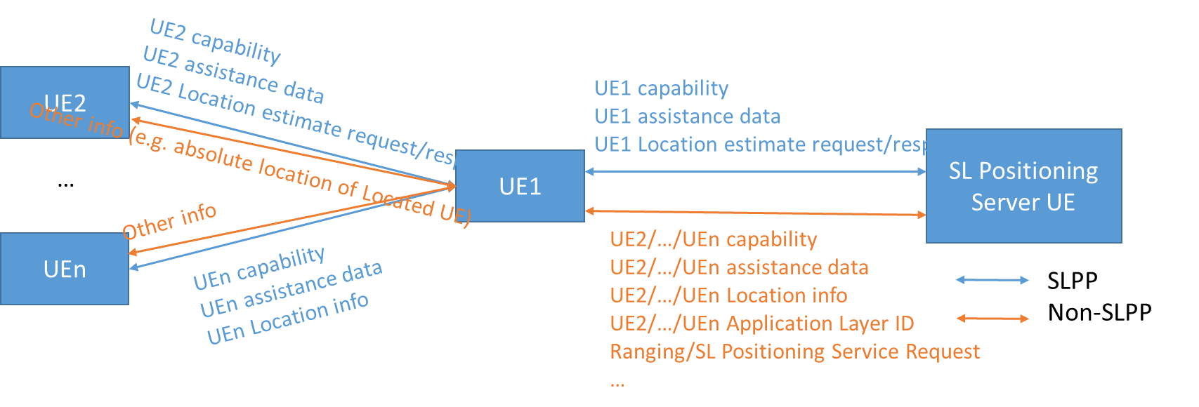
Figure 1: RSPP messages between SL Positioning Server UE - Target UE / SL Reference UE / Located UE

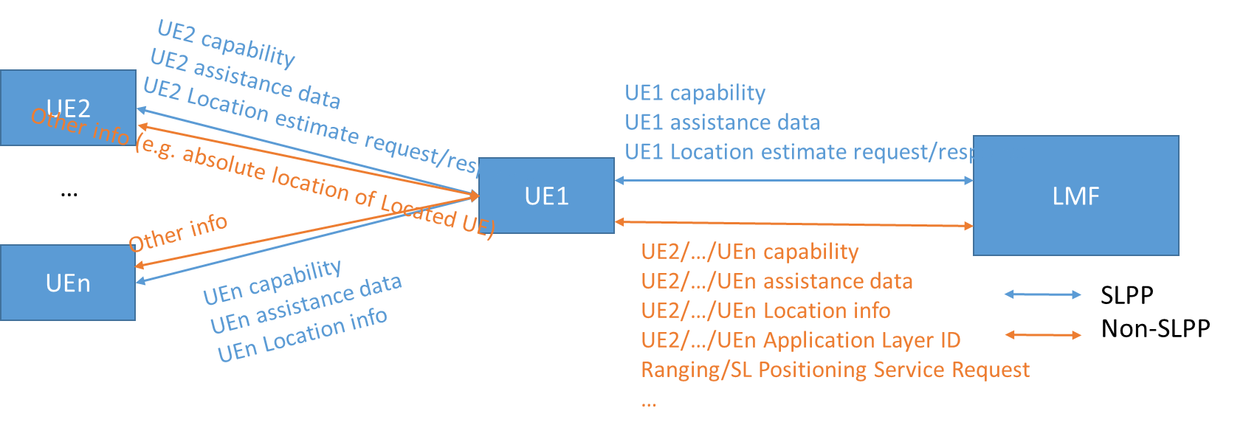
Figure 2: RSPP messages between LMF - Target UE / SL Reference UE / Located UE

Proposed Way Forward:
- Proposal 1 (Joint SA2-RAN2 pre#160 CC): Item 2 listed in S2-2311896 will be developed by CT WGs as the LCS SS message, and CT WGs will decide how to design the message.
- Proposal 2 (Joint SA2-RAN2 pre#160 CC): SA2 will send a LS out to RAN2 and CT WGs to clarify this new agreement.
- Proposal 3: For interactions between SL Positioning Server UE and Target UE / SL Reference UE / Located UE:

  - There is 1 SLPP session between SL Positioning Sever UE and UE1 for transferring capability, assistance data and Location estimate request/response of UE1
  - There is 1 non-SLPP session between SL Positioning Sever UE and UE1 for transferring capability, assistance data, Location estimate request/response of UE2/…/Uen, Application ID of UE2/…/Uen, Ranging/SL Positioning Service Request and any other information
  - There is individual SLPP session between UE1 and UE2/…/UEn for transferring capability, assistance data and Location estimate request/response of UE2/…/UEn
  - There is individual non-SLPP session between UE1 and UE2/…/UEn for transferring any information other than capability, assistance data and Location estimate request/response of UE2/…/UEn, e.g. absolute location of Located UE
- Proposal 4: Message from Target UE to Located UE to request Located UE’s absolute location, i.e. step 17 of 6.20.1 in TS 23.273 (see S2-2311465) is transferred as non-SLPP message over SR5

2 Whether it is necessary for LMF serving the Ranging/SL Positioning session to establish SLPP session with all the UEs
SA2 existing solution:
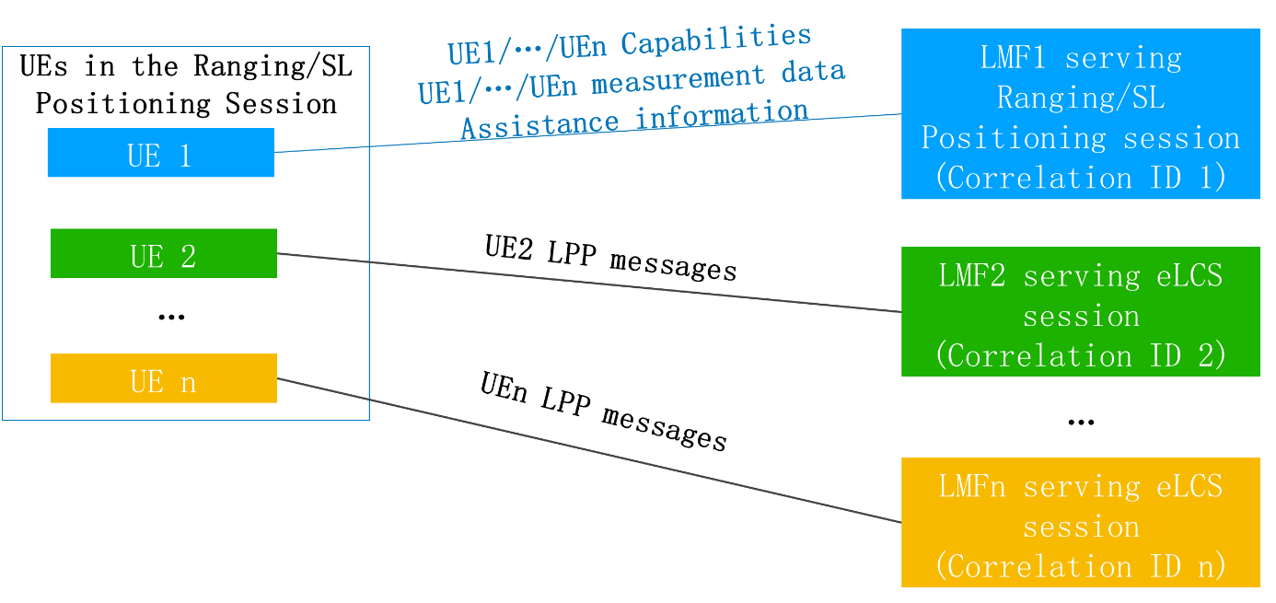
Problem Statement:
RP-232670
    - Specify the protocol and procedures for SL positioning between UEs and a single LMF for in coverage scenario only, including joint PC5-Uu scenarios.
      - NOTE: Assumes all involved UEs are served by same LMF.

SA2 understanding:
Option 1 (with forwarding)
Existing solution, see above.
Option 2 (no forwarding)
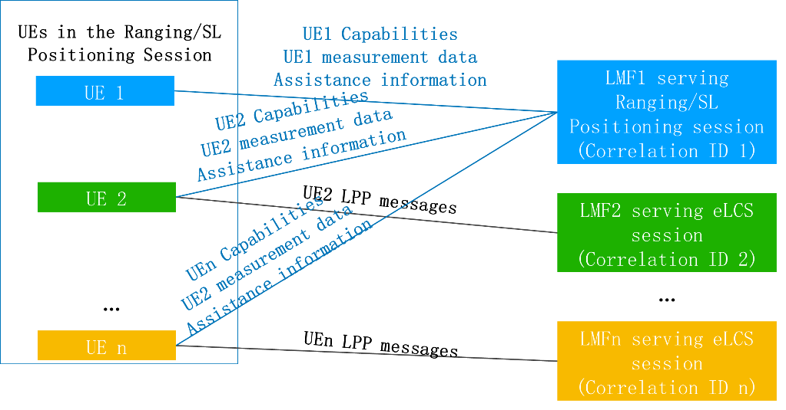
LMF1 has to establish SLPP session with all the UEs of the Ranging/SL Positioning session.
NAS connection establishment for all UEs.
Option 3 (no forwarding)
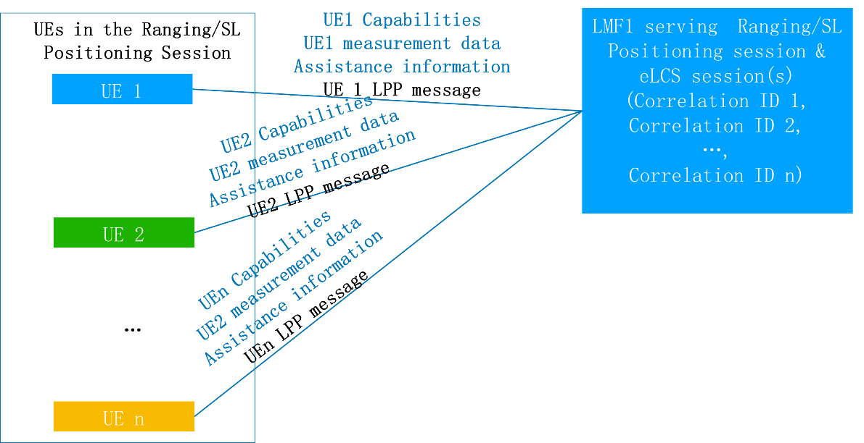
Same LMF is selected to serve UE1/UE2/…/UEn for both Ranging/SL Positioning session and eLCS session, i.e. Serving AMF of UE2/…/UEn selects the LMF1 to serve the UE.
NAS connection establishment for all UEs.
SA2 agreement:
See S2-2311465.
Proposed Way Forward:
Proposal 5 (Joint SA2-RAN2 pre#160 CC): SA2 existing solution i.e. Option 1, is acceptable to be used as the baseline, with the assumption that additional information, i.e. forwarding information of UE2/…/UEn, will not be developed for SLPP, and they will be developed by CT WGs.

3 RSPP VS SLPP
Problem Statement:
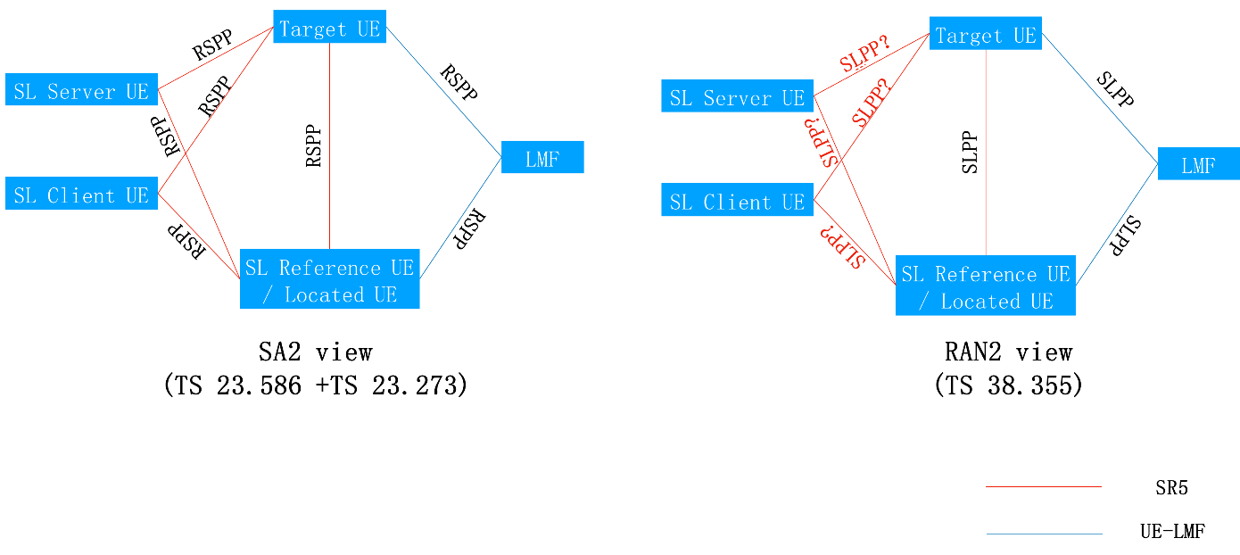
Figure 3: Current definition of RSPP and SLPP
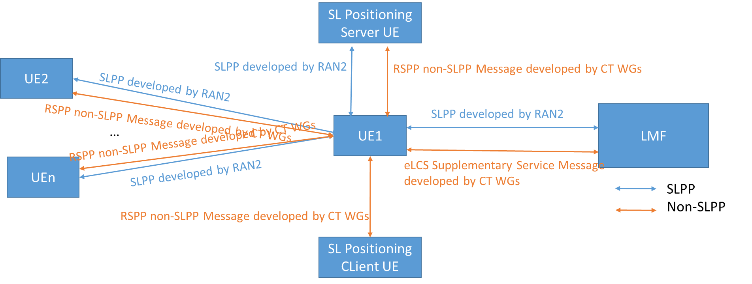
Figure 4: RSPP messages

SLPP (Sidelink Positioning Protocol) is defined in TS 38.355 by RAN2. RSPP (Ranging/SL Positioning Protocol) is the term used in SA2 to describe the SR5 and UE-LMF interface as shown in the above figure, which is currently interpreted as SLPP. However, considering that RSPP contains both SLPP messages and non-SLPP messages, it is not suitable to be the SLPP equivalent.
Additionally, CT WGs do not incline to define PC5-U traffic if it is not understood as any protocol.
Proposed Way Forward:
Proposal 6:
- Clarify in TS 23.586 that RSPP includes SLPP messages, eLCS Supplementary Service messages and RSPP non-SLPP messages at SR5 and UE-LMF interfaces.
- CT WGs are responsible for developing RSPP non-SLPP messages at SR5 and UE-LMF interfaces.
- RAN2 is responsible for developing SLPP messages at SR5 and UE-LMF interfaces.

2. Proposal
It is proposed to agree the following way forward for Ranging_SL:
- Proposal 1 (Joint SA2-RAN2 pre#160 CC): Item 2 listed in S2-2311896 will be developed by CT WGs as the LCS SS message, and CT WGs will decide how to design the message.
- Proposal 2 (Joint SA2-RAN2 pre#160 CC): SA2 will send a LS out to RAN2 and CT WGs to clarify this new agreement.
- Proposal 3: For interactions between SL Positioning Server UE and Target UE / SL Reference UE / Located UE:
  - There is 1 SLPP session between SL Positioning Sever UE and UE1 for transferring capability, assistance data and Location estimate request/response of UE1
  - There is 1 non-SLPP session between SL Positioning Sever UE and UE1 for transferring capability, assistance data, Location estimate request/response of UE2/…/Uen, Application ID of UE2/…/Uen, Ranging/SL Positioning Service Request and any other information
  - There is individual SLPP session between UE1 and UE2/…/UEn for transferring capability, assistance data and Location estimate request/response of UE2/…/UEn
  - There is individual non-SLPP session between UE1 and UE2/…/UEn for transferring any information other than capability, assistance data and Location estimate request/response of UE2/…/UEn, e.g. absolute location of Located UE

  - Proposal 4: Message from Target UE to Located UE to request Located UE’s absolute location, i.e. step 17 of 6.20.1 in TS 23.273 (see S2-2311465) is transferred as non-SLPP message over SR5
- Proposal 5 (Joint SA2-RAN2 pre#160 CC): SA2 existing solution i.e. Option 1, is acceptable to be used as the baseline, with the assumption that additional information, i.e. forwarding information of UE2/…/UEn, will not be developed for SLPP, and they will be developed by CT WGs.
- Proposal 6:
  - Clarify in TS 23.586 that RSPP includes SLPP messages, eLCS Supplementary Service messages and RSPP non-SLPP messages at SR5 and UE-LMF interfaces.
  - CT WGs are responsible for developing RSPP non-SLPP messages at SR5 and UE-LMF interfaces.
  - RAN2 is responsible for developing SLPP messages at SR5 and UE-LMF interfaces.

