**3GPP TSG-WG SA2 Meeting #143E e-meeting *S2-210xxxx***

**Elbonia, February 24 – March 09, 2020 (revision of S2-200xxxx)**

**Source: Huawei, HiSilicon, Others?**

**Title: Architectural reference model for 5G ProSe**

**Document for: Approval**

**Agenda Item: 8.8.2**

**Work Item / Release: FS_5G_ProSe / Rel-17**

*Abstract: This contribution proposes to define the architectural reference models for 5G ProSe.*

# 1. Introduction/Discussion

This contribution proposes to define the architectural reference model based on the KI#1 conclusion in TR 23.752.

# 2. Text Proposal

It is proposed to capture the following changes vs. TS 23.304.

* * * * First change (all new) * * * *

## 4.2 Architectural reference model

### 4.2.1 Non-roaming reference architecture

Figure 4.2.1-1 shows the high-level view of the non-roaming 5G System architecture for Proximity-based Services (ProSe). In this figure, UE A and UE B use a subscription of the same PLMN.

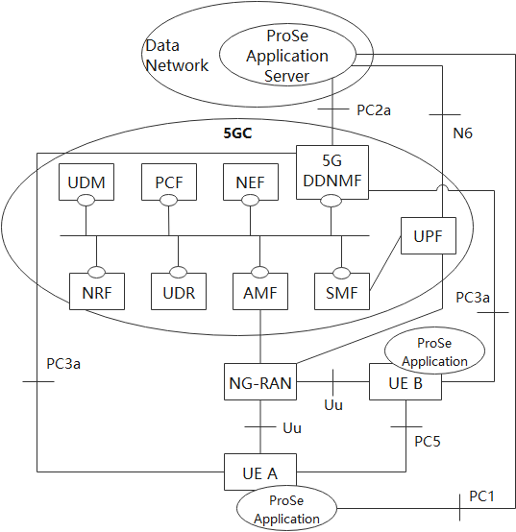

Figure 4.2.1-1: Non-roaming 5G System architecture for Proximity-based Services

Figure 4.2.1-2 shows the high-level view of the non-roaming 5G System architecture for Proximity-based Services (ProSe) in reference point representation. In this figure, UE A and UE B use a subscription of the same PLMN.

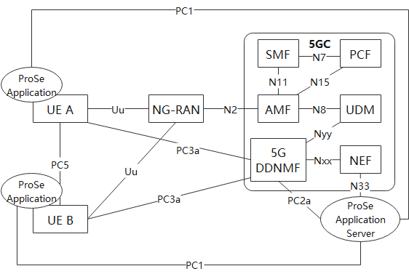

Figure 4.2.1-2: Non-roaming 5G System architecture for Proximity-based Services in reference point representation

### 4.2.2 Roaming reference architecture

Figure 4.2.2-1 show the high-level view of the roaming 5G System architecture for Proximity-based Services (ProSe). In the figure, UE A uses a subscription of HPLMN.

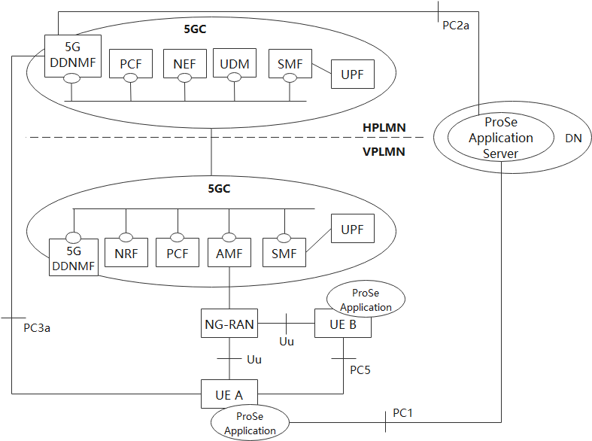

Figure 4.2.2-1: roaming 5G System architecture for Proximity-based Services

### 4.2.3 Inter-PLMN reference architecture

The following figure 4.2.3-1 show the high level view of the non-roaming inter-PLMN architecture. In this figure, PLMN A is the HPLMN of UE A and PLMN B is the HPLMN of UE B.

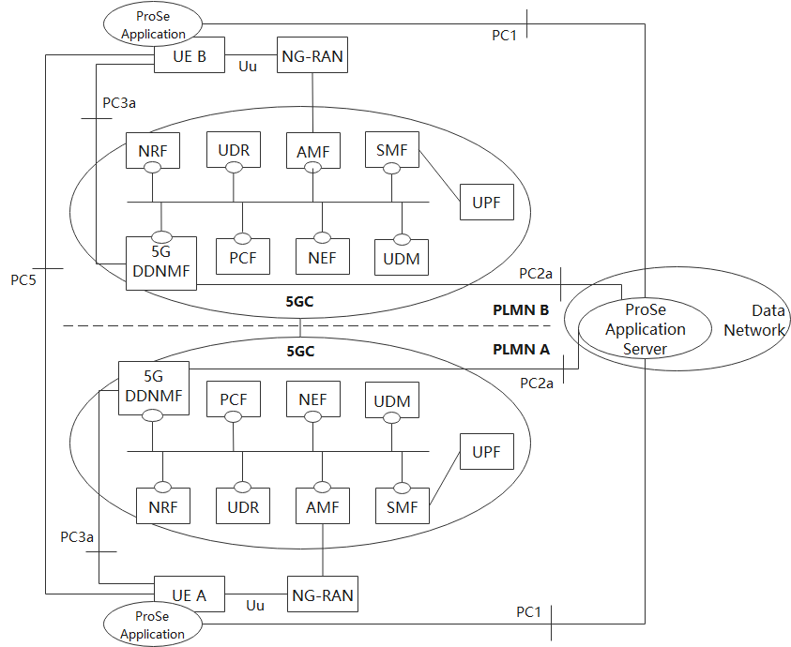

Figure 4.2.3-1: non-roaming Inter-PLMN 5G System architecture for Proximity-based Services

Figure 4.2.3-2 shows the high level view of the roaming architecture. In this figure, UE A uses a subscription of PLMN A and UE B uses a subscription of PLMN B; UE A is roaming in PLMN C while UE B is not roaming.

4.2.4 AF-based service parameter provisioning

The 5G System provides NEF services to enable communication between NFs in the PLMN and a ProSe Application Server. Figure 4.2.4-1 shows the high level view of AF-based service parameter provisioning for ProSe communications. The ProSe Application Server may provide ProSe service parameters to the PLMN via NEF. The NEF stores the ProSe service parameters in the UDR.



Figure 4.2.4-1: 5G System architecture for AF-based service parameter provisioning for ProSe communications

4.2.5 Reference points

**PC1**: The reference point between the ProSe application in the UE and in the ProSe Application Server. It is used to define application level signalling requirements. This reference point is not specified in this release of the specification.

**PC2a**: The reference point between the ProSe Application Server and the 5G DDNMF. It is used to define the interaction between ProSe Application Server and 5G DDNMF for ProSe Direct Discovery.

**PC3a**: The reference point between the UE and the 5G DDNMF.

**PC5**: The reference point between ProSe-enabled UEs used for control and user plane for ProSe Direct Discovery, ProSe Direct Communication and ProSe UE-to-Network Relay.

**Nyy**: The reference point between the UDM and 5G DDNMF. It is used to provide subscription information in order to authorise access for ProSe Direct Discovery and ProSe Direct Communication on a per PLMN basis.

**Nzz**: The reference point between the PCF and 5G DDNMF. It is used to provide authorisation information in order to authorise access for ProSe Direct Discovery and ProSe Direct Communication on a per PLMN basis.

Editor's note: Whether Nyy or Nzz is selected is FFS.

**Naa**: The reference point between the 5G DDNMF in the HPLMN and the 5G DDNMF in a Local PLMN (ProSe Direct Discovery). This reference point is used for HPLMN control of ProSe service authorization.

**Nbb**: The reference point between the 5G DDNMF in the HPLMN and the 5G DDNMF in the VPLMN. It is used for HPLMN control of ProSe service authorization.

NOTE: Nyy, Nzz, Naa and Nbb show the interactions that exist between the NF services in the NFs. These reference points are realised by corresponding NF service-based interfaces and by specifying the identified consumer and producer NF service as well as their interaction in order to realize a particular system procedure.

4.2.6 Service-based interfaces

**N5g-ddnmf:** Services provided by 5G DDNMF are used for HPLMN control of ProSe.

In addition to the relevant services defined in TS 23.501 [x] for the following service-based interfaces, in the case of ProSe Service, the services can be provided by corresponding NF are as follows.

**Nudm**: Services provided by UDM are used to get ProSe Service related subscription information to the AMF during Initial Registration procedure or UE Configuration Update (UCU) procedure to inform the AMF the subscription information has changed. The subscription information in described in TS 23.502 [x].

**Npcf**: Services provided by H-PCF are used to provide ProSe Service related parameters to V-PCF for the UE and NG-RAN in the roaming case.

**Nudr**: Services provided by UDR are used to notify the PCF and the UDM of the update of the ProSe Service related information as described in TS 23.502 [x].

**Nnef**: Services provided by NEF are used by the ProSe Application Server to update ProSe Service related information of 5GC.

**Namf:** Services provided by AMF are consumed by PCF to provide the ProSe Service related parameters for the UE and the NG-RAN to the AMF, and to enable the AMF create or update the UE context related to ProSe service.

**Nnrf:** Services provided by NRF are used to discover the PCF that supports ProSe service and for 5G DDNMF in HPLMN to discover other 5G DDNMFs in VPLMN or local PLMN.

* * * * End of changes * * * *