3GPP TSG-SA2 Meeting #139E S2-2003792
Elbonia, June 1 - 12, 2020
Source: Samsung
Title: Updates to Sol#2 on support for slice SLA guarantee
Document for: Approval
Agenda Item: 8.1
Work Item / Release: FS_eNA_Ph2/ Rel-17
Abstract of the contribution: Updates to Sol#2 on support for slice SLA guarantee for FS_eNA_Ph2 studies in Rel-17.

1. Background
This paper updates Sol#2.

2. Text Proposal
It is proposed to adopt the following text within the TR.

*** First change ***

2 References
The following documents contain provisions which, through reference in this text, constitute provisions of the present document.
- References are either specific (identified by date of publication, edition number, version number, etc.) or non-specific.
- For a specific reference, subsequent revisions do not apply.
- For a non-specific reference, the latest version applies. In the case of a reference to a 3GPP document (including a GSM document), a non-specific reference implicitly refers to the latest version of that document in the same Release as the present document.
[1] 3GPP TR 21.905: "Vocabulary for 3GPP Specifications".
[2] 3GPP TS 23.501: "System Architecture for the 5G System; Stage 2".
[3] 3GPP TS 23.502: "Procedures for the 5G System; Stage 2".
[4] 3GPP TS 23.503: "Policy and Charging Control Framework for the 5G System; Stage 2".
[5] 3GPP TS 23.288: "Architecture enhancements for 5G System (5GS) to support network data analytics services; Stage 2".
[6] ITU-T Recommendation P.1203.3: "Parametric bitstream-based quality assessment of progressive download and adaptive audiovisual streaming services over reliable transport - Quality integration module".
[7] 3GPP TS 38.331: "NR; Radio Resource Control (RRC) protocol specification".
[8] 3GPP TS 36.331: "Evolved Universal Terrestrial Radio Access (E-UTRA); Radio Resource Control (RRC); Protocol specification".
[9] 3GPP TS 38.215: "NR; Physical layer measurements".
[Y] 3GPP TS 23700-40: "Study on enhancement of network slicing ".

*** Second change ***

6.2 Solution for Key Issue #4: Remaining aspects on how to ensure that slice SLA is guaranteed

6.2.1 Description
This solution addresses Key Issue #4 by leveraging NWDAF slice level analytics to trigger a slice load distribution mechanism aimed at assisting with SLA guarantee. Relying motly on observed service experience analytics for a Network Slice as defined in [5], the proposed load distribution mechanism can act at Network Slice level, Network Slice instance level, or both, and the consumer NF of analytics that also triggers the mechanism can be NSSF, or in its absence, AMF.

6.2.1.1 General
In this solution, NSSF or AMF subscribe to slice service experience analytics and NWDAF collects the corresponding data as detailed in TS 23.288 [5]. In addition, NSSF or AMF subscribe to slice load analytics to avoid selecting an overloaded slice for new UE registrations and/or PDU session establishments.
To assist with slice SLA, NSSF/AMF continuously analyze statistics and/or predictions for both service experience and load of the slice. The internal logic of NSSF/AMF determine when a load distribution decision is required to address an issue identified by processing the analytics. For example, when a slice is detected or forecasted to experience service experience degradation, new UE registrations or PDU sessions may not be assigned to that slice anymore by triggering a Network Slice load distribution mechanism. The proposed mechanism can act on both Network Slice and Network Slice instance levels, and
is based on the simple idea of establishing a restriction for UE registrations and/or PDU sessions on a Network Slice or Network Slice instance whenever NSSF/AMF decide to do so based on the slice level NWDAF analytics. The restriction(s) may be enforced by a quota management NF when applied to a Network Slice, as described in [Y].
In addition to NSSF/AMF, OAM may also simultaneously subscribe to both slice service experience and slice load analytics from NWDAF. OAM may use these analytics in addition to other management plane data to make eventual management decisions on a slice (e.g. scaling of a slice) and, if required, it may inform 5GC of such decisions.

6.2.1.2 Procedures
NOTE: In all the procedures below, AMF* indicates the AMF instance involved in the call flow may refer to any AMF instance(s) within a same AMF Set.

6.2.1.2.1 NSSF based solution

Figure 6.2.1.2.1-1: Procedure for NWDAF-assisted slice SLA guarantee solution based on NSSF
0a.-0b. OAM creates a new slice and configures initial resources in RAN and in CN allocated to the slice. The slice is also configured to support a maximum number of UEs and/or PDU sessions.
1a.-1b. NSSF and optionally OAM subscribe to slice service experience analytics from NWDAF. One or multiple subscriptions to one or multiple S-NSSAI(s), NSI ID(s) are possible.
2. NSSF and optionally OAM subscribe to slice load analytics from NWDAF.
Editor's note: How input data for slice load analytics is collected by NWDAF is FFS.
3. New UEs get continously registered in the slice.
NOTE 1: Steps 0b and 3 should be performed according to the currently ongoing eNS_ph2 work on how to enforce UE and/or PDU session quotas on a Network Slice.

4. NWDAF collects input data required to derive slice service experience analytics as described in [5].
NOTE 2: Figure 6.2.1.2.1-1 does not show the exhaustive list of NFs that may provide input data to NWDAF.
5. Slice service experience analytics are continuously delivered by NWDAF to NSSF and optionally to OAM.
6. Slice load analytics are continuously delivered by NWDAF to NSSF and optionally to OAM.
NOTE 3: How OAM may use NWDAF slice level analytics needs to be determined by SA5
7. NSSF continuously analyzes statistics and predictions on slice load and service experience aiming to improve slice assignment decisions.
8. [OPTIONAL] OAM continuously monitors slice SLA. For that purpose it may use as optional inputs NWDAF slice level analytics in addition to other management data.
9. NSSF decides to trigger action based on the slice analytics provided by NWDAF. Hence, NSSF may trigger either Network Slice load distribution, or Network Slice instance load distribution, or both.

NOTE 4: This solution assumes that more than one slice may have been previously created by OAM.
10a. [OPTIONAL] NSSF triggers a Network Slice load distribution procedure (details below).
10b. [OPTIONAL] NSSF triggers a Network Slice instance load distribution procedure (details below).
NOTE 5: Step 10b can only be applied if the deployment choice of the operator allows Network Slice instance(s) in the 5GC, and those are identified via NSI ID(s)..
11. [OPTIONAL] OAM may take management decisions based on the collected inputs including managament data and NWDAF analytics. If required, OAM may inform 5GC of such management decisions.

(Figure 6.2.1.2.1-1, Step 10a) NSSF triggers a Network Slice load distribution procedure:

Figure 6.2.1.2.1-2: Detail of Step 10a in Figure 6.2.1.2.1-1

- Based on the slice level analytics provided by NWDAF, NSSF concludes a Network Slice restriction is required. Two alternatives are possible to execute the restrictions, depending on whether there is a quota management NF in the network as described in [Y] or not enforcing a maximum quota of UE registrations and maximum quota of PDU sessions on a Network Slice.

Alternative 1: A quota management (QM) NF other than NSSF exists in the network
2a. NSSF sends a recommendation for a Network Slice restriction to the QM NF.
2b. [OPTIONAL] The QM NF may inform NSSF of having accepted or declined the recommendation for the Network Slice restriction.
2c. The enforcement of the Network Slice restriction is performed by the QM NF according to [Y].

Alternative 2: QM NF is NSSF or does not exist in the network
3a. NSSF sends a Network Slice restriction to AMF.
3b. The UE initiates registration procedure requesting registration on the restricted Network Slice (via e.g. S-NSSAI) .
3c. AMF/NSSF determine whether the Network Slice restriction can be satisfied for UE registration leveraging the Network Slice registration procedures defined in 3GPP TS 23.501.
3d. The UE registration is completed or rejected. If completed, PDU sessions may be establised for the registered UE if/when required.

Editor's note: Whether further alignment with eNS_ph2 is required may require the eNS_Ph2 study to make further progress.

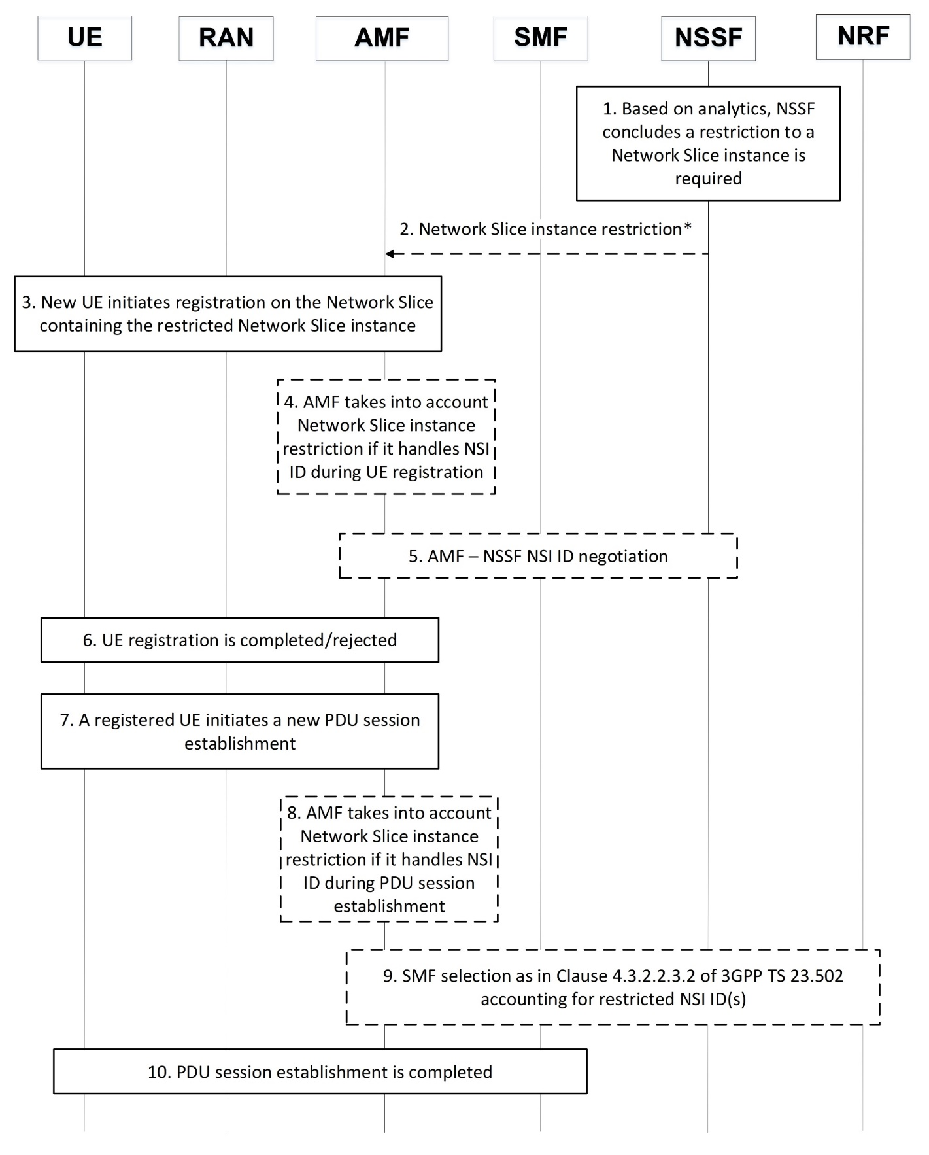
(Figure 6.2.1.2.1-1 Step 10b) NSSF triggers a Network Slice instance load distribution procedure:

Figure 6.2.1.2.1-3: Detail of Step 10b in Figure 6.2.1.2.1-1

- Based on the slice level analytics provided by NWDAF, NSSF concludes a Network Slice instance restriction is required.
- [OPTIONAL] NSSF sends a Network Slice instance restriction to AMF.
- New UE initiates registration procedure requesting registration on the Network Slice (identified via S-NSSAI) containing the restricted Network Slice instance (identified via NSI ID).
- [OPTIONAL] If AMF handles NSI ID(s) information during UE registration, it may take into account the Network Slice instance restriction to assign NSI ID to the new UE registration.
- [OPTIONAL] AMF and NSSF may interact as described in 3GPP TS 23.501 to determine the NSI ID to be used for the new UE registration.
- UE registration is completed or rejected
- A UE already registered in the network requests a new PDU session establishment according to 3GPP TS 23.502.
- [OPTIONAL] If AMF handles NSI ID(s) information during PDU session establishment, it may take into account the Network Slice instance restriction to assign NSI ID to the new PDU session establishment.
- [OPTIONAL] SMF selection is performed according to 3GPP TS 23.502 accounting for the restricted NSI ID(s).
- PDU session establishment is completed.

6.2.1.2.2 AMF based solution

Figure 6.2.1.2.2-1: Overall procedure for NWDAF-assisted slice SLA guarantee solution based on AMF

0a.-0b. OAM creates a new slice and configures initial resources in RAN and in CN allocated to the slice. The slice is also configured to support a maximum number of UEs and/or PDU sessions.
1a.-1b. AMF and optionally OAM subscribe to slice service experience analytics from NWDAF. One or multiple subscriptions to one or multiple S-NSSAI(s), NSI ID(s) are possible.
- AMF and optionally OAM subscribe to slice load analytics from NWDAF.
Editor's note: How input data for slice load analytics is collected by NWDAF is FFS.
3. New UEs get continously registered in the Network Slice.
NOTE 1: Steps 0b and 3 should be performed according to the currently ongoing eNS_ph2 work on how to enforce UE and/or PDU session quotas on a Network Slice.
- NWDAF collects input data required to derive slice service experience analytics as described in 3GPP TS 23.288.
NOTE 2: Figure 6.2.1.2.2-1 does not show the exhaustive list of NFs that may provide input data to NWDAF.
5. Slice service experience analytics are continuously delivered by NWDAF to AMF and optionally to OAM.
6. Slice load analytics are continuously delivered by NWDAF to AMF and optionally to OAM.
NOTE 3: How OAM may use NWDAF slice level analytics needs to be determined by SA5
7. AMF continuously analyzes statistics and predictions on slice load and service experience.
8. [OPTIONAL] OAM continuously monitors slice SLA. For that purpose it may use as optional inputs NWDAF slice level analytics in addition to other management data.
9. AMF decides to trigger action based on the slice analytics provided by NWDAF. Hence, AMF may trigger either Network Slice load distribution, or Network Slice instance load distribution, or both.
NOTE 4: This solution assumes that more than one slice may have been previously created by OAM.
10a. [OPTIONAL] AMF triggers Network Slice load distribution (details below).
10b. [OPTIONAL] AMF triggers Network Slice instance load distribution (details below).
NOTE 5: Step 10b can only be applied if the deployment choice of the operator allows Network Slice instance(s) in the 5GC, and those are identified via NSI ID(s).
11. [OPTIONAL] OAM may take management decisions based on the collected inputs including managament data and NWDAF analytics. If required, OAM may inform 5GC of such management decisions.

(Figure 6.2.1.2.2-1, Step 10a) AMF triggers a Network Slice load distribution procedure:

Figure 6.2.1.2.2-2: Detail of Step 10a in Figure 6.2.1.2.2-1
- Based on the slice level analytics provided by NWDAF, AMF concludes a Network Slice restriction is required. Two alternatives are possible to execute the restrictions, depending on whether there is a quota management NF in the network as described in [Y] or not enforcing a maximum quota of UE registrations and maximum quota of PDU sessions on a Network Slice.

Alternative 1: A quota management (QM) NF other than AMF exists in the network
2a. AMF sends a recommendation for a Network Slice restriction to the QM NF.
2b. [OPTIONAL] The QM NF may inform AMF of having accepted or declined the recommendation for the Network Slice restriction.
2c. The enforcement of the Network Slice restriction is performed by the QM NF according to 3GPP TR 23.700-40.

Alternative 2: QM NF is AMF or does not exist in the network
3a. The UE initiates registration procedure requesting registration on the restricted Network Slice (via e.g. S-NSSAI) .
3b. AMF determines whether the Network Slice restriction can be satisfied for UE registration leveraging the Network Slice registration procedures defined in 3GPP TS 23.501.
3c. The UE registration is completed or rejected. If completed, PDU sessions may be establised for the registered UE if/when required.
Editor's note: Whether further alignment with eNS_ph2 is required may require the eNS_Ph2 study to make further progress.

(Figure 6.x.1.2.2-1, Step 10b) AMF triggers a Network Slice instance load distribution procedure:

Figure 6.2.1.2.2-3: Detail of Step 10b in Figure 6.2.1.2.2-1

- Based on the slice level analytics provided by NWDAF, AMF concludes a Network Slice instance restriction is required.
- New UE initiates registration procedure requesting registration on the Network Slice (identified via S-NSSAI) containing the restricted Network Slice instance (identified via NSI ID).
- [OPTIONAL] If AMF handles NSI ID(s) information during UE registration, it may take into account the Network Slice instance restriction to assign NSI ID to the new UE registration.
- UE registration is completed or rejected
- A UE already registered in the network requests a new PDU session establishment according to 3GPP TS 23.502.
- [OPTIONAL] If AMF handles NSI ID(s) information during PDU session establishment, it may take into account the Network Slice instance restriction to assign NSI ID to the new PDU session establishment.
- SMF selection is performed according to 3GPP TS 23.502 accounting for the restricted NSI ID(s).
- PDU session establishment is completed.

6.2.2 Impacts on Existing Nodes and Functionality
NWDAF:
- Needs to provide both slice service experience and slice load analytics to NSSF, AMF and OAM.
NSSF/AMF:
- Subscribe to both slice service experience and slice load analytics from NWDAF;
- Continuously analyze slice level analytics (i.e. service experience and load) provided by NWDAF;
- Based on analytics, trigger Network Slice and/or Network Slice instance load distribution procedure.
- Support Network Slice/Network Slice instance restriction.
OAM:
- May take management decisions using NWDAF slice level analytics as inputs and inform 5GC if required.

*** End of changes ***

