10th of August 1999

Dear Ladies and Gentlemen,

On behalf of SIEMENS AG it is a pleasure for me to invite you to the

3GPP_TSG_SA_WG1 S1 meeting #4.

The meeting will be hosted by SIEMENS AG and held in

Bernried, Starnberger See, Germany,
from the

27th of September to the 1st of October 1999,

at the Hotel Seeblick.

We are pleased to send you some information about the meeting as well as a preliminary schedule. The chairman will send you a detailed agenda nearer the start of the meeting, which will cover both GSM and UMTS business. In addition you will find enclosed travel information.

Please complete the attached registration form and send it to us by
E-mail: andrea.handler@siemens.at or
Fax: +43.1.1707.51924
by 10th of September at the latest.

Documents for the meeting should be sent by E-mail in advance to Mr. Michael Clayton
(E-mail: michael.clayton@etsi.fr).
We all welcome you back to our community and we hope that you will enjoy working together with us again.
At this point we would like to thank Roger Tarazi for his excellent support but even more for his refreshing humour he brought to the meetings. We are looking forward to meet you again. Good luck for your new carrier!

Input documents will be made available on the 3GPP server. FTP and HTTP links will be provided in time by Mr. Clayton.

Please note that it will be a paperless meeting. Bring CD-ROM and diskette readers for your notebooks.
We have made provisional bookings at the Hotel Seeblick at the special rate of 198.-DM. To fix the reservation, please call directly the Hotel Seeblick and refer to the booking code 3GPP.
The block reservation is guaranteed until the 10th of September.
Due to the Munich Oktoberfest, please note that the region of Munich is very busy at this time and make sure to do your reservation not later than the 10th of September.

Information you need to make your reservations:

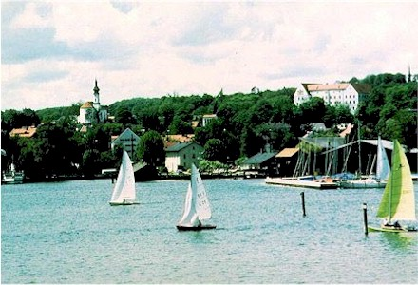

Hotel SEEBLICK

Tutzinger Straße 9
D-82347 Bernried
GERMANY
Phone: +49 8158 2540
Fax: +49 8158 3056

Bernried is a small village situated at the southern bank of the Lake Starnberg. The lake itself is located south of Munich. Munich is the capital of Bavaria. For people interested in the sights at and around Munich, please click

http://www.munich-tourist.de/

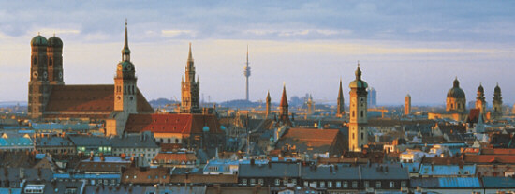

As a very special attraction, we proudly invite you to the Münchner Oktoberfest. The world's biggest “folk” festival takes place according to custom at the foot of the Bavaria Statue. For 16 days visitors from far and wide crowd onto the "Wiesn" to try out the new fairground attractions and to enjoy beer and food in the beer tents.

If you have any questions or needs concerning the co-ordination of the meeting, please feel free to contact

Mr. Peter REINISCH | or | Mrs. Andrea Handler
Vice President
Marketing Communication & Public Relations |  | Product Marketing Assistant
SIEMENS AG |  | SIEMENS AG
Hofmannstraße 51, |  | Autokaderstraße 29
81359 München, |  | 1210 Wien
Germany |  | Austria
Tel.: +49 172 6106470 |  | Tel: +43 1 1707 21241
Fax: +49 89 722 44780 |  | Fax: +43 1 1707 51924
E-mail: peter.reinisch@icn.siemens.de |  | E-mail: andrea.handler@siemens.at

We are looking forward to meeting you at the Hotel Seeblick by the end of September,

Kind regards,

Manfred Leitgeb
Mobile Network Solutions,
Product Marketing GSM,
SIEMENS AG,
GSM: +43.664.3005914,
Tel: +43.1.1707.21355
Email: manfred.leitgeb@siemens.at
TRAVEL INFORMATION

How to reach Bernried by train (recommended)

At Munich Airport please go to the central terminal (sign postet “Z”) and look for the railway station. You have to buy a ticket to Tutzing at the vending machine. The price is around 15 DM for the single trip.
Trains are leaving every 10 minutes, starting at 6 minutes past the hour (e.g. 08:06, 08:16, ........).
Take S1 or S8 to Munich central station (Münchner Hauptbahnhof). It will take about 45 minutes.
At Hauptbahnhof you have to change to a regional train to Tutzing. The train will leave from platforms 27 to 36. Trains leave always on the hour and will take 26 minutes to Tutzing.
When you are arriving in Tutzing a Taxi – Transport will be available departing from the station. You only have to look for the „3GPP – Meeting“ sign there. It will take you about 2 hours from the airport to Bernried.

How to reach Tutzing by car

Start on the motorway A92 in the direction of Munich. At the interchange with A9 continue on A9 to Munich. At the end of A9 take the Mittleren Ring and follow the signs to Garmisch Partenkirchen (A95). Leave the Mittleren Ring at the exit to Garmisch Partenkirchen, A95. At the A95 you have to take the exit Starnberg.
Pass Possenhofen, Feldafing and Tutzing to Bernried. At the entrance to the village of Bernried, you will find the Hotel Seeblick on your right hand in a distance of approx. 500 meters.
Distance from Munich Airport approx. 100 km (about 1 hour to drive).

(A92 to Munich → change to A9 to Munich → take the Mittleren Ring and leave at exit A95 to Garmisch Partenkirchen → leave A95 at exit Starnberg → pass Possenhofen → pass Feldafing → pass Tutzing to BERNRIED)
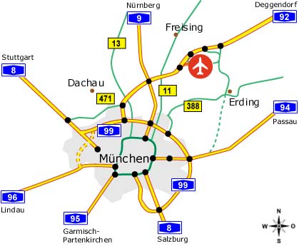
SCHEDULE (PRELIMINARY)

3GPP TSG SA WG1, 27th of September to 1st of October 1999

Day | Time | Activity

Monday | 900 - 1700 | Ad-hoc meetings, e.g. CAMEL
Tuesday | 900  930  1000 - 1230  1400 | Registration  Opening of 3GPP TSG S1  S1 plenary session  begin of ad-hoc groups, e.g. CAMEL / GPRS joint session
Wednesday | 900 - 1500 | S1 plenary
Thursday | 900 - 1800 | S1 plenary
Friday | 900 - 1300  1330 | S1 plenary  End of the meeting

- Coffee breaks are planned at 1030 and 1530,
- Whole Monday and Tuesday afternoon are reserved for ad-hoc meetings,
- Wednesday evening you will be invited by Siemens to the Münchner Oktoberfest.

REGISTRATION FORM

For the 3GPP TSG SA WG1 Meeting #4
27th of September to the 1st of October 1999
Bernried, Germany
Please fill in this form and return it by 10th of September 1999 to: | Mrs. Andrea Handler  E-mail:andrea.handler@siemens.at or  Fax: +43.1.1707.51924

Title: | Ms Mrs. Mr. Dr.
Family name: | _____
First name: | _____
Postal address: | _____
Telephone: | _____
Fax: | _____
E-mail: | _____
Date and time of arrival: | _____ Taxi Service requested
Date and time of departure: | _____
I will attend:
I am unable to attend on this occasion:

Status of Member Represented (tick one box in one column 1, 2 or 3):

1) Organizational Partner Representative (SDO)  (tick one box below) | 2) Individual Member Representative  (tick one box below) | 3) Market Representation Partner Representative  (tick one box below)
Representing Partner:  ARIB | Representing Partner:  ARIB | Representing Partner:  UMTS Forum
ETSI | ETSI | GSA
T1 | T1
TTA | TTA
TTC | TTC
Other: _____ | Other: _____ | Other: _____
Individual Member organization* Name:
_____
I am the voting representative for this Individual Member.

* For a list of Individual Member organizations, see: HREF="http://www.3gpp.org/Individual_Member.htm

