**33GPP TSG-RAN5 Meeting #104R5-24XXXX**

**Maastricht, Netherlands, 19th Aug 2024 – 23th Aug 2024**

**Source:** Huawei, HiSilicon

**Title:** Discussion to split DAPS test case

**Agenda item:** 6.4.7

**Document for:** Endorsement

# Discussion

**Observation 1: interFreqDAPS-r16 is per BC UE capability, and it is reported in CA-parametersNR-v1610. At present, RAN5 test case and GCF treat this feature as per Band feature.**

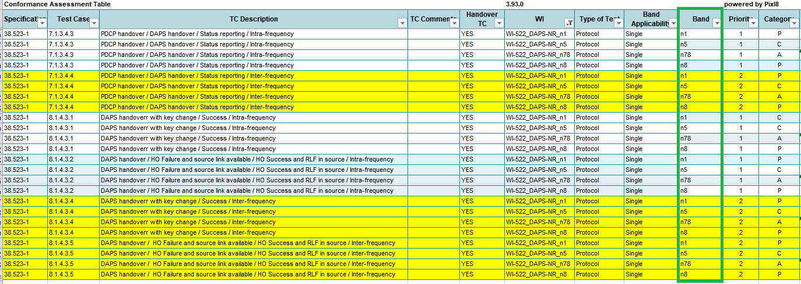

UE may only report interFreqDAPS-r16 in Intra-band contiguous BC or only report it in Intra-band non-contiguous BC or report it in both Intra-band contiguous BC and Intra-band non-contiguous BC.

If UE only support interFreqDAPS-r16 in Intra-band contiguous BC, this kind of UE support interFreqDAPS-r16 but cannot test any of the inter-frequency DAPS test case (i.e 7.1.3.4.4/8.1.4.3.4/8.1.4.3.5).

Because those test case configure source NR Cell in Low Range test frequency (NRf1) and target NR Cell in High Range/Mid Range/Mid-Low Range test frequency(NRf2)

For the GCF interested band n1/n5/n8/n78, all this band have four test frequencies, so the NRf2 is Mid-Low Range test frequency. At present, the test frequency for Source NR Cell and Target NR Cell in all the GCF interested band is configured as intra-band non-contiguous configuration.

|  |  |  |  |  |
| --- | --- | --- | --- | --- |
| NR Band | SCS(KHz) | CBW[MHz] | Downlink Carrier centre for Low Range[MHz]  Source NR Cell | Downlink Carrier centre for Mid-Low Range[MHz]  Target NR Cell |
| n78 | 30 | 100 | 3305.01 | 3483.33 |
| n1 | 15 | 10 | 2115 | 2131.7 |
| n5 | 15 | 5 | 871.5 | 878.2 |
| n8 | 15 | 5 | 927.5 | 937.5 |

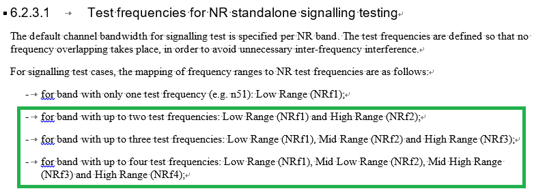

**Therefore, UE, only support interFreqDAPS-r16 in Intra-band contiguous BC, may skip or fail the inter-frequency DAPS test case.**

**Observation 2: Although it is highly possible that UE supporting interFreqDAPS on one BC also support CA on this BC, it is not mandatory that UE supporting interFreqDAPS on one BC also support CA on this BC.**

1. 38.306 does not indicated that is mandatory.
2. For one BC, UE have method to report it support interFreqDAPS but not support CA( same as the method for UE support DC but not support CA in R2-2004436). That is in one BC, the UE can set FeatureSetUplinkId and FeatureSetDownlinkId to 0 in the featureSetCombination to indicate not supporting CA, and set interFreqDAPS-r16 and featureSetCombinationDAPS-r16 to indicate supporting interFreqDAPS.

**Therefore, Redefine the interFreqDAPS test case based on CA capability is not appropriate.**

**Observation 3: RRM interfreqDAPS test case can be set with different test frequencies configuration based on UE capabilities in one test case. However, based on discussion with TF160 expert, SIG may not easy to realize it in one test case.**

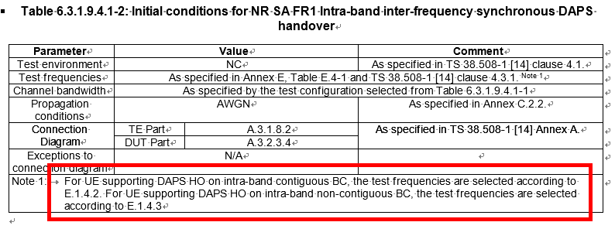

# Proposal

Based on the above discussion

**Proposal 1: Add new PICS to split the capability based on BC and then split interFreqDAPS test case 7.1.3.4.4/8.1.4.3.4/8.1.4.3.5.**

**For 38.523-1, the original 7.1.3.4.4/8.1.4.3.4/8.1.4.3.5 change nothing except for the title (i.e add / Intraband non-contiguous in the test case title), test frequency configuration is still the same as other inter frequency test case. New interFreqDAPS test cases 7.1.3.4.4a/ 8.1.4.3.4a/ 8.1.4.3.5a are added, and the test frequency configuration is the same as the intra-band contiguous CA test cases.**

**For 38.523-2 and 38.508-2, add two PICS, one for intra-band contiguous BC and one for intra-band non-contiguous BC**

If UE supports inter-frequency DAPS handover only on intra-band non-contiguous BC, UE test 7.1.3.4.4/8.1.4.3.4/8.1.4.3.5.

If UE supports inter-frequency DAPS handover only on intra-band contiguous BC, UE test 7.1.3.4.4a/8.1.4.3.4a/8.1.4.3.5a.

If UE supports inter-frequency DAPS handover on both intra-band non-contiguous BC and intra-band contiguous BC, UE test 7.1.3.4.4a/8.1.4.3.4a/8.1.4.3.5a or 7.1.3.4.4/8.1.4.3.4/8.1.4.3.5.

**[38.508-2 new PICS]**

|  |  |  |  |  |  |  |  |
| --- | --- | --- | --- | --- | --- | --- | --- |
| XX1 | support inter-frequency DAPS handover on intra-band contiguous BC | 38.306, 4.2.7.4 | Rel-16 | pc_interFreqDAPS_on_intraband_contiguous_BC | No |  | If UE support interFreqDAPS on intraband contiguous BC, it set to true. |
| XX2 | Support inter-frequency DAPS handover on intra-band non-contiguous BC | 38.306, 4.2.7.4 | Rel-16 | pc_interFreqDAPS_on_intraband_noncontiguous_BC | No |  | If UE support interFreqDAPS on intraband noncontiguous BC, it set to true. |

**[38.523-2 test applicability]**

|  |  |  |  |  |
| --- | --- | --- | --- | --- |
| 7.1.3.4.4 | PDCP handover / DAPS handover / Status reporting / Inter-frequency / Intraband non-contiguous | Rel-16 | C130 | UEs supporting 5G Core and inter-frequency DAPS handover and support inter-frequency DAPS handover on intra-band non-contiguous BC |
| 7.1.3.4.4a | PDCP handover / DAPS handover / Status reporting / Inter-frequency / Intraband contiguous | Rel-16 | C130A | UEs supporting 5G Core and inter-frequency DAPS handover and support inter-frequency DAPS handover on intra-band contiguous BC |

| Clause | Specific ICS | Specific IXIT | Number of TC Executions | Release other RAT |
| --- | --- | --- | --- | --- |
| 7.1.3.4.4 |  |  | If 7.1.3.4.4a is executed this test case is optional |  |
| 7.1.3.4.4a |  |  | If 7.1.3.4.4 is executed this test case is optional |  |