**3GPP TSG-RAN WG4 Meeting #99-e R4-2108659   
Electronic Meeting, May 19-27, 2021**

**Agenda item: 10.1.1**

**Source: vivo, Anritsu**

**Title: TP to TR38.884 v0.3.0 on measurement uncertainty**

**Document for: Approval**

# 1 Introduction

This contribution provides the text proposals related to FR2 ETC test system.

# 2 Discussion

In the last RAN4 meeting, some aspects related to ETC test system have been agreed [1][2]:

(Obj 1) CFFNF MU

* **Agreement**
  + **New MU elements and uncertainty mechanisms related to the CFFNF setup include the following:**
    - **Estimation of DUT antenna location, including compensation of the path loss with respect to the active array, and is applicable to CFFNF using the black and black&white box approach**
    - **Compensation of the probe antenna pattern**
    - **EIRP measurement error**
    - **Whether interaction between probe antenna and DUT antenna at the near distances from the DUT can be introduced is FFS**
  + **Preliminary assessment of EIRP measurement error due to expansion technique**
    - **A detailed impact of the SNR on EIRP measurement error is needed**
    - **TE vendors are encouraged to align simulation assumptions on SNR**

**(Obj 1) CFFDNF setup**

* **Agreement**
  + **New MU elements and uncertainty mechanisms related to the CFFDNF setup include the following:**
    - **Compensation of the probe antenna pattern**
    - **EIRP measurement error**
    - **TRP measurement error**
    - **Whether interaction between probe antenna and DUT antenna at the near distances from the DUT can be introduced is FFS**
    - **Estimation of DUT antenna location, including compensation of the path loss with respect to the active array**

(Obj 1) CFFDNF MU (EIRP and TRP measurement errors)

* **NOTE: outcome of Issues 1-2-2 and 1-2-3**
* **Agreement**
  + **The tables below as the baseline and finalize the MU element description and preliminary assessment of the value next meeting**



ETC test system, test procedure and temperature limit should be captured in the TR.

# 3 References

[1] R4-2106127, “WF on agreements and remaining issues with FR2 test method enhancements”, apple, RAN4# 98bis-e, Apr 2021.

[2] R4-2106157, “Email discussion summary for [98e][330] FR2_enhTestMethods”, Apple, RAN4# 98bis-e, Apr 2021.

# 4 Text Proposal to TR 38.884

**--------------Start of text proposal -------------**

Annex B:  
Measurement uncertainty

# B.1 Measurement uncertainty budget for UE RF testing methodology

Editor’s note: collect the MU elements which are impacted by the enhancements in Clauses 5 and 6 in this clause; if impact on the MU budget of the RRM and/or demodulation setups is identified, the corresponding clauses can be added. Organize the Annex to mirror the TR38.810 structure

## B.1.1 High DL power and low UL power

Editor’s note: the conclusion of MU impacts of the enhanced test methods (i.e. direct Near Field (DNF), Combined Far-Field/Direct Near Field (CFFDNF), and Combined Far-Field/Near Field (CFFNF)) should be captured.

### B.1.1.1 Uncertainty Contributions

~~The uncertainty tables cover the new MU element for different enhanced test systems in the following tables.~~

This section covers the additional MU elements to DFF for different enhanced test systems in the following tables.

Table B.1.1.1-1: Uncertainty contributions for CFFNF system

| **UID** | **Description of uncertainty contribution** | **Details in annex** |
| --- | --- | --- |
| **Measurement stage** | | |
| 1 | DUT antenna location estimation | TBD |
| 2 | Probe antenna pattern | TBD |
| 3 | EIRP measurement error | TBD |
| 4 | Near-field interaction between probe antenna and DUT antenna | TBD |
| 5 | Influence of noise | TBD |
| 6 | Influence of power measurement uncertainty | TBD |

Table B.1.1.1-2: Uncertainty contributions for CFFDNF system

| **UID** | **Description of uncertainty contribution** | **Details in annex** |
| --- | --- | --- |
| **Measurement stage** | | |
| 1 | DUT antenna location estimation | TBD |
| 2 | Probe antenna pattern | TBD |
| 3 | EIRP measurement error | TBD |
| 4 | TRP measurement error | TBD |
| 5 | Near-field interaction between probe antenna and DUT antenna | TBD |

### B.1.1.2 Uncertainty Contributions descriptions

FFS

### B.1.1.3 Uncertainty assessment

FFS

## B.1.2 Polarization basis mismatch between the TE and DUT

For TPMI-based test method for EIRP measurement, the fixed TPMI index is used to configure the UE to ensure 1 layer 2 port transmission. The test setup and test procedure keep unchanged, thus no additional MU is identified for this enhanced test method.

## B.1.3 Inter-band (FR2+FR2) CA

For IFF-based off-focus test system defined in Clause 5.3, the Quality of quiet zone (QoQZ) will be impacted by both the main antenna and of the offset antenna. The preliminary QoQZ difference is analysed to present the measurement uncertainty induced by the off-focus test system.

The difference between the QoQZ of main antenna and of the offset antenna is summarized in Table B.1.3-1 and plotted in Figure B.1.3-1. Note that these values are specific to the feed antenna (amplitude taper) in this experiment and thus they may vary depending on an antenna pattern used by each test equipment vendor.

Table B.1.3-1: Estimation of QoQZ difference between main and offset antenna

|  |  |  |  |
| --- | --- | --- | --- |
|  | Estimation of QoQZ difference (EIRP) [dB] | | |
| δ [mm] | 23.45 GHz | 32.125 GHz | 40.8 GHz |
| 0 | 0.00 | 0.00 | 0.00 |
| 15 | 0.02 | 0.02 | 0.01 |
| 30 | 0.04 | 0.05 | 0.03 |
| 45 | 0.08 | 0.08 | 0.06 |
| 60 | 0.11 | 0.11 | 0.09 |
| 75 | 0.14 | 0.15 | 0.11 |

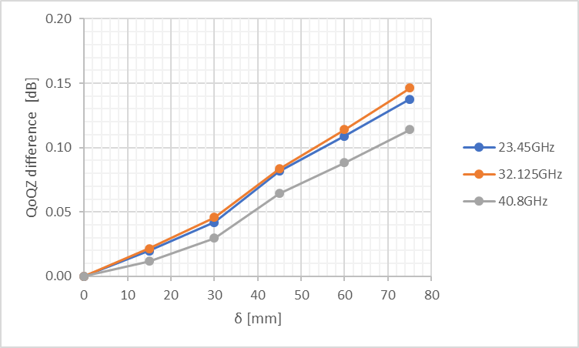

Figure B.1.3-1: Plot of QoQZ difference

## B.1.4 Test system for ETC

The ETC test method has been defined in Clause 5.4. The ETC test system will increase measurement uncertainty compared with NTC test system. For MOP-EIRP and REFSENS-EIS, the comparison of the MU under NTC and ETC is summarized in the table B.1.4-1.

Table B.1.4-1: Comparison of MOP-EIRP and REFSENS-EIS MTSUs.

|  |  |  |  |  |
| --- | --- | --- | --- | --- |
| Test Case | MTSU [dB] | | | |
| **NTC** | | **ETC** | |
| **FR2A**  **(23.45GHz - 32.125GHz)** | **FR2B**  **(32.125GHz - 40.8GHz)** | **FR2A**  **(23.45GHz - 32.125GHz)** | **FR2B**  **(32.125GHz - 40.8GHz)** |
| MOP-EIRP | 4.89 | 5.09 | 5.17 | 5.37 |
| REFSENS-EIS | 5.19 | 5.19 | 5.45 | 5.45 |

Whether the recommended ±[4]ºC temperature tolerance limit of FR2 ETC system defined in clause 5.4.4 would introduce additional MU or not, is FFS.

**--------------End of text proposal -------------**