3GPP TSG-RAN WG4 Meeting #99-e [Draft]R4-2108584

Electronic Meeting, 12th– 20th May, 2021

**Agenda Item: 6.3.2.4.3**

**Source: Samsung**

**Title: TP to TS38.176-2 on Annex I and Annex K**

**Document for: Approval**

# Introduction

According to agreed WF[1] and agreed TS skeleton to TS38.176-2, this contribution provides TP for Annex I and Annex K. The content is mainly from corresponding Annex in TS38.141-2 with minor adaptation for IAB.

This is revision of R4-2109999 according to comment received during 1st round discussion

|  |  |
| --- | --- |
| R4-2109999  Samsung | Ericsson: ok  Huawei: This is ok, I think it’s a direct copy form 38.141-2? However this is quite detailed technical text and is quite hotly debated and seems subject to change quite often. I wonder if its more maintenance proof just to reference 38.141-2?  Samsung: fine to update according to HW’s comment if it is OK for group. |

# Reference

[1] R4-2103856, WF on IAB conformance specification work split and drafting guidelines

[2] R4-2106313, Proposal on the skeleton of TS38.176-2

# Text proposal

**<Start of TP>**

Annex I (normative):

TRP measurement procedures

The Annex I in TS38.141-2[X] applies to IAB.

**<Unchanged part skipped>**

Annex K (informative):

Measuring noise close to noise-floor

As the emission level seen by the measurement receiver (*PUEM*) for co-location requirements are very low, it is suggested to measure relative noise change instead of absolute noise level. For the situation where the noise level is stable, the noise level change can be identified by a relative noise measurement method. This method measures the relative noise change extracted from when the test object is operating and when the power is disconnected. From the two measured noise levels the relative noise change can be determined. The relations between measured noise change *1*, noise floor N0 and the relation to *PUEM* with respect to the noise floor denoted *2* is visualized in the left drawing in figure K-1.

 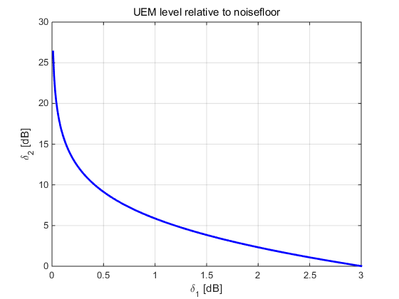

Figure K-1: Relative noise measurement

The absolute emission level in decibel scale is determined from a relative measurement of *1* as:

where *N0* is the noise floor of the measurement receiver and *2* is plotted as function of *1* at the right in figure K-1. The absolute noise floor of the measurement receiver, including probe antenna, cables, filter and LNA is determined by a calibration procedure. The calibration will determine the absolute emission level (*N0*) accuracy of measuring out-of-band unwanted emission close to the thermal noise floor.

**<End of TP>**