3GPP TSG-RAN WG4 Meeting # 99-e R4-21xxxxx
Electronic Meeting, 19th – 27th May, 2021

Agenda item: 13.2
Source: Moderator (OPPO)
Title: Email discussion summary for [99-e][159] NR_reply_LS_RF_Part1
Document for: Information

Introduction
In this paper, the LS to RAN5 on the UL MIMO ON/OFF time mask requirements and to RAN2 on the LS DC location reporting will be discussed.

Topic #1: UL MIMO ON/OFF time mask

Companies’ contributions summary
T-doc number | Company | Proposals / Observations
R4-2108802 | Qualcomm | We propose a reply LS [2].  We further propose CR content as captured in the Annex of this document.
R4-2109368 | Qualcomm | 1. Overall Description:  RAN4 would like to thank RAN5 for the LS on minimum requirements for Transmit ON/OFF time mask in UL MIMO FR1.  The following clarifications are limited to FR1.  The transmit ON power for UL MIMO is defined as the sum of the output powers measured at each transmit antenna connector. ON power applies to any power level bounded by the maximum output power requirement in sub clause 6.2D.1 and the minimum output power requirement in sub clause 6.3D.1.  The transmit OFF power for UL MIMO is defined at each connector, as documented in sub clause 6.3D.2 in TS 38.101-1.  RAN4 confirms the power definitions above apply to the requirements in 6.3D.3. RAN4 will separately clarify the power definitions in section 6.3D.3 consistent with above understanding to address wording ambiguity.
R4-2109684 | vivo | Observation 1: There is no specific requirement in RAN4 for the “ON” power defined in ON/OFF mask. The intention is to have a reasonable fully operational and steady status.  Proposal 1: Clarify there is no inconsistency issue for current definition.  Observation 2: RAN5’s current testing method of summing up the powers can be regarded as a methodology are not really contradicting with RAN4’s requirements.  Proposal 2: Explicitly feedback to RAN5 that the current RAN5’s test method does not really contradict to RAN4 requirements.  [Draft] Reply LS On minimum requirements for Transmit ON/OFF time mask in UL MIMO FR1
R4-2110805 | OPPO | Observation 1: The time alignment error between connectors (0.13us) is non-neglectable comparing to the transient period especially UEs with small transient period capability (2us tp/0.5us tp_{start}).  Proposal 1: Keep UL MIMO ON/OFF time mask requirement defined at each antenna connector.  Observation 2: RAN5 test ON/OFF time mask requirement based on OFF power and ON power before and after the transient period. And for UL MIMO the ON power is measured as sum of the antenna connectors.  Observation 3: RAN5 testing method is different from RAN4 core requirement where the ON/OFF time mask requirement is defined based on each antenna connector.  Proposal 2: Reply RAN5 that the ON/OFF time mask is defined at each antenna connector and UE performance of UL MIMO ON/OFF time mask should be judged based on each antenna connector rather than sum of connectors due to the potential time alignment error between antenna connectors.  [Draft] Reply LS On minimum requirements for Transmit ON/OFF time mask in UL MIMO FR1

1.2 Open issues summary

1.2.1 Sub-topic #1-1
Issue 1-1-1: Whether time alignment error between connectors (0.13us) will impact the UL MIMO ON/OFF time mask requirement if measured by the sum of power from each antenna connector?
Moderator note: This issue is from paper R4-2110805 where the time alignment error between connectors (0.13us) is compared with the transient period capability (2us tp/0.5us tp_{start}) and conclude that this TAE will cause the UL MIMO ON/OFF time mask inaccuracy if measured by the sum of power for each antenna connector.
- Proposals
  - Option 1: Yes
  - Option 2: No
- Recommended WF
Company | Comments
ZTE | Option 1, UL MIMO ON/OFF time mask requirement impact, but maybe no performance impact.  In our understanding, if a UE indicates a short transient period capability, e.g., 2us, with TAE 0.13us, the sum of power from both connectors may show a transient period a bit larger than 2us, maximum 2.13us. However, the increment may not impact performance since MIMO receiver can tolerate the TAE.
Qualcomm | Option 2: No  We appreciate the paper from Oppo.  In our view, the ON/OFF mask requirement remains at 10us regardless of UE declaration, and so the motivation for this proposal does not exist. In an offline Oppo identified another potential ambiguity in wording which suggests 6.3D.3 covers ON/ON as well as on/OFF requirements because of reference to 6.3.3 and not 6.3.3.2. We are ok to limit the scope of 6.3D.3 to 6.3.3.2 to address this ambiguity.
OPPO | Option 1, The requirement defined in UL MIMO refers to the 6.3.3 which is the ON/OFF time mask includes general ON-OFF and ON-ON time masks. The time alignment error not impact the general ON/OFF time mask, however, for the ON-ON time masks with the transient period the time alignment error will have impact on them.  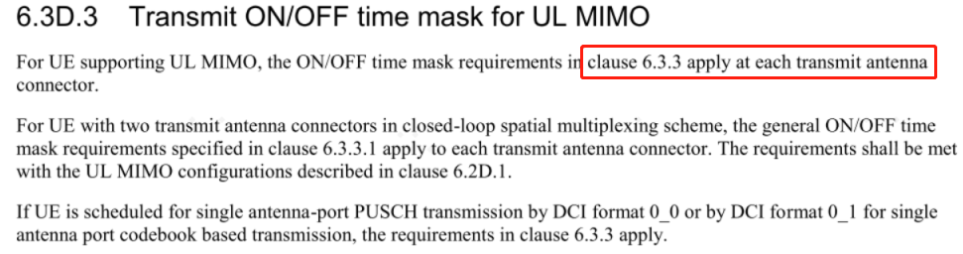
Xiaomi | If on off time mask is not measured by each connector, the time alignment error should be considered.
Huawei, HiSilicon | Option 1.
vivo | Conceptually option 1 is more precise, but the actual performance difference is most likely to be neglectable. In addition, for other UL-MIMO output power which scenarios are actually similar to the ON power in the mask, this alignment errors are not considered

Issue 1-1-2: Whether the ON power in UL MIMO ON/OFF time mask need to be changed from single antenna connector to sum of antenna connectors?
- Proposals
  - Option 1: Yes.
  - Option 2: No.
- Recommended WF
Company | Comments
ZTE | Option 2.
Qualcomm | No. We prefer ON power for ON/OFF mask to remain consistent with output power definition in other places for UL MIMO (sum of measured powers from connectors)
OPPO | Option 2 No.
Xiaomi | Option 2
Huawei, HiSilicon | Option 2.
vivo | Option 2

Issue 1-1-3: Whether the ON power in UL MIMO ON/OFF time mask applies to any power level bounded by the maximum output power requirement in sub clause 6.2D.1 and the minimum output power requirement in sub clause 6.3D.1? If Yes, then whether this needs to be clarified in the spec?
- Proposals
  - Option 1: Yes, and it needs to be clarified in the spec.
  - Option 2: Yes, but it doesn’t needs to be clarified in the spec.
  - Option 3: No.
- Recommended WF
Company | Comments
Nokia | Option 1
MediaTek | Option 1 or 2 is fine.
ZTE | Option 2. This is a common sense on the ON power.
Qualcomm | We are proponents of option 1, but are willing to discuss if there is a better way.
OPPO | No strong view, maybe Option 2 is enough
Xiaomi | Either option 1 or option 2
Huawei, HiSilicon | Option 2. We think that the clarification may not be necessary.
vivo | Prefer Option 2. Option 1 can also be discussed if some wording is possible.

Issue 1-1-4: If choose option 1 in Issue 1-1-3, then does the proposed changes in R4-2108802 is acceptable?
- Proposals
  - Option 1: Yes, the changes in R4-2108802 is ok.
  - Option 2: No, further changes are needed for R4-2108802.
- Recommended WF
Company | Comments
Nokia | Option 2  The proposed changes look good in8802, but it would be better to clarify what ON state means as well. During on state, UE needs to meet all the accompanied requirements according to power level, though some of the requirements must be met regardless of the power level.
MediaTek | Option 1 is fine for now. We do not fully understand the final sentence proposed Nokia, it goes beyond defining what the state is, and seems confusing to us to talk about applicability to other requirements in a generic manner.
ZTE | Option 2. We think the current specs is clear enough.
Qualcomm | Option 1, but we are open to improving the wording, so ok with option 2 also.  In an offline Oppo identified another potential ambiguity in wording which suggests 6.3D.3 covers ON/ON as well as on/OFF requirements because of reference to 6.3.3 and not 6.3.3.2. We are ok to limit the scope of 6.3D.3 to 6.3.3.2 to address this ambiguity.
OPPO | For the UL MIMO ON/OFF time mask, in our view, the requirements in the 6.3.3 all apply to UL MIMO. But we can further discuss on this aspect.
Xiaomi | Option 2, we think the text “For UE supporting UL MIMO, the ON/OFF time mask requirements in clause 6.3.3 apply at each transmit antenna connector” in current spec shall be kept.
Huawei, HiSilicon | Option 2. Clarification seems not necessary.
vivo | Option 2. We do not think it is necessary and precise.

Issue 1-1-5: Whether RAN4 needs to confirm RAN5 testing method or focus on the RAN4 requirement clarification?
- Proposals
  - Option 1: Yes, RAN4 confirm RAN5 testing method is ok/not ok
  - Option 2: No, focus on the RAN4 requirement clarification
- Recommended WF
Company | Comments
MediaTek | We assume that RAN5 warrants some response from RAN4 once we have agreed what to do.
ZTE | Option 2. Testing method is RAN5’s job.
Qualcomm | Option 2
OPPO | Option 2. Clarification of RAN4 requirements is enough.
Xiaomi | Option 2
Huawei, HiSilicon | Option 2.
vivo | Option 1 may reduce further question from RAN5, while Option 2 can also be accepted.

1.3 Summary for 1st round

1.3.1 Open issues
 | Status summary
Issue 1-1-1: Whether time alignment error between connectors (0.13us) will impact the UL MIMO ON/OFF time mask requirement if measured by the sum of power from each antenna connector? | Moderator summary:  Majority of companies support Option 1 and one company think Option 1 is more precise and another company think the time alignment error will not impact UL MIMO time mask if change the current requirement from whole ON/OFF and ON/ON time mask to only general ON/OFF time mask.  Change of UL MIMO requirement may need further study, but this is not the main point of this discussion, and conclusion can based on the current requirements.  Therefore, moderator suggest that the Option 1 is agreed, i.e. time alignment will impact the UL MIMO ON/OFF time mask, but it should be noted that if UL MIMO ON/OFF time mask (6.3D.3) is changed to only the general ON-OFF time requirement (6.3.3.2) and no ON-ON requirement then the impact of time alignment error will be neglectable.
Issue 1-1-2: Whether the ON power in UL MIMO ON/OFF time mask need to be changed from single antenna connector to sum of antenna connectors? | Moderator summary:  All but one company think the current UL MIMO ON/OFF time mask requirement should be unchanged, i.e. defined at single antenna connector.  Based on the status, moderator feels that changing requirement from single antenna connector to sum of antenna connectors is less likely to be agreed at the moment. And further discussion can still be happen. LS can based on the current requirements, and if further agreements are achieved in future meetings, then it can update with RAN5.
Issue 1-1-3: Whether the ON power in UL MIMO ON/OFF time mask applies to any power level bounded by the maximum output power requirement in sub clause 6.2D.1 and the minimum output power requirement in sub clause 6.3D.1? If Yes, then whether this needs to be clarified in the spec? | Moderator summary:  No majority view is shown among Option 1 and Option 2. The consensus is that the ON power in UL MIMO ON/OFF time mask applies to any power level bounded by the maximum output power requirement in sub clause 6.2D.1 and the minimum output power requirement in sub clause 6.3D.1. No conclusion on adding this consensus to spec.  Moderator suggest to not change spec, but inform RAN5 about the consensus above.
Issue 1-1-4: If choose option 1 in Issue 1-1-3, then does the proposed changes in R4-2108802 is acceptable? | Moderator summary:  No change is needed according to issue 1-1-3.
Issue 1-1-5: Whether RAN4 needs to confirm RAN5 testing method or focus on the RAN4 requirement clarification? | Moderator summary:  Majority support Option 2, i.e. the LS should focus on the RAN4 requirement clarification. And it is suggest to agree on Option 2.

1.4 Discussion on 2nd round

1.4.1 Open issues
Issue 1-1-6: Whether UL MIMO ON/OFF time mask (6.3D.3) should be changed to from referring to clause 6.3.3 to clause 6.3.3.2 (general ON-OFF time mask) and no ON-ON requirement apply to UL MIMO?
Option 1: Yes
Option 2: No

Moderator note:
This is the follow up discussion of issue 1-1-1, one company propose to change the UL MIMO requirement from all the ON-OFF and ON-ON requirement in clause 6.3.3 to only ON-OFF requirement in clause 6.3.3.2.
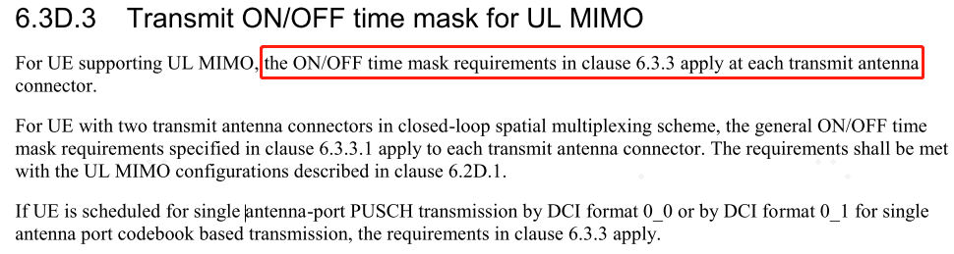
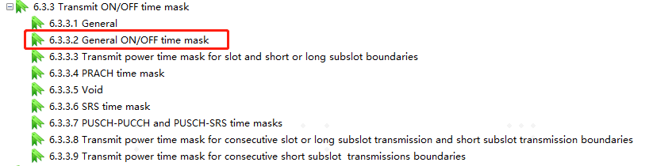

Company | Comments

Issue 1-1-7: Comments on content of “Reply LS On minimum requirements for Transmit ON/OFF time mask in UL MIMO FR1”

Company | Comments

1.4.2 Companies views’ collection for 2nd round

1.4.3 Summary on 2nd round

Topic #2: DC location reporting for intra-band UL CA

Companies’ contributions summary
T-doc number | Company | Proposals / Observations
R4-2111390 | HW | Proposal 1: we propose Answers to the 2 issues in the LS:  - Answer 1: RAN4 confirms the DC location reporting does not need to consider SUL in the case of intra-band UL CA.  - Answer 2: RAN4 confirms the use case of UE reporting Tx DC location info for the second PA (when the UE supports dual PA) when the SCell is deactivated, is not needed.

1.2 Open issues summary

1.2.1 Sub-topic #2-1
Issue 2-1-1: Does DC location needs to be reported for SUL in the case of intra-band UL CA?
- Proposals
  - Option 1: Yes
  - Option 2: No
- Recommended WF
Company | Comments
ZTE | Option 2, not needed.
MTK | Option 2, not needed.
Huawei, HiSilicon | Option 2, not needed.
OPPO | Option 2
Xiaomi | Option 2

Issue 2-1-2: Whether UE needs to report Tx DC location info for the second PA (when the UE supports dual PA) when the SCell is deactivated?
- Proposals
  - Option 1: Yes.
  - Option 2: No.
- Recommended WF
Company | Comments
ZTE | Option 2, not needed.
MTK | Option 2, not needed.
Qualcomm | Option 2, however, it should be noted that the text in the proponents paper “For alt-2, if Scell is deactivated, the LO for 2nd PA will be moved with the 1st PA, because the 2 RF chains share the LO for this case. There is also no need to report the LO for 2nd PA.” is not correct. The LO will not move with 1st PA but will remain where it was based on 2 PA configuration. This has no impact on the proposal.
Huawei, HiSilicon | Option 2, not needed. To QC, understood, for this case whether LO moves depends on UE implementation. Could moderator allocate a new T-doc for our reply LS?
OPPO | Option 2.
Xiaomi | Option 2

1.3 Summary for 1st round

1.3.1 Open issues
 | Status summary
Issue 2-1-1: Does DC location needs to be reported for SUL in the case of intra-band UL CA? | Moderator summary:  Option 2 is agreed, i.e. DC location doesn’t needs to be reported for SUL in the case of intra-band UL CA
Issue 2-1-2: Whether UE needs to report Tx DC location info for the second PA (when the UE supports dual PA) when the SCell is deactivated? | Moderator summary:  Option 2 is agreed, i.e. UE doesn’t need to report Tx DC location info for the second PA (when the UE supports dual PA) when the SCell is deactivated

1.4 Discussion on 2nd round

1.4.1 Open issues
Issue 2-1-3: Comments on content of “Reply LS on DC location reporting for intra-band UL CA”

Company | Comments

1.4.2 Companies views’ collection for 2nd round

1.4.3 Summary on 2nd round

Recommendations for Tdocs

1st round
New tdocs
Title | Source | Comments
Reply LS on DC location reporting for intra-band UL CA | Huawei | To: RAN2
Reply LS On minimum requirements for Transmit ON/OFF time mask in UL MIMO FR1 | OPPO | To: RAN5

Existing tdocs
Tdoc number | Title | Source | Recommendation | Comments
R4-2108802 | ON/OFF time mask inconsistency issue | Qualcomm | Noted
R4-2109368 | Reply LS On minimum requirements for Transmit ON/OFF time mask in UL MIMO FR1 | Qualcomm | Noted
R4-2109684 | Discussion and reply LS On minimum requirements for Transmit ON/OFF time mask in UL MIMO FR1 | vivo | Noted
R4-2110805 | Reply LS of UL MIMO ON OFF time mask | OPPO | Noted
R4-2111390 | Reply LS to RAN2 on DC location | Huawei | Noted

Notes:
- Please include the summary of recommendations for all tdocs across all sub-topics incl. existing and new tdocs.
- For the Recommendation column please include one of the following:
  - CRs/TPs: Agreeable, Revised, Merged, Postponed, Not Pursued
  - Other documents: Agreeable, Revised, Noted
- For new LS documents, please include information on To/Cc WGs in the comments column
- Do not include hyper-links in the documents

2nd round

Tdoc number | Title | Source | Recommendation | Comments
R4-210xxxx | WF on … | YYY
R4-210xxxx | LS on … | ZZZ

Notes:
- Please include the summary of recommendations for all tdocs across all sub-topics.
- For the Recommendation column please include one of the following:
  - CRs/TPs: Agreeable, Revised, Merged, Postponed, Not Pursued
  - Other documents: Agreeable, Revised, Noted
- Do not include hyper-links in the documents

