**3GPP TSG-RAN WG4 Meeting # 99-e R4-21xxxxx**

**Electronic Meeting, May. 19-27, 2021**

**Agenda item:** 9.14.5

**Source:** Moderator (CATT)

**Title:** Email discussion summary for [99-e][143] NRSL_enh_Part_2

**Document for:** Information

# Introduction

In RAN4#98-bis-e meeting, partially used SL operation with Uu in licensed band was discussed with a lot of issues unsettled. This email discussion summary will continue to focus on operating scenarios, synchronous operation, RF requirements for intra-band V2X operation.

The agenda items involved are as follows:

*9.14.5 Partially used SL operation with NR Uu operating bands [NR_SL_enh-Core]*

*9.14.5.1 FDM operation [NR_SL_enh-Core]*

*9.14.5.2 TDM operation [NR_SL_enh-Core]*

*9.14.5.3 Synchronous operation between NR Uu and NR SL in a TDD band [NR_SL_enh-Core]*

*9.14.5.4 Others [NR_SL_enh-Core]*

The candidate targets of this email discussion for 1st round and 2nd round:

* 1st round
  + Companies to provide comments on each sub-topic and try to converge.
  + Companies to check TPs and provide comments
  + Assign the corresponding WF after the 1st round discussion.
* 2nd round
  + Capture the agreements and open issues if any in WF and further discuss the WF.
  + Recommend the final status of the WFs and TPs.

# Topic #1: Operating scenarios for intra-band V2X operation

## Companies’ contributions summary

|  |  |  |
| --- | --- | --- |
| **T-doc number** | **Company** | **Proposals / Observations** |
| [R4-2109947](https://www.3gpp.org/ftp/TSG_RAN/WG4_Radio/TSGR4_99-e/Docs/R4-2109947.zip) | LG Electronics France | Title: RF requirements for partial used licensed band bewteen NR Uu and NR SL operation  **Observation 1: RAN4 can consider 13us NTA offset for NR only 500m ISD cell. The all SCS waveform do not have any interference problem in its own device based on RAN1 & RRM agreement.**  **Observation 2: The partial usage V2X operation scenarios in a licensed band are considered the half duplexer mode in SL operation perspective.**  **Proposal 1: RAN4 specify ON/OFF Time Mask for TDM operation in same carrier as shown in Figure 2-1 to Figure 2-3.**  **Proposal 2: For the ON/OFF time mask for TDM operation in different carrier, RAN4 can follow the decision of TDM operation in ITS spectrum with different carrier.**  **Proposal 3: For the SL transmission time alignment, RAN4 can keep the current RRM agreements as specified in section 12.2.3 in TS38.133.**  **Proposal 4: RAN4 would allow the intra-band con-current SL operation with adjacent carrier for FDM operation in TDD band without in-device coexistence study.**  **Proposal 5: RAN4 need study whether to allow the intra-band con-current SL operation with adjacent carrier for FDM operation in FDD specific band based on operator request due to self-interference problem.**  **Proposal 6: For the FDD/TDD intra-band con-current operation with non-adjacent carrier, RAN4 need further discussion on the detail coexistence scenarios based on operator deployment scenarios and request. It will be treated as 3rd priority in Rel-17.**  **Proposal 7: Based on Table 4-1, RAN4 define the detailed RF requirements for intra-band con-current V2X operation in TDD band.**  **Proposal 8: Based on Table 4-2, 4-3 and 4-4, RAN4 define the REFSENS requirements for intra-band con-current V2X operation in n79.** |
| [R4-2110025](https://www.3gpp.org/ftp/TSG_RAN/WG4_Radio/TSGR4_99-e/Docs/R4-2110025.zip) | Xiaomi | Title: on full half duplex and TDM FDM operation scenario for intra-band con-current operation  **Observation 1: It has been agreed different RF chain architecture based on TDM/FDM operation scenario.**  **Observation 2: The TDM operation between spectrally partially used PC5 SL and Uu UL/DL operation cannot be categorized as TDM or FDM operation and the RF architecture assumption cannot apply to this scenario.**  **Observation 3: It is straightforward to assume half-duplex mode with single RF chain and full-duplex mode with separate RF chain.**  **Proposal: It is proposed below scenarios and priority:**  **1st priority: TDM only: Half-duplex without frequency separation (Single RF chain for TX as baseline)**  **2nd priority: FDM only: Full-duplex with adjacent carrier (Separate RF chain for TX as baseline)**  **3rd priority: FDM only: Full-duplex with non-adjacent carrier (Separate RF chain for TX as baseline)**  **4th priority: TDM + FDM: Half-duplex with frequency separation (Single RF chain for TX as baseline)** |
| [R4-2110024](https://www.3gpp.org/ftp/TSG_RAN/WG4_Radio/TSGR4_99-e/Docs/R4-2110024.zip) | Xiaomi | Title: on FDM intra-band concurrent operation  **Observation 1: The guard period should both cover the 2 time transient period and the TTA.**  **Proposal 1: To set guard period as 1/2/3 symbols for SCS 15/30/60kHz respectively.**  **Observation 2: The simultaneous TX/RX combination frequency separation can be starting point for non-adjacent FDM operation**  **Observation 3: an extra FDD duplexer will be needed to guarantee enough isolation for the UL and SL RF chain.** |
| [R4-2111187](https://www.3gpp.org/ftp/TSG_RAN/WG4_Radio/TSGR4_99-e/Docs/R4-2111187.zip) | Ericsson | Title: FDM operation for partially used SL operation in licensed band  **Proposal-1: Use the “concurrent SL transmission and Uu transmission operation ” and “concurrent reception of SL and Uu transmission operation” terminology to separate the discussion of the FDM operation between Uu and SL operating in a licensed band.**  **Observation#1: There is no concurrent reception of and Uu transmission in licensed band for LTE ProSe and LTE V2X.**  **Observation#2: There is no concurrent reception of SL in one carrier and SL transmission in another carrier in B47 band for LTE V2X.**  **Observation#3: Only non-concurrent reception of SL in one carrier and Uu transmission in a band for NR V2X. The concurrent reception of SL and Uu transmission is allowed for inter-band operation.**  **Proposal-2: RAN4 discuss whether to introduce the concurrent reception of SL and Uu transmission operation in the licensed band.**  **Observation-4: If RAN4 would allow concurrent SL transmission and Uu transmission operation within a licensed band using the single PA RF architecture, the synchronization mechanism for SL transmission timing using network as sync source would be impacted also.** |
| [R4-2109033](https://www.3gpp.org/ftp/TSG_RAN/WG4_Radio/TSGR4_99-e/Docs/R4-2109033.zip) | CATT | Title: Discussion on TDM operation between SL and Uu  **Observation 1: One important issue needing to be clarified is whether the same carrier here means the same carrier frequency and same channel bandwidth. If different channel bandwidths with the same carrier frequency between SL and Uu are allowed, the time occupied by different channel bandwidths configuration during the switching process should be taken into account.**  **Proposal 1: To consider the time mask in Figure 1 and Figure 2 for SL and Uu switching with the same carrier.**  **Proposal 2: To locate the switching period based on the prioritization for SL and Uu, i.e. the switching period is located on the RAT that has a lower priority.**  **Proposal 3: To consider the time mask in Figure 3 and Figure 4 for SL and Uu switching with different carriers without dual PA capability.** |
| [R4-2110028](https://www.3gpp.org/ftp/TSG_RAN/WG4_Radio/TSGR4_99-e/Docs/R4-2110028.zip) | Xiaomi | Title: on TDM intra-band concurrent operation  **Observation 1: The overlap of UL and SL only occurs when there is switching from SL to UL.**  **Observation 2: The guard period between the SL to UL switching should consider both Timing advance and the switching time of SL to UL.**  **Proposal 1: To agree with the guard period to consider both switching time and timing advance as illustrated in figure 2.**  **Proposal 2: Apply Scheduling restriction to the NR SL to UL switching to cover the switching time and timing advance.** |
| R4-2109693 | vivo | Further discussion on synchronization issues for intra-band V2X operation  **Observation 1: Only different carriers are considered for intra-band V2X operation, for both of TDM/FDM operation.**  **Proposal 1: RAN4 needs to prioritize the scenario for Uu and SL in the same carrier for intra-band V2X operation.**  **Observation 2: For intra-band V2X operation, single RF chain can support TDM, not FDM; separate RF chains can support both TDM and FDM.**  **Proposal 2: Send LS to RAN1 to ask whether SL transmission timing and synchronization reference source can be revisited for the intra-band V2X operation.**  **Observation 3: Instead of using the duplex term, whether to allow SL and Uu transmission simultaneously would be more appropriate.**  **Observation 4: For intra-band V2X operation, SL and Uu are not allowed simultaneously transmitted.**  **Proposal 3: No need to introduce the frequency separation for the case Uu and SL are in different channels for intra-band con-current operation.**  **Proposal 4: The time mask requirement for intra-band V2X operation can follow the consideration of defining time mask for the switching between LTE V2X and NR V2X case.** |

## Open issues summary

Based on above contributions, the following sub-topics and issues regarding operating scenarios for partially used SL operation will be discussed in this clause:

* Sub-topic 1-1: Clarification on duplex mode
* Issue 1-1-1: Duplex mode
* Sub-topic 1-2: Intra-band V2X con-current operation (FDM)
* Issue 1-2-1: Intra-band con-current V2X operation with adjacent carrier for TDD band
* Issue 1-2-2: Intra-band con-current V2X operation with adjacent carrier for FDD band
* Issue 1-2-3: Frequency separation for non-adjacent carriers
* Sub-topic 1-3: Intra-band V2X operation (TDM)
* Issue 1-3-1: Intra-band V2X operation with same carrier
* Issue 1-3-2: Switching period length
* Issue 1-3-3: Switching period position
* Issue 1-3-4: Scheduling restriction for switching
* Issue 1-3-5: Time mask for TDM with same carrier
* Issue 1-3-6: Time mask for TDM with different carriers

### Sub-topic 1-1: Clarification on duplex mode

**Issue 1-1-1: Duplex mode**

* Proposals
  + Option 1: It is proposed below scenarios and priority:

1st priority: TDM only: Half-duplex without frequency separation (Single RF chain for TX as baseline)

2nd priority: FDM only: Full-duplex with adjacent carrier (Separate RF chain for TX as baseline)

3rd priority: FDM only: Full-duplex with non-adjacent carrier (Separate RF chain for TX as baseline)

4th priority: TDM + FDM: Half-duplex with frequency separation (Single RF chain for TX as baseline)

* + Option 2: Use the “concurrent SL transmission and Uu transmission operation ” and “concurrent reception of SL and Uu transmission operation” terminology to separate the discussion of the FDM operation between Uu and SL operating in a licensed band.
* Recommended WF
  + Need more discussion.

### Sub-topic 1-2: Intra-band V2X con-current operation (FDM)

**Issue 1-2-1: Intra-band con-current V2X operation with adjacent carrier for TDD band**

* Proposals
  + Option 1: RAN4 would allow the intra-band con-current SL operation with adjacent carrier for FDM operation in TDD band without in-device coexistence study.
* Recommended WF
  + Need more discussion.

**Issue 1-2-2: Intra-band con-current V2X operation with adjacent carrier for FDD band**

* Proposals
  + Option 1: RAN4 need study whether to allow the intra-band con-current SL operation with adjacent carrier for FDM operation in FDD specific band based on operator request due to self-interference problem.
* Recommended WF
  + Need more discussion.

**Issue 1-2-3: Frequency separation for non-adjacent carriers**

* Proposals
  + Option 1: RAN4 discuss whether to introduce the concurrent reception of SL and Uu transmission operation in the licensed band.
  + Option 2: For the FDD/TDD intra-band con-current operation with non-adjacent carrier, RAN4 need further discussion on the detail coexistence scenarios based on operator deployment scenarios and request. It will be treated as 3rd priority in Rel-17.
  + Option 3: No need to introduce the frequency separation for the case Uu and SL are in different channels for intra-band con-current operation.
* Recommended WF
  + Need more discussion.

### Sub-topic 1-3: Intra-band V2X operation (TDM)

**Issue 1-3-1: Intra-band V2X operation with same carrier**

* Proposals
  + Option 1: RAN4 needs to prioritize the scenario for Uu and SL in the same carrier for intra-band V2X operation.
* Recommended WF
  + Need more discussion.

**Issue 1-3-2: Switching period length**

* Proposals
  + Option 1: To agree with the guard period to consider both switching time and timing advance as illustrated in figure 1.

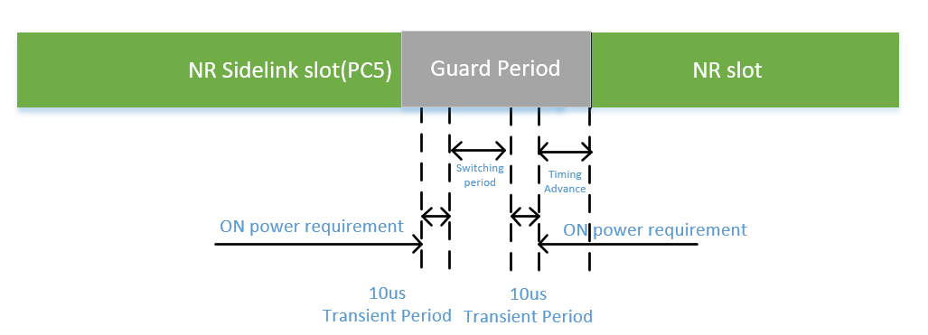

Figure 1: Guard period needed to cover the timing advance and SL to UL switching

* Recommended WF
  + Need more discussion.

**Issue 1-3-3: Switching period position**

* Proposals
  + Option 1: To locate the switching period based on the prioritization for SL and Uu, i.e. the switching period is located on the RAT that has a lower priority.
* Recommended WF
  + Need more discussion.

**Issue 1-3-4: Scheduling restriction for switching**

* Proposals
  + Option 1: Apply Scheduling restriction to the NR SL to UL switching to cover the switching time and timing advance.
* Recommended WF
  + Need more discussion.

**Issue 1-3-5: Time mask for TDM with same carrier**

* Proposals
  + Option 1: RAN4 specify ON/OFF Time Mask for TDM operation in same carrier as shown in Figure 2 to Figure 3.

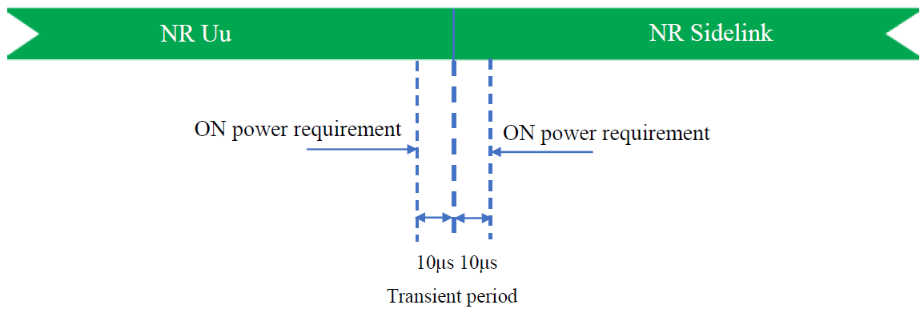

Figure 2: Time mask for NR Uu switching to NR SL

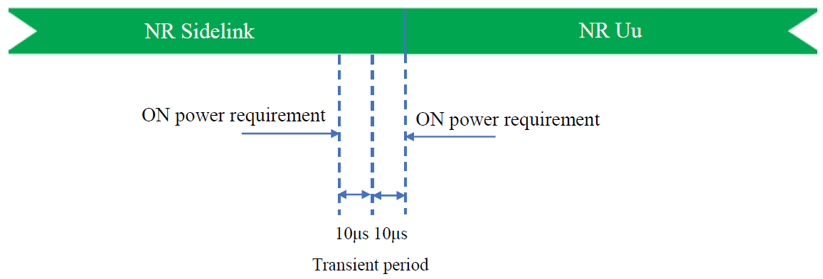

Figure 3: Time mask for NR SL switching to NR Uu

* Recommended WF
  + Need more discussion.

**Issue 1-3-6: Time mask for TDM with different carriers**

* Proposals
  + Option 1: RAN4 can follow the decision of TDM operation in ITS spectrum with different carrier.
  + Option 2: To consider the time mask in Figure 4 and Figure 5 for SL and Uu switching with different carriers without dual PA capability.

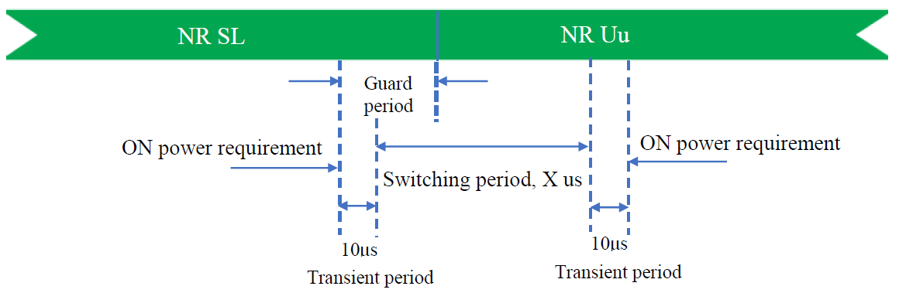

Figure 4: Time mask for NR SL (higher priority) switching to NR Uu without dual PA capability

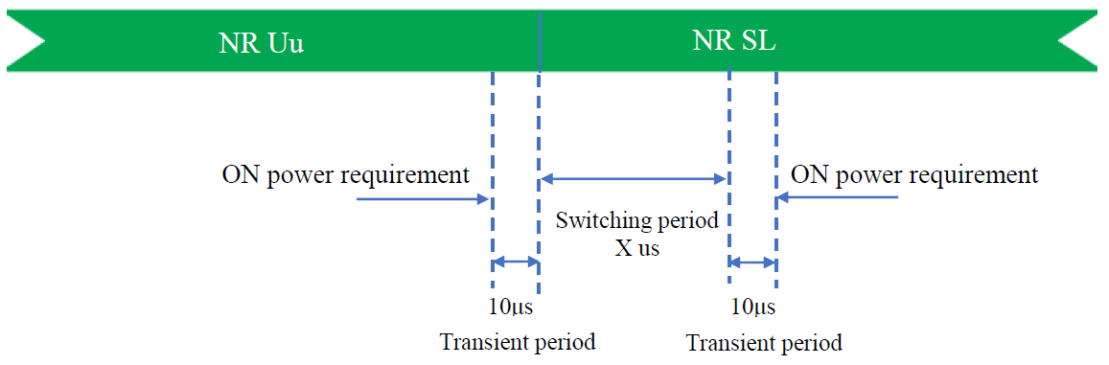

Figure 5: Time mask for NR Uu (higher priority) switching to NR SL without dual PA capability

* Recommended WF
  + Need more discussion.

## Companies views’ collection for 1st round

### Open issues

**Issue 1-1-1: Duplex mode**

|  |  |
| --- | --- |
| **Company** | **Comments** |
|  |  |
|  |  |
|  |  |

**Issue 1-2-1: Intra-band con-current V2X operation with adjacent carrier for TDD band**

|  |  |
| --- | --- |
| **Company** | **Comments** |
|  |  |
|  |  |
|  |  |

**Issue 1-2-2: Intra-band con-current V2X operation with adjacent carrier for FDD band**

|  |  |
| --- | --- |
| **Company** | **Comments** |
|  |  |
|  |  |
|  |  |

**Issue 1-2-3: Frequency separation for non-adjacent carriers**

|  |  |
| --- | --- |
| **Company** | **Comments** |
|  |  |
|  |  |
|  |  |

**Issue 1-3-1: Intra-band V2X operation with same carrier**

|  |  |
| --- | --- |
| **Company** | **Comments** |
|  |  |
|  |  |
|  |  |

**Issue 1-3-2: Switching period length**

|  |  |
| --- | --- |
| **Company** | **Comments** |
|  |  |
|  |  |
|  |  |

**Issue 1-3-3: Switching period position**

|  |  |
| --- | --- |
| **Company** | **Comments** |
|  |  |
|  |  |
|  |  |

**Issue 1-3-4: Scheduling restriction for switching**

|  |  |
| --- | --- |
| **Company** | **Comments** |
|  |  |
|  |  |
|  |  |

**Issue 1-3-5: Time mask for TDM with same carrier**

|  |  |
| --- | --- |
| **Company** | **Comments** |
|  |  |
|  |  |
|  |  |

**Issue 1-3-6: Time mask for TDM with different carriers**

|  |  |
| --- | --- |
| **Company** | **Comments** |
|  |  |
|  |  |
|  |  |

### CRs/TPs comments collection

*Major close-to-finalize WIs and Rel-15 maintenance, comments collections can be arranged for TPs and CRs. For Rel-16 on-going WIs, suggest to focus on open issues discussion on 1st round.*

|  |  |
| --- | --- |
| **CR/TP number** | **Comments collection** |
|  |  |
|  |
|  |

## Summary for 1st round

### Open issues

*Moderator tries to summarize discussion status for 1st round, list all the identified open issues and tentative agreements or candidate options and suggestion for 2nd round i.e. WF assignment.*

|  |  |
| --- | --- |
|  | **Status summary** |
| **Sub-topic#1** | *Tentative agreements:*  *Candidate options:*  *Recommendations for 2nd round:* |
|  |  |
|  |  |

*Recommendations on WF/LS assignment*

|  |  |  |
| --- | --- | --- |
|  | **WF/LS t-doc Title** | **Assigned Company,**  **WF or LS lead** |
|  |  |  |

### CRs/TPs

*Moderator tries to summarize discussion status for 1st round and provides recommendation on CRs/TPs Status update*

|  |  |
| --- | --- |
| **CR/TP number** | **CRs/TPs Status update recommendation** |
| XXX | *Based on 1st round of comments collection, moderator can recommend the next steps such as “agreeable”, “to be revised”* |
|  |  |

## Discussion on 2nd round (if applicable)

## Companies views’ collection for 2nd round

### Open issues

### CRs/TPs comments collection

|  |  |
| --- | --- |
| **CR/TP number** | **Comments collection** |
|  |  |
|  |
|  |

## Summary on 2nd round (if applicable)

*Moderator tries to summarize discussion status for 2nd round and provided recommendation on CRs/TPs/WFs/LSs Status update suggestion*

|  |  |
| --- | --- |
| **CR/TP/LS/WF number** | **T-doc Status update recommendation** |
| XXX | *Based on 2nd round of comments collection, moderator can recommend the next steps such as “agreeable”, “to be revised”* |
|  |  |

# Topic #2: Synchronous operation between SL and Uu

## Companies’ contributions summary

|  |  |  |
| --- | --- | --- |
| **T-doc number** | **Company** | **Proposals / Observations** |
| R4-2109035 | CATT | Title: Discussion on synchronous operation between SL and Uu  **Proposal 1: To send an LS to RAN1 to reflect the current situation on SL transmission timing in RAN4. Proposal 2: To consider the following two solutions to timing misalignment issue between SL and Uu:  *Solution 1: SL timing aligned with UL timing of Uu.  Solution 2: Only allow Uu UL transmission prior to SL reception and transmission, i.e. configure SL Rx/Tx slots to be located in the back of Uu UL Tx slots.* Proposal 3: If the LS will be sent out for SL transmission timing issue, it is proposed to include the sync reference source together with SL timing issue in the LS.** |
| R4-2109380 | Qualcomm Incorporated | Title: Timing reference for NR SL on SL enhancements  **Observation 1: Current RAN1 agreement states that DL timing should be used for NR sidelink when gNB/eNB is used as a synchronization reference Observation 2 : The selection of which timing reference to use for the SL when gNB/eNB is used as a synchronization reference falls within the purview of RAN1** |
| R4-2109693 | vivo | Title: Further discussion on synchronization issues for intra-band V2X operation  **Observation 1: Only different carriers are considered for intra-band V2X operation, for both of TDM/FDM operation. Proposal 1: RAN4 needs to prioritize the scenario for Uu and SL in the same carrier for intra-band V2X operation. Observation 2: For intra-band V2X operation, single RF chain can support TDM, not FDM; separate RF chains can support both TDM and FDM. Proposal 2: Send LS to RAN1 to ask whether SL transmission timing and synchronization reference source can be revisited for the intra-band V2X operation. Observation 3: Instead of using the duplex term, whether to allow SL and Uu transmission simultaneously would be more appropriate. Observation 4: For intra-band V2X operation, SL and Uu are not allowed simultaneously transmitted. Proposal 3: No need to introduce the frequency separation for the case Uu and SL are in different channels for intra-band con-current operation. Proposal 4: The time mask requirement for intra-band V2X operation can follow the consideration of defining time mask for the switching between LTE V2X and NR V2X case.** |
| R4-2110026 | Xiaomi | Title: on SL transmission timing  **Observation 1: For TDM operation the overlapping caused by DL timing alignment should also consider the whole switching time hence the TTA is not critical. Observation 2: For FDM operation, the guard period of 1 symbol length is not long enough for higher SCS even take out the consideration of TTA.  Proposal: To keep current timing advance of TS 38.133 unchanged for intra-band concurrent operation.** |
| R4-2110834 | OPPO | Title: R17 SL transmission timing  **Observation 1: SL align with NR DL timing has been determined since LTE stage, and RAN1 doesn’t differentiate licensed or unlicensed bands in this sense.**  **Observation 2: The potential interference is foreseen, however, can be solved by the guard period configured.**  **Proposal 1: It is proposed to follow RAN1 agreement and align the SL timing with NR DL and no need to send LS to RAN1.** |
| R4-2111189 | Ericsson | Title: SL UE synchronization issue for licensed operation  **Observation#1: To avoid the interference to the network UL receiving, the SL guard period should be greater than (2*Tp+ Transient time)**  **Observation#2: If Uu transmission should happen after SL transmission at time slot immediately after SL transmission, to avoid the disturbance to its own SL transmission, the SL guard period should be greater than (3*Tp+ TA_Offset+Transient time)**  **Observation#3: The time mask for the SL and Uu TDM operation needs to be discussed together with the synchronization discussion.**  **Observation#4: More symbols needs to be punctured for 8km cell radius for SL transmission to protect the network from the SL UE inteference: 4 symbol for SCS=60kHz, 2 symbols for SCS=30kHz.**  **Observation#5: More symbols needs to be punctured for 8km cell radius for SL transmission to avoid the disturbance to its own SL transmission: 6 symbol for SCS=60kHz, 3 symbols for SCS=30kHz and 2 symbols for SCS = 15kHz.Observation#6: SL transmission time alignment with Uu uplink timing will not need puncture more symbols.**  **Observation#6: SL transmission time alignment with Uu uplink timing will not need puncture more symbols.**  **Observation#7: The DL timing alignment will introduce the phase discontinuity for FDM operation between SL and Uu transmission and degrade the uplink performance impact on network side.**  **Proposal-1: There is system benefit on SL if the SL transmission could be time aligned with the Uu uplink timing:**  **• No more symbols to be punctured to protect the network from SL UE transmission interference**  **• No more symbols to be punctured to avoid the disturbance to its own SL transmission**  **• Allow the single PA architecture to implement the FDM operation between SL and Uu**  **Proposal-2: Because the uplink timing alignment is against the RAN1 agreement and thus possible LS should be sent to RAN1 when RAN4 reach consensus.**  **Observation#8: The DL timing alignment or UL time alignment cannot solve the SL UE’s communication with different synch source.**  **Observation#9: The new introduced intra-band concurrent operation between SL and Uu in licensed band motivate the new feasibility of the RAN1 Rel-16 SL transmission timing solution.** |
| R4-2111429 | Huawei, HiSilicon | Title: Further consideration on SL timing alignment  **Proposal 1: For sidelink transmissions,**  **- SL transmission timing is aligned with Uplink timing when Uu and sidelink is TDMed coexistence in the same band, including TDM coexistence within the same carrier or different carriers.**  **- Otherwise, SL transmission timing is aligned with Downlink timing.** |
| R4-2109036 | CATT | Title: LS on synchronous operation between Uu and SL in TDD band n79 |
| R4-2111430 | Huawei, HiSilicon | Title: On synchronization reference source  **Observation1: there is an agreement reached in RAN1#96 as follow:**  **• Whether GNSS-based synchronization or gNB/eNB-based synchronization is used is (pre)-configured.**  **Proposal 1: RAN4 follow the existing RAN1 design on sync reference source and the agreement as well as corresponding information is captured in the TR for NR-V2X.** |
| R4-2111431 | Huawei, HiSilicon | Title: TP for 38.785: synchronization reference source for SL enhancements |

## Open issues summary

Based on above contributions, the following sub-topics and issues regarding synchronous operation between SL and Uu are summarized.

* Sub-topic 2-1: SL transmission timing
* Issue 2-1-1: Pros and cons of SL transmission timing aligned with UL timing
* Issue 2-1-2: SL transmission timing
* Sub-topic 2-2: Sychronization reference source
* Issue 2-2-1: SL synchronization reference source

### Sub-topic 2-1: SL transmission timing

**Issue 2-1-1: Pros and cons of SL transmission timing aligned with UL timing**

* Proposals
  + Option 1: There is system benefit on SL if the SL transmission could be time aligned with the Uu uplink timing:
    - No more symbols to be punctured to protect the network from SL UE transmission interference
    - No more symbols to be punctured to avoid the disturbance to its own SL transmission
    - Allow the single PA architecture to implement the FDM operation between SL and Uu
* Recommended WF
  + Need more discussion.

**Issue 2-1-2: SL transmission timing**

* Proposals
  + Option 1: SL transmission timing to be aligned with UL timing of Uu.
  + Option 2: For sidelink transmissions,
    - SL transmission timing is aligned with Uplink timing when Uu and sidelink is TDMed coexistence in the same band, including TDM coexistence within the same carrier or different carriers.
    - Otherwise, SL transmission timing is aligned with Downlink timing.
  + Option 3: Only allow Uu UL transmission prior to SL reception and transmission, i.e. configure SL Rx/Tx slots to be located in the back of Uu UL Tx slots.
  + Option 4: Follow existing SL transmission timing aligned with DL timing of Uu.
* Recommended WF
  + Need more discussion.

### Sub-topic 2-2: Synchronization reference source

**Issue 2-2-1: SL synchronization reference source**

* Proposals
  + Option 1: RAN4 follow the existing RAN1 design on sync reference source and the agreement as well as corresponding information is captured in the TR for NR-V2X.
* Recommended WF
  + Need more discussion.

### Sub-topic 2-3: LS on synchronous operaetion

**Issue 2-3-1: LS on SL timing and sync reference source**

* Proposals
  + Option 1: Send LS to RAN1 if RAN4 have any agreement/divergence on timing and sync reference source of SL.
* Recommended WF
  + Need more discussion.

## Companies views’ collection for 1st round

### Open issues

**Issue 2-1-1: Pros and cons of SL transmission timing aligned with UL timing**

|  |  |
| --- | --- |
| **Company** | **Comments** |
|  |  |
|  |  |
|  |  |

**Issue 2-1-2: SL transmission timing**

|  |  |
| --- | --- |
| **Company** | **Comments** |
|  |  |
|  |  |
|  |  |

**Issue 2-2-1: SL synchronization reference source**

|  |  |
| --- | --- |
| **Company** | **Comments** |
|  |  |
|  |  |
|  |  |

**Issue 2-3-1: LS on SL timing and sync reference source**

|  |  |
| --- | --- |
| **Company** | **Comments** |
|  |  |
|  |  |
|  |  |

### CRs/TPs comments collection

*Major close to finalize WIs and Rel-15 maintenance, comments collections can be arranged for TPs and CRs. For Rel-16 on-going WIs, suggest to focus on open issues discussion on 1st round.*

|  |  |
| --- | --- |
| **CR/TP number** | **Comments collection** |
| R4-2109036  (LS on synchronous operation between Uu and SL in TDD band n79) |  |
|  |
|  |
| R4-2111431  (TP for 38.785: synchronization reference source for SL enhancements) |  |
|  |
|  |

## Summary for 1st round

### Open issues

*Moderator tries to summarize discussion status for 1st round, list all the identified open issues and tentative agreements or candidate options and suggestion for 2nd round i.e. WF assignment.*

|  |  |
| --- | --- |
|  | **Status summary** |
| **Sub-topic#1** | *Tentative agreements:*  *Candidate options:*  *Recommendations for 2nd round:* |
|  |  |
|  |  |
|  |  |

*Suggestion on WF/LS assignment*

|  |  |  |
| --- | --- | --- |
|  | **WF/LS t-doc Title** | **Assigned Company,**  **WF or LS lead** |
|  |  |  |

### CRs/TPs

*Moderator tries to summarize discussion status for 1st round and provided recommendation on CRs/TPs Status update suggestion*

|  |  |
| --- | --- |
| **CR/TP number** | **CRs/TPs Status update recommendation** |
| XXX | *Based on 1st round of comments collection, moderator can recommend the next steps such as “agreeable”, “to be revised”* |
| R4-2109036 |  |
| R4-2111431 |  |

## Discussion on 2nd round (if applicable)

## Companies views’ collection for 2nd round

### Open issues

### CRs/TPs comments collection

*Major close to finalize WIs and Rel-15 maintenance, comments collections can be arranged for TPs and CRs. For Rel-16 on-going WIs, suggest to focus on open issues discussion on 1st round.*

|  |  |
| --- | --- |
| **CR/TP number** | **Comments collection** |
|  |  |
|  |
|  |

## Summary on 2nd round (if applicable)

*Moderator tries to summarize discussion status for 2nd round and provided recommendation on CRs/TPs/WFs/LSs Status update suggestion*

|  |  |
| --- | --- |
| **CR/TP/LS/WF number** | **T-doc Status update recommendation** |
| XXX | *Based on 2nd round of comments collection, moderator can recommend the next steps such as “agreeable”, “to be revised”* |
|  |  |
|  |  |

# Topic #3: Other RF requirements

## Companies’ contributions summary

|  |  |  |
| --- | --- | --- |
| **T-doc number** | **Company** | **Proposals / Observations** |
| [R4-2109947](https://www.3gpp.org/ftp/TSG_RAN/WG4_Radio/TSGR4_99-e/Docs/R4-2109947.zip) | LG Electronics France | Title: RF requirements for partial used licensed band bewteen NR Uu and NR SL operation  **Observation 1: RAN4 can consider 13us NTA offset for NR only 500m ISD cell. The all SCS waveform do not have any interference problem in its own device based on RAN1 & RRM agreement.**  **Observation 2: The partial usage V2X operation scenarios in a licensed band are considered the half duplexer mode in SL operation perspective.**  **Proposal 1: RAN4 specify ON/OFF Time Mask for TDM operation in same carrier as shown in Figure 2-1 to Figure 2-3.**  **Proposal 2: For the ON/OFF time mask for TDM operation in different carrier, RAN4 can follow the decision of TDM operation in ITS spectrum with different carrier.**  **Proposal 3: For the SL transmission time alignment, RAN4 can keep the current RRM agreements as specified in section 12.2.3 in TS38.133.**  **Proposal 4: RAN4 would allow the intra-band con-current SL operation with adjacent carrier for FDM operation in TDD band without in-device coexistence study.**  **Proposal 5: RAN4 need study whether to allow the intra-band con-current SL operation with adjacent carrier for FDM operation in FDD specific band based on operator request due to self-interference problem.**  **Proposal 6: For the FDD/TDD intra-band con-current operation with non-adjacent carrier, RAN4 need further discussion on the detail coexistence scenarios based on operator deployment scenarios and request. It will be treated as 3rd priority in Rel-17.**  **Proposal 7: Based on Table 4-1, RAN4 define the detailed RF requirements for intra-band con-current V2X operation in TDD band.**  **Proposal 8: Based on Table 4-2, 4-3 and 4-4, RAN4 define the REFSENS requirements for intra-band con-current V2X operation in n79.** |
| [R4-2109950](https://www.3gpp.org/ftp/TSG_RAN/WG4_Radio/TSGR4_99-e/Docs/R4-2109950.zip) | LG Electronics France | Title: TP on RF requirements for intra-band con-current V2X operation in licensed band |
| R4-2109702 | LG Electronics Polska | Title: MPR for NR V2X intra-band con-current operation with Uu  **Observation 1: In most cases, required MPR is higher when min. RB of SL(10PRB) and UL(1PRB) are allocated at either left or right edge of allocated channel bandwidth compared to other cases.**  **Observation 2: The higher the modulation order is, the smaller the difference of MPR according to allocated RB positions. For example, in case of maximum total power of 26dBm, the difference of MPR is about 1dB in case of 256QAM, however, it is enlarged to about 4dB in case of QPSK and 16QAM.**  **Observation 3: For 2PAs with 23dBm per PA, the case that maximum total power is restricted to 23dBm requires less MPR than the case that maximum total power is not restricted but allowed to 26dBm.**  **Proposal 1: Define MPR for NR V2X intra-band con-current operation of SL PC5 and Uu taking configured Modulation Order and RB allocations into account.**  **Proposal 2: Do not consider the ratio of total RB allocations over 1MHz (‘B’) for MPR for NR V2X intra-band con-current operation of SL and Uu Link.**  **Proposal 3: Decide whether to define power class 3 or power class 2 or both for NR V2X intra-band con-current operation.**  **Proposal 4: Specify MPR in Table 2.1 and 2.2 for NR V2X intra-band con-current operation for maximum total output power of 26dBm.**  **Proposal 5: Specify MPR in Table 2.3 and 2.4 for NR V2X intra-band con-current operation for maximum total output power of 23dBm.** |

## Open issues summary

Based on above contributions, the following sub-topics and issues on RF requirements for intra-band con-current operation are summarized.

* Sub-topic 3-1: RF requirements for intra-band con-current V2X operation
* Issue 3-1-1: RF requirements in TP (R4-2109950)
* Sub-topic 3-2: MPR for intra-band V2X con-current operation
* Issue 3-2-1: Modulation order and RB allocation
* Issue 3-2-2: Ratio of total RB allocation over 1MHz
* Issue 3-2-3: MPR for 26dBm
* Issue 3-2-4: MPR for 23dBm

### Sub-topic 3-1: RF requirements for intra-band con-current V2X operation

**Issue 3-1-1: RF requirements in TP (R4-2109950)**

* Proposals
  + Option 1: To adopt the UE RF requirements for intra-band con-current V2X operation proposed in TP R4-2109950.
* Recommended WF
  + Need more discussion.

### Sub-topic 3-2: MPR for intra-band V2X con-current operation

**Issue 3-2-1: Modulation order and RB allocation**

* Proposals
  + Option 1: Define MPR for NR V2X intra-band con-current operation of SL PC5 and Uu taking configured Modulation Order and RB allocations into account.
* Recommended WF
  + Need more discussion.

**Issue 3-2-2: Ratio of total RB allocation over 1MHz**

* Proposals
  + Option 1: Do not consider the ratio of total RB allocations over 1MHz (‘B’) for MPR for NR V2X intra-band con-current operation of SL and Uu Link.
* Recommended WF
  + Need more discussion.

**Issue 3-2-3: MPR for 26dBm**

* Proposals
  + Option 1: Specify MPR in Table 1 and 2 for NR V2X intra-band con-current operation for maximum total output power of 26dBm.

Table 1: Contiguous RB allocation for maximum total output power of 26dBm (Power Class 2)

|  |  |  |  |
| --- | --- | --- | --- |
| Modulation | | MPR for bandwidth class B(dB) | |
| inner | outer |
| CP-OFDM | QPSK | ≤ 1.5 | ≤ 3.5 |
| 16QAM | ≤ 2.0 | ≤ 3.5 |
| 64QAM | ≤ 3.0 | ≤ 3.5 |
| 256QAM | ≤ 5.0 | ≤ 5.0 |
| Note : Bandwidth class B is that the aggregated channel bandwidth 20 MHz ≤ BWChannel_SL&UL ≤ 100 MHz. | | | |

Table 2: Non-contiguous RB allocation for maximum total output power of 26dBm (Power Class 2)

|  |  |  |  |  |
| --- | --- | --- | --- | --- |
| Modulation | | MPR for bandwidth class B(dB) | | |
| inner | Outer1 | Outer2 |
| CP-OFDM | QPSK | ≤ 2.0 | ≤ 4.0 | ≤ 6.0 |
| 16QAM | ≤ 2.5 | ≤ 4.0 | ≤ 6.0 |
| 64QAM | ≤ 3.5 | ≤ 4.5 | ≤ 6.0 |
| 256QAM | ≤ 4.5 | ≤ 5.0 | ≤ 6.0 |
| Note : Bandwidth class B is that the aggregated channel bandwidth 20 MHz ≤ BWChannel_SL&UL ≤ 100 MHz. | | | | |

* Recommended WF
  + Need more discussion.

**Issue 3-2-4: MPR for 23dBm**

* Proposals
  + Option 1: Specify MPR in Table 3 and 4 for NR V2X intra-band con-current operation for maximum total output power of 23dBm.

Table 3: Contiguous RB allocation for maximum total output power of 23dBm(Power Class 3)

|  |  |  |  |
| --- | --- | --- | --- |
| Modulation | | MPR for bandwidth class B(dB) | |
| inner | outer |
| CP-OFDM | QPSK | ≤ 1.0 | ≤ 1.0 |
| 16QAM | ≤ 1.0 | ≤ 1.0 |
| 64QAM | ≤ 1.0 | ≤ 1.0 |
| 256QAM | ≤ 1.5 | ≤ 1.5 |
| Note : Bandwidth class B is that the aggregated channel bandwidth 20 MHz ≤ BWChannel_SL&UL ≤ 100 MHz. | | | |

Table 4: Non-contiguous RB allocation for maximum total output power of 23dBm(Power Class 3)

|  |  |  |  |  |
| --- | --- | --- | --- | --- |
| Modulation | | MPR for bandwidth class B(dB) | | |
| inner | Outer1 | Outer2 |
| CP-OFDM | QPSK | ≤ 1.0 | ≤ 1.5 | ≤ 3.0 |
| 16QAM | ≤ 1.0 | ≤ 1.5 | ≤ 3.0 |
| 64QAM | ≤ 1.0 | ≤ 1.5 | ≤ 3.0 |
| 256QAM | ≤ 1.5 | ≤ 2.0 | ≤ 3.0 |
| Note : Bandwidth class B is that the aggregated channel bandwidth 20 MHz ≤ BWChannel_SL&UL ≤ 100 MHz. | | | | |

* Recommended WF
  + Need more discussion.

## Companies views’ collection for 1st round

### Open issues

**Issue 3-1-1: RF requirements in TP (R4-2109950)**

|  |  |
| --- | --- |
| **Company** | **Comments** |
|  |  |
|  |  |
|  |  |

**Issue 3-2-1: Modulation order and RB allocation**

|  |  |
| --- | --- |
| **Company** | **Comments** |
|  |  |
|  |  |
|  |  |

**Issue 3-2-2: Ratio of total RB allocation over 1MHz**

|  |  |
| --- | --- |
| **Company** | **Comments** |
|  |  |
|  |  |
|  |  |

**Issue 3-2-3: MPR for 26dBm**

|  |  |
| --- | --- |
| **Company** | **Comments** |
|  |  |
|  |  |
|  |  |

**Issue 3-2-4: MPR for 23dBm**

|  |  |
| --- | --- |
| **Company** | **Comments** |
|  |  |
|  |  |
|  |  |

### CRs/TPs comments collection

*Major close to finalize WIs and Rel-15 maintenance, comments collections can be arranged for TPs and CRs. For Rel-16 on-going WIs, suggest to focus on open issues discussion on 1st round.*

|  |  |
| --- | --- |
| **CR/TP number** | **Comments collection** |
| [R4-2109950](https://www.3gpp.org/ftp/TSG_RAN/WG4_Radio/TSGR4_99-e/Docs/R4-2109950.zip)  (TP on RF requirements for intra-band con-current V2X operation in licensed band) |  |
|  |
|  |

## Summary for 1st round

### Open issues

*Moderator tries to summarize discussion status for 1st round, list all the identified open issues and tentative agreements or candidate options and suggestion for 2nd round i.e. WF assignment.*

|  |  |
| --- | --- |
|  | **Status summary** |
|  |  |
|  |  |
|  |  |

*Suggestion on WF/LS assignment*

|  |  |  |
| --- | --- | --- |
|  | **WF/LS t-doc Title** | **Assigned Company,**  **WF or LS lead** |
| #1 |  |  |

### CRs/TPs

*Moderator tries to summarize discussion status for 1st round and provided recommendation on CRs/TPs Status update suggestion*

|  |  |
| --- | --- |
| **CR/TP number** | **CRs/TPs Status update recommendation** |
| XXX | *Based on 1st round of comments collection, moderator can recommend the next steps such as “agreeable”, “to be revised”* |
| [R4-2109950](https://www.3gpp.org/ftp/TSG_RAN/WG4_Radio/TSGR4_99-e/Docs/R4-2109950.zip) |  |

## Discussion on 2nd round (if applicable)

### CRs/TPs comments collection

*Major close to finalize WIs and Rel-15 maintenance, comments collections can be arranged for TPs and CRs. For Rel-16 on-going WIs, suggest to focus on open issues discussion on 1st round.*

|  |  |
| --- | --- |
| **CR/TP number** | **Comments collection** |
|  |  |
|  |
|  |
|  |  |
|  |
|  |

## Summary on 2nd round (if applicable)

*Moderator tries to summarize discussion status for 2nd round and provided recommendation on CRs/TPs/WFs/LSs Status update suggestion*

|  |  |
| --- | --- |
| **CR/TP/LS/WF number** | **T-doc Status update recommendation** |
| XXX | *Based on 2nd round of comments collection, moderator can recommend the next steps such as “agreeable”, “to be revised”* |
|  |  |

# Recommendations for Tdocs

## 1st round

**New tdocs**

|  |  |  |
| --- | --- | --- |
| **Title** | **Source** | **Comments** |
| WF on … | YYY |  |
| LS on … | ZZZ | To: RAN_X; Cc: RAN_Y |
|  |  |  |
|  |  |  |

**Existing tdocs**

|  |  |  |  |  |
| --- | --- | --- | --- | --- |
| **Tdoc number** | **Title** | **Source** | **Recommendation** | **Comments** |
| R4-210xxxx | CR on … | XXX | Agreeable, Revised, Merged, Postponed, Not Pursued |  |
|  |  |  |  |  |
|  |  |  |  |  |

Notes:

1. Please include the summary of recommendations for all tdocs across all sub-topics incl. existing and new tdocs.
2. For the Recommendation column please include one of the following:
   1. CRs/TPs: Agreeable, Revised, Merged, Postponed, Not Pursued
   2. Other documents: Agreeable, Revised, Noted
3. For new LS documents, please include information on To/Cc WGs in the comments column
4. Do not include hyper-links in the documents

## 2nd round

|  |  |  |  |  |
| --- | --- | --- | --- | --- |
| **Tdoc number** | **Title** | **Source** | **Recommendation** | **Comments** |
| R4-210xxxx | CR on … | XXX | Agreeable, Revised, Merged, Postponed, Not Pursued |  |
|  |  |  |  |  |
|  |  |  |  |  |

Notes:

1. Please include the summary of recommendations for all tdocs across all sub-topics.
2. For the Recommendation column please include one of the following:
   1. CRs/TPs: Agreeable, Revised, Merged, Postponed, Not Pursued
   2. Other documents: Agreeable, Revised, Noted
3. Do not include hyper-links in the documents