**3GPP TSG-RAN WG4 Meeting # 99-e R4-2107743**

**Electronic Meeting, May. 19-27, 2021**

|  |  |  |  |  |  |  |  |  |
| --- | --- | --- | --- | --- | --- | --- | --- | --- |
| *CR-Form-v12.1* | | | | | | | | |
| **CHANGE REQUEST** | | | | | | | | |
|  | | | | | | | | |
|  | **38.101-3** | **CR** | **0525** | **rev** | **1** | **Current version:** | **16.7.0** |  |
|  | | | | | | | | |
| *For* [***HE******LP***](http://www.3gpp.org/3G_Specs/CRs.htm#_blank)*on using this form: comprehensive instructions can be found at* [*http://www.3gpp.org/Change-Requests*](http://www.3gpp.org/Change-Requests)*.* | | | | | | | | |
|  | | | | | | | | |

|  |  |  |  |  |  |  |  |  |
| --- | --- | --- | --- | --- | --- | --- | --- | --- |
| ***Proposed change affects:*** | UICC apps |  | ME | **X** | Radio Access Network |  | Core Network |  |

|  |  |  |  |  |  |  |  |  |  |  |
| --- | --- | --- | --- | --- | --- | --- | --- | --- | --- | --- |
|  | | | | | | | | | | |
| ***Title:*** | CR for TS 38.101-3, Time mask for NR V2X and LTE V2X switching in ITS band | | | | | | | | | |
|  |  | | | | | | | | | |
| ***Source to WG:*** | CATT | | | | | | | | | |
| ***Source to TSG:*** | RAN4 | | | | | | | | | |
|  |  | | | | | | | | | |
| ***Work item code:*** | 5G_V2X_NRSL-Core | | | | |  | ***Date:*** | | | 2021-05-10 |
|  |  | | | |  | |  | | |  |
| ***Category:*** | F |  | | | | | ***Release:*** | | | Rel-16 |
|  | *Use one of the following categories:* ***F*** *(correction)* ***A*** *(mirror corresponding to a change in an earlier release)* ***B*** *(addition of feature),* ***C*** *(functional modification of feature)* ***D*** *(editorial modification)*  Detailed explanations of the above categories can be found in 3GPP [TR 21.900](http://www.3gpp.org/ftp/Specs/html-info/21900.htm). | | | | | | | | *Use one of the following releases: Rel-8 (Release 8) Rel-9 (Release 9) Rel-10 (Release 10) Rel-11 (Release 11) Rel-12 (Release 12)* *Rel-13 (Release 13) Rel-14 (Release 14) Rel-15 (Release 15) Rel-16 (Release 16)* | |
|  |  | | | | | | | | | |
| ***Reason for change:*** | | The output power dynamics requirements for NR V2X should be introduced in TS 38.101-3. | | | | | | | | |
|  | |  | | | | | | | | |
| ***Summary of change:*** | | Add the output power dynamics requirements for NR V2X in clause 6.3E. | | | | | | | | |
|  | |  | | | | | | | | |
| ***Consequences if not approved:*** | | The output power dynamics requirements for NR V2X would be missing. | | | | | | | | |
|  | |  | | | | | | | | |
| ***Clauses affected:*** | | 6.3E | | | | | | | | |
|  | |  | | | | | | | | |
|  | | **Y** | **N** |  | | | |  | | |
| ***Other specs*** | |  | **X** | Other core specifications | | | | TS/TR ... CR ... | | |
| ***affected:*** | | **X** |  | Test specifications | | | | TS 38.521-3 | | |
| ***(show related CRs)*** | |  | **X** | O&M Specifications | | | | TS/TR ... CR ... | | |
|  | |  | | | | | | | | |
| ***Other comments:*** | |  | | | | | | | | |
|  | |  | | | | | | | | |
| ***This CR's revision history:*** | | Revision of R4-2109045 | | | | | | | | |

*<Start of Change 1>*

### 6.3E Output power dynamics for V2X

### 6.3E.1 General

The E-UTRA SL and NR SL switching time mask defines the observation period between E-UTRA subframe and NR slot/mini-slot boundary. Both E-UTRA subframe and NR slot/mini-slot have ON power transmissions. The ON power is defined as the mean power over the symbol duration excluding any transient period. For E-UTRA subframe or NR slot/mini-slot having OFF power transmission, the general time mask for E-UTRA or NR shall apply.

### 6.3E.2 Output power dynamics for intra-band V2X operation

For intra-band V2X operation bands specified in subclause 5.3E.1 and 5.3E.2, the UL switching time masks in Figure 6.3E.2-1 shall apply.

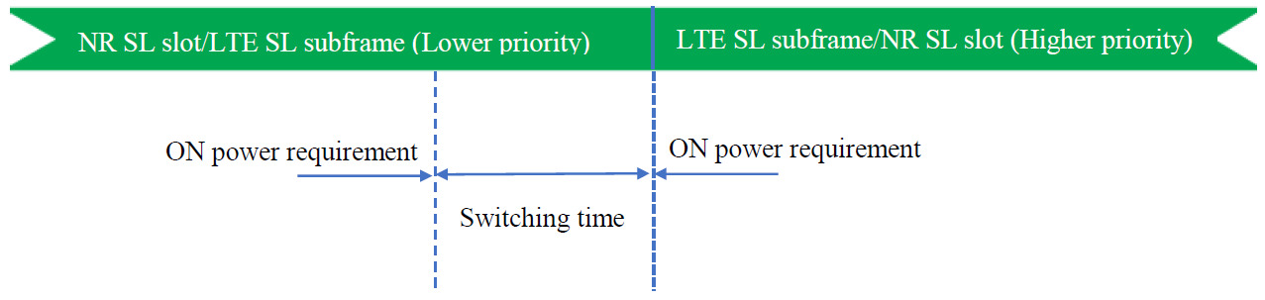

Figure 6.3E.2-1: Time mask for NR SL switching to LTE SL

### 6.3E.3 Output power dynamics for inter-band V2X con-current operation

For inter-band con-current NR V2X operation, the output power dynamics requirement shall be applied per each component carrier. The output dynamic requirements specified in clause 6.3 of TS 36.101 [4] apply for E-UTRA UL transmission and the requirements specified in clause 6.3E of TS 38.101-1 [2] apply for NR SL transmission. The output dynamic requirements specified in clause 6.3.2G, 6.3.3G, 6.3.4G of TS 36.104 [4] apply for E-UTRA SL transmission and the requirements specified in clause 6.3 of TS 38.101-1 [2] apply for NR UL transmission.

*<End of Change 1>*