3GPP TSG-RAN WG4 Meeting #99-e R4-21xxxxx

Electronic Meeting, May 19-27, 2021

**Title:** draft LS on time mask for NR V2X and LTE V2X switching in ITS band

**Response to:**

**Release:** Rel-16

**Work Item:** 5G_V2X_NRSL-Core

**Source:** RAN4

**To:** RAN5

**Cc:**

**Contact Person:**

**Name:** Liu Ye

**E-mail Address:** leo.liuye@huawei.com

**Attachments**: N/A

**1. Overall Description:**

Time mask for NR V2X and LTE V2X switching in ITS band is a remaining issue for Rel-16 NR-V2X WI. RAN4 had reached consensus on the time mask requirement as below:

The switching time shall be located on the RAT of lower priority when NR SL and LTE SL have different priorities based on priority information specified in TS 38.213. It is up to UE implementation when NR SL and LTE SL have the same priority based on priority information specified in TS 38.213.

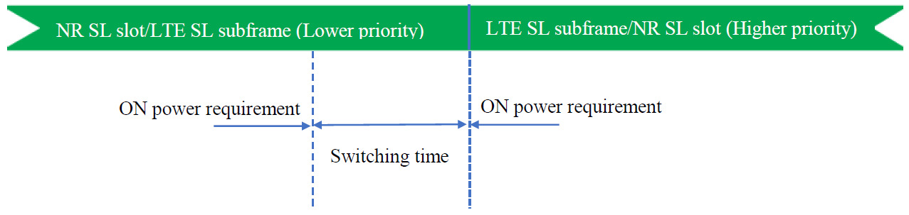

Figure 1: Time mask for switching between NR SL and E-UTRA SL

The above time mask requirement is to give criteria on how the switching period position is decided based on priority information. RAN4 made an agreement that no RF test is needed for this SL switching time mask requirement defined in TS 38.101-3 Clause 6.3E.2.

**2. Actions:**

**To RAN5:**

**ACTION:** RAN4 respectfully asks RAN5 to take the above information into account.

**3. Date of Next TSG WG RAN4 Meetings:**

TSG-RAN4 Meeting#100-e Aug 2021 E-meeting

TSG-RAN4 Meeting#101-e Nov 2021 E-meeting