3GPP TSG-RAN WG4 Meeting # 95-e-Bis R4-2006742

Electronic Meeting, May 25th – June 5th 2020

Agenda item: 9.1.3.2
Source: Keysight Technologies, Spirent Communications
Title: TP to 38.827 to add PSP validation procedure
Document for: Approval

Introduction
This contribution outlines the FR2 channel model PSP validation procedure in chapter 7.4 [1] of TR38.827.

Discussion
The goal of channel model validation is to accurately characterize the channel model under test in the quiet zone. Power delay profile (PDP), Doppler and temporal correlation, cross-polarization, power and PAS similarity percentage (PSP) are the validation metrics agreed for FR2 channel model validation [1].
In this contribution, the FR2 PSP validation procedure based on the method proposed in [2] is described. The PSP validation procedure is a two-step process that involves measurement data acquisition and MUSIC algorithm based analysis for PSP evaluation. The validation procedure is outlined in the draft text proposal below.
Proposal: Adopt the following proposed draft text in FR2 channel model verification part of TR38.827.

References
- TR 38.827, Study on radiated metrics and test methodology for the verification of multi-antenna reception performance of NR User Equipment (UE), V1.4.0 (2020-04)
- R4-2006741, ‘On FR2 PSP Validation’, Keysight Technologies, 3GPP TSG-RAN WG4, May 2020.

Draft Text Proposal
<<< START OF CHANGES >>>
<<< START OF CHANGE >>>

7.4.1.6 PAS similarity percentage (PSP)

The PSP validation measurements aim at evaluating PAS similarity percentage (PSP), which is one of the validation metrics for characterizing FR2 channel model under test in the quite zone of 3D-MPAC. The measurement array is essentially a virtual array configuration realized in 3D-MPAC through a φ-θ positioning system. The measurement array is a semi-circle and sectored array configuration illustrated in Figure 7.4.1.6-1 where complex channel frequency response is measured at each antenna location 0.5 λ apart using a vector network analyser (VNA) setup. The vertical sectors of the measurement array are limited to 60° (±30°) and the horizontal sector to 180° (±90°) with the broad side direction points towards the probes. The radius of the array element locations with respect to the centre of the test zone is 5 cm, which is equivalent to the half of the test zone radius at 28 GHz. For different frequency bands, the radius of the measurement array sectored semi-circles remains fixed at 5 cm while the spatial sampling of the array varies. This measurement validates the proper angular behaviour in the test zone.
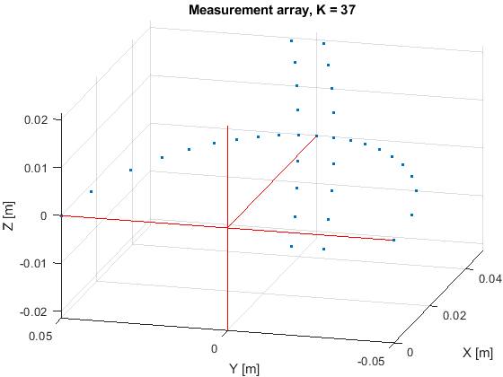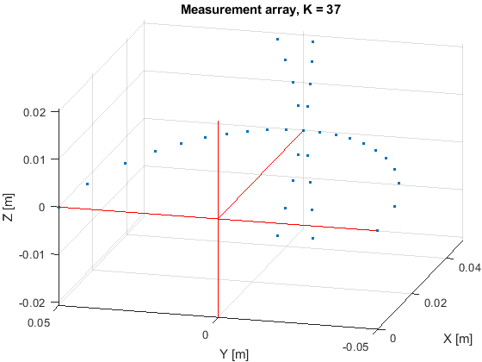
Figure 7.4.1.6-1: Semi-circle measurement array configurations with K = 37 elements (at 28 GHz). On the left with two crossed vertical sectors, on the right with two parallel vertical sectors.

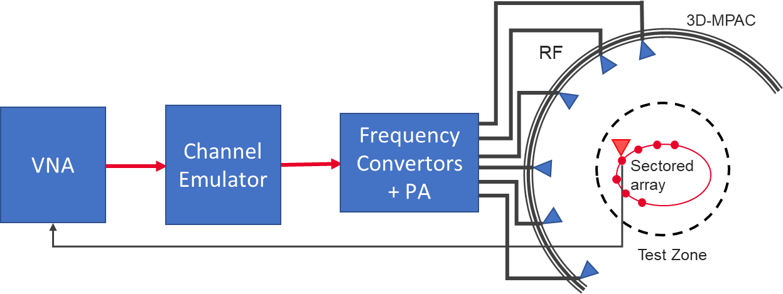
Figure 7.4.1.6-2: Setup for PSP validation measurements

The PSP validation is measured with a vector network analyser as shown in Figure 7.4.1.6-2 illustrating the PSP measurement setup. Port 1 of the VNA transmits signals through the fading emulator and radiate them through L probes within the anechoic chamber. The radiated signals are then received at the test antenna that is positioned inside the test zone. The test antenna is mounted on a φ-θ positioner which is capable of moving the antenna to pre-defined spatial locations on a fixed radius from the centre of the quiet zone according the measurement array configuration. Finally, the signal is received at port 2 of the VNA. The test antenna considered is an omnidirectional antenna.
The measurement and analysis procedure are given as follows:
- Set the target channel model in the Channel Emulator.
- For each position of the test antenna on the measurement array configuration in the test zone, step & pause the emulator to different time instances. Measure the complex frequency responses for all stepped channel snapshots , where the interval between frequency and time samples is and , respectively. The number of channel snapshots and frequency samples .
- Move the measurement antenna with a positioner to another location and repeat step 2 to record frequency responses of all stepped channel snapshots.
- Repeat step 3 to record frequency responses at all spatial sample points.
- Estimate the measured PAS through the following two-step processing:
  - In the first step, calculate the discrete azimuth and elevation angles (DoA) for the measurement array configuration by applying the MUSIC algorithm. Estimate the powers from the DoA and auto-covariance matrix of the received signal acquired through VNA complex frequency response data. A near field to far-field conversion is then applied to the transfer function between probes and measurement array positions.
  - In the second step, use the angle and power estimates, i.e. the discrete PAS of N azimuth and elevation directions and power values in conjunction with a 4x4 DUT sampling array for beamforming with the conventional Bartlett beamformer to estimate the “measured PAS seen by DUT” for PSP calculation.
- Evaluate the reference OTA PAS for the 4x4 DUT array by applying the conventional Bartlett beamformer to the OTA probe weights and the strongest beam from the code book of 128 beam-grid with 4x4 DUT sampling array.
- Calculate total variation distance (D_{p}) from the reference and measured PAS. Mathematically,
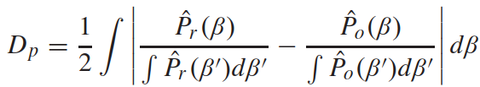
- Calculate PSP values as PSP = (1-D_{p}) x 100%.
VNA settings:
Table 7.4.1.6-1: VNA settings for PDP measurements
Item | Unit | Value
Center frequency | MHz | Downlink center frequency  in Table 7.4.1-2
Span | MHz | 0 (or the minimum)
Number of traces |  | 1000
Number of points |  | 1

Channel model specification:
Table 7.4.1.6-2: Channel model specification for FR2 PSP measurements
Item | Unit | Value
Center frequency | MHz | Downlink center frequency  in Table 7.4.1-2
Distance between traces in channel model | wavelength (Note) | > 2
Channel model |  | As specified in Clause 7.2
NOTE: Time [s] = distance [λ] / MS speed [λ/s]
MS speed [λ/s] = MS speed [m/s] / Speed of light [m/s] * Center frequency [Hz]

Time Domain Alternative Method:
PSP validation can also be implemented using time-domain techniques using the testing setup presented in Figure 7.4.1.6-3. The VNA is substituted by a signal generator, and a signal analyser.
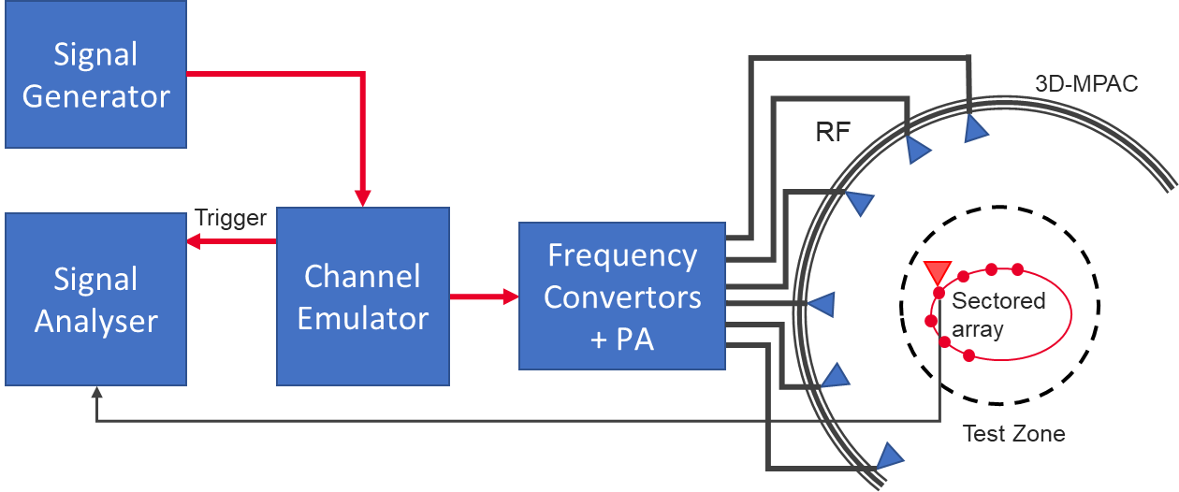
Figure 7.4.1.6-3: Setup for PSP validation measurements based on time domain
Table 7.4.1.6-3: Signal Generator Settings
Item | Unit | Value
Center frequency | MHz | Downlink centre frequency in 3GPP as required per band
Output power | dBm | Function of the CE. Sufficiently above Noise Floor

Table 7.4.1.6-4: Signal Analyzer Settings
Item | Unit | Value
Center frequency | MHz | Downlink centre frequency in 3GPP as required per band
Sampling | Hz | At least 10 times bigger than the max Doppler spread (f_{d}=v/λ)
Observation time | s | At least 32s

The measurement and analysis procedure are given as follows:
Follow the same procedure as before, but M is set to 1. The Channel Emulator is not stepped, but it is allowed to play in free run mode for each of the K spatial points.

<<< Skip unchanged sections >>>
<<< END OF CHANGES >>>

