TSG-RAN Working Group 4 (Radio) meeting #95-E *R4-2008854*

**Electronic Meeting, 25 May – 5 June, 2020**

**Source:** Ericsson, Rohde & Schwarz

**Title:** TP to TR 37.941: Improvement of technical background information in Clause 6

**Agenda item:** 6.19.1

**Document for:** Approval

# Introduction

At the last RAN4 meeting (RAN4#94bis-E) draft text for TR 37.941 was created. The text was copied from internal technical reports (TR 37.840, TR 37.843 and TR 38.817-02).

In this contribution we have provided a text proposal to improve the readability by adding missing information, aligning information and correcting error. The text proposal is attached at the end of this contribution and is presented for approval.

# Discussion

Based on the source text in the first merged version of TR 37.941 [1] a text proposal with improvements have been created.

The improvements are summarized as:

1. In subclause 6.1, explanation and corresponding definition for TRP, EIRP and EIS have been added. All definitions in this subclause are based on power density to be consistent.
2. In subclause 6.2.2, the heading is changed to “Beam parameter definitions” to better reflect the contents.
3. In subclause 6.3.1, Improve the detailed definition of TRP to be consistent with the introduction in subclause 6.1.

# Conclusion

The attached text proposal is presented for approval.

# References

[1] R4-2002430, “Draft TR 37.941”, Huawei

TEXT PROPOSAL:

[Start of Text Proposal]

# 2 References

The following documents contain provisions which, through reference in this text, constitute provisions of the present document.

- References are either specific (identified by date of publication, edition number, version number, etc.) or non‑specific.

- For a specific reference, subsequent revisions do not apply.

- For a non-specific reference, the latest version applies. In the case of a reference to a 3GPP document (including a GSM document), a non-specific reference implicitly refers to the latest version of that document *in the same Release as the present document*.

[1] 3GPP TR 21.905: "Vocabulary for 3GPP Specifications"

[2] J. Fridén, A. Razavi, and A. Stjernman, “Angular sampling, Test Signal, and Near-Field Aspects for Over-the-Air Total Radiated Power Assessment in Anechoic Chambers”, IEEE Access, 2018, https://ieeexplore.ieee.org/stamp/stamp.jsp?arnumber=8470084.

[Unchanged Sections]

# 6 Measurement types

## 6.1 Spatial definitions

Spatial definitions for classification of the OTA requirements were introduced below. OTA transmitter requirements can be split into either:

1. Directional requirements: The manufacturer to declare beam(s) and coverage ranges over which the beam can be steered. Directional requirement type does not imply the requirement is only in one direction as many requirements have a number of compliance directions. It implies the requirement applies to a single direction at a time.

TRP requirements: TRP is defined as the total radiated power of the BS. 3. Co-location requirements: Co-location requirements are requirements which are based on assuming the OTA AAS BS or *BS type 1-O* is co-located with another BS of the same base station class, they ensure that both co-located systems can operate with minimal degradation to each other. Co-location requirements are only applicable for FR1.

## 6.2 Directional measurements

### 6.2.1 General

Some directional requirements are defined with respect to an isotropic antenna in terms of EIRP and EIS, where





,where *r* is the radius of a sphere in the far field, ** is the wavelength and *PD* is the power density. EIS is the power density of a plane wave incident on the BS when the power level in the receiver is at the sensitivity level. Furthermore, $λ^{2}/4π$ is the illuminated area of an isotropic (unit gain) antenna.

### 6.2.2 Beam parameter definitions

A beam (of the antenna) is the main lobe of the radiation pattern of an *antenna array* of the BS. A beam is created by means of a superposition of the signals radiated from different parts of the *antenna array*.

Each *beam direction pair* is associated with half-power contour of the *beam centre direction* and a *beam peak direction*. The EIRP is declared at the *beam peak direction*. The *beam centre direction* is used for describing beam steering.



**Figure 6.2.2-1: Example of *beam direction pair***

In figure 6.2.2-1 left sub-figure shows a symmetrical beam where *beam centre direction* and *beam peak direction* are the same. In figure 6.2.2-1 right sub-figure shows an example of a beam with ripple where the *beam centre direction* and the *beam peak direction* are different.

The number of declared BS beams is for the manufacturer to declare. Some examples of declarations of beams are illustrated in a *directions diagram* in figure 6.2.2-2.



**Figure 6.2.2-2: Examples of BS beam declarations depicted in a *directions diagram***

In figure 6.2.2-2 the shaded areas/points represent the declared EIRP directions set, which may be continuous (top right, bottom right) or not continuous (bottom left), or be restricted to just the points of maximum steering (top left). The red coloured points represent the compliance test points at which EIRP is declared. The maximum EIRP and its accuracy are defined for the declared beams when activated individually on all corresponding RE and the requirements are placed per individual beam.

The maximum radiated transmit power of the BS beam is the mean power level measured at the declared *beam peak direction* at the RF channels B (bottom), M (middle) and T (top) when configured for maximum EIRP value for a specific BS beam of the supported frequency channels declared by the manufacturer.

Another form of directional measurement is the *OTA sensitivity directions declaration(s)* (OSDD) used for the receiver directional requirements. OSDD is declared for OTA sensitivity requirement and described in more details in clause 6.2.3.

### 6.2.3 OSDD

If an OSDD does not include a *receiver target redirection range*, conformance testing is performed for the following five directions, as depicted in the example in figure 6.2.3-1:

- The receiver target reference direction.

- The direction determined by the maximum  value achievable inside the sensitivity RoAoA maintaining the receiver target reference direction  value.

- The direction determined by the minimum  value achievable inside the sensitivity RoAoA maintaining the receiver target reference direction  value.

- The direction determined by the maximum  value achievable inside the sensitivity RoAoA maintaining the receiver target reference direction  value.

- The direction determined by the minimum  value achievable inside the sensitivity RoAoA maintaining the receiver target reference direction  value.

The manufacturer declares the five directions for conformance testing.



Figure 6.2.3-1: OSDD without target redirection capability

In figure 6.2.3-1 a direction diagram shows a RoAoA without *receiver target* redirection capability. The *receiver target reference direction* and the extreme directions subject to conformance testing are marked by red crosses.

If an OSDD includes a *receiver target redirection range*, conformance testing is performed for the following five directions, as depicted in the example in figure 6.2.3-2:

- The receiver target reference direction.

- The direction determined by the maximum  value achievable inside the receiver target redirection range maintaining the receiver target reference direction  value.

- The direction determined by the minimum  value achievable inside the receiver target redirection range maintaining the receiver target reference direction  value.

- The direction determined by the maximum  value achievable inside the receiver target redirection range maintaining the receiver target reference direction  value.

- The direction determined by the minimum  value achievable inside the receiver target redirection range maintaining the receiver target reference direction  value.

The manufacturer declares the five directions for conformance testing, the setting of the AAS BS to achieve conformance at each of the conformance test directions, and the resulting *sensitivity RoAoA* for each of these settings.

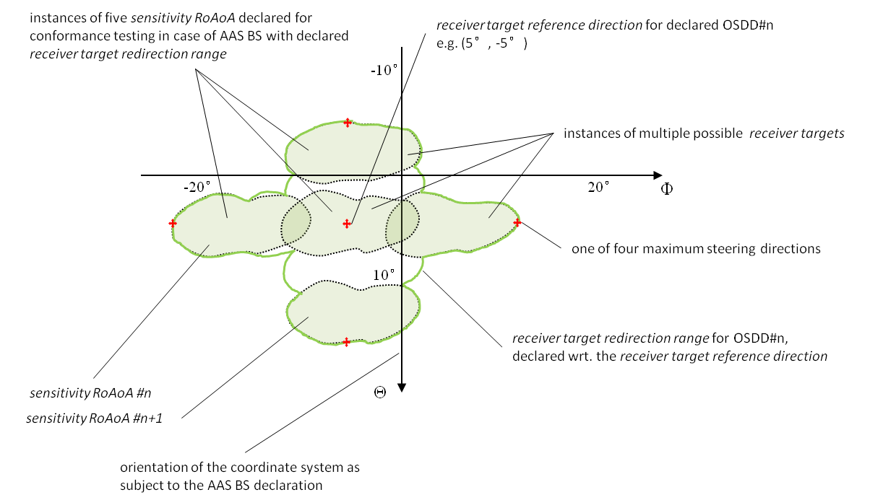

Figure 6.2.3-2: OSDD with target redirection capability

In figure 6.2.3-2, a direction diagram is showing a *receiver target redirection range* (with discrete settings for the *sensitivity RoAoA*). The *receiver target reference direction* and the extreme directions subject to conformance testing are marked by red crosses. The *sensitivity RoAoA* for each conformance test setting is shown as shaded. Note that each *sensitivity RoAoA* is exceptionally small compared to the *receiver target redirection range*, for demonstration purposes.

## 6.3 TRP measurement

### 6.3.1 General

The TRP or the radiated power is simply the total power radiated by a BS. Due to energy conservation, TRP is independent of choice of test distance and shape of the used closed measurement surface. The distance chosen should be considered past the reactive near field region. Below is a more general expression for TRP which is general expression:



Here *PD* is the power density of the power flux directed out of a surface S, the surface $S$ is any surface enclosing the BS, and the integral is a closed surface integral over the BS.

For practical reasons the spherical surface is a common choice and in this case;



, where the coordinate system defined in clause 3 is used, *PD* is the power density and *r* is the radius of spherical surface. In the far-field region (criteria) the radiation intensity;



TRPReference is defined as t



where *U(θ, ϕ) $U(θ,ϕ)$* is the radiation intensity at each angle in watts per Steradian. In the far field, the radiation intensity can be defined as



$U\left(θ,ϕ\right)=\frac{EIRP(θ,ϕ)}{4π}$

Thus, the definite integral for TRPReference becomes ${TRP}_{Reference}= \frac{1}{4π} \int_{θ=0}^{π}{\int_{ϕ=0}^{2π}{EIRP\left(θ,ϕ\right) \sin{θ}dθdϕ}}$

EIRP is defined only in the far field. However, in some occasions the power measurements can be performed at distances less than 2d2/λ (the traditional approximate far-field distance), that is, in the radiative (Fresnel) near-field region. In such cases it is possible to measure power density in the radiative near field considering only the magnitude of the tangential part of E field, $\left|E_{t}\left(r,θ,ϕ\right)\right|,$ with an acceptable level of accuracy [2].

For power density measurments use the approximation $P_{D}\left(r,θ,ϕ\right)=\frac{{\left|E_{t}\left(r,θ,ϕ\right)\right|}^{2}}{η}$ and $η=\sqrt{\frac{μ_{0}}{ε_{0}}}≈377 Ω$ (intrinsic impedance of vacuum).

The minimum distance between the measurement antenna and the smallest sphere enclosing the BS must be at least 2λ. More details about the necessary conditions for accurate power density measurements close to BS are included in annex F.

When measuring radiated power, at each measurement point, two partial results for two orthogonal polarizations needs to be added. These can be the θ and ϕ polarizations or any pair of orthogonal polarizations.

The distribution of sampling points on the spherical surface depends on the type of sampling grids applied, the frequency and the size of the radiating source. In the following clauses, several spherical sampling grids which can be applied to EIRP or power density measurements are described.

[End of Text Proposal]