3GPP TSG-RAN WG4 Meeting # 94-e-Bis DRAFT R4-2005179

Electronic Meeting, 20 – 30 Apr., 2020

**Source:** Huawei

**Title:** TP to TR 38.820: Updates to the PA survey

**Agenda Item:** 9.2.4

**Document for:** Approval

# Introduction

The PA survey data in the current TR is based on data collected in [2]. Recently, the PA database in [2] was updated (as of February 2020). The updated database captures over 3200 data points, with over 1200 data points for CMOS, SiGe PAs and over 1500 data points for GaN, GaAs, InP PAs. Delta to the previous version captures additional 500MHz to 1.5 THz PAs designs and sub-THz/THz power/signal generation circuits published between 07/2019 and 02/2020. Based on the summary figures comparison, it was observed that there were also modifications to the 7 – 24 GHz region.

Therefore it is seen reasonable to update the related information in the TR as well.

This TP to TR 38.820 [1] provides updates to the PA survey data sourced from the external database, which was recently updated.

# References

[1] TR 38.820 v 1.2.0 Study on the 7 to 24 GHz frequency range for NR

[2] Hua Wang, Fei Wang, Huy Thong Nguyen, Sensen Li, Tzu-Yuan Huang, Amr S. Ahmed, Michael Edward Duffy Smith, Naga Sasikanth Mannem, Jeongseok Lee, Edgar Garay, Sanghoon Lee, and David Munzer, "Power Amplifiers Performance Survey 2000-Present," <https://gems.ece.gatech.edu/PA_survey.html>

# TP to the TR 38.820

*------------------------------ Modified section ------------------------------*

# 2 References

The following documents contain provisions which, through reference in this text, constitute provisions of the present document.

- References are either specific (identified by date of publication, edition number, version number, etc.) or non‑specific.

- For a specific reference, subsequent revisions do not apply.

- For a non-specific reference, the latest version applies. In the case of a reference to a 3GPP document (including a GSM document), a non-specific reference implicitly refers to the latest version of that document *in the same Release as the present document*.

[1] 3GPP TR 21.905: "Vocabulary for 3GPP Specifications".

[2] 3GPP TR 38.913: “Study on Scenarios and Requirements for Next Generation Access Technologies”

[3] 3GPP TS 38.113: “NR; Base Station (BS) ElectroMagnetic Compatibility (EMC)”

[4] 3GPP TR 38.817-02: “NR; General aspects for Base Station (BS) Radio Frequency (RF) for NR”

[5] 3GPP TS 38.104: "NR; Base Station (BS) radio transmission and reception"

[6] 3GPP TS 38.141-2: "NR; Base Station (BS) conformance testing Part 2: Radiated conformance testing"

[7] Recommendation ITU-R SM.329-12: "Unwanted emissions in the spurious domain"

[8] IEC 61000-4-3: 2006+AMD1:2007+AMD2:2010 CSV: "Electromagnetic compatibility (EMC) - Part 4-3: Testing and measurement techniques - Radiated, radio-frequency, electromagnetic field immunity test"

[9] Hua Wang et al., "Power Amplifiers Performance Survey 2000-Present," 2008, Available: <https://gems.ece.gatech.edu/PA_survey.html>

[10] 3GPP TS 37.105: “Active Antenna System (AAS) Base Station (BS) transmission and reception”

[11] Hua Wang, Fei Wang, Huy Thong Nguyen, Sensen Li, Tzu-Yuan Huang, Amr S. Ahmed, Michael Edward Duffy Smith, Naga Sasikanth Mannem, Jeongseok Lee, Edgar Garay, Sanghoon Lee, and David Munzer, "Power Amplifiers Performance Survey 2000-Present," 2020.02, <https://gems.ece.gatech.edu/PA_survey.html>

[12] Code of Federal Regulations, Title 47: Telecommunication; Part 2—Frequency Allocations and Radio Treaty Matters; General Rules and Regulations, <https://www.ecfr.gov/cgi-bin/text-idx?SID=983c3dd433919e69fce5a8bd4b565cfb&mc=true&node=pt47.1.2&rgn=div5>

[13] 3GPP TS 38.211: “NR; Physical channels and modulation”

[14] 3GPP TS 38.213: “NR; Physical layer procedures for control”

[15] 3GPP TS 38.214: “NR; Physical layer procedures for data”

[16] 3GPP TS 38.141-1: “NR; Base Station (BS) conformance testing Part 1: Conducted conformance testing”

[17] 3GPP TS 38.101-1: “NR; User Equipment (UE) radio transmission and reception; Part 1: Range 1 Standalone”

[18] 3GPP TS 38.101-2: “NR; User Equipment (UE) radio transmission and reception; Part 2: Range 2 Standalone”

[19] 3GPP TS 38.101-3: “NR; User Equipment (UE) radio transmission and reception; Part 3: Range 1 and Range 2 Interworking operation with other radios”

[20] 3GPP TS 38.133: “NR; Requirements for support of radio resource management”

[21] R4-1907593: “LS on UE feature list for NR”, RAN4#91

[22] 3GPP TR 25.942: “Radio Frequency (RF) system scenarios”

[23] The European table of frequency allocations and applications in the frequency range 8.3 kHz to 3000 GHz, ECO, <https://www.ecodocdb.dk/document/593>

[24] 3GPP TS 36.104: “Evolved Universal Terrestrial Radio Access (E-UTRA); Base Station (BS) radio transmission and reception”

[25] 3GPP TS 37.104: “NR, E-UTRA, UTRA and GSM/EDGE; Multi-Standard Radio (MSR) Base Station (BS) radio transmission and reception”

[26] Kambiz Hadipour, Andrea Ghilioni1, Andrea Mazzanti1, Matteo Bassi1, Francesco Svelto, “A 40GHz to 67GHz Bandwidth 23dB Gain 5.8dB Maximum NF mm-Wave LNA in 28nm CMOS”, 2015 IEEE Radio Frequency Integrated Circuits Symposium

[27] Domenico Pepe, Domenico Zito, “32 dB Gain 28 nm Bulk CMOS W-Band LNA”, IEEE Microwave and Wireless Components Letters, Vol. 25, No. 1, January 2015

[28] Domenico Pepe1, Domenico Zito, “72 GHz CMOS LNA with Transformer-based Input Integrated Matching”, IEEE 2015

[29] Hossein Noori, Miles Sanner, Naveen Yanduru, “A 0.8 dB NF, 4.6 dBm IIP3, 1.8 - 2.2 GHz, Low-Power LNA in 130 nm RF SOI CMOS Technology”, IEEE 2015

[30] Joost Melai, Peter Magnée, Ivo Pouwel, Pieter Weijs, Ihor Brunets, Rob van Dalen, Anurag Vohra, Luuk Tiemeijer, Ralf Pijper, Hans Tuinhout, Nicole Wils, Nicolae Cazana, “QUBiC generation 9, a new BiCMOS process optimized for mmWave applications”, IEEE 2015

[31] Cristina Andrei, Olof Bengtsson, Ralf Doerner, Serguei A. Chevtchenko, Wolfgang Heinrich, Matthias Rudolph, “Dynamic behaviour of a Low-Noise Amplifier GaN MMIC under input power overdrive”, Proceedings of the 45th European Microwave Conference

[32] Recommendation ERC/REC 70-03 "Relating to the use of Short Range Devices (SRD)"

[33] ECC, ECC Recommendation (02)/05 "Unwanted Emissions"

[34] ERC Recommendation 74-01 "Unwanted emissions in the spurious domain" (amended 29 May 2019)

[35] LMX2594, 15 GHz Wideband RF Synthesizer, Texas Instruments. <http://www.ti.com/product/LMX2594>

[36] ADF41513 26.5 GHz, Integer N/Fractional-N, PLL Synthesizer, Analog Devices, https://www.analog.com/en/products/adf41513.html

[37] Staffan Ek et al., A 28-nm FD-SOI 115-fs Jitter PLL-Based LO System for 24-30-GHz Sliding-IF 5G Transceivers, [IEEE Journal of Solid-State Circuits](https://ieeexplore.ieee.org/xpl/RecentIssue.jsp?punumber=4) (Volume: 53, [Issue: 7](https://ieeexplore.ieee.org/xpl/tocresult.jsp?isnumber=8396884) , July 2018)

[38] K. Raczkowski et. al. “A 9.2–12.7 GHz Wideband Fractional-N Subsampling PLL in 28 nm CMOS With 280 fs RMS Jitter”, IEEE Journal of Solid-State Circuits, vol. 50, no. 5, pp. 1203-1213, May 2015

[39] Ximenes, G. Vlachogiannakis, R. Staszewski, “An Ultracompact 9.4–14.8-GHz Transformer-Based Fractional-N All-Digital PLL in 40-nm CMOS”, IEEE Transactions on Microwave Theory and Techniques, vol. 65, no. 11, pp. 4241-4254, Nov. 2017

[40] N. Markulic et. al. “A Self-Calibrated 10Mb/s Phase Modulator with -37.4dB EVM Based on a 10.1-to-12.4GHz, -246.6dB-FOM, Fractional-N Subsampling PLL”, IEEE International Solid-State Circuits Conference 2016, pp. 176-177

[41] R4-1700305, "[DRAFT] LS on Characteristics of terrestrial IMT systems for frequency sharing/interference analysis in the frequency range between 24.25 GHz and 86 GHz"

[42] Recommendation ITU-R SM.328-11 (2006), “Spectra and bandwidth of emissions”

[43] Recommendation ITU-R M.1580-5 (02/2014), “Generic unwanted emission characteristics of base stations using the terrestrial radio interfaces of IMT-2000”

[44] Recommendation ITU-R M.2070-1 (02/2017), “Generic unwanted emission characteristic of base stations using the terrestrial radio interfaces of IMT-Advanced”

[45] ECC Recommendation (02)05, “Unwanted emissions” (Amended 30 March 2012)

[46] ETSI TR 101 854: “Fixed Radio Systems; Point-to-point equipment; Derivation of receiver interference parameters useful for planning fixed service point-to-point systems operating different equipment classes and/or capacities”

[47] P. Ökvist, H. Asplund, A. Simonsson, B. Halvarsson, J. Medbo and N. Seifi, "15 GHz propagation properties assessed with 5G radio access prototype," 2015 IEEE 26th Annual International Symposium on Personal, Indoor, and Mobile Radio Communications (PIMRC), Hong Kong, 2015, pp. 2220-2224.

[48] K. Zhao et al., "Channel Characteristics and User Body Effects in an Outdoor Urban Scenario at 15 and 28 GHz," in IEEE Transactions on Antennas and Propagation, vol. 65, no. 12, pp. 6534-6548, Dec. 2017.

[49] R4-1609122, NR RF parameters and template for WP5D, RAN4 #81

[50] R4-168770, Way forward on UE and BS estimated NF for mm-waves and ITU-R related work, RAN4 #80bis

[51] R4-1904127, 7-24GHz discuss implications of FR1 and FR2 architectures, RAN4 #90bis

[52] R4-165001, UE reference architecture and other considerations at millimeter wave, RAN4 #80

[53] R4-168076, NR UE system Noise Figure proposal, RAN4 #80bis

[54] R4-1905846, [7-24GHz] Applicable FR1 UE Technologies, RAN4 #91

[55] RP-170021, Reply LS to ITU-R WP5D/374 (Attachment 4.13) on Characteristics of terrestrial IMT systems for frequency sharing/interference analysis in the frequency range between 24.25 GHz and 86 GHz, RAN #75

[56] PTA(19)087 New Resolution IMT below 24GHz, ETNO[57] PTA(19)073 GSMA_Input to PTA on AI 10, GSMA

[58] APT19-4 4th / Final African Preparatory Meeting for WRC-19 (APM19-4), report, 26-30.08.2019

[59] World Radiocommunication Conference 2019 (WRC-19), Provisional Final Acts, ITU <https://www.itu.int/dms_pub/itu-r/opb/act/R-ACT-WRC.13-2019-PDF-E.pdf>

[60] 3GPP TS 25.104: “Base Station (BS) radio transmission and reception (FDD)”

[61] 3GPP TS 25.951: “FDD Base Station (BS) classification”

*------------------------------ Next modified section ------------------------------*

## 5.4 RF technology considerations in the 7 – 24 GHz range

### 5.4.1 PA trends

For 7 – 24 GHz frequency range, it is essential to perform in-depth analysis of power amplifiers based on different semi-conductor technologies. In addition, complex relation between output power, ACLR (linearity) and efficiency is an important aspect considering the performance and feasibility for example frequencies.

The PA technology and trends are based on professor Hua Wang [11] work where a large power amplifier survey consisting of more than 3200 data points with over 1200 data points for CMOS, SiGe PAs and over 1500 power amplifier data points has been collected for GaN, GaAs, InP. Wang’s database covers published results, both from the open literature, as well as commercial amplifiers from various vendors.

Based on the information from [11], the PA database information was summarized for all the considered RF technologies in figure 5.4.1-1. It can be observed that based on the available information, there is no data for the LDMOS technology for the 7 – 24 GHz range, while the InP technology data is available from 20 GHz upwards.

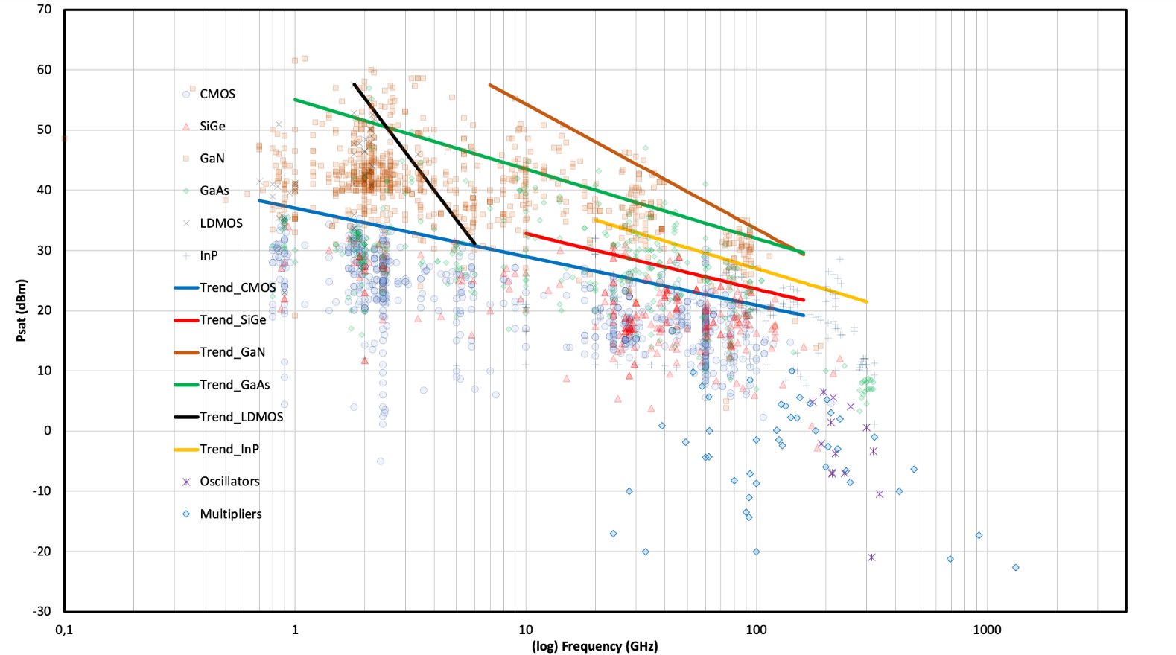

**Figure 5.4.1-1: Saturated output power versus frequency (red box depicts 7 – 24 GHz range) [11]**

In order to derive more accurate PA trends, all the figures below were plotted with PA operating frequencies much wider then just 7 – 24 GHz range. More detailed technology-specific plots (e.g. PAE vs. Psat, or Psat vs. frequency) can be found in the Excel sheet capturing all the PA survey data in [11].

Based on the analysis of the achievable Psat trends over the 7 – 24 GHz range, the saturated output power maximum trend values for 7.125 GHz and 24.25 GHz from [11] were listed in table 5.4.1-1, further extended with additional extrapolated values. It may be noted here that trend of SiGe BiCMOS PA in figure 5.4.1-1 is limited to 10 GHz frequency. If the trend line is extrapolated down to 7 GHz then Pout of 36 dBm is expected.

**Table 5.4.1-1: Maximum trend values of the saturated output power**

|  |  |  |
| --- | --- | --- |
| RF technology | Estimated maximum trend value of the saturated output power @7.125 GHz (dBm) | Estimated maximum trend value of the saturated output power @24.25 GHz (dBm) |
| CMOS | 30 | 26 |
| SiGe | 36 | 30 |
| GaN | 58 | 46 |
| GaAs | 45 (HBT) | 28 (pHEMT) |
| LDMOS | - | - |
| InP | - | 34 |

The following analysis covers the saturated peak output power and power added efficiency (PAE). It should be noted that for all presented characteristics, the results are based on peak power, non-linearized power amplifiers without considering the bandwidth impact to show the trends with respect to frequency for different technologies.

*----------------------------- End of modified section ------------------------------*