**3GPP TSG-RAN WG4 Meeting # 110bis R4-240xxxx**

**Changsha, China, 15th - 19th April, 2024**

**Agenda item:** 4.4

**Source:** Moderator (CMCC)

**Title:** Topic summary for [110bis][202] NR_ATG

**Document for:** Information

# Introduction

This summary focuses on RRM core and perf requirements maintenance for Rel-18 NR ATG, including agenda 4.2.7.3 and 4.2.7.4. The agreed way forward in previous meetings are R4-2403545, R4-2321608, R4-2317341, R4-2314307, R4-2310159, R4-2306344, R4-2303226, R4-2220361, R4-2217256 and R4-2214347.

Recommendation of prioritized topics for online discussion

**Issue 2-1: Test method for UE with antenna array**

**Issue 2-2: The sharing factor between L1 and L3 measurement in RLM and BFD test case**

**Issue 1-1: Whether to change the reference point of the tolerance for deriveSSB-IndexFromCell and deriveSSB-IndexFromCellInter-r17**

**Issue 1-2: Whether to introduce propagation delay time difference or RTD reporting for ATG UE to assist network scheduling**

**Issue 2-3: UE location (GNSS) setting in the location-based CHO test case**

# Topic #1: Core Maintenance

## Companies’ contributions summary

|  |  |  |
| --- | --- | --- |
| **T-doc number** | **Company** | **Proposals / Observations** |
| R4-2404343 | Apple | Observation: changing the interpretation of *deriveSSB-IndexFromCell* tolerance and *deriveSSB-IndexFromCellInter-r17* tolerance can help to reduce the neighbor cell search time and optimize the network scheduling restrictions.  Proposal 1: it is proposed to change the reference point of the tolerance for *deriveSSB-IndexFromCell* and *deriveSSB-IndexFromCellInter-r17*.   * When *deriveSSB-IndexFromCell* is enabled, the ATG UE assumes frame boundary alignment (including half frame, subframe and slot boundary alignment) across cells on the same frequency carrier is within a tolerance not worse than 3us at BS antenna connectors or radiated interface boundaries, and the SFNs of all cells on the same frequency carrier are the same. * When *deriveSSB-IndexFromCellInter-r17* is enabled, the ATG UE assumes frame boundary alignment (including half frame, subframe and slot boundary alignment) across cells on the target carrier and reference cell is within a tolerance not worse than 3us at BS antenna connectors or radiated interface boundaries, 1 PDSCH symbol of the reference cell) and the SFNs of all cells on the target carrier and reference cell are the same. The reference cell is the serving cell which is used for SSB indexes derivation as indicated via *deriveSSB-IndexFromCellInter-r17*.   Proposal 2: it is proposed to introduce propagation delay time difference or RTD reporting for ATG UE to assist network scheduling. |
| R4-2404344 | Apple | (NR_ATG-Core) On deriveSSB-IndexFromCell |
| R4-2404345 | Apple | (NR_ATG-Core) On scheduling restriction for ATG UE |
| R4-2404680 | CMCC | (NR_ATG-Core) draftCR to TS 38.133: Correction of RRM core requirements for ATG |
| R4-2404775 | ZTE Corporation | [NR_ATG-Core] Draft CR for the measurement procedure of R18 ATG |
| R4-2404776 | ZTE Corporation | [NR_ATG-Core] Draft CR for the TCI state indication of R18 ATG |

## Open issues summary

**Issue 1-1: Whether to change the reference point of the tolerance for deriveSSB-IndexFromCell and deriveSSB-IndexFromCellInter-r17**

* **Background**
  + **Currently, the DeriveSSB-IndexFromCell and DeriveSSB-IndexFromCellInter-r17 tolerance is as follows:**

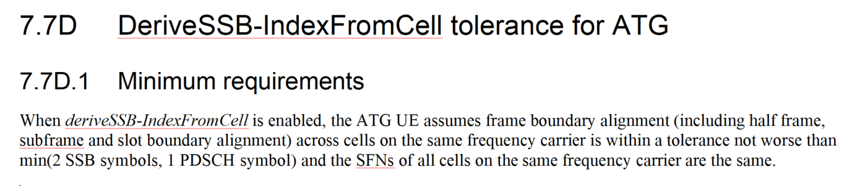

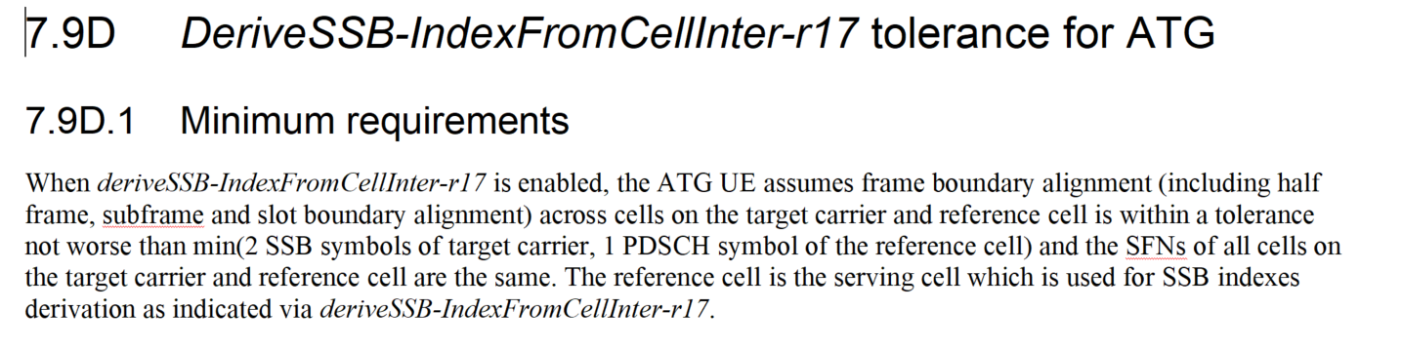

* + **The following requirements (cell identification requirements and scheduling restriction) depends whether network configure the DeriveSSB-IndexFromCell and DeriveSSB-IndexFromCellInter-r17 or not (take intra-frequency as an example)**

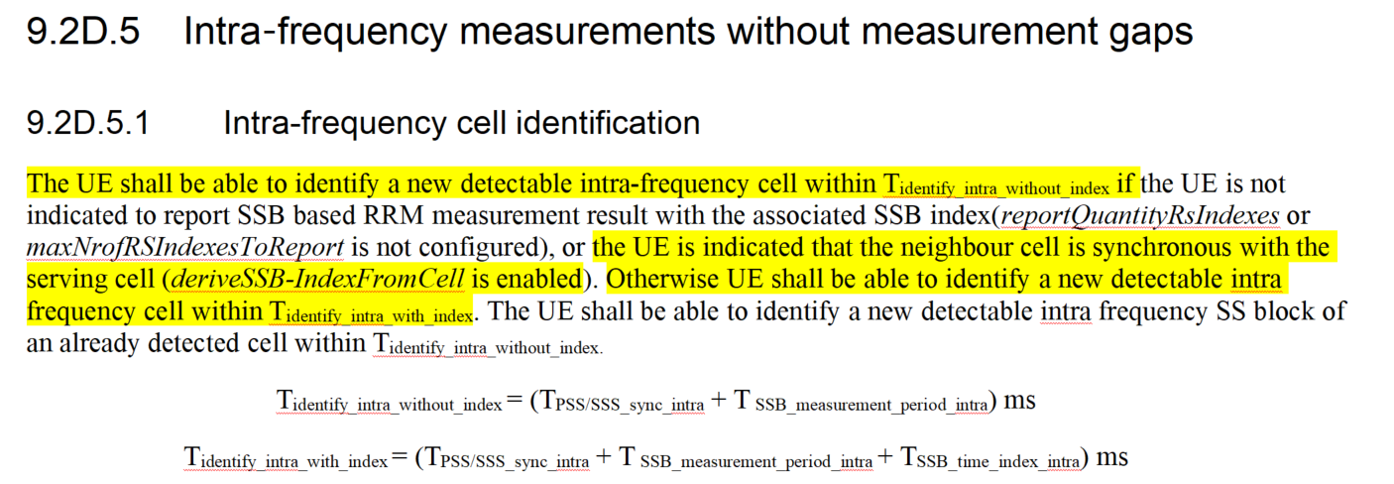

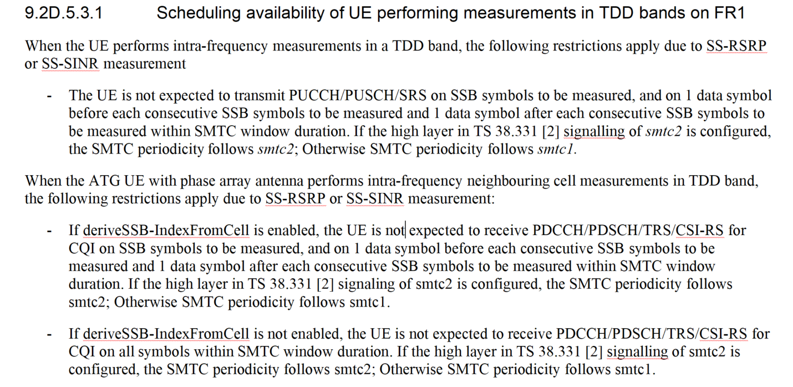

* Proposals
  + Option 1: Change the reference point of the tolerance for deriveSSB-IndexFromCell and deriveSSB-IndexFromCellInter-r17. (Apple)
    - When deriveSSB-IndexFromCell is enabled, the ATG UE assumes frame boundary alignment (including half frame, subframe and slot boundary alignment) across cells on the same frequency carrier is within a tolerance **not worse than 3us at BS antenna connectors or radiated interface boundaries**, and the SFNs of all cells on the same frequency carrier are the same.
    - When deriveSSB-IndexFromCellInter-r17 is enabled, the ATG UE assumes frame boundary alignment (including half frame, subframe and slot boundary alignment) across cells on the target carrier and reference cell is within a tolerance **not worse than 3us at BS antenna connectors or radiated interface boundaries, 1 PDSCH symbol of the reference cell)** and the SFNs of all cells on the target carrier and reference cell are the same. The reference cell is the serving cell which is used for SSB indexes derivation as indicated via deriveSSB-IndexFromCellInter-r17
* Recommended WF
  + To be discussed

**Issue 1-2: Whether to introduce propagation delay time difference or RTD reporting for ATG UE to assist network scheduling**

* Proposals
  + Option 1: Introduce propagation delay time difference or RTD reporting for ATG UE to assist network scheduling. (Apple)
* Recommended WF
  + To be discussed

**CR for core maintenance**

|  |  |  |  |
| --- | --- | --- | --- |
| **T-doc number** | **Company** | **Proposals / Observations** | **Recommended WF** |
| R4-2404344 | Apple | (NR_ATG-Core) On deriveSSB-IndexFromCell | Depends on Issue 1-1 |
| R4-2404345 | Apple | (NR_ATG-Core) On scheduling restriction for ATG UE | Depends on Issue 1-1 and Issue 1-2 |
| R4-2404680 | CMCC | (NR_ATG-Core) draftCR to TS 38.133: Correction of RRM core requirements for ATG | If no comments, then can be endorsed |
| R4-2404775 | ZTE Corporation | [NR_ATG-Core] Draft CR for the measurement procedure of R18 ATG | To be revised  Moderator:   1. The revision mark is missing in Clause 9.2D.6.3 2. If everyone agree to delete the concurrent gap and NCSG related wording, then some other wording need to be deleted as well, for instance:    1. Clause 9.3D.9.1   When inter frequency SMTC is partially overlapping with measurement gaps, Kp = 1/(1- (SMTC period /MGRP)), where SMTC period < MGRP. When inter-frequency SMTC is partially overlapping with NCSG, Kp = 1/(1- (SMTC period /VIRP)), where SMTC period < VIRP.   * 1. Clause 9.3D.4   When measurement gaps are provided, or the UE supports capability of conducting such measurements without gap, the UE shall be able to identify a new detectable inter frequency cell within Tidentify_inter_without_index if UE is not indicated to report SSB based RRM measurement result with the associated SSB index (*reportQuantityRsIndexes* or *maxNrofRSIndexesToReport* is not configured) or *deriveSSB-IndexFromCellInter-r17* is configured for the FR1 target frequency layers and UE supporting *deriveSSB-IndexFromCellInterNon-NCSG-r17*.  2.3. Table 9.3D.4-1, 9.3D.4-2, 9.3D.5-1  Note 2 shall be deleted (Note 2: Void) |
| R4-2404776 | ZTE Corporation | [NR_ATG-Core] Draft CR for the TCI state indication of R18 ATG | If no comments, then can be endorsed |

# Topic #2: ATG RRM performance requirements

## Companies’ contributions summary

|  |  |  |
| --- | --- | --- |
| **T-doc number** | **Company** | **Proposals / Observations** |
| R4-2404410 | CATT | Draft CR on test cases for ATG performance RRM requirements |
| R4-2404681 | CMCC | Proposal 1: Prefer to keep the current test cases which scaling factor = 1.  Proposal 2: For ATG UE with the antenna array, if scaling factor is 1 in the test cases, no need to consider the sharing factor between L1 and L3 measurement. |
| R4-2404682 | CMCC | (NR_ATG-Perf) draftCR to TS 38.133: Correction of RRM test cases for ATG |
| R4-2404763 | ZTE Corporation | Proposal 1: Performing the conducted test without scaling factor is preferred by us for the UE with antenna array.  Proposal 2: The GNSS change should be set with the consideration of two distance threshold distanceThreshFromReference1 and distanceThreshFromReference2, e.g. max{distanceThreshFromReference1,distanceThreshFromReference2}+50m. |

## Open issue summary

**Issue 2-1: Test method for UE with antenna array**

* Proposals
  + Option 1: Conducted test without scaling factor (Scaling factor = 1) (CMCC, ZTE)
* Recommended WF
  + Since no company propose to use scaling factor in this meeting, Option 1 can be agreed.

**Issue 2-2: The sharing factor between L1 and L3 measurement in RLM and BFD test case**

* Proposals
  + Option 1: For ATG UE with the antenna array, if scaling factor is 1 in the test cases, no need to consider the sharing factor between L1 and L3 measurement. (CMCC)
* Recommended WF
  + To be discussed

**Issue 2-3: UE location (GNSS) setting in the location-based CHO test case**

* Background:
  + Currently, the UE location (GNSS) setting in the location-based CHO test case is set as follows:
    - During T1, cell 1 is not detectable
    - Starting T2, cell 2 becomes detectable and offset better than cell 1, and location condition event condEventD1-r17 is fulfilled.
      * distance to source cell reference location is $\sqrt{{(3000)}^{2}+{(1200∗1000/3600∗15−(−4600))}^{2}}$ = 10057.8m, and D1-1 = 10000m
      * distance to target cell reference location is $\sqrt{{(3000)}^{2}+{(1200∗1000/3600∗15−(14479))}^{2}}$ = 9942.4m, and D1-2 = 10000m
      * i.e. D1-1 and D1-2 conditions are fulfilled at start of T2 with >=50m location margin.
* Proposals
  + Option 1: The GNSS change should be set with the consideration of two distance threshold distanceThreshFromReference1 and distanceThreshFromReference2, e.g. max{distanceThreshFromReference1,distanceThreshFromReference2}+50m. (ZTE)
* Recommended WF
  + Need more clarification. To be discussed.

**CR for performance maintenance**

|  |  |  |  |
| --- | --- | --- | --- |
| **T-doc number** | **Company** | **Proposals / Observations** | **Recommended WF** |
| R4-2404410 | CATT | Draft CR on test cases for ATG performance RRM requirements | To be revised |
| R4-2404682 | CMCC | (NR_ATG-Perf) draftCR to TS 38.133: Correction of RRM test cases for ATG | Depends on issue 2-2 |