3GPP TSG-RAN WG4 Meeting # 108bis Rev R4-2315097

Xiamen, China, October 09 – October 13, 2023

Title: ATG non-synchronized co-existence simulation results

Source: CATT

Agenda item: 5.13.1.4

Document for: Discussion

# Background

This contribution provides more results non-synchronized co-existence simulation results after some offline calibration.

# Discussion

## 2.1 Scenario 5: 4GHz ATG DL interfering TN UL

The simulation results are shown in the following figures,

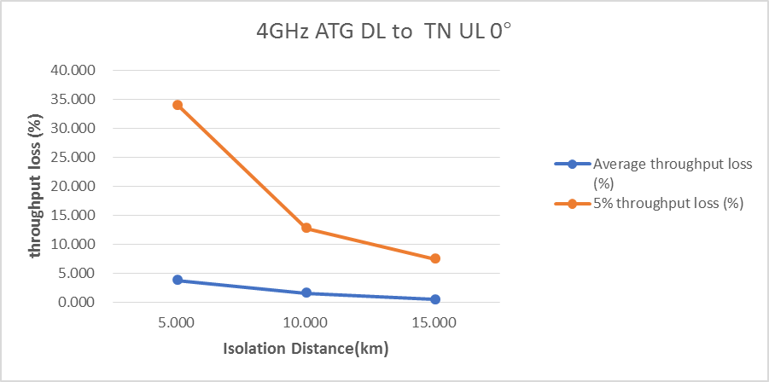

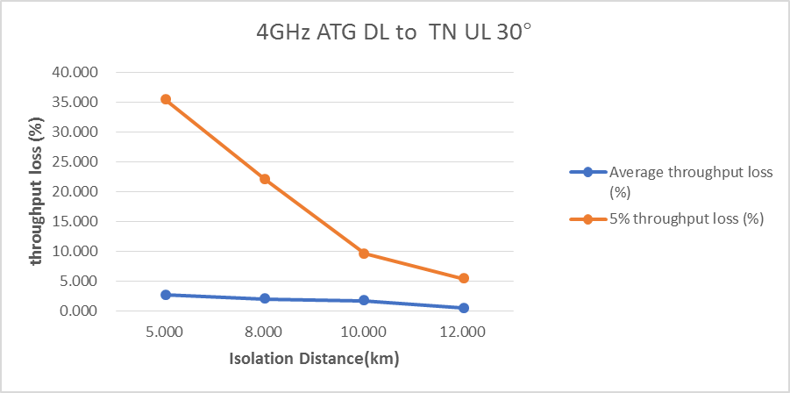

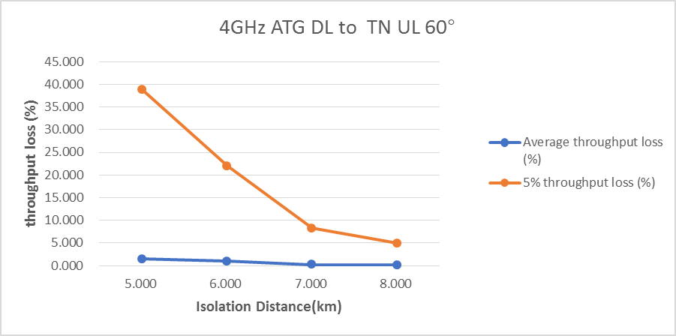

The isolation distances are summarized in Table 1.

**Table 1: Simulation results for Scenario 5 – 4GHz ATG DL interfering TN UL**

|  |  |  |  |  |  |
| --- | --- | --- | --- | --- | --- |
| **Company** | **ATG/ TN BS antenna model** | **Performance Metric** | **Isolation distance (km) for 5% throughput loss** | | |
| **Angle between ATG BS boresight and nearest TN BS boresight in azimuth** | | |
| **0°** | **30°** | **60°** |
| CATT | Non-subarray | 5% of users within the cell with largest throughput loss for the case of TN UL victim | 19 | 13 | 8 |
| Average of all users within the cell with largest throughput loss for the case of TN UL victim | <5 | <5 | <5 |

## 2.2 Scenario 7: 4GHz TN DL interfering ATG UL

The simulation results are shown in the following figures,

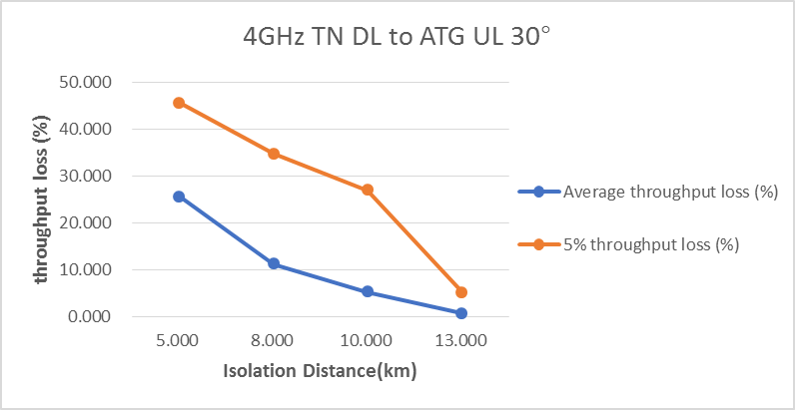

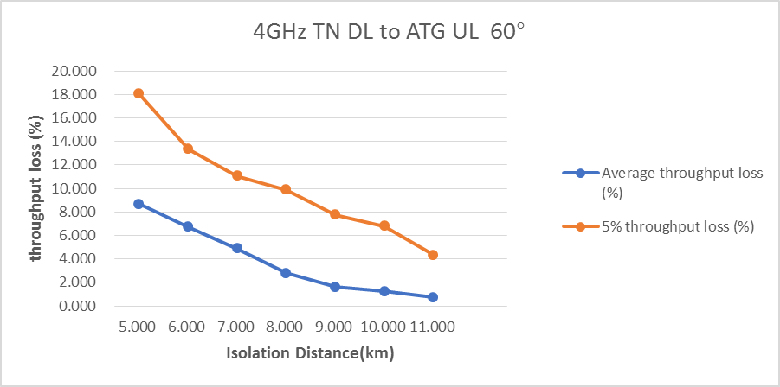

The isolation distances are summarized in Table 2.

**Table 2: Simulation results for Scenario 7 – 4GHz TN DL interfering ATG UL**

|  |  |  |  |  |  |
| --- | --- | --- | --- | --- | --- |
| **Company** | **ATG/ TN BS antenna model** | **Performance Metric** | **Isolation distance (km) for 5% throughput loss** | | |
| **Angle between ATG BS boresight and nearest TN BS boresight in azimuth** | | |
| **0°** | **30°** | **60°** |
| CATT | Non-Subarray | 5% in the whole network | 18 | 13 | 11 |
| Average of all users in the whole network | 15 | 10 | 7 |

## 2.3 Scenario 14: 2GHz TN DL interfering ATG UL

The simulation results are shown in the following figures,

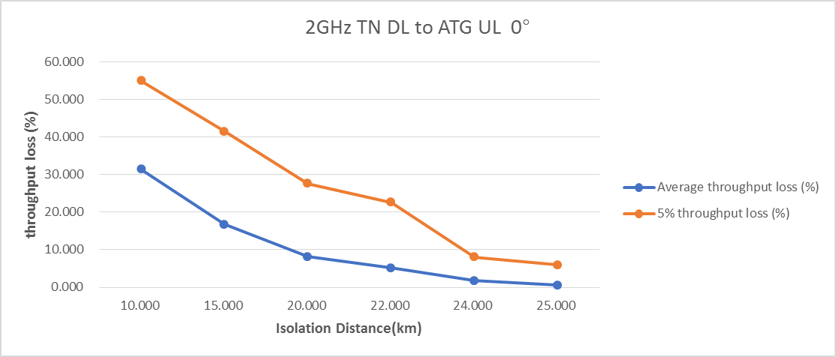

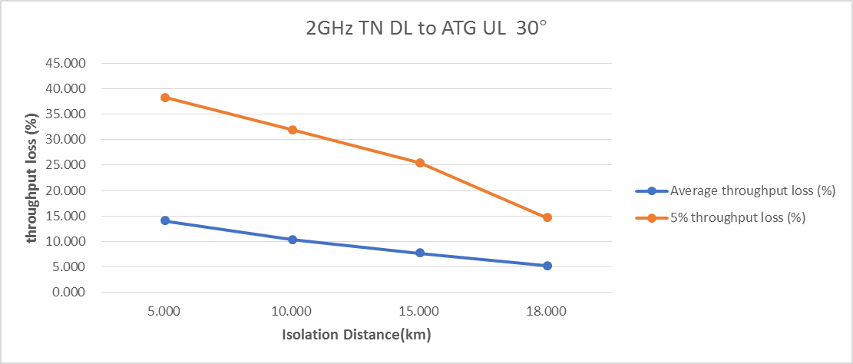

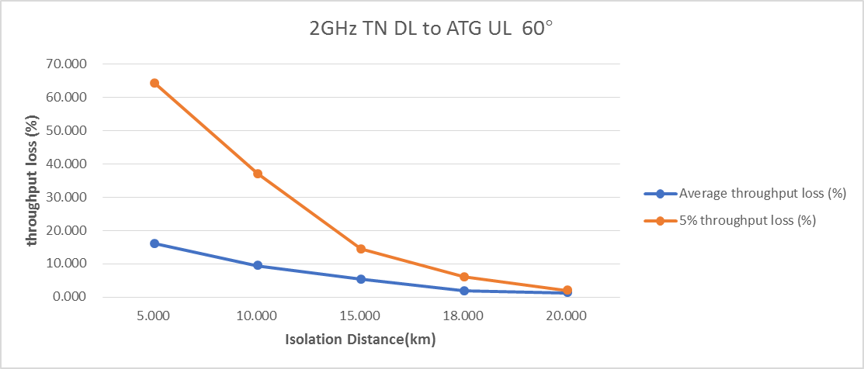

The isolation distances are summarized in Table 3.

**Table 3: Simulation results for Scenario 14 – 2GHz TN DL interfering ATG UL**

|  |  |  |  |  |  |
| --- | --- | --- | --- | --- | --- |
| **Company** | **ATG/ TN BS antenna model** | **Performance Metric** | **Isolation distance (km) for 5% throughput loss** | | |
| **Angle between ATG BS boresight and nearest TN BS boresight in azimuth** | | |
| **0°** | **30°** | **60°** |
| CATT | Non-Subarray | 5% in the whole network | 26 | 19 | 19 |
| Average of all users in the whole network | 22 | 18 | 16 |

# Summary

This contribution provides more simulation results for ATG non-synchronized scenarios.

# Reference

[1] R4-2314755, “WF on ATG co-existence evaluation”, RAN4#108, CMCC

[2] TR 38.876