**3GPP TSG-****RAN WG4 Meeting** **# 107 R4-2308741  
Incheon, KR, May 22 – May 26, 2023**

**Agenda item: 8.17.2**

**Source:** **CAICT**

**Title:** **Updated Framework for** **FR2 MIMO OTA performance requirements development (May 2023)**

**Document for: Approval**

# 1 Introduction

At RAN4 #106 meeting, the updated framework for FR2 MIMO OTA performance requirements development was approved [1]. Some detailed working procedures were further discussed at RAN4 #106-bis-e meeting, with agreements captured in the WF [2] as below.

|  |
| --- |
| **Issue 2-1-1: FR2 lab alignment activity**  **<Agreement>**:   * Use measured MASC values as pass/fail criteria to decide the lab alignment outcome. * RAN4 needs to finalize the preliminary MU budget for FR2 3D-MPAC system firstly and then make the decision on pass/fail limit based on the MU budget and measurement results conducted in lab alignment activity. Adopt [0.5-1]*preliminary MU as starting point and further check after the FR2 MU is decided and some PAD measurement results are available. * Each lab should finalize PAD measurement within 10 workdays, and deliver to the next lab in the same country ASAP with PAD In/Out information shared via email-reflector; otherwise, labs in the same country should equally share the period for testing the PADs.   **Issue 2-1-3: Minimum number of measurement data for requirements development**  **<Agreement>**:   * Keep the previous agreement [8-15], FFS after receiving some feedback from volunteer labs on the estimated amount of measurement data can be provided. More measurement data is preferred.   **Issue 2-1-4: Approaches to increase the measurement data for requirements development**  **<Agreement>**:   * Include the PAD measurement results from aligned labs into the data pool for specifying FR2 MIMO OTA performance requirements, if allowed by PAD providers. FFS how to process the PAD measurement results from aligned labs. |



In Section 2, we suggest the updates of the framework for FR2 MIMO OTA requirements development based on the agreements achieved at the last meeting [2] and this meeting [3].

# 2 Updated Framework for FR2 MIMO OTA performance requirements development (for approval)

**2.1 Overall work flow**

The overall work flow of FR2 MIMO OTA performance requirements development is illustrated in Fig. 1.

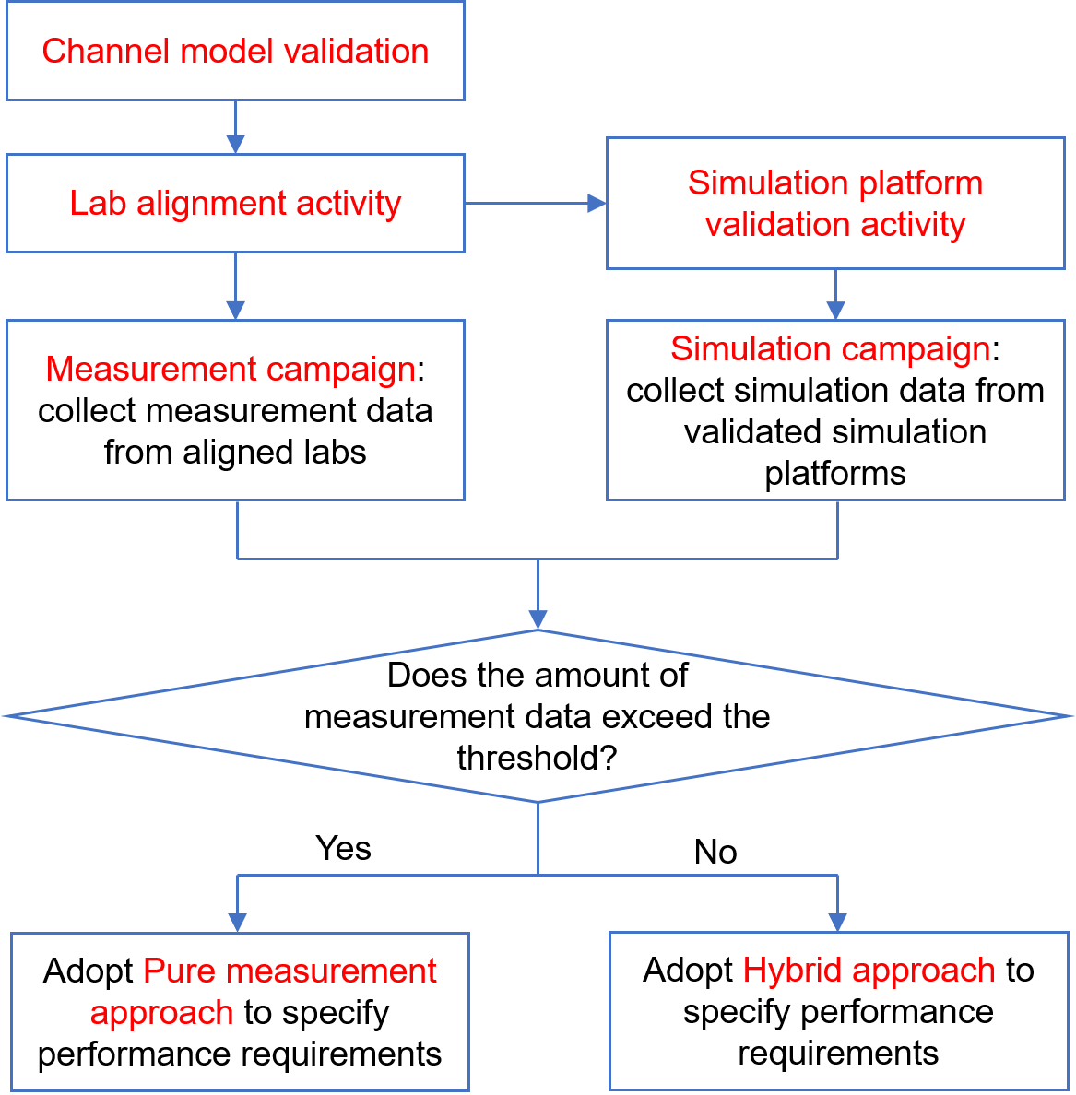

Fig. 1. Work flow of FR2 MIMO OTA performance requirements development

In general, either the hybrid approach (simulation and measurement) or the pure measurement approach will be adopted to define the FR2 MIMO OTA performance requirements. Once [8-15] or more measurement results of different commercial devices per band are collected, the pure measurement approach will be adopted and simulation results will only be provided for information and not included in the data pool for requirement development. The detailed working procedures for specifying FR2 MIMO OTA performance requirements are described in Section 2.2.

The simulation efforts and measurement efforts can be conducted in parallel. To establish valid and trustable simulation and measurement data pools for defining FR2 MIMO OTA requirements, the following activities are required:

1. Simulation platform validation activity: The purpose of the validation activity is to ensure that simulation results can be aligned or correlated with measurement results. Companies shall complete simulation platform validation before submitting simulation results into the data pool for defining FR2 MIMO OTA requirements, validation results should be submitted to RAN4 for review. Details of the simulation platform validation activity is specified in 2.2.1.
2. Channel model validation activity: Companies shall complete channel model validation before submitting measurement results, validation results should be submitted to RAN4 for review. Details of the channel model validation is specified in 2.2.2.
3. Lab alignment activity: An FR2 MIMO OTA lab alignment should be done. Only aligned labs can share measurement results into the data pool for defining FR2 MIMO OTA requirements. The measurement results used for the Simulation platform validation activity should also come from the aligned lab(s). Details of the lab alignment activity is specified in 2.2.3.

* At least 3 participating labs and 2~4 Performance Alignment Devices (PADs) per band are required.

**2.2 Detailed working procedures**

**2.2.1** **Simulation Platform Validation Activity**

1. The purpose of Simulation Platform Validation Activity is to ensure that simulation results can be aligned or correlated with measurement results.
2. Method and requirement:
   1. Validate the simulation platform by comparing the simulation results with the measurement results using the same set of parameters as some selected example UE’s implementation. The gaps between simulated and measured MIMO Average Spherical Coverage (MASC) values will be used as pass/fail criteria.
   2. The simulation platform is allowed to be adjusted and improved during the activity towards meeting the pass/fail criteria.
   3. Companies shall complete channel model validation before providing measurement results
   4. RAN4 should discuss how many measurement environments are sufficient for the Validation Activity.
   5. The lab alignment is required for the validation activity, i.e., the measurement results used for the validation activity should come from the aligned lab(s).
   6. Measurement results that will be selected to validate simulation models, should be accompanied by its antenna system radiation pattern, the format in which the radiation pattern is provided will be based on simulation platform proponents’ requirements.
      * Further discuss how to obtain the antenna system radiation patterns
      * FFS on other impact such as baseband capability
3. Band: n261
4. The minimum number of devices (i.e., different sets of parameters of UE implementations for simulation) required per band: [2-4]
5. Device selection criteria:
   1. To align the assumptions in the simulation with the measurement, use prototypes and commercial devices (1st priority)
   2. FFS number of panels per UE
6. Validation results submission: The information that should be provided is FFS
7. Pass/fail criteria:
   1. (1st priority) Each simulation result has a gap less than X dB with the corresponding measurement result from each measurement environment. The value of X is FFS, or defined as the measurement uncertainty (MU) of FR2 3D-MPAC system. If Criterion a. is met, the simulation results generated by the simulation platform(s) can be considered as aligned with measurement.
      * Define the value of X no later than RAN4 #106-bis-e meeting (Apr. 2023)
   2. (If Criterion a. cannot be met, Criterion b. is acceptable.) The simulation results have a stable and reasonable gap with the measurement results. Detailed acceptable values of the gaps are FFS. If Criterion b. is met, the simulation results generated by the simulation platform(s) can be correlated with measurement.

**2.2.2 Channel Model Validation**

1. The purpose of Channel Model Validation is to ensure that the channel models are correctly implemented and hence capable of generating the propagation environment, as described by the model, within the test zone of the 3D-MPAC system.
2. The channel model validation measurements shall be performed as described in Annex D.3 of TS 38.151, including:
   1. Power delay profile (PDP)
   2. Doppler/Temporal correlation
   3. PAS similarity percentage (PSP)
   4. Cross-polarization
   5. Power validation
3. Channel model: FR2 UMi CDL-C, as specified in Annex D.1 of TS 38.151
4. Test band: n261
5. Pass/fail limits: as defined in Annex D.2 of TS 38.151

**2.2.3** **Lab Alignment Activity**

1. The purpose of Lab Alignment Activity is to ensure there is no unexpected lab deviation and establish full trust and confidence on the measurement results. At least 3 participating labs and 2~4 PADs for each band are required.
2. Test labs are invited to participate in the lab alignment activity, the following conditions should be fulfilled:
   1. Participating labs shall complete channel model validation.
   2. Participating labs should have sufficient test resource to provide on-time measurement results without delay.
   3. Each lab should finalize PAD measurement within 10 workdays, and deliver to the next lab in the same country ASAP with PAD In/Out information shared via email-reflector; otherwise, labs in the same country should equally share the period for testing the PADs.
3. Test methodology:
   1. Test plan: 3GPP TS 38.151
4. Test cases for Lab Alignment Activity:
   1. Test band: n261 (for PADs that support n261), n257 (for the PAD that does not support n261)
   2. Number of test cases: 2~4 PADs per-band
   3. Operation mode: NR Non-Standalone (NSA) is preferred and SA is not precluded, and should be mapped with the measurement results submission.
   4. Power class: PC3
5. Test results submission:
   1. Use the same worksheet template in R4-2308740 to submit the measurement results
   2. The measurement results should be submitted to RAN4 by anonymous approach (the UE model shall not be disclosed publicly)
   3. Results shall not be shared between labs before submitting to RAN4 meetings or sharing in the RAN4 reflector. Comparison and lab alignment analysis should only be done in RAN4 meetings/discussions
6. Lab alignment criteria:
   1. The pass/fail criteria are defined as the maximum deviation between the MASC measurement result and the reference value
   2. The reference value is derived based on the per-band averaging approach of lab alignment data pool from ≥ 3 labs, whether apparent outliers will be considered in averaging process, or not, is FFS
   3. Pass/fail limit for lab alignment should be derived from the preliminary MU value. RAN4 should complete preliminary FR2 MU assessment before the end of Lab alignment activity, i.e., no later than RAN4#109 (Nov 2023). Adopt [0.5-1]*preliminary MU as starting point and further check after the FR2 MU is decided and some PAD measurement results are available.

**2.2.4 Simulation Campaign**

1. The purpose of Simulation Campaign is to collect simulation results with different UE antenna assumptions which follow practical implementations from valid simulation platforms after the Simulation Platform Validation Activity for specifying FR2 MIMO OTA performance requirements.
2. Simulation assumptions for FR2 MIMO OTA Simulation Campaign: TBD
   1. The simulation assumptions agreed in R17 MIMO OTA WI can be considered as the baseline.
   2. Companies are encouraged to provide inputs on different antenna configurations following practical UE implementations for collecting more simulation data.
3. Simulation cases:
4. Band: n261 (first stage)
5. Operation mode: NR Non-Standalone (NSA) (first stage)
6. Powe class: PC3 (first stage)
7. FFS on the number of antenna panel and whether to consider the proportion of a certain number of antenna panel UE.
8. Simulation results submission:
   1. Use the same worksheet template to submit the simulation results (a template will be submitted to RAN4 meetings for approval)
   2. The following information should be provided:
      1. The number of antenna panels of each UE
      2. Otherinformation that should be provided is FFS

**2.2.5 Measurement Campaign**

1. The purpose of Measurement Campaign is to collect measurement results of commercial devices from permitted labs after the Lab Alignment Activity for specifying FR2 MIMO OTA performance requirements.
   * + Consider and discuss how to avoid the same UE model being tested multiple times by different labs. Consider to adopt similar approaches in R4-2220265 (WF for test device information collection for the measurement data pool from Rel-17 TRP TRS WI and Rel-17 FR1 MIMO OTA), i.e., identify a neutral observer to collect device pool information and handle the data of the same UE model. The duty of the observer and detailed working procedures should be specified, consider to reuse the discussion outcomes of Rel-17 TRP TRS.
2. Test cases for FR2 MIMO OTA Measurement Campaign:
   1. Test band: n261 (first stage)
   2. Operation mode: NR Non-Standalone (NSA) (first stage)
   3. Powe class: PC3 (first stage)
3. Commercial Device (Smartphone) selection criteria:
   1. DUT capability: at least support n261 (for the first stage)
   2. The following selection criteria can also be considered:
      1. Year of production: 2019-2023
      2. Brand variety
      3. Popularity
      4. Number of bands supported
   3. Power Class: PC3 (for the first stage)
4. Commercial devices preparation:
   1. Test labs can collect commercial devices by themselves based on the above selection criteria
   2. Other companies are also encouraged to provide commercial devices based on the above selection criteria.
5. Measurement results submission:
   1. Use the same worksheet template to submit the measurement results (a template will be submitted to RAN4 meetings for approval)
   2. The measurement results should be submitted to RAN4 by anonymous approach (the UE model should not be disclosed). The following information should be provided:
      1. All FR2 bands supported by each UE
      2. Production year of each UE
      3. Other information that should be disclosed is FFS
   3. The plan and progress of each lab are encouraged to be shared via the RAN4 reflector (e.g., how many devices are planned to be/ have been measured)

**2.2.6 Specifying Performance Requirements**

**2.2.6.1 Pure measurement approach**

1. Minimum number of commercial devices for defining requirements: [8-15] per band
   * + FFS after receiving some feedback from volunteer labs on the estimated amount of measurement data can be provided. More measurement data is preferred.
     + To increase the number of measurement data, include the PAD measurement results from aligned labs into the data pool for specifying FR2 MIMO OTA performance requirements, if allowed by PAD providers. FFS how to process the PAD measurement results from aligned labs.
2. Method: Derive the requirements based on the measurement data pool

**2.2.6.2 Hybrid approach**

Starting point: one of the following three approaches can be adopted based on different applicable conditions. Revisit and refine the approaches when some simulation and measurement results are available.

* + - Note: If finally, the number of results including measurement and simulation could not reach the minimum number, FFS how to decide FR2 MIMO OTA requirements

1. Hybrid approach 1:
   1. Applicable conditions: the simulation results are verified to be aligned with the measurement results
   2. Method: Treat the simulation and measurement results equally and define the requirements based on the hybrid data pool including both simulation results and measurement data
   3. Minimum amount of data in the hybrid data pool for defining requirements: [8-20] per band, with the minimum amount of measurement results: [3-10] per band or FFS
2. Hybrid approach 2:
   1. Applicable conditions: the simulation results are verified to be aligned with the measurement results, or can be correlated with the measurement
   2. Method: Define the requirements based on the hybrid data pool, and focus more on measurement results than simulation results
      * How to correlate the simulation with the measurement, is FFS and depending on the results come from the Simulation platform validation activity
      * How to focus more on the measurement results to define FR2 requirements, is FFS
   3. Minimum amount of data in the hybrid data pool for defining requirements: [8-20] per band, with the minimum amount of measurement results: [3-10] per band or FFS
3. Hybrid approach 3 (with the lowest priority):
   1. Applicable conditions: the simulation results can be correlated with the measurement, and the amount of measurement results is less than [3], or others/FFS
   2. Method: Define a range or tentative values with square brackets for FR2 MIMO OTA requirements based on simulations, further adjust the tentative requirements based on the measurement results to obtain final requirements
   3. Minimum amount of data in the hybrid data pool for defining requirements: [8-20] per band

**2.2.7 UE antenna panel assumption impact on performance requirements**

1. RAN4 needs to study the impact of different UE implementation assumptions on the number of panels on MIMO OTA requirements
2. FFS how to accommodate different UE assumptions of number of panels for deriving MIMO OTA requirements

**2.3 Time plan**

1. Finalize the framework and time plan for FR2 Lab Alignment Activity in RAN4 #106 (Feb 2023).

2. Lab volunteers and PADs announced in RAN4#106 or via email-reflector before the starting of RAN4#106-bis-e (17 Apr 2023) are considered.

3. Conclude lab volunteers, PADs’ information, and delivery scheme in RAN4#106-bis-e. PAD providers should make sure the PADs are ready by the end of RAN4#106-bis-e (26 Apr 2023). Lab Alignment Activity can start with the labs that have completed channel model validation, after RAN4#106-bis-e immediately, if ≥ 3 lab volunteers and [2-3] PADs are confirmed.

4. Lab volunteers shall complete channel model validation before the starting of RAN4#108 (21 Aug 2023). The results shall be submitted to RAN4 by formal T-docs. Lab volunteer can share the validation results via email-reflector before submitting to RAN4 meetings, and then ask for PADs to participate in the Lab Alignment Activity.

5. Collect all lab alignment measurement results from lab volunteers based on contribution-driven manner in RAN4#109 (Nov 2023). Conclude the lab alignment outcome in RAN4#109. Measurement Campaign can start after RAN4#109 immediately, if ≥ 3 labs are aligned. (Lab volunteers that fail to complete PAD measurement and/or reach alignment at RAN4#109, if any, can have a chance to submit the PAD measurement results to RAN4#110 (Feb 2024) and be confirmed as aligned labs.)

6. Companies are encouraged to prepare and purchase commercial devices for the Measurement Campaign as early as possible. Count the number of the commercial devices no later than RAN4 #108-bis-e (Oct 2023) to estimate how much measurement data can be collected. Providers should make sure the commercial devices are ready by the end of RAN4#109 (17 Nov 2023).

7. Down-selection between the pure measurement approach and the hybrid approach should be done as early as possible, the deadline is RAN#109 (Nov 2023), based on the estimated amount of measurement data can be collected.

8. Simulation Platform Validation Activity can start from RAN4#109 (Nov 2023), if ≥ 3 labs are aligned and the hybrid approach is selected. Complete the Simulation Platform Validation Activity by the end of RAN4#110 (Feb 2024). (If applicable)

9. Collect measurement results of commercial devices from aligned labs based on contribution-driven manner in RAN4#110 (Feb 2024) and RAN4#111 (Apr 2024).

10. Collect simulation results from validated simulation platforms based on contribution-driven manner in RAN4#111 (Apr 2024). (If applicable)

11. Conclude FR2 MIMO OTA performance requirements at or before RAN4#112 (May 2024).

**Proposal 1: Approve the updated Framework defined in this contribution to guide the FR2 MIMO OTA performance requirements related work. Further refinement is not precluded based on discussion outcomes in future meetings.**

# 3 Conclusion

In this paper, we suggest some updates of the Framework for FR2 MIMO OTA performance requirements development.

**Proposal 1: Approve the updated Framework defined in this contribution to guide the FR2 MIMO OTA performance requirements related work. Further refinement is not precluded based on discussion outcomes in future meetings.**

# References

1. R4-2302927, “Updated Framework for FR2 MIMO OTA performance requirements development”, CAICT, 3GPP RAN4#106, Feb. 2022.
2. R4-2305910, “WF on Rel-18 MIMO OTA”, CAICT, 3GPP RAN4#106-bis-e, Apr. 2023.
3. R4-2309821, “WF on Rel-18 MIMO OTA”, CAICT, 3GPP RAN4#107, May 2023.