3GPP TSG-RAN WG4 Meeting # 107 R4-23XXXXX
Incheon, KR, May 22nd – May 26th , 2023

Agenda item: 8.17.6
Source: Moderator (CAICT)
Title: Ad-hoc minutes for [107][333] NR_MIMO_OTA_enh
Document for: Information

Introduction
This document contains meeting minutes and agreements reached during an ad-hoc meeting for Rel-18 MIMO OTA enhancement.

Topic #1: FR1 MIMO OTA

Open issues summary

Sub-topic 1-1 FR1 MIMO OTA test with Hand phantoms
Issue 1-1-1: Necessity of FR1 MIMO OTA test with hand phantom
- Proposals
  - Proposal 1: It is necessary to enhance the FR1 MIMO OTA test methodology for smartphone with hand phantoms. (CAICT, Huawei, Xiaomi)
  - Proposal 2: Operators’ actual demands need to be taken into account. (based on Observation 3 in R4-2309014).
- Recommended WF
  - TBA

Discussions:
OPPO: Support P1. Measurement results have shown the necessity.
Apple: Support P2.
Keysight: Measurement results show overall aligned Rankings of TRS with hand and MIMO OTA with hand, so the measurement results cannot be a strong justification.
CAICT: Not all the rankings are the same.
Vivo: Similar view as Keysight. With hand phantom, it seems introduce new channel model.
Apple: Operators’ feedback should be taken in to account.
Keysight: Suggest to check operators’ view at online session.
Chair: Ask for operators’ feedback at online session. Also Email to operators to ask for answers.
CMCC: The MIMO OTA test with hand phantom is necessary.

Issue 1-1-2: Feasibility of FR1 MIMO OTA test with hand phantom
- Proposals
  - Proposal 1: The hand phantom (excluding adapters and fixtures) and smartphone shall be fully contained within the QZ. (Keysight)
  - Proposal 2: For the DMP condition only, consider offsetting the phone and phantom to fully enclose both within the 20 cm QZ. The offsets with respect to the centre of test system can be (-3, -11, 37.5). (Keysight, OPPO)
  - Proposal 3: Adjust the WID to augment the existing 20 cm QZ/test zone with a 30 cm QZ if phantoms are considered for NR FR1 MIMO OTA testing in DMP and DMSU conditions. (Keysight)
  - Proposal 4: In the absence of introducing another QZ/test zone, do not consider phantoms for NR FR1 MIMO OTA testing in DMP and DMSU conditions. (Keysight)
  - Proposal 5: Review and endorse the MU table in R4-2307242 for MIMO OTA tests with hand phantoms. (Huawei)
- Recommended WF
  - TBA

Discussions:
Apple: Support P1, 4, add P6: make the decision based on data, suggest to perform an alignment campaign to check if the QZ is large enough.
Keysight: P2 is a subset of P1. Questions on P5.
Apple: P2: where are the offsets come from? the offsets are device dependent.
OPPO: The offsets can apply to most UE sizes. Propose to adopt this offset to all UEs.
Samsung: Cannot agree to P2 now. How to handle UEs with larger sizes in the future?
Huawei: Answer to Keysight on P5: MU is form material and positions.
Apple: Why test DMP only and check operators’ feedback.
Samsung: Similar with Apple. DMP cannot totally reflect UE performance.
Apple: Do not support O1. For O2: This option will cause a new channel model validation and a new lab alignment.
Keysight: Lager QZ means new channel model rather than new test system.
Vivo: Should confirm the necessity first.
Chair: FFS the following options at online session.

Summarized Options during ad-hoc meeting:
Option 1: Test DMP condition only, consider offsetting the phone and phantom to fully enclose both within the 20 cm QZ. FFS the offsets.
Option 2: Both DMP and DMSU shall be tested. Enlarge the QZ size from 20cm to 30cm. This option will cause a new channel model validation and a new lab alignment.

Sub-topic 1-2 FR1 MIMO OTA requirements related work
Background: It was agreed in the time plan (R4-2305911) to conclude lab volunteers, PADs’ information, and delivery scheme at this for Rel-18 FR1 lab alignment activity.
Issue 1-2-1: Volunteer labs for FR1 lab alignment activity
- Proposal
  - Confirm the Volunteer labs for FR1 MIMO OTA lab alignment. The information collection form can be updated during this meeting.
Volunteer lab | City | Contact
Apple | Cupertino, California, USA | Istvan Szini  Istvan@apple.com
CAICT | Beijing, China | Xuan Yi, yixuan@caict.ac.cn
CMCC&BUPT joint lab | Beijing, China
MediaTek | Beijing, China
Xiaomi | Beijing, China
Huawei | Shanghai, China

- Recommended WF
  - Volunteer labs are invited to provide and confirm the information before/during this meeting.
  - Capture confirmed information in WF.

Issue 1-2-2: PADs for FR1 lab alignment activity
- Proposal
  - Confirm the PADs for FR1 MIMO OTA lab alignment. The information collection form can be updated during this meeting.
Provider | How many PADs | Supported FR1 bands | PAD current location | When will the PAD(s) be ready | Note
[Vivo]
[Xiaomi]

- Recommended WF
  - PAD providers are invited to provide and confirm the information before/during this meeting.
  - Capture confirmed information in WF.

Issue 1-2-3: Implementation of FR1 MIMO OTA lab alignment
- Proposals (CAICT)
  - Proposal 1: Adopt the following PAD delivery scheme for FR1 MIMO OTA lab alignment activity. The delivery scheme can be updated/refined during this meeting with formally confirmation of volunteer labs/PADs.
- Labs in Beijing -> Labs in Shanghai -> (transfer the PADs at Oct RAN4) -> Labs outside Asia
        - Note: The PADs can be tested in different labs located in the same country in parallel during the same period.
  - Proposal 2: FR1 Lab Alignment Activity can start with the labs that completed channel model validation at band n28, after RAN4#107 immediately, once PADs are ready.
- Recommended WF
  - P1 and P2 are agreeable.

Discussions:

Agreements:
  - Proposal 1: Adopt the following PAD delivery scheme for FR1 MIMO OTA lab alignment activity. The delivery scheme can be updated/refined during this meeting with formally confirmation of volunteer labs/PADs.
- Labs in Beijing -> Labs in Shanghai -> (transfer the PADs at Oct RAN4) -> Labs outside Asia
        - Note: The PADs can be tested in different labs located in the same country in parallel during the same period.
  - Proposal 2: FR1 Lab Alignment Activity can start with the labs that completed channel model validation at band n28, after RAN4#107 immediately, once PADs are ready.

Issue 1-2-4: Channel model validation results submission
Note: It was agreed in the time plan (R4-2305911) that the deadline for channel model validation results submission is the starting of RAN4#108 (21 Aug 2023).
- Observation:
  - MediaTek submitted the channel model validation results in R4-2307506; CAICT submitted part of channel model validation results in R4-2301048 at RAN4#106.

Discussion:
Vivo: The understanding on Power validation may not be correct.

Topic #2: FR2 MIMO OTA

Open issues summary
Before Meeting, moderators shall summarize list of open issues, candidate options and possible WF (if applicable) based on companies’ contributions.

Sub-topic 2-1 Framework for FR2 MIMO OTA
An updated framework is provided in R4-2308741.
Issue 2-1-1: Whether to consider a certain number of UE panels
- Proposals
  - Option 1: Approve the updates proposed in the updated framework (R4-2308741), i.e., not to consider the proportions of any certain number of UE panels in Simulation Platform Validation Activity, Simulation Campaign, and Measurement Campaign; and not to consider the UE panel impact on performance requirements. (CAICT, Qualcomm)
  - Others
- Recommended WF
  - TBA

Discussions:
Apple: We don’t agree to remove antenna panel information from simulation. If the group agree to remove antenna panel information from simulation, we can compromise to use the simulation to obtain an offset for relax the performance requirement.
Qualcomm: Clarification to Apple: We should separate measurement approach and measurement approach.
Samsung: In the future, there will be single panel UE. Considering single panel UE is a must. For simulation, single panel UE should be included. For measurement, we have agreed that the antenna panel impact should be considered.
Apple: To QC: we are talking about the relationship between Simulation and Measurement. They should be correlated.
Huawei: Similar views with Samsung. Single panel UE will be popular.
Keysight: Simulation results should be contribution-driven approach, you cannot force some companies to simulate the single panel UE. Companies who interested in single panel UE shall submit some single panel UEs in measurement campaign, otherwise, no relaxation should be considered.
Qualcomm: To Samsung: The number of panels should base on the current market rather than future market. Echo Keysight’s comments.
Samsung: The impact of single panel UE should be considered since there are few single panel UE on the market now.
Samsung: The impact of single panel on requirements should also be considered.
Keysight: The relaxation will make the requirement too low.
OPPO: Can we consider two different requirement for single-panel UEs and for multi-panel UEs?
Qualcomm: To OPPO: how can we know the numbers of panels? Based on OEM diclariton ?
Apple:
Vivo:
Samsung:
Keysight:

Agreements:
Not to require a min. number of single-panel UEs in Measurement Campaign.
The previous agreements on Clause 2.2.7 in the framework (R4-2302927) is kept.
OEM are encouraged to provide UEs different numbers of antenna panels for the Measurement Campaign.

Issue 2-1-2: Working procedures for Measurement campaign
This issue was not discussed during Ad-hoc meeting.
- Proposal:
  - Approve the updated working procedures for Measurement campaign in R4-2308741:
- Test cases for FR2 MIMO OTA Measurement Campaign:
  - Test band: n261 (first stage)
  - Operation mode: NR Non-Standalone (NSA) (first stage)
  - Powe class: PC3 (first stage)
  - FFS whether RAN4 shall guarantee the considerable proportion of single panel UE and how to guarantee the proportion of single panel UE
- Commercial Device (Smartphone) selection criteria:
  - DUT capability: at least support n261
  - The following selection criteria can also be considered:
    - Year of production: 2019-2023
    - Brand variety
    - Popularity
    - Number of bands supported
  - Power Class: PC3
- Commercial devices preparation:
  - Test labs can collect commercial devices by themselves based on the above selection criteria
  - Other companies are also encouraged to provide commercial devices based on the above selection criteria.
- Measurement results submission:
  - Use the same worksheet template to submit the measurement results (a template will be submitted to RAN4 meetings for approval)
  - The measurement results should be submitted to RAN4 by anonymous approach (the UE model should not be disclosed). The following information should be provided:
    - All FR2 bands supported by each UE
    - Production year of each UE
    - Other information that should be disclosed is FFS, consider to reuse the discussion outcomes of Rel-17 TRP TRS.
  - The plan and progress of each lab are encouraged to be shared via the RAN4 reflector (e.g., how many devices are planned to be/ have been measured)

- Recommended WF
  - TBA

Issue 2-1-3: How to process the PAD measurement results to be included into the data pool
This issue was not discussed during Ad-hoc meeting.
The agreements of the last meeting in the WF:
Issue 2-1-4: Approaches to increase the measurement data for requirements development
<Agreement>:
- Include the PAD measurement results from aligned labs into the data pool for specifying FR2 MIMO OTA performance requirements, if allowed by PAD providers. FFS how to process the PAD measurement results from aligned labs.

- Proposals:
  - Proposal 1 (R4-2308741): Directly include the lab alignment reference values of PAD measurement results into the data pool for specifying FR2 MIMO OTA performance requirements. (The generation process of reference values is described in 6b. of cluses 2.2.3 of the framework).
- Recommended WF
  - P1 is agreeable.

Sub-topic 2-2 FR2 MIMO OTA requirements related work
This sub-topic was not discussed during Ad-hoc meeting.
Issue 2-2-1: Collect PADs’ information on supported LTE bands
This issue is related to Issue 2-3-1.
- Proposals
  - Proposal 1: Collect PAD’s information on the supported LTE bands corresponding to the NR FR2 tested band in lab alignment campaign, and the tested EN-DC band combination should be recorded in test results. (Samsung)
- Recommended WF
  - The supported LTE bands information can be collected and shared publicly.
  - The tested EN-DC band combination should be shared among the volunteer labs to ensure a same test condition, but should not be disclosed publicly to avoid any PADs being identified.

Issue 2-2-2: Template for FR2 MIMO OTA lab alignment activity
A template is provided in R4-2308740 for PAD measurement results submission during FR2 MIMO OTA lab alignment activity.
- Recommended WF
  - Approve the template

Sub-topic 2-3 EN-DC band combination selection for FR2 MIMO OTA
This sub-topic was not discussed during Ad-hoc meeting.
Issue 2-3-1: EN-DC band combination selection for FR2 MIMO OTA
Reference: The Decision tree for TRP/TRS testing in TS 38.161:
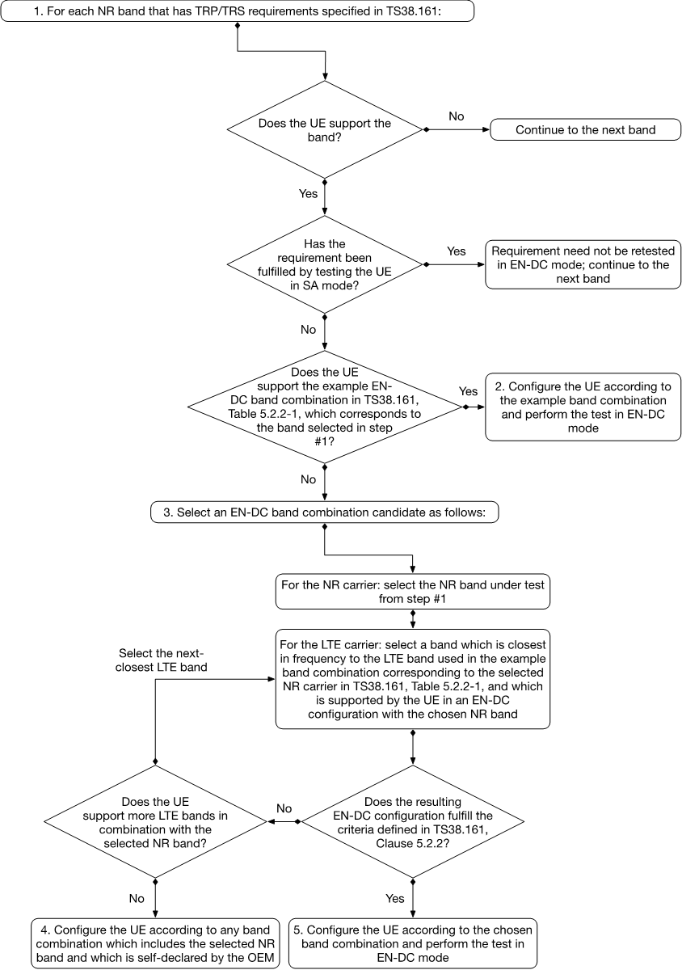
Figure 5.2.2-1: Decision tree to select the EN-DC band combination for TRP/TRS testing

- Proposals
  - Option 1 (Stick to previous agreements): To make sure a consistent test condition for a particular UE across different labs, an example LTE anchor band along with a decision tree shall be defined. LTE B66 is selected as the example LTE anchor band for n261 FR2 MIMO OTA test. For UEs that don’t support B66, use a decision tree to select the LTE anchor band.
    - Proposal 1: Reuse the same decision tree of FR1 TRP TRS for FR2 MIMO OTA to select EN-DC band combination. (Samsung)
  - Option 2 (Huawei): RAN4 not consider defining the criteria for selecting the LTE anchor band and any LTE anchor band can be used for the measurement activity.
- Recommended WF
  - Option 1. Is Proposal 1 agreeable?

Issue 2-3-2: Applicability rules for MIMO OTA testing of FR2 SA and NSA UEs
Reference: The Applicability rules in TS 38.161:

4.3 Applicability rules for testing of FR1 SA and NSA UEs
The applicability and test coverage rules for Non-Standalone (NSA) only capable devices shall include the following:
- For each NR band supported by the device, test the UE in EN-DC mode using any one example configuration containing that NR band or configuration declaration decision tree as per recommended TRP/TRS test procedures in this specification.
The applicability and test coverage rules for Standalone (SA) and NSA (EN-DC) capable devices shall include the following:
- For each NR band in a device, test the UE in Standalone Mode as per the TRP/TRS test procedures in this specification.
- This shall also fulfil coverage for all EN-DC FR1 minimum performance requirements for that NR band and need not be retested in EN-DC mode.

- Proposal
  - Proposal 1: RAN4 further discuss how to handle the applicability rules for both SA and NSA capable FR2 UEs. (Samsung)
- Recommended WF
  - TBA

Sub-topic 2-4 Preliminary MU assessment for FR2 MIMO OTA
This sub-topic was not discussed during Ad-hoc meeting.
Issue 2-4: FR2 channel emulator MU element
- Proposals
  - Proposal 1: Re-use the FR1 Channel Emulator definition and MU values for FR2. (Keysight, Spirent)
- Recommended WF
  - P1 is agreeable.

Topic #3: Rel-17 MIMO OTA maintenance
This topic was not discussed during Ad-hoc meeting.

Open issues summary

Sub-topic 3-1 FR2 channel model validation
Issue 3-1: FR2 Channel Model Power Validation
- Proposals
  - Option 1 (Apple, Keysight): Implement on TS 38.151 an option to measure the EPRE Power Validation adopting a test equipment capable to decode the NR signal, as the CR in R4-2309476.
  - Option 2 (Huawei): Considering unaligned decoding algorithm and the enough accuracy of legacy power validation, not recommendation the EPRE power validation.
- Recommended WF
  - O1 or O2? It is suggested to clarify the reason why adding the EPRE Power Validation as an alternative.

Issue 3-2: Is the CR R4-2307241 on FR1 power validation pass fail limit agreeable?
- Recommended WF
  - Yes. The formatting issues on cover page should be corrected.

Issue 3-3: Is the CR R4-2309474 on PDP Targets for FR2 CDL-C channel model agreeable?
- Recommended WF
  - Yes. The formatting issues on cover page should be corrected.

Issue 3-4: Is the CR R4- 2309475 on TCF Test Methodology for FR2 CDL-C channel model agreeable?
- Recommended WF
  - Yes. The formatting issues on cover page should be corrected.

Issue 3-5: Is the CR R4-2308739 on FR1 spatial correlation pass/fail limits agreeable?
- Recommended WF
  - Yes.

Issue 3-6: Is the CR R4-2309250 for clarifications on FR1 channel model parameters agreeable?
- Recommended WF
  - Yes.

Issue 3-7: Is the CR R4-2309744 on TS 38.151 Annex C editorial updates agreeable?
Ad-hoc chair: Suggest not to discuss this issue at the ad-hoc meeting, to leave more time for companies to check the details.

