**3GPP TSG-WG4 Meeting #107 *R4-2309818***

**Incheon, South Korea, 22nd May – 26th May 2023**

|  |  |  |  |  |  |  |  |  |
| --- | --- | --- | --- | --- | --- | --- | --- | --- |
| *CR-Form-v12.2* | | | | | | | | |
| **CHANGE REQUEST** | | | | | | | | |
|  | | | | | | | | |
|  |  | **CR** | **0009** | **rev** | **1** | **Current version:** |  |  |
|  | | | | | | | | |
| *For* [***HE******LP***](http://www.3gpp.org/3G_Specs/CRs.htm#_blank)*on using this form: comprehensive instructions can be found at* [*http://www.3gpp.org/Change-Requests*](http://www.3gpp.org/Change-Requests)*.* | | | | | | | | |
|  | | | | | | | | |

|  |  |  |  |  |  |  |  |  |
| --- | --- | --- | --- | --- | --- | --- | --- | --- |
| ***Proposed change affects:*** | UICC apps |  | ME | **x** | Radio Access Network |  | Core Network |  |

|  |  |  |  |  |  |  |  |  |  |  |
| --- | --- | --- | --- | --- | --- | --- | --- | --- | --- | --- |
|  | | | | | | | | | | |
| ***Title:*** | Update on TCF Test Methodology for FR2 CDL-C channel model | | | | | | | | | |
|  |  | | | | | | | | | |
| ***Source to WG:***  ***Source to TSG:*** | Apple Hungary kft., Keysight Technologies  R4 | | | | | | | | | |
|  |  | | | | | | | | | |
| ***Work item code:*** | NR_MIMO_OTA | | | | |  | ***Date:*** | | | 2023-05-23 |
|  |  | | | |  | |  | | |  |
| ***Category:*** | F |  | | | | | ***Release:*** | | | Rel-17 |
|  | *Use one of the following categories:* ***F*** *(correction)* ***A*** *(mirror corresponding to a change in an earlier release)* ***B*** *(addition of feature),* ***C*** *(functional modification of feature)* ***D*** *(editorial modification)*  Detailed explanations of the above categories can be found in 3GPP [TR 21.900](http://www.3gpp.org/ftp/Specs/html-info/21900.htm). | | | | | | | | *Use one of the following releases: Rel-8 (Release 8) Rel-9 (Release 9) Rel-10 (Release 10) Rel-11 (Release 11) … Rel-16 (Release 16) Rel-17 (Release 17) Rel-18 (Release 18) Rel-19 (Release 19)* | |
|  |  | | | | | | | | | |
| ***Reason for change:*** | | TS 38.151 update on FR2 TCF test methodology for CDL-C channel model | | | | | | | | |
|  | |  | | | | | | | | |
| ***Summary of change:*** | | Editorial change on FR2 Doppler/Temporal correlation adding the Time Domain alternate method | | | | | | | | |
|  | |  | | | | | | | | |
| ***Consequences if not approved:*** | | Improvement on FR2 channel model validation specifications and actual measurements | | | | | | | | |
|  | |  | | | | | | | | |
| ***Clauses affected:*** | | Annex D.3.3 | | | | | | | | |
|  | |  | | | | | | | | |
|  | | **Y** | **N** |  | | | |  | | |
| ***Other specs*** | |  | **x** | Other core specifications | | | | TS/TR ... CR ... | | |
| ***affected:*** | |  | **x** | Test specifications | | | | TS/TR ... CR ... | | |
| ***(show related CRs)*** | |  | **x** | O&M Specifications | | | | TS/TR ... CR ... | | |
|  | |  | | | | | | | | |
| ***Other comments:*** | |  | | | | | | | | |
|  | |  | | | | | | | | |
| ***This CR's revision history:*** | | This is a revised CR from R4-2309475 | | | | | | | | |

## **<Start of Change>**

## D.3.3 FR2 Doppler/Temporal correlation

This measurement checks the Doppler/temporal correlation. For Doppler/Temporal correlation validation measurement, only Vertical validation is required.

The Doppler spectrum is measured with a spectrum analyser as shown in Figure D.3.3-1. In this case a signal generator transmits CW signal through the NR MIMO OTA test system. The signal is received by a test antenna within the test area. Finally, the signal is analysed by a spectrum analyser and the measured spectrum is compared to the target spectrum. This setup can be used to measure Doppler Spectrum of the Channel models defined in Annex D.2.

**Method of measurement:**

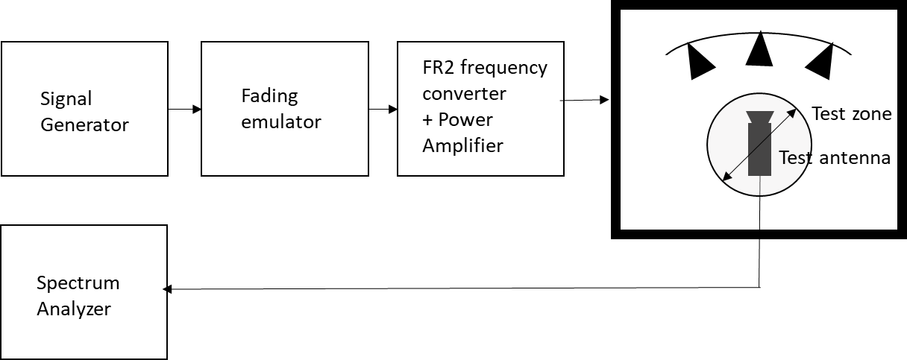

Figure D.3.3-1: Setup for FR2 Doppler measurements

Sine wave (CW, carrier wave) signal is transmitted from the signal generator. The signal is connected from the signal generator to fading emulator via cables. The fading emulator output signals are connected to frequency converter and power amplifier boxes via cables. The amplified signals are then transferred via cables to the probe antennas. The probe antennas radiate the signals over the air to the test antenna The Doppler spectrum is measured by the spectrum analyser and the trace is saved.

**Signal generator settings:**

Table D.3.3-1: Signal generator settings for FR2 Doppler/Temporal correlation measurements

| Item | Unit | Value |
| --- | --- | --- |
| Centre frequency | MHz | Downlink centre frequency  in Table D.3.1-1 |
| Modulation |  | OFF |

**Spectrum analyser settings:**

Table D.3.3-2: Spectrum analyser settings for FR2 Doppler/Temporal correlation measurements

| Item | Unit | Value |
| --- | --- | --- |
| Centre frequency | MHz | Downlink centre frequency  in Table D.3.1-1 |
| Minimum Span | Hz | 4 kHz |
| RBW | Hz | 1 |
| VBW | Hz | 1 |
| Number of points |  | 16002 |
| Averaging |  | 100 |

**Channel model specification:**

Table D.3.3-3: Channel model specification for FR2 Doppler/Temporal correlation measurements

| Item | Unit | Value |
| --- | --- | --- |
| Centre frequency | MHz | Downlink centre frequency  in Table D.3.1-1 |
| Channel model |  | As specified in Annex D.1 |
| Mobile speed | km/h | 3 |

Method of measurement result analysis: Measurement data file (Doppler power spectrum) is saved into hard drive. The data is read into, e.g., Matlab. The analysis is performed by taking the Fourier transformation of the Doppler spectrum. The resulting temporal correlation function  is normalized such that max(abs(*Rt*(∆*t*)))=1. Then the function values left from the maximum is cut out. Further on the function values after, e.g. seven periods is cut out.

The detailed Temporal correlation reference value for FR2 CDL-C UMi channel model validation is defined is table D.3.3-4.

Table D.3.3-4: Temporal correlation Targets

|  |  |  |  |
| --- | --- | --- | --- |
| Distance [λ] | X2V Corr. | Distance [λ] | X2V Corr. |
| 0 | 1.0000 | 2.5 | 0.1769 |
| 0.1 | 0.9929 | 2.6 | 0.1717 |
| 0.2 | 0.9717 | 2.7 | 0.1649 |
| 0.3 | 0.9379 | 2.8 | 0.1564 |
| 0.4 | 0.8937 | 2.9 | 0.1456 |
| 0.5 | 0.8414 | 3 | 0.1327 |
| 0.6 | 0.7834 | 3.1 | 0.1177 |
| 0.7 | 0.7223 | 3.2 | 0.1011 |
| 0.8 | 0.6601 | 3.3 | 0.0829 |
| 0.9 | 0.5986 | 3.4 | 0.0638 |
| 1 | 0.5387 | 3.5 | 0.0449 |
| 1.1 | 0.4817 | 3.6 | 0.0272 |
| 1.2 | 0.4284 | 3.7 | 0.0121 |
| 1.3 | 0.3796 | 3.8 | 0.0023 |
| 1.4 | 0.3362 | 3.9 | 0.0079 |
| 1.5 | 0.2984 | 4 | 0.0104 |
| 1.6 | 0.2667 | 4.1 | 0.0083 |
| 1.7 | 0.2416 | 4.2 | 0.0026 |
| 1.8 | 0.2221 | 4.3 | 0.0095 |
| 1.9 | 0.2081 | 4.4 | 0.0235 |
| 2 | 0.1987 | 4.5 | 0.0397 |
| 2.1 | 0.1921 | 4.6 | 0.0572 |
| 2.2 | 0.1879 | 4.7 | 0.0738 |
| 2.3 | 0.1844 | 4.8 | 0.0890 |
| 2.4 | 0.1812 | 4.9 | 0.1018 |
|  |  | 5 | 0.1109 |

**Time Domain Alternate Method**

Time domain techniques can also be used to validate the tempoal correlation. The temporal correlation validation measurement setup is illustrated in Figure D.3.3-2. In this case a Signal generator transmits a CW signal through the MIMO test system. The signal is received by a test antenna within the test area. Finally, the signal is collected by a signal analyser and the measured signal is stored as IQ data format for postprocessing.

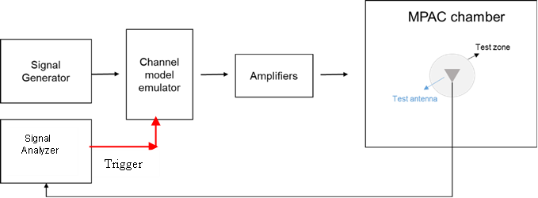

Figure D.3.3-2: Setup for Doppler measurements based on time domain technique

The time domain doppler spectrum is measured by the signal analyzer and the trace in IQ format is saved. Follow the same procedure to post process the data and calculate the temporal correlation curve. Data recording is synchronized with the channel emulator trigger.

The settings for the signal analyzer are in Table D.3.3-5:

Table D.3.3-5: Signal Analyser Settings

|  |  |  |
| --- | --- | --- |
| Item | Unit | Value |
| Centre frequency | MHz | Downlink centre frequency in Table D.3.1-1 |
| Sampling | Hz | At least 15 times bigger than the max Doppler spread (*fd=v/λ)* |
| Observation time | s | At least 16s. Channel Model length should be the same or greater than the observation time. |

## **<End of Change>**