3GPP TSG-WG4 Meeting #107 R4-2309817

Incheon, South Korea, 22nd May – 26th May 2023
CR-Form-v12.2
CHANGE REQUEST
 | 38.151 | CR | 0008 | rev | 1 | Current version: | 17.3.0
For HELP on using this form: comprehensive instructions can be found at
http://www.3gpp.org/Change-Requests.

Proposed change affects: | UICC apps |  | ME | x | Radio Access Network |  | Core Network

Title: | Update on PDP Targets for FR2 CDL-C channel model
Source to WG:  Source to TSG: | Apple Hungary kft., Keysight Technologies  R4
Work item code: | NR_MIMO_OTA |  |  |  |  |  | Date: |  |  | 2023-05-23
Category: | F |  |  |  |  |  | Release: |  |  | Rel-17
 | Use one of the following categories:  F (correction)  A (mirror corresponding to a change in an earlier release)  B (addition of feature),  C (functional modification of feature)  D (editorial modification)  Detailed explanations of the above categories can  be found in 3GPP TR 21.900. |  |  |  |  |  |  |  | Use one of the following releases:  Rel-8 (Release 8)  Rel-9 (Release 9)  Rel-10 (Release 10)  Rel-11 (Release 11)  …  Rel-16 (Release 16)  Rel-17 (Release 17)  Rel-18 (Release 18)  Rel-19 (Release 19)
Reason for change: |  | TS 38.151 update FR2 PDP Target for CDL-C channel model, combined cluster index at delay 0 ns
Summary of change: |  | Editorial change on Table D.3.2-3 adding 0 ns cluster
Consequences if not approved: |  | Lack of requirements alignment between FR2 channel model validation specifications and actual measurements
Clauses affected: |  | Annex D.3.2
 |  | Y | N
Other specs |  |  | x | Other core specifications |  |  |  | TS/TR ... CR ...
affected: |  |  | x | Test specifications |  |  |  | TS/TR ... CR ...
(show related CRs) |  |  | x | O&M Specifications |  |  |  | TS/TR ... CR ...
Other comments:
This CR's revision history: |  | This is a revised CR from R4-2309474

<Start of Change>
D.3.2 FR2 Power Delay Profile (PDP)
This measurement checks that the resulting power delay profile (PDP) is in-line with the PDP defined for the channel model. For PDP validation measurement, only Vertical validation is required.
The PDP measurement is performed with a Vector Network Analyser (VNA). An example setup for PDP measurement is shown in Figure D.3.2-1. VNA transmits frequency sweep signals thorough the NR MIMO OTA test system. A reference antenna, within the centre of the test zone, receives the signal and VNA analyses the frequency response of the system. A number of traces (frequency responses) are measured and recorded by VNA and analysed by a post processing SW, e.g., Matlab. Special care has to be taken into account to keep the fading conditions unchanged, i.e. frozen, during the short period of time of a single trace measurement. The fading may proceed only in between traces.
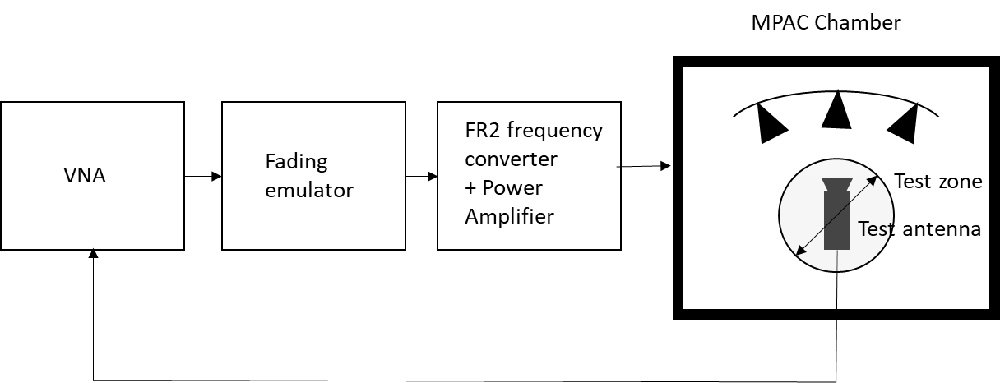
Figure D.3.2-1: Setup for PDP measurements (FR2)
Step the emulation and store traces from VNA. I.e. run the emulation to CIR number 1, pause, measure VNA trace, run the emulation to CIR number 10, pause, measure VNA trace. Continue until 1000 VNA traces are measured.
VNA settings:
Table D.3.2-1: VNA settings for FR2 PDP measurements
Item | Unit | Value
Centre frequency | MHz | Downlink centre frequency  in Table D.3.1-1
Span | MHz | 200
Number of traces |  | 1000
Number of points |  | 1101
Averaging |  | 1

Channel model specification:
Table D.3.2-2: Channel model specification for FR2 PDP measurements
Item | Unit | Value
Centre frequency | MHz | Downlink centre frequency  in Table D.3.1-1
Distance between traces in channel model | wavelength (Note) | > 2
Channel model |  | As specified in Annex D.1
NOTE: Time [s] = distance [λ] / MS speed [λ/s]
MS speed [λ/s] = MS speed [m/s] / Speed of light [m/s] * Centre frequency [Hz]

Method of measurement result analysis:
Measured VNA traces (frequency responses H(t,f)) are saved into a hard drive. The data is read into, e.g., Matlab.
The analysis is performed by taking the Fourier transform of each trace. The resulting impulse responses h(t,) are averaged in power over time:
Finally, the resulting PDP is shifted in delay, such that the first tap is on delay zero.
The detailed PDP reference value for FR2 CDL-C UMi validation are defined in the following table:
Table D.3.2-3: PDP Targets for FR2 CDL-C UMi
Combined Clusters index | Delay(ns) | Power(dB)
1 | 0 | -27.8
2-5 | 15 | -18.3
6-11 | 40 | 0.0
13-14 | 75 | -31.2

<End of Change>

