**3GPP TSG-RAN WG4 Meeting # 107 *R4-23xxxxx***

**Incheon, Korea, May 22 – May 26, 2023**

|  |  |  |  |  |  |  |  |  |
| --- | --- | --- | --- | --- | --- | --- | --- | --- |
| *CR-Form-v12.2* | | | | | | | | |
| **CHANGE REQUEST** | | | | | | | | |
|  | | | | | | | | |
|  | **38.161** | **CR** | **0003** | **rev** | **-** | **Current version:** | **17.2.0** |  |
|  | | | | | | | | |
| *For* [***HE******LP***](http://www.3gpp.org/3G_Specs/CRs.htm#_blank)*on using this form: comprehensive instructions can be found at* [*http://www.3gpp.org/Change-Requests*](http://www.3gpp.org/Change-Requests)*.* | | | | | | | | |
|  | | | | | | | | |

|  |  |  |  |  |  |  |  |  |
| --- | --- | --- | --- | --- | --- | --- | --- | --- |
| ***Proposed change affects:*** | UICC apps |  | ME | **X** | Radio Access Network |  | Core Network |  |

|  |  |  |  |  |  |  |  |  |  |  |
| --- | --- | --- | --- | --- | --- | --- | --- | --- | --- | --- |
|  | | | | | | | | | | |
| ***Title:*** |  | | | | | | | | | |
|  |  | | | | | | | | | |
| ***Source to WG:*** | Samsung, Apple | | | | | | | | | |
| ***Source to TSG:*** | R4 | | | | | | | | | |
|  |  | | | | | | | | | |
| ***Work item code:*** | NR_FR1_TRP_TRS | | | | |  | ***Date:*** | | | 2023-05-22 |
|  |  | | | |  | |  | | |  |
| ***Category:*** | **F** |  | | | | | ***Release:*** | | | Rel-17 |
|  | *Use one of the following categories:* ***F*** *(correction)* ***A*** *(mirror corresponding to a change in an earlier release)* ***B*** *(addition of feature),* ***C*** *(functional modification of feature)* ***D*** *(editorial modification)*  Detailed explanations of the above categories can be found in 3GPP [TR 21.900](http://www.3gpp.org/ftp/Specs/html-info/21900.htm). | | | | | | | | *Use one of the following releases: Rel-8 (Release 8) Rel-9 (Release 9) Rel-10 (Release 10) Rel-11 (Release 11) … Rel-16 (Release 16) Rel-17 (Release 17) Rel-18 (Release 18) Rel-19 (Release 19)* | |
|  |  | | | | | | | | | |
| ***Reason for change:*** | | According to the decision tree to select the EN-DC band combination for TRP/TRS testing as indidated in step #3 of Figure 5.2.2-1, if UE does not support the example band combination in TS38.161 Table 5.2.2-1 for corresponding NR band, select a LTE band which is closest in frequency to the LTE band used in the example band combination, and which is supported by the UE in an EN-DC configuration with the chosen NR band.  It is not clear the LTE band selection criteria “closest in frequency” is in terms of uplink freuqency or downlink frequency. | | | | | | | | |
|  | |  | | | | | | | | |
| ***Summary of change:*** | | Clarify that the LTE band selection criteria “closest in frequency” is in terms of uplink freuqency in Figure 5.2.2-1 | | | | | | | | |
|  | |  | | | | | | | | |
| ***Consequences if not approved:*** | | Ambiguity remains in the decision tree to select the EN-DC band combination for TRP/TRS testing | | | | | | | | |
|  | |  | | | | | | | | |
| ***Clauses affected:*** | | 5.2.2 | | | | | | | | |
|  | |  | | | | | | | | |
|  | | **Y** | **N** |  | | | |  | | |
| ***Other specs*** | |  | **X** | Other core specifications | | | | TS/TR ... CR ... | | |
| ***affected:*** | |  | **X** | Test specifications | | | | TS/TR ... CR ... | | |
| ***(show related CRs)*** | |  | **X** | O&M Specifications | | | | TS/TR ... CR ... | | |
|  | |  | | | | | | | | |
| ***Other comments:*** | |  | | | | | | | | |
|  | |  | | | | | | | | |
| ***This CR's revision history:*** | |  | | | | | | | | |

< start of change >

### 5.2.2 FR1 EN-DC band combinations

*<Editor’s note: Example EN-DC combinations can be further added. >*

Principle of EN-DC band combinations selection for FR1 TRP TRS OTA testing:

1) Focus on the performance of the NR carrier and do not consider multiple permutations between different LTE bands and NR band under test, i.e., for each NR band, only select one EN-DC band combination.

2) For UE supporting multiple EN-DC band combinations for the same NR band, consider only those EN-DC configurations which have no MSD impact on either LTE or NR, i.e., the selected EN-DC combination should be no MSD issue identified in TS 38.101-3 Section 7.3B.2.3 (Inter-band EN-DC within FR1).

Table 5.2.2-1: Measurement parameters for example inter-band EN-DC band combinations (two bands)

| EN-DC  configuration | E-UTRA configurations | NR configurations |
| --- | --- | --- |
| DC_3A_n28A | Note1 | Note2 |
| DC_2A_n41A | Note1 | Note2 |
| DC_1A_n78A | Note1 | Note2 |
| DC_1A_n79A | Note1 | Note2 |
| Note 1: As per TS 37.544 [8], Clause 5.3 and 5.4 (Measurement frequencies for E-UTRA FDD and TDD).  Note 2: As per Table 5.3-1 and Table 5.3-2 in this specification. The measurement parameters for NR Low Mid High ranges correspond to E-UTRA Low Mid High ranges respectively. | | |

With the above basic principle and EN-DC example band combination, the selection logic for testing is defined by the decision tree below.

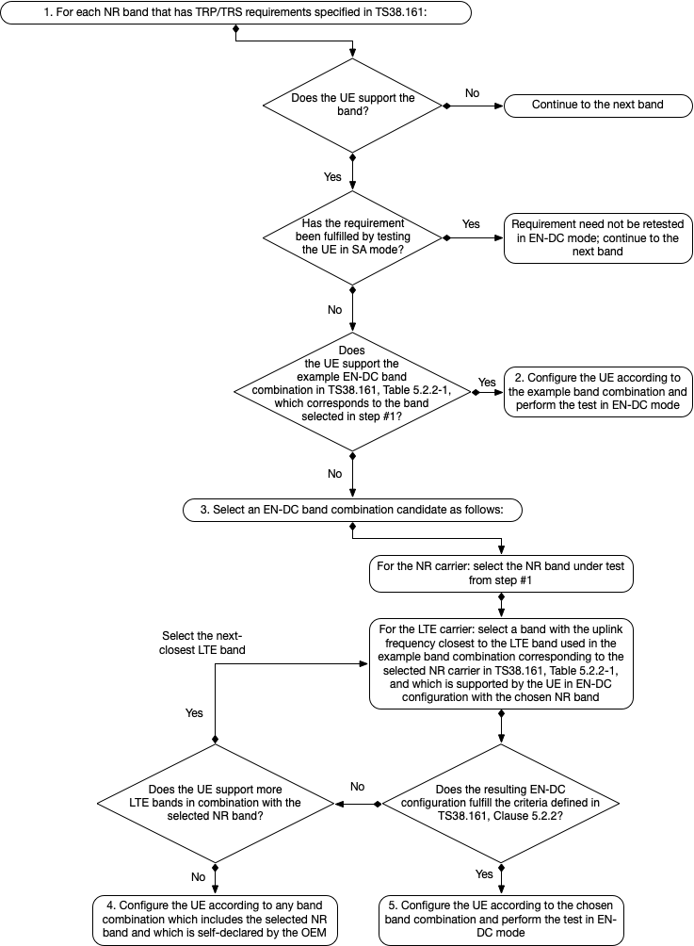

Figure 5.2.2-1: Decision tree to select the EN-DC band combination for TRP/TRS testing

< end of change >