3GPP TSG-RAN WG4 Meeting # 107 R4-2309814

Incheon, 22 - 26 May, 2023

**Title:** TP for CBW and spatial uniformity test procedures in TR38.870

**Source:** EMITE, Bluetest, Huawei, HiSilicon

**Agenda item:** 8.16.2.2

**Document for:** endorsement

# Introduction

In RAN4 #106bis, WF [1] captures the following agreement. **Issue 3-1-1: spatial uniformity and verification for RC**

Agreements:

* + Endorse the procedure in Annex 1 of R4-2305906, also listed in the annex part of this WF. Formal TP is needed next meeting. Further supplementary details might be needed.

**Issue 3-1-3: Test procedure to verify Coherence bandwidth of RC**

Proposal:

* + Endorse the procedure in Annex 2 of R4-2305906, also listed in the annex part of this WF. Formal TP is needed next meeting. Further supplementary details might be needed.

This contribution provides the text proposals for TR 38.870 based on the annex 1 and 2 of R4-2305906 [2].

# Discussion

Annex in this contribution contains text proposal for TR 38.870. The text proposals for spatial uniformity and coherence bandwidth test procedures are agreed in RAN4 #106bis according to the WF [1] and captured in R4-2305906 [2] with illustrations and modifications to improve clarity, also a correction on degree of freedom in expanded uncertainty.

**Proposal**: approve the text proposal in Annex of R4-2307247.

# Conclusions

This contribution makes the following proposal.

**Proposal**: approve the text proposal in Annex of R4-230xxxx.

# References

1. R4-2305904 WF for Rel-18 TRP/TRS requirements
2. R4-2305906 Proposals for spatial uniformity and CBW test procedures in RC

**Annex** TP for spatial uniformity and coherence bandwidth test procedures in TR 38.870

<<< START OF CHANGE >>>

# 2 References

The following documents contain provisions which, through reference in this text, constitute provisions of the present document.

- References are either specific (identified by date of publication, edition number, version number, etc.) or non‑specific.

- For a specific reference, subsequent revisions do not apply.

- For a non-specific reference, the latest version applies. In the case of a reference to a 3GPP document (including a GSM document), a non-specific reference implicitly refers to the latest version of that document in the same Release as the present document.

[1] 3GPP TR 21.905: "Vocabulary for 3GPP Specifications".

[2] 3GPP TR 38.827: “Study on radiated metrics and test methodology for the verification of multi-antenna reception performance of NR User Equipment (UE)”.

[3] 3GPP TS 38.101-1: “NR; User Equipment (UE) radio transmission and reception; Part 1: Range 1 Standalone”.

[4] 3GPP TS 38.101-3: “NR; User Equipment (UE) radio transmission and reception; Part 3: Range 1 and Range 2 Interworking operation with other radios”.

[5] 3GPP TS 38.521-1: “NR; User Equipment (UE) conformance specification; Radio transmission and reception; Part 1: Range 1 Standalone”.

[6] 3GPP TS 38.521-3: “NR; User Equipment (UE) conformance specification; Radio transmission and reception; Part 3: Range 1 and Range 2 Interworking operation with other radios”.

[7] 3GPP TS 38.508-1: “5GS; User Equipment (UE) conformance specification; Part 1: Common test environment “.

[8] 3GPP TR 25.914: “Measurements of radio performances for UMTS terminals in speech mode”.

[9] IEEE Std 149: “IEEE Standard Test Procedures for Antennas”, IEEE.

[10] JCGM 100:2008: “Evaluation of measurement data — Guide to the expression of uncertainty in measurement”.

[11] ETSI TR 102 273-1-1: “Electromagnetic compatibility and Radio spectrum Matters (ERM); Improvement on Radiated Methods of Measurement (using test site) and evaluation of the corresponding measurement uncertainties; Part 1: Uncertainties in the measurement of mobile radio equipment characteristics; Sub-part 1: Introduction”.

[12] ETSI TR 100 028-2: “ElectroMagnetic Compatibility and Radio Spectrum Matters (ERM); Uncertainties in the measurement of mobile radio equipment characteristics; Part 2”.

[13] ETSI TR 102 273-1-2: “Electromagnetic compatibility and Radio spectrum Matters (ERM); Improvement on Radiated Methods of Measurement (using test site) and evaluation of the corresponding measurement uncertainties; Part 1: Uncertainties in the measurement of mobile radio equipment characteristics; Sub-part 2: Examples and annexes”.

[14] CTIA Certification™ OTA Test Plan: “CTIA Certification Test Plan for Wireless Device Over-the-Air Performance, Version 3.9.X “, <https://ctiacertification.org/test-plans/>

[15] Foegelle, M.D., “The Surface Standard Deviation Method for TRP Measurement Uncertainty”, 25th Proceedings of the Antenna Measurement Techniques Association (AMTA 2003), A03-027

[16] 3GPP TR 37.902: “Measurements of User Equipment (UE) radio performances for LTE/UMTS terminals; Total Radiated Power (TRP) and Total Radiated Sensitivity (TRS) test “.

[17] 3GPP TS 37.544: “Universal Terrestrial Radio Access (UTRA) and Evolved Universal Terrestrial Radio Access (E-UTRA); User Equipment (UE) Over The Air (OTA) performance; Conformance testing “.

[18] 3GPP TR 37.941: “Radio Frequency (RF) conformance testing background for radiated Base Station (BS) requirements”

[19] 3GPP TR 38.810: “Study on test methods”

[20] 3GPP TR 38.903, “Derivation of test tolerances and measurement uncertainty for User Equipment (UE) conformance test cases”

[21] “Reverberation Chamber Metrology for Wireless Internet of Things Devices”, Anouk Hubrechsen, Kate A. Remley and Sara Catteau, IEEE Microwave Magazine, February 2022, pp.75-85

[22] “Proximity and antenna orientation effects for large-form-factor devices in a reverberation chamber” Willem T. C. Burger, Kate A. Remley, Christopher L. Holloway, John M. Ladbury, 2013 IEEE International Symposium on Electromagnetic Compatibility, pp.671-676

[23] “A Significance Test for Reverberation-Chamber Measurement Uncertainty in Total Radiated Power of Wireless Devices”, Kate A. Remley, Chih-Ming Jack Wang, Dylan F. Williams, Johannes J. aan den Toorn and Christopher L. Holloway, IEEE TRANSACTIONS ON ELECTROMAGNETIC COMPATIBILITY, VOL. 58, NO. 1, FEBRUARY 2016, pp.207-219

[24] 3GPP TR 38.834: “Measurements of User Equipment (UE) Over-the-Air (OTA) performance for NR FR1; Total Radiated Power (TRP) and Total Radiated Sensitivity (TRS) test methodology (Release 17)”

<<< END OF CHANGE >>>

<<< Skip unchanged sections >>>

<<< START OF CHANGE >>>

### 8.3.2 Chamber loading for coherence bandwidth

The reverberation chamber can be loaded to control the power delay profile or coherence bandwidth in the chamber. However, the reverberation chamber should not be loaded to such an extent that the mode statistics in the chamber are impaired. It is important to keep the same loss profile in the chamber during calibration, measurement and test, in order not to change the average power transfer function between these two cases. Examples of lossy objects are blocks of RF absorber, head and hand phantoms. The configuration should be calculated to achieve a minimum coherence bandwidth of [5 times the subcarrier spacing].

#### 8.3.2.1 Coherence bandwidth calculation

The coherence bandwidth (CBW) is a metric to determine the correlation in frequency within a working volume of a reverberation chamber (RC). To measure CBW, one should calculate the complex autocorrelation of the transmission parameter ($S_{21}$) for each mode-stirred sample over a minimum [100] MHz bandwidth, as follows [21]:

 (1)

Where represents the normalized correlation function at the $i^{th}$ frequency step and the $n^{th}$ mode stirring sample. S21 (fj, n) represents the measured complex S21 at the frequency step fj with [P] frequency points measured within a given bandwidth (BW) such that and $f_{P}=f_{c}+(\frac{BW}{2}$). The symbol * represents the complex conjugation acting on this parameter. n is the mode stirring sample index with a total number equal to [N].

 is the frequency offset index with a frequency resolution of, i.e., $Δf=i \frac{f_{P}-f_{1}}{P-1 }$, and $-\left(P-1\right)≤i ≤\left(P-1\right)$ [21].

The test points could be the same as in step (a) given in Section 8.3.3 namely, T=12 for chambers with a turntable or T=24 for chambers without a turntable.

To measure CBW, follow these steps:

1. Select the center frequency fc and BW. A typical measurement frequency range of min[100] MHz channel bandwidth is used as the default.
2. Determine the number of measurement points P with respect to frequency.
3. Determine the total number of stirring sequence N.
4. Measure the S-parameters, specifically $S_{21}$ and calculate the correlation function using equation (1).
5. Average the autocorrelation functions R(i, n) over all mode stirring sequence (i.e. index n) at each frequency point (i.e., index i).
6. Identify the coherence bandwidth corresponding to a value of [0.5] in autocorrelation function R(i, n), as shown in Figure 1.
7. Steps (a) through (f) may be repeated for different chamber loading configurations, e.g., using absorbers or similar materials, to meet specific coherence bandwidth requirements.
8. 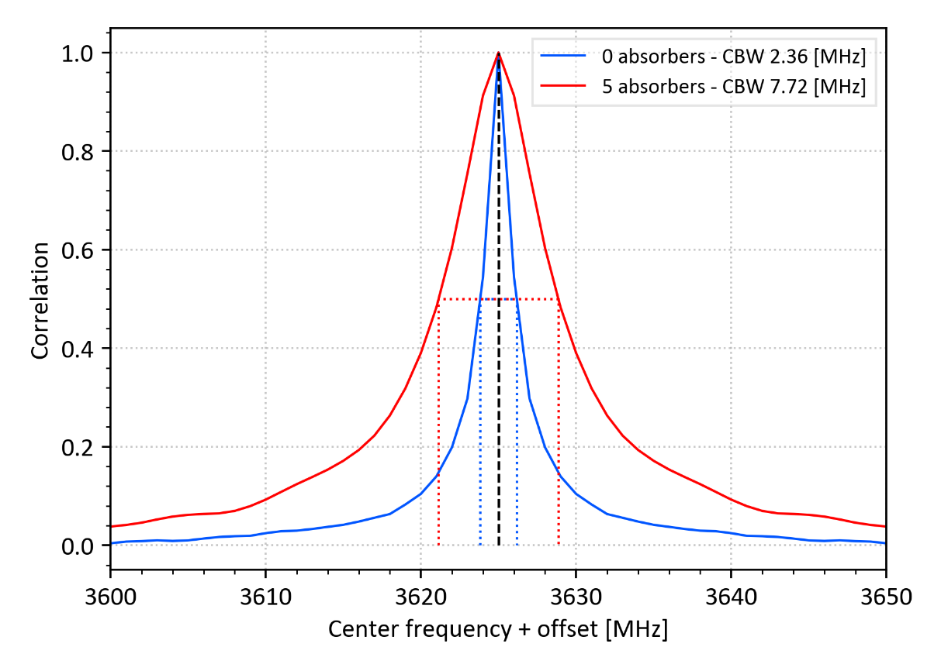

Figure 1: The CBW plots based on the correlation function for loading with two different amounts of RF absorbers in the chamber. The threshold of 0.5 is chosen as shown by the dotted lines.

### 

### 8.3.3 Chamber spatial uniformity

The reverberation chamber shall have a working volume large enough to support the number of modes needed for the stated accuracy at the lowest operating frequency. The spatial uniformity test defines this working volume as the valid test zone of the chamber which must be large enough to contain the entire DUT plus any test scenario elements such as phantom fixtures. If DUT size is not known at the time of chamber validation, the minimum test zones described in the reference method [24] of 30cm x 30cm or 50cm x 36cm can be used in order to enable the same device size applicability. The test positions T describing this working volume need to maintain the same distance requirements as the calibration antennas throughout the procedure, i.e. reference antenna or DUT shall maintain a distance of more than 0.7 wavelengths from chamber loading and more than 0.5 wavelengths from reflective surfaces.

The value of the uncertainty contribution is determined by repeated calibration measurements for $T$ different positions and orientations of the calibration antenna to determine the statistical variation as a function of frequency, or at least at the frequencies at which the chamber is to be used. It can be assumed that this uncertainty contribution value is normally distributed.

The T calibration configurations refer to T reference antenna positions. The operator should select these positions depending on whether or not a turntable is present in the chamber. The following instructions and explanation will assist the operator to perform the measurements.

* If there is a turntable in the RC:
  + Assume a cylindrical working volume by selecting two positions on the turntable (the outermost and innermost radial positions of the turntable are recommended). Then select two elevations (the highest and lowest possible are recommended, but far enough away from absorbent and metallic objects, if any). The cylindrical volume would become a toroid with rectangular cross-section if Rmin is non-zero due to proximity effects, as described in [22]. The role of the turntable is to stir the source to obtain more independent samples.
* If there is no turntable in the RC:
  + Choose eight positions as corners of an imaginary cubic volume. This means the recommended heights are the highest and lowest possible, but far enough away from absorbing and metallic objects.

The test steps are as follows.

1. Choose either a cylindrical or a cubic working volume if there is or is not a turntable in the reverberation chamber. As shown by the red dots in Figure 2, use either the 4 corners of the imaginary rectangle that would form the cylindrical working volume or the 8 corners of the cubic working volume as locations for the measurement. For each location, point the antenna at three different angles, preferably at three orthogonal orientations (e.g., 45 degrees, -45 degrees, and horizontal plane). This results in a number of 12 or 24 measurements i.e., T=12 or T=24.
2. Measure transmission coefficient $S_{21}$ for all 12 or 24 in a complete mode stirring sequence.
3. Calculate the power $P_{ref,t}$ for all 12 or 24 positions. In this way, $P_{ref,t}$ is the reference power transfer function for position $t$ of the calibration antenna.
4. Calculate the average of power transfer function $P_{ref}$ over the calibration positions, i.e. $T=12$ or $T=24$ using the following relation:


5. Calculate the standard deviation of the power transfer function over T different calibration antenna positions by


6. Calculate $σ_{P_{ref}}$ in dB by


7. Repeat steps (a) through (e) for at least [25] frequency points evenly distributed across the NR FR1 bands.
8. Steps (a) through (e) are repeated for various chamber loading configurations, e.g. using absorbers or similar materials, to meet specific coherence bandwidth requirements

(Rmin, Zmin)

(Rmax, Zmin)

(Rmin, Zmax)

(Rmax, Zmax)

1. (b)

Figure 2: Illustration of a working volume with (a) for cylindrical and (b) for cubic volumes.

<<< END OF CHANGE >>>