**3GPP TSG-RAN WG4 Meeting # 107 R4-2310451**

**Incheon, KR, May 22nd – May 26th , 2023**

**Agenda item:** 8.29.7

**Source:** Moderator (CATT)

**Title:** Topic summary for [107][313] NR_netcon_repeater_RFConformance

**Document for:** Information

# Introduction

This contribution is the summary for the topic [313] NR_netcon_repeater_RFConformance. I covers the contributions in AI 8.29.4.

# Topic #1: General

## Companies’ contributions summary

|  |  |  |
| --- | --- | --- |
| **T-doc number** | **Company** | **Proposals / Observations** |
| R4-2308524 | Ericsson | Observation 1 Attempting to test the FWD and MT simultaneously in DL may not work, since the input power levels needed to test FWD are likely to differ to MT.  Observation 2 If separate BS side and UE side types are allowed, then there is a need for conformance specifications for mixed conducted input / radiated output.  Observation 3 Different types on BS side and UE side would impact MU.  Proposal 1 For downlink, test NCR-MT RX requirements and NCR-FWD requirements separately.  Proposal 2 Develop both separate and joint test conditions for NCR-FWD and NCR-MT for UL  Proposal 3 If NCR type is declared separately, it should be declared for BS side and UE side separately, not for DL and UL directions separately.  Proposal 4 RAN4 to discuss whether 1 or 2 new conformance specifications are needed in case different types on BS side and UE side are allowed. |

## Open issues summary

### Sub-topic 1-1

**Issue 1-1: Downlink test for NCR-MT and NCR-Fwd**

* Proposals
  + Proposals in R4-2308524 (Ericsson):
    - Proposal 1: For downlink, test NCR-MT RX requirements and NCR-FWD requirements separately.
    - Proposal 2: Develop both separate and joint test conditions for NCR-FWD and NCR-MT for UL
* Recommended WF
  + Discuss the above proposals in the meeting

### Sub-topic 1-2

**Issue 1-2: NCR type declaration**

* Proposals
  + Proposals in R4-2308524 (Ericsson):
    - Proposal 3: If NCR type is declared separately, it should be declared for BS side and UE side separately, not for DL and UL directions separately.
    - Proposal 4: RAN4 to discuss whether 1 or 2 new conformance specifications are needed in case different types on BS side and UE side are allowed.
* Recommended WF
  + Discuss the above proposals in the meeting

# Topic #2: Manufacturer declarations

## Companies’ contributions summary

|  |  |  |
| --- | --- | --- |
| **T-doc number** | **Company** | **Proposals / Observations** |
| R4-2307385 | CATT | Proposal 1: For NCR type 1-H, 1-O and 2-O Fwd radiated requirements, the existing manufacturer declarations for repeater type 2-O in TS 38.115-2 can be reused.  Proposal 2: For NCR type 1-H, 1-O and 2-O MT radiated requirements, the existing manufacturer declarations for IAB-MT type 1-H, 1-O and 2-O in TS 38.176-2 can be reused. |

## Open issues summary

### Sub-topic 2-1

**Issue 2-1: NCR-Fwd manufacturer declarations**

* Proposals
  + Proposal in R4-2307385 (CATT)
    - Proposal 1: For NCR type 1-H, 1-O and 2-O Fwd radiated requirements, the existing manufacturer declarations for repeater type 2-O in TS 38.115-2 can be reused.
* Recommended WF
  + Discuss the above proposal in the meeting

### Sub-topic 2-2

**Issue 2-2: NCR-MT manufacturer declarations**

* Proposals
  + Proposal in R4-2307385 (CATT)
    - Proposal 2: For NCR type 1-H, 1-O and 2-O MT radiated requirements, the existing manufacturer declarations for IAB-MT type 1-H, 1-O and 2-O in TS 38.176-2 can be reused.
* Recommended WF
  + Discuss the above proposal in the meeting

# Topic #3: Test model

## Companies’ contributions summary

|  |  |  |
| --- | --- | --- |
| **T-doc number** | **Company** | **Proposals / Observations** |
| R4-2309191 | ZTE Corporation | **Proposal 1**: for test model for NCR-MT, propose to use the Rel-16 IAB-MT test model as baseline. |

## Open issues summary

### Sub-topic 3-1

**Issue 3-1: NCR-MT test model**

* Proposals
  + Proposal in R4-2309191 (ZTE)
    - **Proposal 1**: for test model for NCR-MT, propose to use the Rel-16 IAB-MT test model as baseline.
* Recommended WF
  + Discuss the above proposal in the meeting

# Topic #4: Measurement setup

## Companies’ contributions summary

|  |  |  |
| --- | --- | --- |
| **T-doc number** | **Company** | **Proposals / Observations** |
| R4-2309191 | ZTE Corporation | **Proposal 2**: for the measurement setup of Input IMD and output IMD of NCR-Fwd type 1-O, propose to consider the following measurement setup for it.  CB820F8A  Figure 1. measurement setup for Input IMD requirement of FR1 NCR-Fwd type 1-O  E2BB4028  Figure 2. measurement setup for output IMD requirement of FR1 NCR-Fwd type 1-O  **Proposal 3**: propose to use the existing measurement setup for Rel-16 IAB-MT as baseline for NCR-MT measurement setup and further consider the joint conformance testing setup for emission related requirement if necessary. |
| R4-2309454 | Keysight Technologies UK Ltd | **Observation**   * Comparing Rel-17 repeater and NC Repeater, difference is existence of C-link.   **Proposal-1**   * For conformance testing, because C-link by itself is not tested for RF conformance, we would like to propose method to provide necessary control for NC repeater to be left for test system implementation.   **Proposal-2**   * Add note text to clarify this point in Measurement system setup-up annex. Following as text to propose.   “Note: Necessary control to Repeater under test can be provided by C-Link or any other method including cable connection.” |

## Open issues summary

### Sub-topic 4-1

**Issue 4-1: Measurement setup of Input IMD and output IMD of NCR-Fwd type 1-O**

* Proposals
  + Proposal in R4-2309191 (ZTE)
    - **Proposal 2**: for the measurement setup of Input IMD and output IMD of NCR-Fwd type 1-O, propose to consider the following measurement setup for it.
* 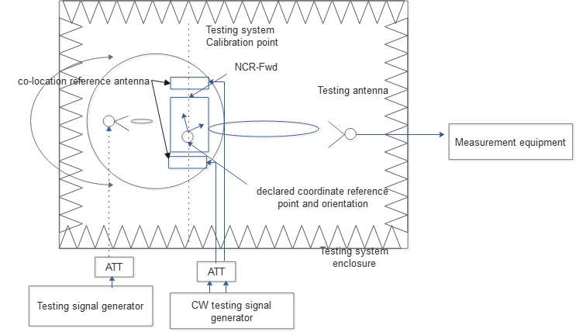
* Figure 1. measurement setup for Input IMD requirement of FR1 NCR-Fwd type 1-O
* 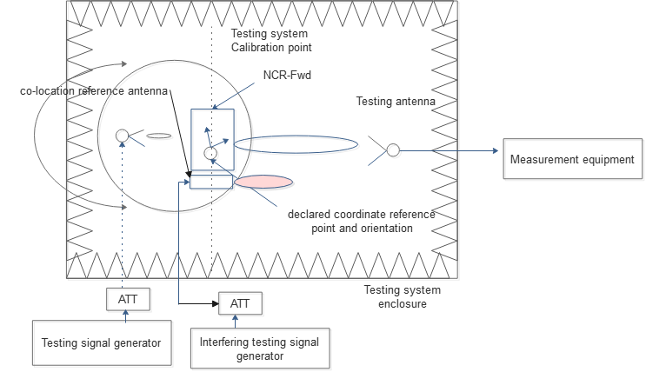
* Figure 2. measurement setup for output IMD requirement of FR1 NCR-Fwd type 1-O
* Recommended WF
  + Discuss the above proposal in the meeting

### Sub-topic 4-2

**Issue 4-2: NCR-MT measurement setup**

* Proposals
  + Proposal in R4-2309191 (ZTE)
    - **Proposal 3**: propose to use the existing measurement setup for Rel-16 IAB-MT as baseline for NCR-MT measurement setup and further consider the joint conformance testing setup for emission related requirement if necessary.
* Recommended WF
  + Discuss the above proposal in the meeting

### Sub-topic 4-3

**Issue 4-3: How to provide the necessary control for NCR Fwd**

* Proposals
  + Observation and proposals in R4-2309454 (Keysignt)
    - Observation: Comparing Rel-17 repeater and NC repeater, difference is existence of C-link.
    - Proposal-1: For conformance testing, because C-link by itself is not tested for RF conformance, we would like to propose method to provide necessary control for NC repeater to be left for test system implementation.
    - Proposal-2: Add note text to clarify this point in Measurement system setup-up annex. Following as text to propose.

“Note: Necessary control to Repeater under test can be provided by C-Link or any other method including cable connection.”

* Recommended WF
  + Discuss the above proposals in the meeting

# Topic #5: Detail proposals for test

## Companies’ contributions summary

|  |  |  |
| --- | --- | --- |
| **T-doc number** | **Company** | **Proposals / Observations** |
| R4-2308627 | Nokia, Nokia Shanghai Bell | **Observation 1: NCR-MT REFSENS requirement need to define new tests in the conformance conducted and radiated test specifications (TS 38.115-1, TS 38.115-2), including the test configurations, test models and test procedures to be applied during the conformance testing.**  **Observation 2: In Rel-17 test configuration one repeater carrier is placed at each edge of each passband in the test configurations for a conventional RF repeater under test, but NCR-MT carrier does not exist in the current test configurations.**  Proposal 1: It is proposed that conformance testing for the REFSENS requirement of the NCR-MT receiver is perform together with ACRR and Input IMD interfering signals.  Proposal 2: It is proposed to test the REFSENS requirement of NCR-MT receiver together with ACRR interfering signals together with the DL ACRR requirements for NCR-Fwd using presented test configurations in Figure 3 and 4. |

## Open issues summary

### Sub-topic 5-1

**Issue 5-1: Potential combined test for NCR-MT REFSENS and ACRR and Input IMD**

* Proposals
  + Proposals in R4-2308627 (Nokia)
    - Proposal 1: It is proposed that conformance testing for the REFSENS requirement of the NCR-MT receiver is perform together with ACRR and Input IMD interfering signals.
    - Proposal 2: It is proposed to test the REFSENS requirement of NCR-MT receiver together with ACRR interfering signals together with the DL ACRR requirements for NCR-Fwd using presented test configurations in Figure 3 and 4.
* 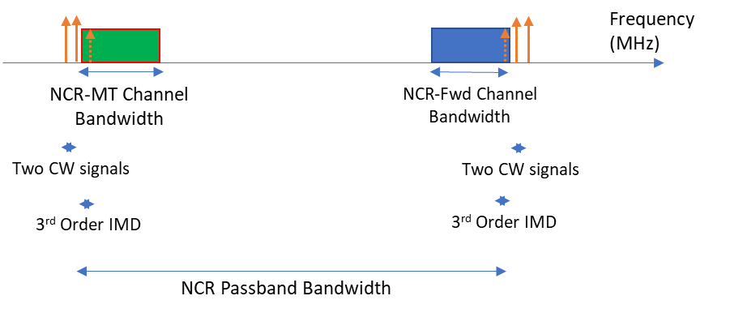
* Figure 3: Contiguous spectrum operation with input intermodulation interfering signals
* 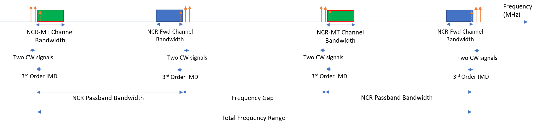
* Figure 4: Non-contiguous spectrum operation with input intermodulation interfering signals
* Recommended WF
  + Discuss the above proposals in the meeting