**3GPP TSG-RAN WG4 Meeting #** **107 R4-230xxxx**

**Incheon, KR, May 22 – May 26, 2023**

**Agenda item:** 8.29.7

**Source:** Moderator (ZTE)

**Title:** Email discussion summary for [107][312] NR_netcon_repeater_RF

**Document for:** Information

# Introduction

*Briefly introduce background, the scope of this email discussion (e.g. list of treated agenda items) and provide some guidelines for email discussion if necessary.*

*List of candidate target of email discussion for 1st round and 2nd round*

* 1st round: TBA
* 2nd round: TBA

It is appreciated that the delegates for this topic put their contact information in the table below.

Contact information

|  |  |  |
| --- | --- | --- |
| **Company** | **Name** | **Email address** |
|  |  |  |
|  |  |  |
|  |  |  |
|  |  |  |
|  |  |  |
|  |  |  |
|  |  |  |

Note:

1. Please add your contact information in above table once you make comments on this email thread.
2. If multiple delegates from the same company make comments on single email thread, please add you name as suffix after company name when make comments i.e. Company A (XX, XX)

The e-mail discussion covers RF part for NCR-fwd and NCR-MT in Rel-18 .

All contributions submitted are divided into the following Topics:

1. Study of RF core and EMC requirements

# Topic #1: System parameter and feature list

## Companies’ contributions summary

|  |  |  |
| --- | --- | --- |
| **T-doc number** | **Company** | **Proposals / Observations** |
| **[R4-2307393](https://www.3gpp.org/ftp/TSG_RAN/WG4_Radio/TSGR4_107/Docs/R4-2307393.zip)** | CATT | Discussion of NCR feature list  **Proposal 1: There’s no feature list for NCR-Fwd.**  **Proposal 2: Table 1 can be taken as a starting point for further discussion of NCR-MT feature list.** |
| **[R4-2307463](https://www.3gpp.org/ftp/TSG_RAN/WG4_Radio/TSGR4_107/Docs/R4-2307463.zip)** | Dell Technologies | Discussion on NCR feature list and class declaration  ***Proposal 1: It is suggested that there is no need to require NCR-Fwd feature list in RAN 4.***  ***Observation 1: Based on TR38.867, it is suggested NCR-MT and NCR-Fwd operating at the same frequency band (FR1orFR2) as the priority. In FR1, it can be wide/medium/local area and in FR2, it is usually local area.***  ***Proposal 2: It is suggested that, in FR1, NCR-MT, NCR-Fwd BS side and NCR-Fwd UE side class shall be declared independently whereas in FR2, the class for NCR-MT, NCR-Fwd BS side and NCR-Fwd UE side can be the same declaration.*** |
| **[R4-2307497](https://www.3gpp.org/ftp/TSG_RAN/WG4_Radio/TSGR4_107/Docs/R4-2307497.zip)** | NEC | Discussion on NCR class declaration  **Proposal 1:**  **Separate NCR class declaration for NCR-fwd BS side and NCR-fwd UE side shall be allowed.**  **Proposal 2:**  **Separate NCR class declaration for NCR-MT and NCR-fwd UE side shall be allowed.**  **Proposal 3:**  **Separate NCR class declaration for NCR-fwd BS side and NCR-MT is not required.** |
| **[R4-2307498](https://www.3gpp.org/ftp/TSG_RAN/WG4_Radio/TSGR4_107/Docs/R4-2307498.zip)** | NEC | Discussion on RF diagram for NCR  **Proposal 1**: Agree to use the figures 1-3 as the RF diagrams for NCR.    Figure 1: NCR type 1-C Figure 2: NCR type 1-H    Figure 3: NCR type 1-O and NCR type 2-O |
| **[R4-2308204](https://www.3gpp.org/ftp/TSG_RAN/WG4_Radio/TSGR4_107/Docs/R4-2308204.zip)** | CMCC | discussion on NCR MT feature list  **Observation 1: summary of all R15 UE features:**   * **Following are mandatory feature without capability signaling** * **64 QAM, 256 QAM and pi/2-BPSK related, i.e. index 1-2, 1-3, 1-4, 1-6, 1-7** * **7.5kHz UL raster shift, i.e. index 1-11** * **Max CBW, i.e. index 2-1** * **Band combination related, i.e.**    + **index 2-2 Simultaneous reception or transmission with same or different numerologies in CA,**   + **index 2-3 Non-contiguous intra-band CA frequency separation class for FR2,**   + **2-4, 2-5, 2-9 Simultaneous reception and transmission,**   + **2-16, 2-17 PA architectures** * **UE power class, i.e. index 2-8** * **Multiple frequency band indication, i.e. index 2-10** * **Multiple NS/P-Max, i.e. index 2-12**   **Proposal 1: it’s suggested to discuss whether 256 QAM, 64 QAM and pi/2 BPSK modulation scheme are mandatory or not for NCR-MT before concluding related feature. Our suggestion is as below**   * + 64 QAM mandatory for both FR1 and FR2 UL and DL   + 256QAM mandatory for FR1 DL, optional for FR1 UL and FR2 UL and DL   + pi/2 BPSK optional for FR1 and mandatory for FR2   + Power boosting for Pi/2 BPSK NCR-MT is optional, the same as UE   **proposal 2: 7.5kHz raster shift, multiple frequency band indication and Multiple NS/P-max are mandatory for NCR-MT**  **proposal 3: max CBW is optional for NCR-MT**  **proposal 4: it’s suggested to figure out whether NCR-MT could support band combinations or only support single carrier in this release. If NCR-MT support band-combinations, the same feature as UE except for max duty cycle related feature which need further check**  **proposal 5: UE power class feature wait for conclusion of NCR-MT power class/class definition.**  **Proposal 6: if MPR requirements are defined for NCR-MT, then Modified MPR behaviour is still optional for NCR-MT, otherwise, such feature is not applicable**  **Proposal 7: max duty cycle related feature are not applicable for NCR-MT.**  **Observation 2: summary of all R16 UE features:**   * **There is only one mandatory feature, i.e. feature index 8-5 Inter-band DL CA(FR2) to report supported beam management type in TR 38.822, all other feature are optional.** * **Features could be categorized as below**   + **Band combination related, including dynamic Tx switching related feature, NR CA related feature, e.g. DC location, CA class, Non-contiguous intra-band DL CA (index 8-4) , Inter-band DL CA (index 8-5) and EN-DC related, e.g. max duty cycle index 2-18 and 2-20**   + **Transient period, i.e. index 7-4**   + **MPE, i.e. index 8-1 P-MPR reporting**   + **MPR Enhancement, i.e. index 8-6**   + **Beam correspondence related, i.e. SSB based Beam correspondence (index 8-2), CSI-RS based Beam correspondence (index 8-3)**   + **Transparent Tx Diversity, i.e. index 2-21**   **Proposal 8: beam correspondence related feature is not applicable for NCR-MT. except for beam correspondence feature, all other optional R16 feature are also optional for NCR-MT.**  **Observation 3: all R17 UE RF features are band combination related feature and all are optional.** |
| **[R4-2308523](https://www.3gpp.org/ftp/TSG_RAN/WG4_Radio/TSGR4_107/Docs/R4-2308523.zip)** | Ericsson | NCR System parameters   1. It likely does not make sense to allow different type declarations for DL and UL directions 2. If different type declarations are made for the UE side and BS side, then new conformance test cases arise with mixed conducted / radiated testing. 3. New conformance testing cases would need thought how to capture in the conformance specifications, and whether new specifications would be needed. 4. Aspects such as MU and declarations would be impacted by differing UE/BS side repeater types. 5. RAN4 discuss the real benefit of allowing different types vs. the specification complexity |
| **[R4-2308622](https://www.3gpp.org/ftp/TSG_RAN/WG4_Radio/TSGR4_107/Docs/R4-2308622.zip)** | Nokia, Nokia Shanghai Bell | Discussion on system parameters for NCR  **Observation 1:** As MT operation is introduced to NCR, the NCR-MT channel bandwidth it could be defined similarly to the TS 38.174 [3] specification. NCR-MT channel bandwidth: RF bandwidth supporting a single NCR-MT RF carrier with the *transmission bandwidth* configured in the uplink or downlink.  Proposal 1: is to define the NCR-MT channel bandwidth according to the IAB-MT channel definition of TS 38.174.  **Observation 2:** RAN1 has endorsed the initial feature list for NCR [5]. RAN1 will further define a separate UE capability will be used to indicate support for access link beam index updates or if the capability will be merged with the semi-persistent beam indication capability.  Proposal 2: The feature list annexed [6], with forthcoming changes, is considered sufficient to meet RAN4 requirements. |
| **[R4-2308623](https://www.3gpp.org/ftp/TSG_RAN/WG4_Radio/TSGR4_107/Docs/R4-2308623.zip)** | Nokia, Nokia Shanghai Bell | Discussion on other issues related to NCR  **Observation 1:** Composite antenna can be common part for NCR-MT and NCR-Fwd on the BS-side of NCR type 1-H, type 1-O and 2-O.  Proposal 1: The RF diagrams for NCR shown in Figures 1-3 are proposed to be considered for further discussion.  **Observation 2:** . The NCR-Fwd and NCR-MT parts are part of the same device. NCR-Fwd and NCR-MT may have their own requirements and parameters to declare, but in practice it makes sense to declare them together.  Proposal 2: C-link and backhaul/access link operate both in-band and multiplexed over the same physical resources thus NCR class do not need be declared separately. NCR class can be declared together for NCR-Fwd and NCR-MT. |
| **[R4-2309186](https://www.3gpp.org/ftp/TSG_RAN/WG4_Radio/TSGR4_107/Docs/R4-2309186.zip)** | ZTE Corporation | Discussion on system parameter for NCR-MT  **Proposal 1:** to set the channel bandwidth per operating band to be optional for NCR-MT and send the LS to RAN2. |
| **[R4-2309187](https://www.3gpp.org/ftp/TSG_RAN/WG4_Radio/TSGR4_107/Docs/R4-2309187.zip)** | ZTE Corporation | Discussion on RAN4 feature list for NCR-MT |
| **[R4-2309188](https://www.3gpp.org/ftp/TSG_RAN/WG4_Radio/TSGR4_107/Docs/R4-2309187.zip)** | ZTE Corporation | Discussion on RF diagram for NCR |
| **[R4-2308397](https://www.3gpp.org/ftp/TSG_RAN/WG4_Radio/TSGR4_107/Docs/R4-2308397.zip)** | NTT DOCOMO, INC. | Discussion on NCR type and class declaration  **Observation 1: Separate declaration for NCR type and class at MT, BS side and UE side can be effective for for flexible coverage expansion.**  **Proposal 1: NCR type should be declared separately for MT, BS side and UE side.**  **Proposal 2: If UL Rx emissions can be separated from DL Tx emissions and vice versa in OTA measurements, the specific requirement of Rx spurious emission is necessary** **even though NCR include NCR type 1-O.** |

## Open issues summary

*Before e-Meeting, moderators shall summarize list of open issues, candidate options and possible WF (if applicable) based on companies’ contributions.*

### Sub-topic 1-1 System parameter for NCR-MT

*Sub-topic description:*

*Open issues and candidate options before e-meeting:*

**Issue 1-1: System parameter for NCR-MT**

* + Proposal 1: is to define the NCR-MT channel bandwidth according to the IAB-MT channel definition of TS 38.174. [Nokia, [R4-2308622](https://www.3gpp.org/ftp/TSG_RAN/WG4_Radio/TSGR4_107/Docs/R4-2308622.zip)]
  + Proposal 2: to set the channel bandwidth per operating band to be optional for NCR-MT and send the LS to RAN2. [ZTE,[R4-2309186](https://www.3gpp.org/ftp/TSG_RAN/WG4_Radio/TSGR4_107/Docs/R4-2309186.zip)]
* Recommend WF
  + Agree with proposal 1;
  + Further discuss the LS to RAN2.

### Sub-topic 1-2 NCR-MT feature list

*Sub-topic description:*

*Open issues and candidate options before e-meeting:*

**Issue 1-2: NCR-MT feature list**

* Proposals
  + Proposal 1: The feature list annexed [6], with forthcoming changes, is considered sufficient to meet RAN4 requirements.[Nokia, [R4-2308622](https://www.3gpp.org/ftp/TSG_RAN/WG4_Radio/TSGR4_107/Docs/R4-2308622.zip)]
  + Proposal 1: not to define feature list for NCR-Fwd part; [ZTE,[R4-2309187](https://www.3gpp.org/ftp/TSG_RAN/WG4_Radio/TSGR4_107/Docs/R4-2309187.zip)]
  + Proposal 2: to further discuss the feature list for NCR-MT as proposed in section 3,4 and 5. [ZTE,[R4-2309187](https://www.3gpp.org/ftp/TSG_RAN/WG4_Radio/TSGR4_107/Docs/R4-2309187.zip)]
  + Proposal 3: There’s no feature list for NCR-Fwd. [CATT,[R4-2307393](https://www.3gpp.org/ftp/TSG_RAN/WG4_Radio/TSGR4_107/Docs/R4-2307393.zip)]
  + Proposal 4: Table 1 can be taken as a starting point for further discussion of NCR-MT feature list. [CATT,[R4-2307393](https://www.3gpp.org/ftp/TSG_RAN/WG4_Radio/TSGR4_107/Docs/R4-2307393.zip)]
  + Proposal 5: It is suggested that there is no need to require NCR-Fwd feature list in RAN 4. [Dell,[R4-2307463](https://www.3gpp.org/ftp/TSG_RAN/WG4_Radio/TSGR4_107/Docs/R4-2307463.zip)]
  + Proposal 6: it’s suggested to discuss whether 256 QAM, 64 QAM and pi/2 BPSK modulation scheme are mandatory or not for NCR-MT before concluding related feature. Our suggestion is as below [CMCC,[R4-2308204](https://www.3gpp.org/ftp/TSG_RAN/WG4_Radio/TSGR4_107/Docs/R4-2308204.zip)]
  + 64 QAM mandatory for both FR1 and FR2 UL and DL
  + 256QAM mandatory for FR1 DL, optional for FR1 UL and FR2 UL and DL
  + pi/2 BPSK optional for FR1 and mandatory for FR2
  + Power boosting for Pi/2 BPSK NCR-MT is optional, the same as UE
  + Proposal 7: 7.5kHz raster shift, multiple frequency band indication and Multiple NS/P-max are mandatory for NCR-MT [CMCC,[R4-2308204](https://www.3gpp.org/ftp/TSG_RAN/WG4_Radio/TSGR4_107/Docs/R4-2308204.zip)]
  + Proposal 8: max CBW is optional for NCR-MT [CMCC,[R4-2308204](https://www.3gpp.org/ftp/TSG_RAN/WG4_Radio/TSGR4_107/Docs/R4-2308204.zip)]
  + Proposal 9: it’s suggested to figure out whether NCR-MT could support band combinations or only support single carrier in this release. If NCR-MT support band-combinations, the same feature as UE except for max duty cycle related feature which need further check [CMCC,[R4-2308204](https://www.3gpp.org/ftp/TSG_RAN/WG4_Radio/TSGR4_107/Docs/R4-2308204.zip)]
  + Proposal 10: UE power class feature wait for conclusion of NCR-MT power class/class definition. [CMCC,[R4-2308204](https://www.3gpp.org/ftp/TSG_RAN/WG4_Radio/TSGR4_107/Docs/R4-2308204.zip)]
  + Proposal 11: if MPR requirements are defined for NCR-MT, then Modified MPR behaviour is still optional for NCR-MT, otherwise, such feature is not applicable [CMCC,[R4-2308204](https://www.3gpp.org/ftp/TSG_RAN/WG4_Radio/TSGR4_107/Docs/R4-2308204.zip)]
  + Proposal 12: max duty cycle related feature are not applicable for NCR-MT. [CMCC,[R4-2308204](https://www.3gpp.org/ftp/TSG_RAN/WG4_Radio/TSGR4_107/Docs/R4-2308204.zip)]
  + Proposal 13: beam correspondence related feature is not applicable for NCR-MT. except for beam correspondence feature, all other optional R16 feature are also optional for NCR-MT. [CMCC,[R4-2308204](https://www.3gpp.org/ftp/TSG_RAN/WG4_Radio/TSGR4_107/Docs/R4-2308204.zip)]
  + Proposal 14: The feature list annexed [6], with forthcoming changes, is considered sufficient to meet RAN4 requirements.[Nokia, [R4-2308622](https://www.3gpp.org/ftp/TSG_RAN/WG4_Radio/TSGR4_107/Docs/R4-2308622.zip)]
* Recommend
  + Companies’ views are encouraged during the meeting.
  + Moderator will provide the summarized proposals in the excel sheet or tdoc for the proposal comparison from companies.

### Sub-topic 1-3 NCR types and class Declarations for NCR-MT and NCR-Fwd

*Sub-topic description:*

*Open issues and candidate options before e-meeting:*

**Issue 1-3-1: Types declaration for NCR**

* Proposals
  + Proposal 1: RAN4 discuss the real benefit of allowing different types vs. the specification complexity [Ericsson, [R4-2308523](https://www.3gpp.org/ftp/TSG_RAN/WG4_Radio/TSGR4_107/Docs/R4-2308523.zip)]
  + Proposal 2: propose to add the clarification note in the specification to allow the combination of different NCR-MT and NCR-Fwd types. [ZTE R4-2309188]

NOTE 1: the combinations between different NCR-MT, NCR-Fwd types are not precluded by the specification.

* + Proposal 3: NCR type should be declared separately for MT, BS side and UE side. []
* Recommend WF
  + Companies’ views are encouraged during the meeting.

**Issue 1-3-2: Class declarations for NCR**

* Proposals
  + Proposal 1: It is suggested that, in FR1, NCR-MT, NCR-Fwd BS side and NCR-Fwd UE side class shall be declared independently whereas in FR2, the class for NCR-MT, NCR-Fwd BS side and NCR-Fwd UE side can be the same declaration. [Dell,[R4-2307463](https://www.3gpp.org/ftp/TSG_RAN/WG4_Radio/TSGR4_107/Docs/R4-2307463.zip)]
  + Proposal 2:Separate NCR class declaration for NCR-fwd BS side and NCR-fwd UE side shall be allowed. [NEC,[R4-2307497](https://www.3gpp.org/ftp/TSG_RAN/WG4_Radio/TSGR4_107/Docs/R4-2307497.zip)]
  + Proposal 3: Separate NCR class declaration for NCR-MT and NCR-fwd UE side shall be allowed. [NEC,[R4-2307497](https://www.3gpp.org/ftp/TSG_RAN/WG4_Radio/TSGR4_107/Docs/R4-2307497.zip)]
  + Proposal 4:Separate NCR class declaration for NCR-fwd BS side and NCR-MT is not required. [NEC,[R4-2307497](https://www.3gpp.org/ftp/TSG_RAN/WG4_Radio/TSGR4_107/Docs/R4-2307497.zip)]
  + Proposal 5: C-link and backhaul/access link operate both in-band and multiplexed over the same physical resources thus NCR class do not need be declared separately. NCR class can be declared together for NCR-Fwd and NCR-MT.[Nokia,[R4-2308623](https://www.3gpp.org/ftp/TSG_RAN/WG4_Radio/TSGR4_107/Docs/R4-2308623.zip)]
  + Proposal 6: to declare single class for NCR-Fwd which is applicable for both backhual link and access link. [ZTE R4-2309188]
  + Proposal 7: to declare the separate declaration class for NCR-Fwd and NCR-MT similar as Rel-16 IAB. [ZTE R4-2309188]
  + Proposal 8: The NCR class can be declared as Wide Area NCR, Medium Range NCR, or Local Area NCR, and declarations can be made separately for Fwd UL, Fwd DL and MT. Whether NCR class for Fwd UL and NCR class for MT is same class can be left to declaration. [CATT,R4-2307383]
  + Proposal 9: NCR class can be declared separately for NCR-fwd DL, UL and NCR-MT parts. [CMCC,R4-2308202]
* Recommend WF
  + Companies’ views are encouraged during the meeting.

**Issue 1-3-3: RF diagram for NCR**

* Proposals
  + Proposal 1: to consider the RF diagram as proposed by NEC in R4-2309498.

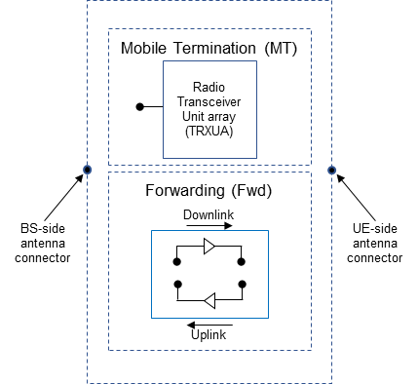 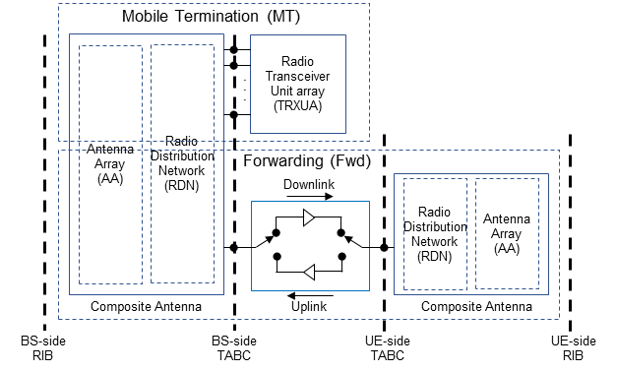

Figure 1: NCR type 1-C Figure 2: NCR type 1-H

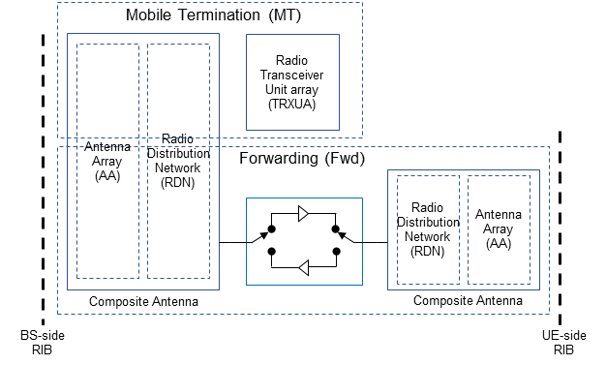

Figure 3: NCR type 1-O and NCR type 2-O

* + Proposal 2: Consider the RF diagram as proposed by Nokia in R4-2308623.

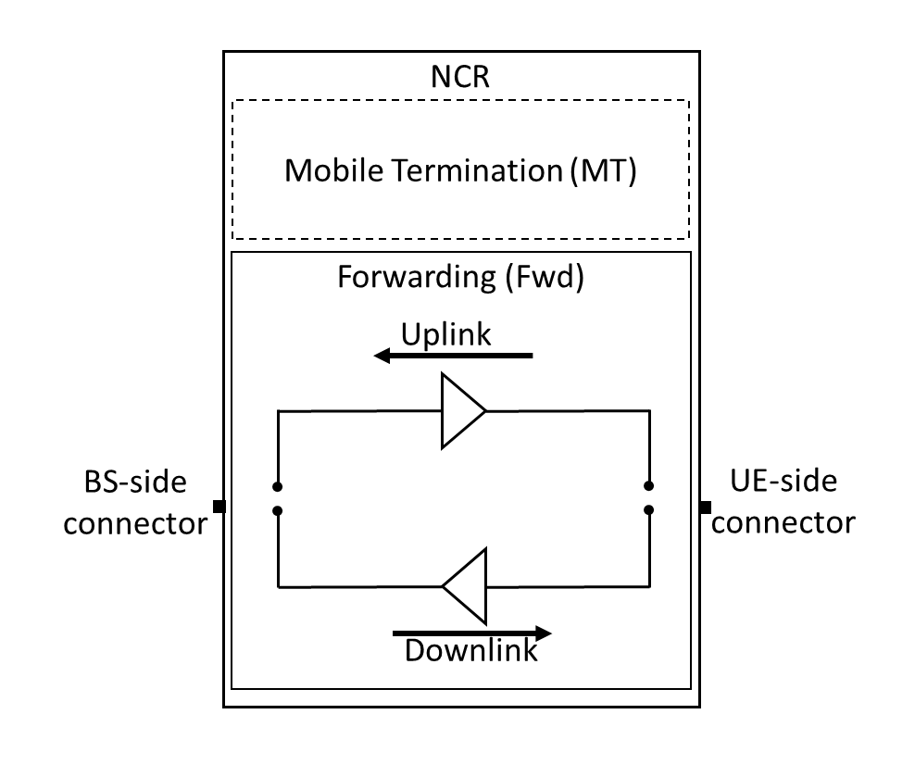

Figure 1. Conducted reference points for NCR type 1-C

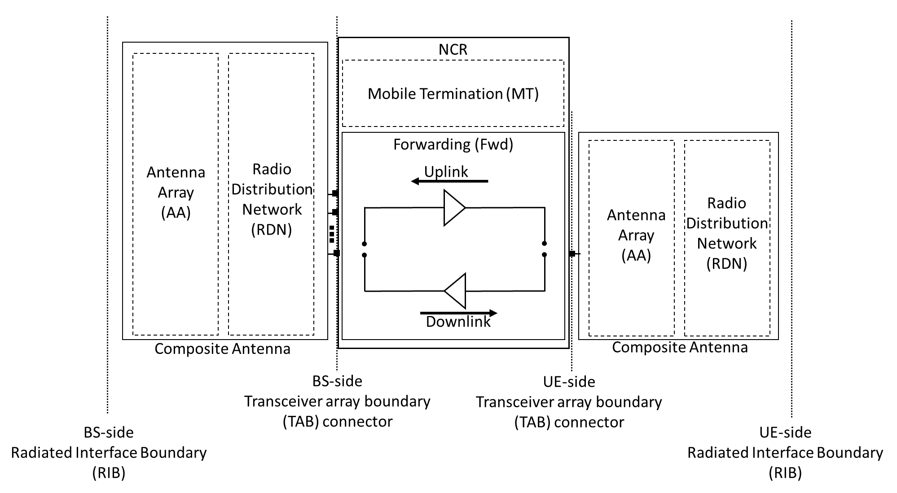

Figure 2. Radiated and conducted reference points for NCR type 1-H

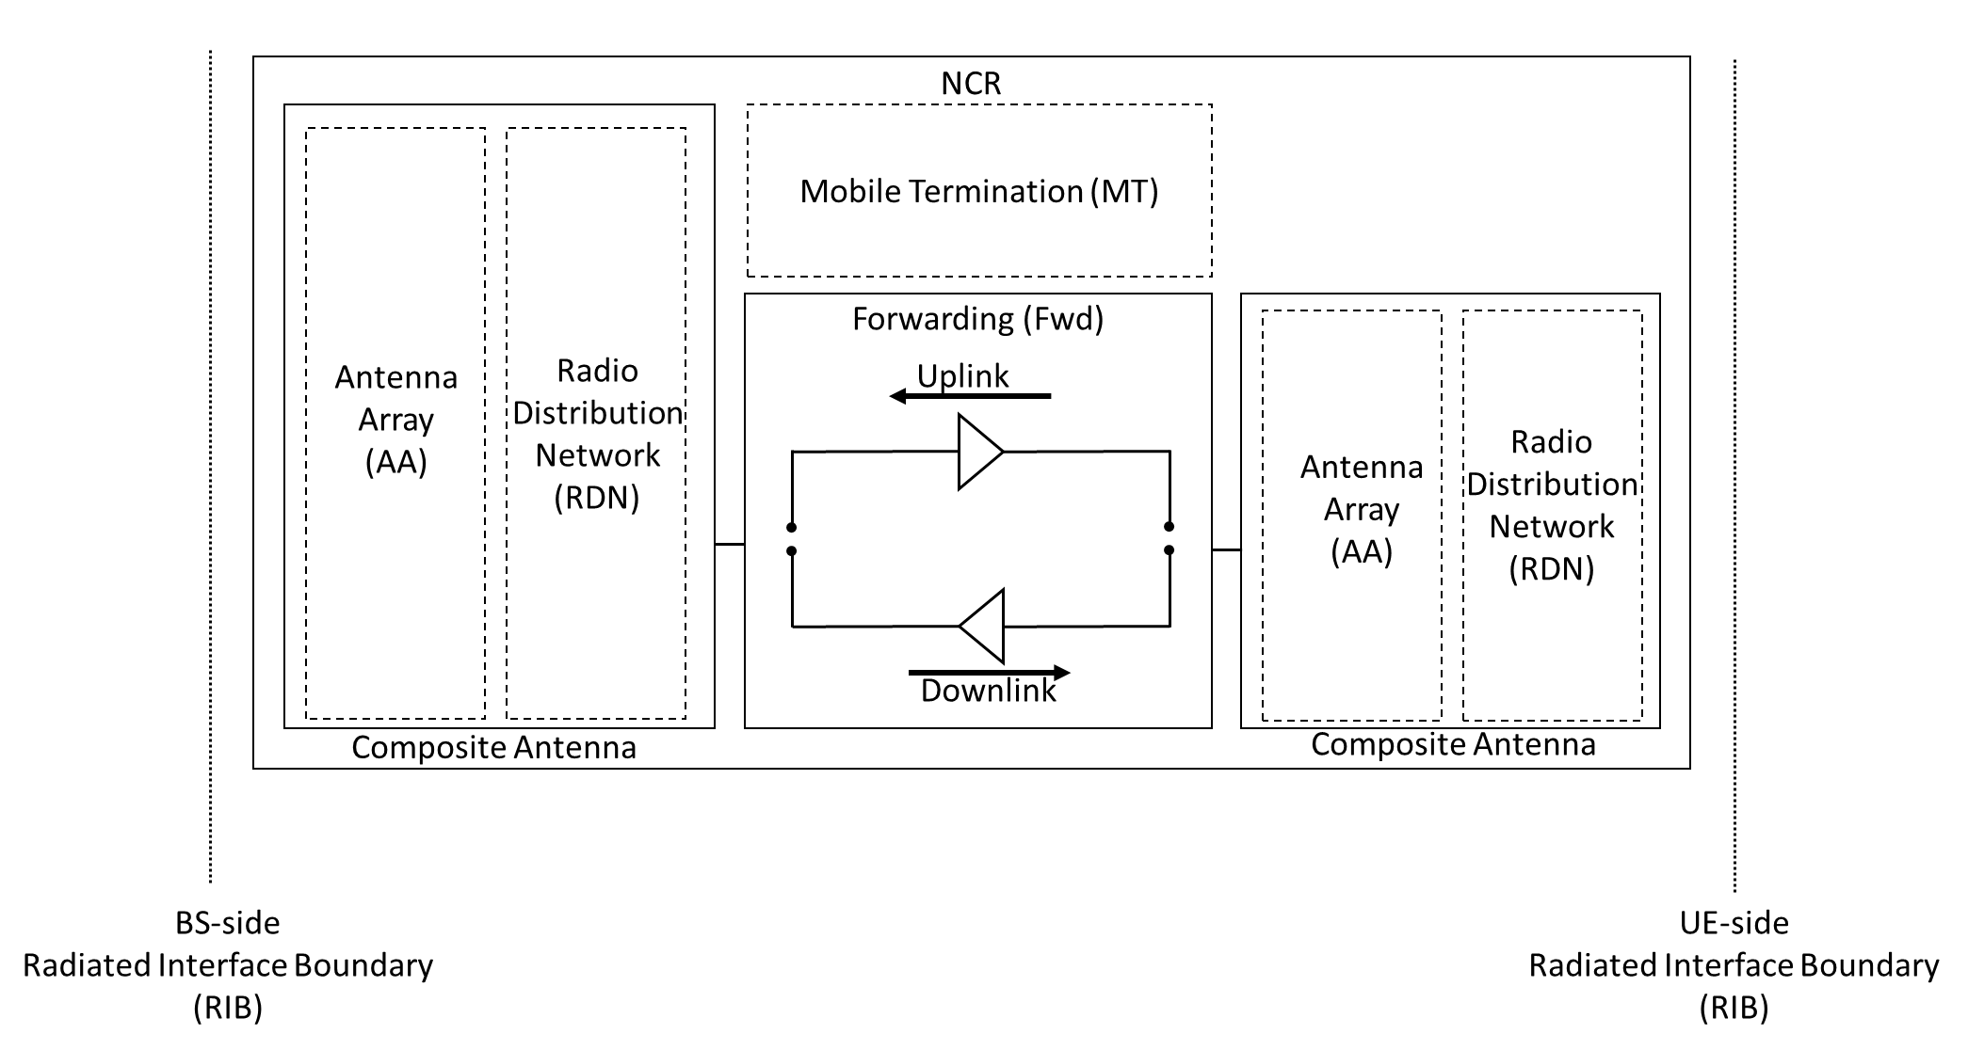

Figure 3. Radiated reference points for NCR type 1-O and 2-O

* + Proposal 3: Consider the RF diagram as proposed by ZTE in R4-2309188.

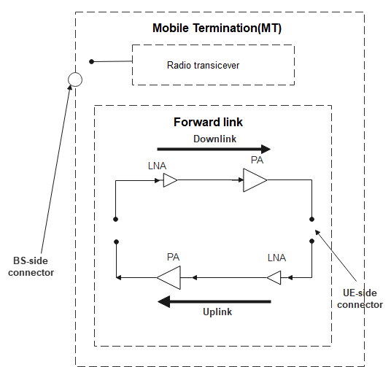

Figure 3. network controlled r*epeater type 1-C* downlink and uplink interface

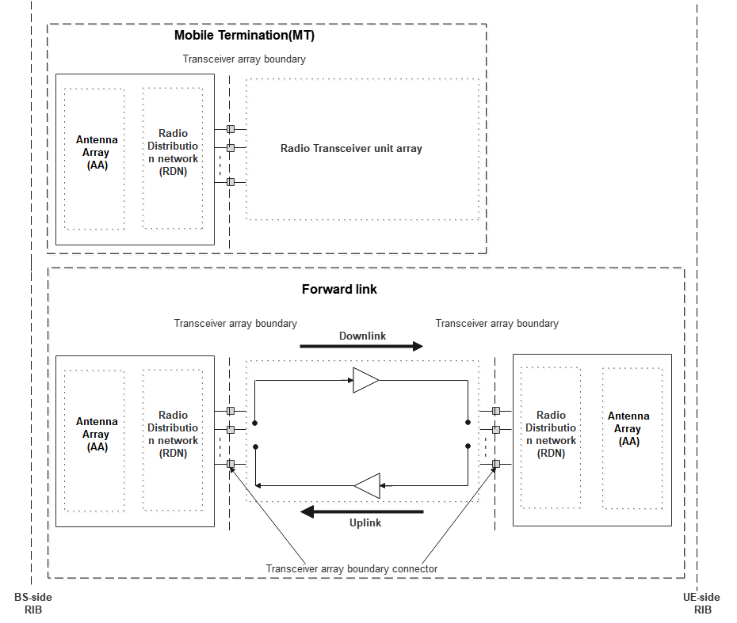

Figure 4. network controlled r*epeater type 1-H* downlink and uplink interface

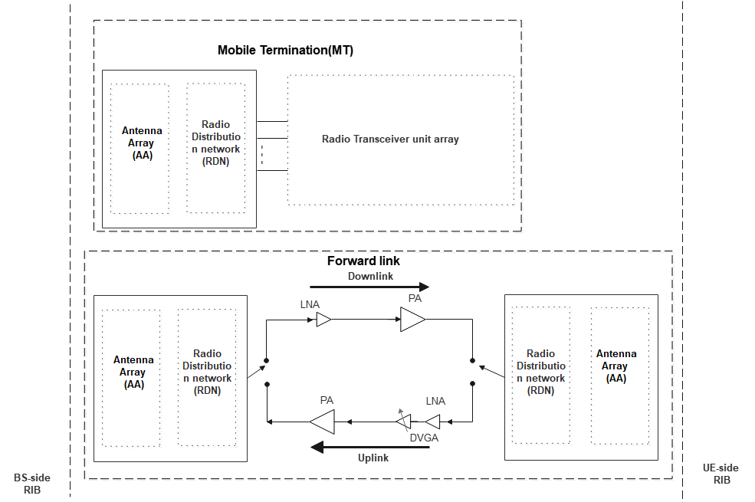

Figure 5. Radiated reference points for network controlled *repeater type 1-O and 2-O*

* Recommend WF
  + Companies’ views are encouraged during the meeting.

## Companies views’ collection for 1st round

### Open issues

Sub-topic 1-1

|  |  |
| --- | --- |
| **Company** | **Comments** |
| Company A |  |
| Company B |  |

Sub-topic 1-2

|  |  |
| --- | --- |
| **Company** | **Comments** |
| Company A |  |
| Company B |  |

Sub-topic 1-3

|  |  |
| --- | --- |
| **Company** | **Comments** |
| Company A |  |
| Company B |  |

Sub-topic 1-4

|  |  |
| --- | --- |
| **Company** | **Comments** |
| Company A |  |
| Company B |  |

# Topic #2: RF requirements for NCR-Fwd

## Companies’ contributions summary

(Cat A CRs are not listed)

|  |  |  |
| --- | --- | --- |
| **T-doc number** | **Company** | **Proposals / Observations** |
| **[R4-2307383](https://www.3gpp.org/ftp/TSG_RAN/WG4_Radio/TSGR4_107/Docs/R4-2307383.zip)** | CATT | Further discussion on RF requirements for NCR-Fwd |
| **[R4-2308203](https://www.3gpp.org/ftp/TSG_RAN/WG4_Radio/TSGR4_107/Docs/R4-2308203.zip)** | CMCC | discussion on NCR forwarding requirements  **Proposal 1: scaling factor for 1-H and 1-O fwding link UL output power is suggested as below.**   * **For LA, max scaling factor is 6dB, implicating max 30dBm output power, i.e. NTXU,counted = min(NTXU,active , 4*Ncells)** * **For WA, max scaling factor is 9dB, i.e. NTXU,counted = min(NTXU,active , 8*Ncells)**   **Observation 1: according to RAN1 agreements, when NCR-MT is OFF, NCR-fwd will be OFF simultaneously.**  **Proposal 2: when considering ON-OFF switching, we need to consider following three cases:**   * **Case 1: NCR-MT and NCR-Fwd turn OFF simultaneously** * **Case 2: NCR-MT turn ON whereas NCR-fwd is OFF** * **Case 3: NCR-fwd turn ON whereas NCR-MT is ON**   **Proposal 3: when NCR-MT and NCR-Fwd turn OFF simultaneously, the OFF power of uplink is the sum of MT part and fwd-uplink, i.e. -50dBm+3=-47dBm. the OFF power for downlink is the sum of fwd-downlink and MT part DL, i.e. i.e. -85+(-50)=-50dBm.**  **Proposal 4: as for transition period, we have following suggestion:**   * **for case 1, MT part is the same as UE spec, fwd-link is the same as RF repeater spec individually. There is no delay between MT part OFF state and fwd-link OFF state.** * **for case 2, the transition period is the same as UE spec.** * **for case 3, the transition period is the same as RF repeater.**   **Proposal 5: for 1-O fwd-link, minimum input power for EVM equals to 1-C requirements minus Rx antenna gain.**  **Proposal 6: the EVM requirements for fwd-link UL and DL are as below:**   |  |  |  | | --- | --- | --- | | **Parameter** | **Unit** | **Average Repeater EVM Level** | | QPSK, 16 QAM, 64QAM | % | 8 | | 256 QAM | % | 3.5 1 | |
| **[R4-2308522](https://www.3gpp.org/ftp/TSG_RAN/WG4_Radio/TSGR4_107/Docs/R4-2308522.zip)** | Ericsson | NCR-FWD remaining RF requirements  Observation 1 If the emissions requirements are defined on the total emissions from MT and FWD, this does not imply that the emissions of MT and FWD need to be measured together as part of conformance testing.  Observation 2 For the BS, 1-H and 1-O EVM use the same EVM target  Observation 3 The minimum signal level at the input should not be below (Minimum Conducted Input Power – Input sub-array gain) if the EVM is to be achieved at the output of the amplifier.  Observation 4 Proposals 10-12 only work if there is no combining between analogue phase shift and amplifier inputs. If there is phase shifting, the signal level at the amplifier input cannot be captured in a specification as it depends on combining implementation. The real minimum signal level would be lower than the level calculated in proposals 10-12 in that case.  Observation 5 If TRP is used for the input intermodulation then the repeater output beamforming does not impact the requirement.  Based on the discussion in the previous sections we propose the following:  Proposal 1 Downlink (i.e., UE side) TX emissions requirements are only defined for the NCR-FWD.  Proposal 2 If the NCR supports simultaneous MT and FWD transmission, then the UL (i.e. BS side) TX emissions requirements should be defined on the total emissions from MT and FWD.  Proposal 3 If the NCR does not support simultaneous MT and FWD transmission, then the UL (i.e. BS side) TX emissions requirements can be defined separately for the FWD and MT  Proposal 4 If the TX emissions for the BS side are defined on the sum of MT and FWD, the RF bandwidth should be the total bandwidth of passband and the MT carrier.  Proposal 5 If the TX emissions for the BS side are defined on the sum of MT and FWD, the bandwidth for the ACLR requirement shall be the MT channel bandwidth.  Proposal 6 Emissions scaling shall not be defined where it is not allowed by regulations.  Proposal 7 The transient time can be defined for FWD and MT separately  Proposal 8 The OFF power should be defined as the total OFF power from the MT and FWD  Proposal 9 The target EVM should be the same for 1-H and 1-O repeaters  Proposal 10 Define the minimum power level for WA for EVM as:  For 8% EVM: -82dBm – Input sub-array gain  For 3.5% EVM: -75dBm – Input sub-array gain  Proposal 11 Calculate the input sub-array gain as follows:  Repeater input RoAoA = The contour of input AoA along which the output EIRP, measured in the output reference direction is 3dB lower than the output EIRP in the output reference direction when an input signal is applied in the input reference direction.  Input sub-array gain = 44.1 - 10*log10(BeWθ,inputRoAoA*BeWφ, inputRoAoA) dB for the reference direction  Proposal 12 Use the same approach as for WA to define the minimum input power for LA and MR EVM  Proposal 13 Define the input intermodulation requirement as the increase in TRP output from the repeater. |
| **[R4-2308624](https://www.3gpp.org/ftp/TSG_RAN/WG4_Radio/TSGR4_107/Docs/R4-2308624.zip)** | Nokia, Nokia Shanghai Bell | Discussion on RF requirements for NCR-Fwd  **Observation 1:** Multi-beam FDM is not supported for NCR. FDM for multiple UEs could be supported on the same beam.  **Observation 2:** NCR-Fwd is in the OFF state when it is not otherwise controlled by the BS. NCR-Fwd is OFF when NCR-MT is in the RRC_idle state or off, but there are other states when NCR-Fwd is OFF (e.g. BS may configure NCR-Fwd to be OFF when NCR-MT is in RRC_IDLE or RRC_CONNECTED state).  Proposal 1: NCR-MT can be individually switched ON-OFF during operation. NCR-Fwd is always in the OFF state when NCR-MT is OFF. When NCR-MT is in the ON state, the ON-OFF states of NCR-Fwd depend on the decision taken by the BS and applied by NCR-MT. |
| **[R4-2309189](https://www.3gpp.org/ftp/TSG_RAN/WG4_Radio/TSGR4_107/Docs/R4-2309189.zip)** | ZTE Corporation | Discussion on RF requirements for NCR-Fwd |

## *Open issues summary*

*Before e-Meeting, moderators shall summarize list of open issues, candidate options and possible WF (if applicable) based on companies’ contributions.*

### Sub-topic 2-4 RF requirement for NCR-Fwd type 1-H

**Issue 2-4-1 RF requirements for NCR-Fwd type 1-H**

* Proposals
  + Please check the summarized proposals in the excel sheet.

|  |  |  |  |  |
| --- | --- | --- | --- | --- |
| For NCR-Fwd type 1-H: | ZTE | CATT | Ericsson | CMCC |
| **RF requirements** |  |  |  |  |
| Repeater output power | Agreement:  for DL part:   * To follow the option 2;   For UL part:   * FFS   ZTE:  In last RAN4 meeting, there were some initial discussions on output power for NCR-MT in the uplink direction, however it’s still FFS.  The main concern on additional 9dB increase will be significantly higher than UE power class. It could understood since high output power in the uplink might block gNB receiver or make system performance degraded, however since this is operator planed network, this could be [manageable](https://www.google.com/search?biw=2133&bih=1076&q=manageable&spell=1&sa=X&ved=2ahUKEwiYhqH3nOX-AhXHQ94KHaqYAQUQkeECKAB6BAgHEAE). In addition, it should be noted that in Rel-17 WA repeater uplink transmission, there are also no power limit defined yet. For Rel-16 IAB-MT, for WA IAB-MT, there are also no power limits and the scaling factors added for LA NCR-MT. In short, we prefer to keep alignment on the power limit handling for IAB-MT.  **Proposal 4:** for NCR-Fwd uplink transmission output power,propose to have the following scaling factor for NCR-Fwd uplink transmission:   * Option 2: NTXU,counted = min(NTXU,active , 8*Ncells) | 2) For UL transmission  Reuse minimum requirement for repeater type 1-C specified in sub-clause 6.2.2 of TS 38.106 for each TAB connector, and add Prated,p,sys with considering 10log(NTXU,counted) scaling. Reuse the ±2.0 dB and ±2.5 dB accuracy from the BS type 1-H in sub-clause 6.2.3 of TS 38.104 for normal test conditions and extreme test conditions, respectively. This requirement for NCR type 1-H is as below:  *Repeater type 1-H* UL transmission classes rated output power limits for repeater classes   |  |  |  | | --- | --- | --- | | Repeater class | Prated,p,sys | Prated,p,TABC | | Wide Area repeater | Note 1 | Note 1 | | Local Area repeater | ≤ 24 dBm + 10log(NTXU,counted) + X, Note 2 | ≤ 24 dBm+ X, Note 2 | | NOTE 1: There is no upper limit for the Prated,p,TABC *rated passband output power* of the Wide Area repeater.  NOTE 2: X = 10*log (ceil (*passband* bandwidth/20MHz)) | | | |  | **Proposal 1: scaling factor for 1-H and 1-O fwding link UL output power is suggested as below.**   * **For LA, max scaling factor is 6dB, implicating max 30dBm output power, i.e. NTXU,counted = min(NTXU,active , 4*Ncells)** * **For WA, max scaling factor is 9dB, i.e. NTXU,counted = min(NTXU,active , 8*Ncells)** |
| Frequency stability | Agreement (complete):  Reuse frequency stability for repeater type 1-C  specified in sub-clause 6.3.2 of TS 38.106. |  |  |  |
| Out of band gain | Agreement (complete):  Reuse out of band gain for repeater type 1-C  specified in sub-clause 6.4.2 of TS 38.106. |  |  |  |
| Adjacent Channel Leakage Power Ratio | Agreement:  Reuse the Rel-17 repeater type 1-C requirements for NCR-Fwd type 1-H and 1-O; [relative value] for DL absolute ACLR limit, to follow the option 2 scaling factor agreed for repeater output power;  ZTE:  For the UL absolute ACLR limit of NCR-Fwd type 1-H, if we apply the scaling factor for NCR-Fwd uplink output power, then it should be quite natural to apply the scaling factors for UL absolute ACLR and CACLR limit.  **Proposal 5:** for absolute ACLR and CACLR limits of NCR-Fwd uplink transmission,propose to have the the same scaling factor for NCR-Fwd uplink transmission output power:   * Option 2: NTXU,counted = min(NTXU,active , 8*Ncells) | The scaling factor X = 10log10(NTXU,countedpercell) can be used for ACLR(CACLR) absolute *basic limits* for UL, where NTXU,countedpercell = NTXU,counted / Ncells, and NTXU,counted = *min(NTXU,active , 8×Ncells).*  Reuse the approach from BS type 1-H in sub-clause 6.6.3.4 of TS 38.104.  1) Use ACLR(CACLR) limits for repeater type 1-C specified in sub-clauses 6.5.2.2 of TS 38.106 as ACLR(CACLR) *basic limits*. This ACLR (CACLR) *basic* *limits*, whichever is less stringent, shall apply for each *TAB connector TX min cell group* for NCR 1-H.  2) Use ACLR(CACLR) absolute *basic limits* for repeater type 1-C specified in sub-clauses 6.5.2.2 of TS 38.106 as ACLR(CACLR) absolute *basic limits*. This ACLR (CACLR) absolute *basic limits* + X (where X = 10log10(NTXU,countedpercell)), whichever is less stringent, shall apply for each *TAB connector TX min cell group* for NCR 1-H. | Proposal 5 If the TX emissions for the BS side are defined on the sum of MT and FWD, the bandwidth for the ACLR requirement shall be the MT channel bandwidth. |  |
| Operating band unwanted emissions | Agreement:  Reuse operating band unwanted emissions for repeater type 1-C specified in sub-clauses 6.5.3.2.1 - 6.5.3.2.6 of TS 38.106 as basic limit; for DL emission power level, follow the option 2 scaling factor agreed for repeater output power;  ZTE:  For OBUE requirement of NCR-Fwd type 1-H, if we apply the scaling factor for NCR-Fwd uplink output power, then it should be quite natural to apply the scaling factors for OBUE requirement .  **Proposal 6:** for OBUE requirement of NCR-Fwd uplink transmission,propose to have the the same scaling factor for NCR-Fwd uplink transmission output power:   * Option 2: NTXU,counted = min(NTXU,active , 8*Ncells) | The scaling factor X = 10log10(NTXU,countedpercell) can be used for operating band unwanted emissions for UL, where NTXU,countedpercell = NTXU,counted / Ncells, and NTXU,counted = *min(NTXU,active , 8×Ncells).*  Reuse the approach from BS type 1-H in sub-clause 6.6.4.4 of TS 38.104.  Use operating band unwanted emissions for repeater type 1-C specified in sub-clauses 6.5.3.2.1 - 6.5.3.2.6 of TS 38.106 as *basic limit.* The power summation emissions at the *TAB connectors* of the *TAB connectors* of each *TAB connector TX min cell group* shall not exceed a limit specified as the *basic limit* + X, where X = 10log10(NTXU,countedpercell), unless stated differently in regional regulation. | Proposal 1 Downlink (i.e., UE side) TX emissions requirements are only defined for the NCR-FWD.  Proposal 2 If the NCR supports simultaneous MT and FWD transmission, then the UL (i.e. BS side) TX emissions requirements should be defined on the total emissions from MT and FWD.  Proposal 3 If the NCR does not support simultaneous MT and FWD transmission, then the UL (i.e. BS side) TX emissions requirements can be defined separately for the FWD and MT  Proposal 4 If the TX emissions for the BS side are defined on the sum of MT and FWD, the RF bandwidth should be the total bandwidth of passband and the MT carrier. |  |
| Transmitter spurious emissions | Agreement:   * Further study on scaling factor for transmitter spurious emission requirement only.   ZTE:  The same reason applies for transmitter spurious emission requirements  **Proposal 7:** for transmitter spurious emission requirements for NCR-Fwd type 1-H,propose to have the the same scaling factor for NCR-Fwd uplink transmission output power:   * Option 2: NTXU,counted = min(NTXU,active , 8*Ncells) | The scaling factor X = 10log10(NTXU,countedpercell) can be used for transmitter spurious emssion for DL and UL, where NTXU,countedpercell = NTXU,counted / Ncells, and NTXU,counted = *min(NTXU,active , 8×Ncells).*  Reuse the approach from BS type 1-H in sub-clause 6.6.5.4 of TS 38.104.  Use transmitter spurious emissions for repeater type 1-C specified in sub-clauses 6.5.4.2.1, 6.5.4.2.2 and 6.5.4.2.3 of TS 38.106 as *basic limit*. The power summation emissions at the *TAB connectors* of the *TAB connectors* of each *TAB connector TX min cell group* shall not exceed a limit specified as the *basic limit* + X, where X = 10log10(NTXU,countedpercell), unless stated differently in regional regulation. | Proposal 6 Emissions scaling shall not be defined where it is not allowed by regulations. |  |
| Receiver spurious emissions | Agreement:   * Further study on scaling factor for receiver spurious emission requirement only.   ZTE:  The same reason applies for receiver spurious emission requirements  **Proposal 8:** for receiver spurious emission requirements for NCR-Fwd type 1-H,propose to have the the same scaling factor for NCR-Fwd uplink transmission output power:   * Option 2: NTXU,counted = min(NTXU,active , 8*Ncells) | The scaling factor X = 10log10(NRXU,countedpercell) can be used for receiver spurious emissions for DL and UL, where NRXU,countedpercell = NRXU,counted / Ncells, and NRXU,counted = *min(NRXU,active , 8* *× Ncells).*  Reuse the approach from BS type 1-H in sub-clause 7.6.4 of TS 38.104.  Use Receiver spurious emissions for repeater type 1-C specified in sub-clause 6.5.5.2 of TS 38.106 as *basic limit*. The power sum of emissions at respective *TAB connectors* for each *TAB connector RX min cell group* shall not exceed the BS limits specified as the *basic limit*s + X, where X = 10log10(NRXU,countedpercell), unless stated differently in regional regulation. | Proposal 6 Emissions scaling shall not be defined where it is not allowed by regulations. |  |
| Error Vector Magnitude | Agreement (complete):  To reuse the Rel-17 repeater type 1-C requirement f or each TAB connector of NCR-Fwd type 1-H; |  |  |  |
| Input intermodulation | Agreement (complete):  To reuse the Rel-17 repeater type 1-C requirement  for each TAB connector of NCR-Fwd type 1-H; |  |  |  |
| Output intermodulation | Agreement (complete):  To reuse the Rel-17 repeater type 1-C requirement  for each TAB connector of NCR-Fwd type 1-H; | 2) Intra-system minimum requirements  Reuse intra-system minimum requirement for BS type 1-H specified in sub-clause 6.7.3.2 of TS 38.104. |  |  |
| Adjacent Channel Rejection Ratio (ACRR) | Agreement (complete):  Reuse the Rel-17 repeater type 1-C requirements |  |  |  |
| Transmit ON/OFF power and transition period | Agreement:  For NCR-MT and NCR-Fwd switch ON-OFF together, proposed to have further study for it;  For NCR-MT and NCR-Fwd switch ON-OFF individually, propose to Reuse the Rel-17 repeater type 1-C requirements;  ZTE:  For NCR-MT and NCR-Fwd switch ON-OFF together, this is possible especially for TDD bands.  For separate antenna connector for NCR-MT and NCR-Fwd backhual link, then transition period and transmit ON-OFF power could be defined separately and tested separately.  For shared antenna connector for NCR-MT and NCR-Fwd backhual link, then transmit ON-OFF power could be measured together and OFF-power could still follow the Rel-17 repeater output power since OFF output power is defined per MHz instead of per pass-band or per carrier. In other words, when NCR-MT and NCR-Fwd backhual link is switched ON together, then its overall OFF “PSD” could be same as the legacy OFF power.  **Proposal 9:**  For separate antenna connector for NCR-MT and NCR-Fwd backhual link, then transition period and transmit ON-OFF power could be defined separately and tested separately.  For shared antenna connector for NCR-MT and NCR-Fwd backhual link, then transition period and transmit ON-OFF power could be defined together and tested together.  For transition period and OFF power requirement for NCR-Fwd type 1-H, propose to follow Rel-17 repeater requirement. | NOKIA proposal:  NCR-MT can be individually switched ON-OFF during operation. NCR-Fwd is always in the OFF state when NCR-MT is OFF. When NCR-MT is in the ON state, the ON-OFF states of NCR-Fwd depend on the decision taken by the BS and applied by NCR-MT. | Proposal 7 The transient time can be defined for FWD and MT separately  Proposal 8 The OFF power should be defined as the total OFF power from the MT and FWD | **Proposal 2: when considering ON-OFF switching, we need to consider following three cases:**   * **Case 1: NCR-MT and NCR-Fwd turn OFF simultaneously** * **Case 2: NCR-MT turn ON whereas NCR-fwd is OFF** * **Case 3: NCR-fwd turn ON whereas NCR-MT is ON**   **Proposal 3: when NCR-MT and NCR-Fwd turn OFF simultaneously, the OFF power of uplink is the sum of MT part and fwd-uplink, i.e. -50dBm+3=-47dBm. the OFF power for downlink is the sum of fwd-downlink and MT part DL, i.e. i.e. -85+(-50)=-50dBm.**  **Proposal 4: as for transition period, we have following suggestion:**   * **for case 1, MT part is the same as UE spec, fwd-link is the same as RF repeater spec individually. There is no delay between MT part OFF state and fwd-link OFF state.** * **for case 2, the transition period is the same as UE spec.** * **for case 3, the transition period is the same as RF repeater.** |
| OTA output power(EIRP) | Agreement (complete):  Define the requirement based on EIRP manufacturer  declaration, with the accuracy of the declared output power value (Prated,p,EIRP).  Reuse the ±2.2dB and ±2.7dB from the BS type 1-H in sub-clause 9.2.2 of TS 38.104 for normal test conditions and extreme test condition, respectively. |  |  |  |

* Recommended WF
  + Companies’ views are encouraged in 1st round.

### Sub-topic 2-5 RF requirement for NCR-Fwd Type 1-O

* **Issue** Proposals

|  |  |  |  |  |
| --- | --- | --- | --- | --- |
| For NCR-Fwd type 1-O | ZTE | CATT | Ericsson | CMCC |
| **RF requirements** |  |  |  |  |
| Repeater output power | Agreement:  for DL part:   * To follow the option 2 with 9dB scaling factor;   For UL part:   * FFS   Similar as the analysis for NCR-Fwd type 1-H, we made the following proposal:  **Proposal 10:** for uplink transmission output power of NCR-Fwd type 1-O ,propose to have the following scaling factor for NCR-Fwd uplink transmission:   * Option 2: X = 9dB | The scaling factor 9 dB can be used for TRP for UL. |  |  |
| Frequency stability | Agreement (complete):  Reuse OTA frequency stability for repeater type 1-C  specified in sub-clause 7.3.2 of TS 38.106. |  |  |  |
| Out of band gain | Agreement(complete):  1) Reuse the Rel-17 repeater type 1-C requirements  for NCR-Fwd type 1-H and 1-O; 2) define the gain for OOB gain as the ratio of TRP output power to directional input power in the same manner as for 2-O. |  |  |  |
| Adjacent Channel Leakage Power Ratio | Agreement:  1) for relative ACLR value, to reuse the Rel-17 repeater type 1-C requirements for NCR-Fwd type 1-H and 1-O 2) for absolute ACLR limits in the downlink part, to follow the 9dB scaling factor, however for uplink, it's FFS  ZTE:  Similar as the analysis for NCR-Fwd type 1-H, we made the following proposal:  **Proposal 11:** for absolute ACLR and CACLR limits of the uplink transmission of NCR-Fwd type 1-O,propose to have the the same scaling factor for NCR-Fwd uplink transmission output power:   * Option 2: X = 9dB | The scaling factor 9 dB can be used for ACLR(CACLR) absolute *basic limits* for UL.  Reuse the approach from BS type 1-O in sub-clause 9.7.3.2 of TS 38.104.  1) Use ACLR(CACLR) limits for repeater type 1-C specified in sub-clauses 6.5.2.2 of TS 38.106 as ACLR(CACLR) *basic limits*. This ACLR (CACLR) *basic* *limits*, whichever is less stringent, shall apply NCR type 1-O.  2) Use ACLR(CACLR) absolute *basic limits* for repeater type 1-C specified in sub-clauses 6.5.2.2 of TS 38.106 as ACLR(CACLR) absolute *basic limits*. This ACLR (CACLR) absolute *basic limits* + X (where X = 9), whichever is less stringent, shall apply for NCR type 1-O. |  |  |
| Operating band unwanted emissions | Agreement:  for NCR-Fwd downlink OBUE requirement, to follow the 9dB scaling factor,  for NCR-Fwd uplink OBUE requirement, FFS on the scaling factor;  ZTE:  Similar as the analysis for NCR-Fwd type 1-H, we made the following proposal:  **Proposal 12:** for OBUE requirement of uplink transmission of NCR-Fwd type 1-O,propose to have the the same scaling factor for NCR-Fwd uplink transmission output power:   * Option 2: X = 9dB | The scaling factor 9 dB can be used for operating band unwanted emissions for UL.  Reuse the approach from BS type 1-O in sub-clause 9.7.4.2 of TS 38.104.  Use Operating band unwanted emissions for repeater type 1-C specified in sub-clauses 6.5.3.2.1 - 6.5.3.2.5 of TS 38.106 as *basic limit.* The TRP power of any unwanted emission shall not exceed a limit specified as the *basic limit* + X, where X = 9, unless stated differently in regional regulation. |  |  |
| Transmitter spurious emissions | Agreement:   * Further study on scaling factor for transmitter spurious emission requirement only.   ZTE:  Similar as the analysis for NCR-Fwd type 1-H, we made the following proposal:  **Proposal 13:** for transmitter spurious emission requirements for NCR-Fwd type 1-O,propose to have the the same scaling factor for NCR-Fwd uplink transmission output power:   * Option 2: X = 9dB | The scaling factor 9 dB can be used for transmitter spurious emissions for UL.  Reuse the approach from BS type 1-O in sub-clause 9.7.5.2 of TS 38.104.  Use Transmitter spurious emissions for repeater type 1-C specified in sub-clauses 6.5.4.2.1, 6.5.4.2.2 and 6.5.4.2.3 of TS 38.106 as *basic limit*. The TRP power of any spurious emission shall not exceed a limit specified as the *basic limit* + X, where X = 9, unless stated differently in regional regulation. |  |  |
| Receiver spurious emissions | Agreement:   * Further study on scaling factor for receiver spurious emission requirement only. * For receiver spurious emission requirement, we need to wait for the conclusion of type declaration of NCR-MT and NCR-Fwd.   ZTE:  First of all, if the NCR Fwd type is type 1-O, then OTA receiver spurious emission requirement could be avoided since the spurious emission measurement could be dominated by the transmitter spurious emission.  In last RAN4 meeting, there are two proposals that DL/UL output as OTA and DL/UL input as conducted, then receiver spurious emission could be measurable. However as analyzed in the companion contribution [xx], these will complicate the combination of NCR declarations e.g. type combinations and class combinations. If there are such kind of device types, then follow the type 1-C or type 1-H requirements.  **Proposal 14:** for the NCR Fwd type is type 1-O, propose to avoid the OTA receiver spurious emission requirements.  For DL/UL output as OTA and DL/UL input as conducted, then follow the type 1-C and type 1-H requirement . | **NTT Docommo:**  **Proposal 2: If UL Rx emissions can be separated from DL Tx emissions and vice versa in OTA measurements, the specific requirement of Rx spurious emission is necessary** **even though NCR include NCR type 1-O.** |  |  |
| Error Vector Magnitude | Agreement:   * Further study   ZTE:  For EVM requirement for NCR-Fwd type 1-O, we propose to go with following proposals where GRX_ANT is the gain of the receive side antennas and is based on EIRP and TRP declaration from transmitter side which is the same as Rel-17 FR2 repeater EVM requirement.  1) Downlink repeater error vector magnitude  Use minimum input power for repeater type 1-C specified in Table 6.6.1.1-1 in sub-clause 6.6.1.1 of TS 38.106 - GRX_ANT for NCR type 1-O Fwd DL. Where GRX_ANT is the gain of the receive side antennas and is based on EIRP and TRP declaration. This requirement for NCR type 1-O is as below:  Minimum input power for repeater EVM for Fwd DL  Repeater DL class Minimum input power spectral density (dBm/MHz)  QPSK, 16 QAM, 64QAM 256QAM1  WA -82- GRX_ANT -75- GRX_ANT  MR -77- GRX_ANT -70- GRX_ANT  LA -74- GRX_ANT -67- GRX_ANT  Note 1: support of 256QAM is based on the declaration  Reuse EVM for repeater type 1-C specified in sub-clause 6.6.1.2 of TS 38.106 NCR type 1-O Fwd DL.  2) Uplink repeater error vector magnitude  Use minimum input power for repeater type 1-C specified in Table 6.6.2.1-1 in sub-clause 6.6.2.1 of TS 38.106 - GRX_ANT for NCR type 1-O Fwd UL. Where GRX_ANT is the gain of the receive side antennas and is based on EIRP and TRP declaration. This requirement for NCR type 1-O is as below:  Minimum input power for repeater EVM for Fwd UL  Repeater UL class Minimum input power spectral density (dBm/MHz)  QPSK, 16 QAM, 64QAM 256QAM1  WA -82- GRX_ANT -75- GRX_ANT  LA -74- GRX_ANT -67- GRX_ANT  Note 1: support of 256QAM is based on the declaration  Reuse EVM for repeater type 1-C specified in sub-clause 6.6.2.2 of TS 38.106 for NCR type 1-O Fwd UL.  **Proposal 15:** for the NCR Fwd type is type 1-O, propose to follow the Rel-17 repeater EVM requirement with its input power offset by GRX_ANT which is the gain of the receive side antennas and is based on EIRP and TRP declaration from transmitter side | 1) Downlink repeater error vector magnitude  Use minimum input power for repeater type 1-C specified in Table 6.6.1.1-1 in sub-clause 6.6.1.1 of TS 38.106 - GRX_ANT for NCR type 1-O Fwd DL. Where GRX_ANT is the gain of the receive side antennas and is based on EIRP and TRP declaration. This requirement for NCR type 1-O is as below:  Minimum input power for repeater EVM for Fwd DL   |  |  |  | | --- | --- | --- | | Repeater DL class | Minimum input power spectral density (dBm/MHz) | | | QPSK, 16 QAM, 64QAM | 256QAM1 | | WA | -82- GRX_ANT | -75- GRX_ANT | | MR | -77- GRX_ANT | -70- GRX_ANT | | LA | -74- GRX_ANT | -67- GRX_ANT | | Note 1: support of 256QAM is based on the declaration | | |   Reuse EVM for repeater type 1-C specified in sub-clause 6.6.1.2 of TS 38.106 NCR type 1-O Fwd DL.  2) Uplink repeater error vector magnitude  Use minimum input power for repeater type 1-C specified in Table 6.6.2.1-1 in sub-clause 6.6.2.1 of TS 38.106 - GRX_ANT for NCR type 1-O Fwd UL. Where GRX_ANT is the gain of the receive side antennas and is based on EIRP and TRP declaration. This requirement for NCR type 1-O is as below:  Minimum input power for repeater EVM for Fwd UL   |  |  |  | | --- | --- | --- | | Repeater UL class | Minimum input power spectral density (dBm/MHz) | | | QPSK, 16 QAM, 64QAM | 256QAM1 | | WA | -82- GRX_ANT | -75- GRX_ANT | | LA | -74- GRX_ANT | -67- GRX_ANT | | Note 1: support of 256QAM is based on the declaration | | |   Reuse EVM for repeater type 1-C specified in sub-clause 6.6.2.2 of TS 38.106 for NCR type 1-O Fwd UL. | Proposal 9 The target EVM should be the same for 1-H and 1-O repeaters  Proposal 10 Define the minimum power level for WA for EVM as:  For 8% EVM: -82dBm – Input sub-array gain  For 3.5% EVM: -75dBm – Input sub-array gain  Proposal 11 Calculate the input sub-array gain as follows:  Repeater input RoAoA = The contour of input AoA along which the output EIRP, measured in the output reference direction is 3dB lower than the output EIRP in the output reference direction when an input signal is applied in the input reference direction.  Input sub-array gain = 44.1 - 10*log10(BeWθ,inputRoAoA*BeWφ, inputRoAoA) dB for the reference direction  Proposal 12 Use the same approach as for WA to define the minimum input power for LA and MR EVM | **Proposal 5: for 1-O fwd-link, minimum input power for EVM equals to 1-C requirements minus Rx antenna gain.**  As for the EVM requirements, it’s suggested to reuse the same as 1-C as below.  **Proposal 6: the EVM requirements for fwd-link UL and DL are as below:**   |  |  |  | | --- | --- | --- | | **Parameter** | **Unit** | **Average Repeater EVM Level** | | QPSK, 16 QAM, 64QAM | % | 8 | | 256 QAM | % | 3.5 1 | | Note 1: support of 256QAM is based on the declaration. | | | |
| Input intermodulation | Agreement:   * Further study   ZTE:  For the general input intermodulation requirement, we propose to use the GRX_ANT which the gain of the receive side antennas and is based on EIRP and TRP declaration from transmitter side as offset to the conducted power.  There are some proposals to use sub-array gain similar as ΔOTAREFSENS_for FR1 BS instead of the whole array gain which also seems reasonable. However this needs declarations of BeWθ,REFSENS, BeWφ,REFSENS which is not possible since we don’t have REFSENS requirement defined for Rel-17 repeater, or we could use 3dB beamwdith (BeWθ,input, BeWφ,input_) of Rel-17 repeater passive antenna    **Proposal 16a:**  For the general input intermodulation requirement, propose to use the GRX_ANT which the gain of the receive side antennas and is based on EIRP and TRP declaration from transmitter side as offset to the conducted power  **Proposal 16b:**  For other Co-location with BS/repeater in other systems and Co-existence with other systems requirement, propose to use the following co-location reference antenna for requirement definition.  C:\Users\10164284\AppData\Local\Microsoft\Windows\INetCache\Content.MSO\BBB5BEFB.tmp | 1) General requirement  Reuse general requirement for repeater type 2-O approach for NCR type 1-O.  Use Interfering Signal Levels for repeater type 1-C specified in Table 6.7.1.2-1 in sub-clause 6.7.1.2 of TS 38.106 - GRX_ANT for NCR type 1-O Fwd DL. Where GRX_ANT is the gain of the receive side antennas and is based on EIRP and TRP declaration. This requirement for NCR type 1-O is as below:  Input intermodulation requirement   |  |  |  |  | | --- | --- | --- | --- | | **f1 offset** | **Interfering Signal Levels** | **Type of signals** | **Measurement bandwidth** | | 1 MHz | -40 dBm - GRX_ANT | 2 CW carriers | 1 MHz |   2) Co-location with BS/repeater in other systems  This requirement is co-location requirement, which is from co-location minimum requirement of out-of-band blocking of BS in TS 38.104. Reuse co-location minimum requirement of out-of-band blocking for BS type 1-O for NCR type 1-O.  Use interfering signal mean power for repeater type 1-C specified in Table 6.7.2.2-1 in sub-clause 6.7.2.2 of TS 38.106 + 30 dB as interfering signal mean power for NCR type 1-O Fwd DL. This interferer power levels are specified at the *co-location reference antenna* conducted input. This requirement for NCR type 1-O is as below:  Input intermodulation requirement for NR repeater DL when co-located with BS/repeater in other frequency bands.   | Frequency range of interfering signal | Interfering signal mean power for repeater with WA UE side (dBm) | Interfering signal mean power for repeater with MR UE side(dBm) | Interfering signal mean power for repeater with LA UE side(dBm) | Type of interfering signals | | --- | --- | --- | --- | --- | | Frequency range of co-located BS’s downlink operating band or located repeater’s *passband* | + 46 | + 38 | + 24 | 2 CW carriers | | NOTE 1: The requirement does not apply when the interfering signal falls within the *passband*.  NOTE 2: For unsynchronized base stations (except in band n46, n96, and n102) or repeaters, special co-location requirements may apply that are not covered by the 3GPP specifications. | | | | |   Use interfering signal mean power for repeater type 1-C specified in Table 6.7.2.2-2 in sub-clause 6.7.2.2 of TS 38.106 +30 dB as interfering signal mean power for NCR type 1-O Fwd UL. This interferer power levels are specified at the *co-location reference antenna* conducted input. This requirement for NCR type 1-O is as below:  Input intermodulation requirement for NR repeater UL when co-located with BS/repeater in other frequency bands.   | Frequency range of interfering signal | Interfering signal mean power for repeater with WA BS side(dBm) | Interfering signal mean power for repeater with LA BS side(dBm) | Type of interfering signals | | --- | --- | --- | --- | | Frequency range of co-located BS’s downlink operating band or located repeater’s *passband* | + 46 | Prated,p,TRP | 2 CW carriers | | NOTE 1: The requirement does not apply when the interfering signal falls within the *passband*.  NOTE 2: For unsynchronized base stations (except in band n46, n96, and n102) or repeaters, special co-location requirements may apply that are not covered by the 3GPP specifications. | | | |   3) Co-existence with other systems  Use interfering signal mean power for repeater type 1-C specified in Table 6.7.3.2-1 in sub-clause 6.7.3.2 of TS 38.106 +30 dB as interfering signal mean power for NCR type 1-O Fwd. This interferer power levels are specified at the *co-location reference antenna* conducted input. This requirement for NCR type 1-O is as below:  Input intermodulation requirement for NR repeater when co-exist with BS/repeater in other non-overlapping frequency bands   | Frequency range of interfering signal | Interfering signal mean power (dBm) | Type of interfering signals | Measurement bandwidth | | --- | --- | --- | --- | | Frequency range of co-existence system operating band | + 15 | 2 CW carriers | 1MHz | | NOTE 1: All the interfering signals should be limited into the frequency ranges that are either X MHz higher than FUL,high or X MHz lower than FUL,low, where X equals to 20MHz when FUL,high - FUL,low is not larger than 200MHz, otherwise X equals to 60MHz | | | | | Proposal 13 Define the input intermodulation requirement as the increase in TRP output from the repeater. |  |
| Output intermodulation | **Agreement:**   * RAN4 should discuss further how to define and apply co-location requirements (for emissions and output intermodulation) considering the complexities of needing both a reference co-location antenna and of supplying a stimulus signal to the repeater.   ZTE:  For the output intermodulation requirement, reference co-location antenna is used shown as following, however output power of co-location reference antenna could be also measured by measurement equipment which can be removed by the individual measurement for co-location reference antenna.  **Proposal 17:** for the output intermodulation requirement for NCR Fwd type is type 1-O, propose to use the following measurement setup for it.C:\Users\10164284\AppData\Local\Microsoft\Windows\INetCache\Content.MSO\8F9EADC1.tmp | 1) Minimum requirements(Co-location)  Reuse OTA transmitter intermodulation for BS type 1-O specified in sub-clause 9.8.2 of TS 38.104. And an interfering signal is injected into the co-location reference antenna. |  |  |
| Adjacent Channel Rejection Ratio (ACRR) | Agreement (complete):  Reuse the Rel-17 repeater type 1-C requirements | Reuse ACRR for repeater type 1-C specified in sub-clause 6.9.2 of TS 38.106. |  |  |
| Transmit ON/OFF power and transition period | ZTE:  Similar as the analysis for NCR-Fwd type 1-H, we made the following proposal:  **Proposal 18:**  For transition period for NCR-Fwd type 1-H, propose to follow Rel-17 repeater requirement and OFF-power requirement could be based on co-location reference antenna with its OFF power as -106dBm/MHz.  Requirement could be applicable for both individual NCR-MT and NCR-Fwd testing and joint testing for NCR-MT and NCR-Fwd when they are switched ON-OFF together. | 1) OTA Transmitter OFF power:  Reuse OTA transmitter OFF power for BS type 1-O specified in sub-clause 9.5.2.2 of TS 38.104. The total power from all *co-location reference antenna* conducted output(s) shall be less than -106 dBm/MHz.  2) OTA Transmitter transient period  Reuse OTA transmitter transient period for BS type 1-O specified in sub-clause 9.5.3.2 of TS 38.104. Transient period length (µs) is 10us. |  |  |

* Recommended WF
  + Companies’ views are encouraged in 1st round.

## Companies views’ collection for 1st round

### Open issues

Sub-topic 2-1

|  |  |
| --- | --- |
| **Company** | **Comments** |
| Company A |  |
| Company B |  |

Sub-topic 2-2

|  |  |
| --- | --- |
| **Company** | **Comments** |
| Company A |  |
| Company B |  |

Sub-topic 2-3

|  |  |
| --- | --- |
| **Company** | **Comments** |
| Company A |  |
| Company B |  |

Sub-topic 2-4 [please provide the comments in the excel sheet directly]

|  |  |
| --- | --- |
| **Company** | **Comments** |
| Company A |  |
| Company B |  |

Sub-topic 2-5 [please provide the comments in the excel sheet directly]

|  |  |
| --- | --- |
| **Company** | **Comments** |
| Company A |  |
| Company B |  |

# Topic #3: RF requirements for NCR-MT

## Companies’ contributions summary

(Cat A CRs are not listed)

|  |  |  |
| --- | --- | --- |
| **T-doc number** | **Company** | **Proposals / Observations** |
| **[R4-2307384](https://www.3gpp.org/ftp/TSG_RAN/WG4_Radio/TSGR4_107/Docs/R4-2307384.zip)** | CATT | Further discussion on RF requirements for NCR-MT |
| **[R4-2308202](https://www.3gpp.org/ftp/TSG_RAN/WG4_Radio/TSGR4_107/Docs/R4-2308202.zip)** | CMCC | discussion on NCR MT requirements |
| **[R4-2308521](https://www.3gpp.org/ftp/TSG_RAN/WG4_Radio/TSGR4_107/Docs/R4-2308521.zip)** | Ericsson | NCR-MT remaining RF requirements |
| **[R4-2308625](https://www.3gpp.org/ftp/TSG_RAN/WG4_Radio/TSGR4_107/Docs/R4-2308625.zip)** | Nokia, Nokia Shanghai Bell | Discussion on RF requirements for NCR-MT |
| **[R4-2309190](https://www.3gpp.org/ftp/TSG_RAN/WG4_Radio/TSGR4_107/Docs/R4-2309190.zip)** | ZTE Corporation | Discussion on RF requirements for NCR-MT |

## *Open issues summary*

*Before e-Meeting, moderators shall summarize list of open issues, candidate options and possible WF (if applicable) based on companies’ contributions.*

### Sub-topic 3-1 Tx requirements for NCR-MT

**Issue 3-1-1 Output power dynamics and power control**

* Proposals
  + Proposal 1: propose not to define the absolute power tolerance requirement for NCR-MT. [ZTE,[R4-2309190](https://www.3gpp.org/ftp/TSG_RAN/WG4_Radio/TSGR4_107/Docs/R4-2309190.zip)]
  + Proposal 2: for relative power tolerance and aggregated power tolerance requirements for NCR-MT, either to follow the output dynamic range requirement of IAB-MT or the legacy UE requirements and corresponding. [ZTE,[R4-2309190](https://www.3gpp.org/ftp/TSG_RAN/WG4_Radio/TSGR4_107/Docs/R4-2309190.zip)]
* Recommended WF
  + Companies’ views are encouraged in 1st round.

**Issue 3-1-2 Transmitter ON-OFF power and transition period**

* Proposals
  + Proposal 1: for NCR-MT transmitter ON-OFF power and transition period requirement, to reuse the Rel-16 IAB-MT RF requirement as baseline. [ZTE,[R4-2309190](https://www.3gpp.org/ftp/TSG_RAN/WG4_Radio/TSGR4_107/Docs/R4-2309190.zip)]
* Recommended WF
  + Companies’ views are encouraged in 1st round.

**Issue 3-1-3 OBW**

* Proposals
  + Proposal 1: for NCR-MT occupied channel bandwidth, to follow the regulation ITU-R SM.328; [ZTE,[R4-2309190](https://www.3gpp.org/ftp/TSG_RAN/WG4_Radio/TSGR4_107/Docs/R4-2309190.zip)]
* Recommended WF
  + Companies’ views are encouraged in 1st round.

**Issue 3-1-4 ACLR**

* Proposals
  + Proposal 1: for NCR-MT ACLR requirements, propose to follow Rel-17 repeater UL ACLR requirement without input signal of repeater UL in uplink direction. [ZTE,[R4-2309190](https://www.3gpp.org/ftp/TSG_RAN/WG4_Radio/TSGR4_107/Docs/R4-2309190.zip)]
  + Proposal 2 : If the TX emissions for the BS side are defined on the sum of MT and FWD, the bandwidth for the ACLR requirement shall be the MT channel bandwidth. [Ericsson,[R4-2308521](https://www.3gpp.org/ftp/TSG_RAN/WG4_Radio/TSGR4_107/Docs/R4-2308521.zip)]
  + Proposal 3: It is OK to allow the ACLR and emissions requirements for the LA NCR-MT class to be the same as for the UE. However, then the same class should be applied to both NCR-FWD and NCR-MT in uplink. [Ericsson,[R4-2308521](https://www.3gpp.org/ftp/TSG_RAN/WG4_Radio/TSGR4_107/Docs/R4-2308521.zip)]
* Recommended WF
  + Companies’ views are encouraged in 1st round.

**Issue 3-1-5 OBUE/SEM**

* Proposals
  + Proposal 1: for NCR-MT OBUE requirements, propose to follow Rel-17 repeater UL OBUE requirement without input signal of repeater UL in uplink direction. [ZTE,[R4-2309190](https://www.3gpp.org/ftp/TSG_RAN/WG4_Radio/TSGR4_107/Docs/R4-2309190.zip)]
  + Proposal 2: it’s suggested to separately define emission requirements for MT part and forwarding link backhaul part. Besides, separate testing is also suggested for both NCR-MT support simultaneous and non-simultaneous emissions. [CMCC,R4-2308202]
  + Proposal 3 If the NCR supports simultaneous MT and FWD transmission, then the UL (i.e. BS side) TX emissions requirements should be defined on the total emissions from MT and FWD. [Ericsson,[R4-2308521](https://www.3gpp.org/ftp/TSG_RAN/WG4_Radio/TSGR4_107/Docs/R4-2308521.zip)]
  + Proposal 4: If the NCR does not support simultaneous MT and FWD transmission, then the UL (i.e. BS side) TX emissions requirements can be defined separately for the FWD and MT [Ericsson,[R4-2308521](https://www.3gpp.org/ftp/TSG_RAN/WG4_Radio/TSGR4_107/Docs/R4-2308521.zip)]
  + Proposal 5: If the TX emissions for the BS side are defined on the sum of MT and FWD, the RF bandwidth should be the total bandwidth of passband and the MT carrier. [Ericsson,[R4-2308521](https://www.3gpp.org/ftp/TSG_RAN/WG4_Radio/TSGR4_107/Docs/R4-2308521.zip)]
* Recommended WF
  + Companies’ views are encouraged in 1st round.

**Issue 3-1-6 transmitter spurious emission**

* Proposals
  + Proposal 1: for NCR-MT transmitter spurious emission requirements, propose to follow Rel-17 repeater transmitter spurious emission requirements. [ZTE,[R4-2309190](https://www.3gpp.org/ftp/TSG_RAN/WG4_Radio/TSGR4_107/Docs/R4-2309190.zip)]
* Recommended WF
  + Companies’ views are encouraged in 1st round.

**Issue 3-1-7 Transmitter transmitter intermodulation**

* Proposals
  + Proposal 1: for NCR-MT transmitter intermodulation requirement, propose to reuse the Rel-16 IAB-MT intermodulation requirements. [ZTE,[R4-2309190](https://www.3gpp.org/ftp/TSG_RAN/WG4_Radio/TSGR4_107/Docs/R4-2309190.zip)]
* Recommended WF
  + Companies’ views are encouraged in 1st round.

### Sub-topic 3-2 Rx requirements for NCR-MT

**Issue 3-2-1 REFSENS requirement**

* Proposals
  + Proposal 1: for NF of IAB-MT, propose to follow the following values [ZTE,[R4-2309190](https://www.3gpp.org/ftp/TSG_RAN/WG4_Radio/TSGR4_107/Docs/R4-2309190.zip)]
* NF is assumed as 5dB for FR1 WA NCR-MT, and 13dB for FR1 LA NCR-MT;
* NF is assumed as 10dB for 30GHz and 12dB for 45GHz for FR2 NCR-MT
  + Proposal 2 for 15kHz FRC of FR1 IAB-MT, propose to use the following FRC. [ZTE,[R4-2309190](https://www.3gpp.org/ftp/TSG_RAN/WG4_Radio/TSGR4_107/Docs/R4-2309190.zip)]

Table A1-1: FRC parameters for FR1 reference sensitivity level for IAB-MT.

|  |  |  |  |  |  |  |
| --- | --- | --- | --- | --- | --- | --- |
| Reference channel | G-FR1-A1-22 | G-FR1-A1-23 | G-FR1-A1-25 | G-FR1-A1-26 | G-FR1-A1-27 | G-FR1-A1-28 |
| Subcarrier spacing (kHz) | 30 | 60 | 30 | 60 | 15 | 15 |
| Allocated resource blocks | 11 | 11 | 51 | 24 | 25 | 106 |
| CP-OFDM Symbols per slot (Note 1) | 9 | 9 | 9 | 9 | 9 | 9 |
| Modulation | QPSK | QPSK | QPSK | QPSK | QPSK | QPSK |
| Code rate (Note 2) | 1/3 | 1/3 | 1/3 | 1/3 | 1/3 | 1/3 |
| NOTE 1:   *DL-DMRS-config-type* = 1 with *DL-DMRS-max-len* = 1, *DL-DMRS-add-pos* = pos2 with = 2, = 6 and 9 as per Table 7.4.1.1.2-3 of TS 38.211 [3].  NOTE 2:   MCS index 4 and target coding rate = 308/1024 are adopted to calculate payload size for receiver sensitivity | | | | | | |

* + Proposal 3: 5dB NF for WA NCR FR1 MT, and 13 dB NF for LA NCR FR1 MT. [CATT,[R4-2307384](https://www.3gpp.org/ftp/TSG_RAN/WG4_Radio/TSGR4_107/Docs/R4-2307384.zip)]
  + Proposal 4: Adopt Table 2-1 for FRC parameters for FR1 reference sensitivity level for NCR-MT. [CATT,[R4-2307384](https://www.3gpp.org/ftp/TSG_RAN/WG4_Radio/TSGR4_107/Docs/R4-2307384.zip)]

Table 2-1: FRC parameters for FR1 reference sensitivity level for NCR-MT.

|  |  |  |  |  |  |  |
| --- | --- | --- | --- | --- | --- | --- |
| Reference channel | G-FR1-A1-21 | G-FR1-A1-22 | G-FR1-A1-23 | G-FR1-A1-24 | G-FR1-A1-25 | G-FR1-A1-26 |
| Subcarrier spacing (kHz) | 15 | 30 | 60 | 15 | 30 | 60 |
| Allocated resource blocks | 25 | 11 | 11 | 106 | 51 | 24 |
| CP-OFDM Symbols per slot (Note 1) | 9 | 9 | 9 | 9 | 9 | 9 |
| Modulation | QPSK | QPSK | QPSK | QPSK | QPSK | QPSK |
| Code rate (Note 2) | 1/3 | 1/3 | 1/3 | 1/3 | 1/3 | 1/3 |
| NOTE 1:   *DL-DMRS-config-type* = 1 with *DL-DMRS-max-len* = 1, *DL-DMRS-add-pos* = pos2 with = 2, = 6 and 9 as per Table 7.4.1.1.2-3 of TS 38.211 [3].  NOTE 2:   MCS index 4 and target coding rate = 308/1024 are adopted to calculate payload size for receiver sensitivity | | | | | | |

* + Proposal 5: Adopt Table 2-2 and Table 2-3 for WA and LA NCR type 1-C and 1-H MT reference sensitivity levels. [CATT,[R4-2307384](https://www.3gpp.org/ftp/TSG_RAN/WG4_Radio/TSGR4_107/Docs/R4-2307384.zip)]

Table 2-2: Wide Area NCR type 1-C and 1-H MT reference sensitivity levels

|  |  |  |  |
| --- | --- | --- | --- |
| NCR-MT channel bandwidth (MHz) | Sub-carrier spacing (kHz) | Reference measurement channel | Reference sensitivity power level, PREFSENS  (dBm) |
| 5, 10, 15 | 15 | G-FR1-A1-21 (Note 1) | -101.5 |
| 10, 15 | 30 | G-FR1-A1-22 (Note 1) | -102.0 |
| 10, 15 | 60 | G-FR1-A1-23 (Note 1) | -99.0 |
| 20, 25, 30, 35, 40, 45, 50 | 15 | G-FR1-A1-24 (Note 1) | -95.2 |
| 20, 25, 30, 40, 50, 60, 70, 80, 90, 100 | 30 | G-FR1-A1-25 (Note 1) | -95.4 |
| 20, 25, 30, 40, 50, 60, 70, 80, 90, 100 | 60 | G-FR1-A1-26 (Note 1) | -95.6 |
| NOTE 1: PREFSENS is the power level of a single instance of the reference measurement channel. This requirement shall be met for each consecutive application of a single instance of the reference measurement channel mapped to disjoint frequency ranges with a width corresponding to the number of resource blocks of the reference measurement channel each, except for one instance that might overlap one other instance to cover the full *NCR-MT channel bandwidth*. | | | |

Table 2-3: Local Area NCR type 1-C and 1-H MT reference sensitivity levels

|  |  |  |  |
| --- | --- | --- | --- |
| NCR-MT channel bandwidth (MHz) | Sub-carrier spacing (kHz) | Reference measurement channel | Reference sensitivity power level, PREFSENS  (dBm) |
| 5, 10, 15 | 15 | G-FR1-A1-21 (Note 1) | -93.5 |
| 10, 15 | 30 | G-FR1-A1-22 (Note 1) | -94.0 |
| 10, 15 | 60 | G-FR1-A1-23 (Note 1) | -91.0 |
| 20, 25, 30, 35, 40, 45, 50 | 15 | G-FR1-A1-24 (Note 1) | -87.2 |
| 20, 25, 30, 40, 50, 60, 70, 80, 90, 100 | 30 | G-FR1-A1-25 (Note 1) | -87.4 |
| 20, 25, 30, 40, 50, 60, 70, 80, 90, 100 | 60 | G-FR1-A1-26 (Note 1) | -87.6 |
| NOTE 1: PREFSENS is the power level of a single instance of the reference measurement channel. This requirement shall be met for each consecutive application of a single instance of the reference measurement channel mapped to disjoint frequency ranges with a width corresponding to the number of resource blocks of the reference measurement channel each, except for one instance that might overlap one other instance to cover the full *NCR-MT channel bandwidth*. | | | |
|  | | | |

* + ,Proposal 6: for LA NCR-MT, the same NF as normal UE is suggested. For WA NCR-MT, the same as WA BS, i.e. 5dB is suggested. [CMCC,R4-2308202]
  + Proposal 7: for NCR-MT FRC, it’s suggested to reuse the same G-FR1-A1-1,2,3,4,5,6 with 15, 30 and 60kHz SCS assumption. [CMCC,R4-2308202]
* Recommended WF
  + Companies’ views are encouraged in 1st round.

**Issue 3-2-2 Dynamic range requirement**

* Proposals
  + Proposal 1: propose not to define the dynamic range requirement for NCR-MT. [ZTE,[R4-2309190](https://www.3gpp.org/ftp/TSG_RAN/WG4_Radio/TSGR4_107/Docs/R4-2309190.zip)]
* Recommended WF
  + Companies’ views are encouraged in 1st round.

**Issue 3-2-3 ACS/IBB**

* Proposals
  + Proposal 1: propose to use the UE ACS requirement as 33dBc for FR1 NCR-MT and 23,22dBc for FR2 NCR-MT update the IAB-MT or BS requirement accordingly. [ZTE,[R4-2309190](https://www.3gpp.org/ftp/TSG_RAN/WG4_Radio/TSGR4_107/Docs/R4-2309190.zip)]
  + Proposal 2: For IBB requirement and NBB requirements of FR1 NCR-MT, IBB interfering signal power level should be 9dB higher than ACS requirement and NBB interfering signal power level should be 3dB higher than ACS requirement.For IBB requirement for FR2 NCR-MT, keep the same power offset as IBB and ACS requirement of legacy FR2 IAB-MT or FR2 BS for FR2 NCR-MT. [ZTE,[R4-2309190](https://www.3gpp.org/ftp/TSG_RAN/WG4_Radio/TSGR4_107/Docs/R4-2309190.zip)]
  + Proposal 3: For ACS for NCR type 1-C, 1-H MT, reuse Minimum requirement for IAB-MT type 1-H specified in sub-clause 7.4.1.3 of TS 38.174. Add 5MHz channel bandwidth for ACS as shown in Table 2-4 and Table 2-5. [CATT,[R4-2307384](https://www.3gpp.org/ftp/TSG_RAN/WG4_Radio/TSGR4_107/Docs/R4-2307384.zip)]
  + Proposal 4: For IBB for NCR type 1-C, 1-H MT, reuse Minimum requirement for IAB-MT type 1-H specified in sub-clause 7.4.2.3 of TS 38.174. Add 5MHz channel bandwidth for IBB as shown in Table 2-6, Table 2-7, and Table 2-8. [CATT,[R4-2307384](https://www.3gpp.org/ftp/TSG_RAN/WG4_Radio/TSGR4_107/Docs/R4-2307384.zip)]
  + Proposal 5: It is OK to use UE ACS for the LA NCR-MT[Ericsson,[R4-2308521](https://www.3gpp.org/ftp/TSG_RAN/WG4_Radio/TSGR4_107/Docs/R4-2308521.zip)]
* Recommended WF
  + Companies’ views are encouraged in 1st round.

**Issue 3-2-4 OOBB requirement**

* Proposals
  + Proposal 1: for OOBB requirement for NCR-MT, propose to reuse the IAB-MT requirement. [ZTE,[R4-2309190](https://www.3gpp.org/ftp/TSG_RAN/WG4_Radio/TSGR4_107/Docs/R4-2309190.zip)]
* Recommended WF
  + Companies’ views are encouraged in 1st round.

**Issue 3-2-5 receiver spurious emission requirement**

* Proposals
  + Proposal 1: for receiver spurious emission requirement for NCR-MT, propose to reuse the IAB-MT requirement for it. [ZTE,[R4-2309190](https://www.3gpp.org/ftp/TSG_RAN/WG4_Radio/TSGR4_107/Docs/R4-2309190.zip)]
* Recommended WF
  + Companies’ views are encouraged in 1st round.

**Issue 3-2-6 receiver intermodulation requirement**

* Proposals
  + Proposal 1: for receiver intermodulation requirement for NCR-MT, propose to reuse the IAB-MT requirement and update the power level of interfering signal according to the existing power offset between RX IMD and RX ACS requirement.[ZTE,[R4-2309190](https://www.3gpp.org/ftp/TSG_RAN/WG4_Radio/TSGR4_107/Docs/R4-2309190.zip)]
* Recommended WF
  + Companies’ views are encouraged in 1st round.

**Issue 3-2-7 receiver in-channel selectivity requirement requirement**

* Proposals
  + Proposal 1: propose not to define the ICS requirement for NCR-MT. [ZTE,[R4-2309190](https://www.3gpp.org/ftp/TSG_RAN/WG4_Radio/TSGR4_107/Docs/R4-2309190.zip)]
* Recommended WF
  + Companies’ views are encouraged in 1st round.

### Sub-topic 3-3 Other

**Issue 3-4 Other**

* Proposals
  + Proposal 1: For RF requirements for NCR type 1-C and 1-H MT, adopt Table 2-9 as starting point. [CATT,[R4-2307384](https://www.3gpp.org/ftp/TSG_RAN/WG4_Radio/TSGR4_107/Docs/R4-2307384.zip)]
  + Proposal 2: For RF requirements for NCR type 1-O and 2-O MT, adopt Table 2-10 as starting point. [CATT,[R4-2307384](https://www.3gpp.org/ftp/TSG_RAN/WG4_Radio/TSGR4_107/Docs/R4-2307384.zip)]
* Recommended WF
  + Companies’ views are encouraged in 1st round.

## Companies views’ collection for 1st round

### Open issues

Sub-topic 3-1

|  |  |
| --- | --- |
| **Company** | **Comments** |
| Company A |  |
| Company B |  |

Sub-topic 3-2 [please provide the comments in the excel sheet directly]

|  |  |
| --- | --- |
| **Company** | **Comments** |
| Company A |  |
| Company B |  |

Sub-topic 3-3 [please provide the comments in the excel sheet directly]

|  |  |
| --- | --- |
| **Company** | **Comments** |
| Company A |  |
| Company B |  |

Sub-topic 3-4

|  |  |
| --- | --- |
| **Company** | **Comments** |
| Company A |  |
| Company B |  |

# Topic #4: NCR EMC requirements

## Companies’ contributions summary

|  |  |  |
| --- | --- | --- |
| **T-doc number** | **Company** | **Proposals / Observations** |
| **[R4-2307795](https://www.3gpp.org/ftp/TSG_RAN/WG4_Radio/TSGR4_107/Docs/R4-2307795.zip)** | ZTE Corporation | Discussion on network controlled repeater EMC  **Observation 1:** The conducted requirements for NCR-Fwd type 1-C can reuse R17 repeater type 1-C’s requirements.  **Observation 2:** The radiated requirements for NCR-Fwd type 2-O can reuse R17 repeater type 2-O’s requirements.  **Observation 3:** Most of the RF requirements for NCR-Fwd type 1-H can reuse R17 repeater type 1-C’s requirements, but the spurious emissions is still under study.  **Observation 4:** Most of the RF requirements for NCR-Fwd type 1-O can reuse R17 repeater type 1-C’s requirements and 2-O requirements, but the spurious emissions is still under study.  **Observation 5:** The test configuration and measurement system set up for NCR-Fwd in RF conformance can reuse the existing R17 test configurations.  **Proposal 1:** The EMC core part requirements for NCR-Fwd type 1-C/1-H/1-O/2-O can reuse the requirements for R17 repeater type 1-C/2-O, except radiated spurious emission test, which requires further study.  **Proposal 2:** There is no big difference between NCR-Fwd and R17 repeater, therefore the existing core part EMC requirement for R17 repeater can be reused for NCR-Fwd.  **Proposal 3:** The existing R17 repeater test configuration can be take as a starting point for NCR-Fwd. |
| **[R4-2308626](https://www.3gpp.org/ftp/TSG_RAN/WG4_Radio/TSGR4_107/Docs/R4-2308626.zip)** | Nokia, Nokia Shanghai Bell | Discussion on EMC requirements for NCR  **Observation 1:** There are benefits if the scope of TS 38.114 is extended to 1-H and 1-O type repeaters. New terms related to interfaces, BS-side RIB, BS-side TAB connector, UE-side TAB connector and UE-side RIB, also needs to be opened.  **Proposal 1:** New terms need to be included in the scope, the list of definitions, and NCR to the list of abbreviations in the [1] specification.  **Proposal 2:** If EMC requirements are extended to cover type 1-H and 1-O, the BS EMC specification TS 38.113 [3] could be used as a reference and starting point for definitions. Figures 1-3 could be used as a starting point for definitions of NCR types and interfaces.  **Proposal 3:** The electromagnetic compatibility test configurations should include the NCR-MT and NCR-Fwd components, but for the performance of the test they would be treated as a single logical unit if applicable. |
| **[R4-2308999](https://www.3gpp.org/ftp/TSG_RAN/WG4_Radio/TSGR4_107/Docs/R4-2308999.zip)** | Ericsson | Discussion on core part of EMC requirements of NCR  **Proposal 1:** For radiated emission requirement of NCR, cover the requirement of type 1-C and 1-H in TS 38.114, and place the requirement of type 1-O and 2-O in TS 38.106, conforming to the test requirement in TS 38.115-2.  **Proposal 2:** For radiated emission requirement, apply the same limits as type 1-C for type 1-H.  **Proposal 3:** For conducted emission requirement of NCR, it is applicable to type 1-C, type 1-H, type 1-O and type 2-O, and the limits are the same for all types.  **Proposal 4:** Both conducted immunity and radiated immunity are applicable to all types of NCR. The test levels for NR repeater can be reused without modification and are the same for all types of NCR.  **Proposal 5:** If “mixed” type of NCR is supported, conducted emission, conducted immunity and radiated immunity are applicable to “mixed” type with same limits for emission tests and same test levels for immunity tests as for type 1-C, type 1-H, type 1-O and type 2-O.  **Proposal 6:** Radiated emission requirement is applicable to “mixed” type of NCR and can be included in TS 38.114. Requirement of type 1-C can be reused with modification. |

## Open issues summary

*Before e-Meeting, moderators shall summarize list of open issues, candidate options and possible WF (if applicable) based on companies’ contributions.*

### Sub-topic 4-1 EMC scope extension for NCR.

*Sub-topic description:*

*Open issues and candidate options before e-meeting:*

**Issue 4-1: Whether extend the scope, list of definitions and abbreviation to include NCR type 1-H and 1-O?**

* + Tentative agreements: Yes. Figures 1-3 in R4-2308626 and TS38.113 could be used as a reference and starting point.[Nokia, R4-2308626]
* Recommend WF
  + Companies’ views are encouraged during the meeting.

### Sub-topic 4-2 NCR EMC test requirement

*Sub-topic description:*

*Open issues and candidate options before e-meeting:*

**Issue 4-2-1: NCR EMC Core requirements**

* Proposals
  + Proposal 1: The EMC core part requirements for NCR-Fwd type 1-C/1-H/1-O/2-O can reuse the requirements for R17 repeater type 1-C/2-O, except radiated spurious emission test, which requires further study. [ZTE, R4-2307795]
  + Proposal 2: Both conducted immunity and radiated immunity are applicable to all types of NCR. The test levels for NR repeater can be reused without modification and are the same for all types of NCR.[Ericsson, R4-2308999]
* Recommend WF
  + Companies’ views are encouraged during the meeting.

**Issue 4-2-2: “Mixed” type of NCR EMC Core requirements**

* Proposals
  + Proposal: For “mixed” type of NCR, conducted emission, conducted immunity and radiated immunity can use the same limits and test level for type 1-C, type 1-H, type 1-O and type 2-O. Radiated emission requirement can reuse the one for type 1-C. [Ericsson, R4-2308999]
* Recommend WF
  + Companies’ views are encouraged during the meeting.

### Sub-topic 4-3 NCR EMC test configuration and performance

*Sub-topic description:*

*Open issues and candidate options before e-meeting:*

**Issue 4-3-1: NCR EMC test configuration**

* Proposals
  + Proposal 1: The existing R17 repeater test configuration can be take as a starting point for NCR-Fwd. [ZTE, R4-2307795]
  + Proposal 2: Both of NCR-MT and NCR-Fwd test configuration show be included in TS38.114.[Nokia, R4-2308626]
* Recommend WF
  + Companies’ views are encouraged during the meeting.

**Issue 4-3-2: NCR EMC performance**

* Proposals
  + Proposal: The performance of NCR-MT and NCR-Fwd can be treated as a single logical unit. [Nokia, R4-2308626]
* Recommend WF
  + Companies’ views are encouraged during the meeting.

## Companies views’ collection for 1st round

### Open issues

**Issue 4-1: Whether extend the scope, list of definitions and abbreviation to include NCR type 1-H and 1-O?**

|  |  |
| --- | --- |
| **Company** | **Comments** |
| Company A |  |
| Company B |  |

**Issue 4-2-1: NCR EMC Core requirements**

|  |  |
| --- | --- |
| **Company** | **Comments** |
| Company A |  |
| Company B |  |

**Issue 4-2-2: “Mixed” type of NCR EMC Core requirements**

|  |  |
| --- | --- |
| **Company** | **Comments** |
| Company A |  |
| Company B |  |

**Issue 4-3-1: NCR EMC test configuration**

|  |  |
| --- | --- |
| **Company** | **Comments** |
| Company A |  |
| Company B |  |

**Issue 4-3-2: NCR EMC performance**

|  |  |
| --- | --- |
| **Company** | **Comments** |
| Company A |  |
| Company B |  |

## Summary for 1st round

### Open issues

*Moderator tries to summarize discussion status for 1st round, list all the identified open issues and tentative agreements or candidate options and suggestion for 2nd round i.e. WF assignment.*

|  |  |
| --- | --- |
|  | **Status summary** |
| **Issue 4-1: Whether extend the scope, list of definitions and abbreviation to include NCR type 1-H and 1-O?** | *Tentative agreements:*    *Candidate options:*  *Recommendations for 2nd round:* |
| **Issue 4-2-1: NCR EMC Core requirements** | *Tentative agreements:*    *Candidate options:*  *Recommendations for 2nd round:* |
| **Issue 4-2-2: “Mixed” type of NCR EMC Core requirements** | *Tentative agreements:*    *Candidate options:*  *Recommendations for 2nd round:* |
| **Issue 4-3-1: NCR EMC test configuration** | *Tentative agreements:*    *Candidate options:*  *Recommendations for 2nd round:* |
| **Issue 4-3-2: NCR EMC performance** | *Tentative agreements:*    *Candidate options:*  *Recommendations for 2nd round:* |

# Recommendations for Tdocs

## 1st round

**New tdocs**

|  |  |  |  |
| --- | --- | --- | --- |
| **New Tdoc number** | **Title** | **Source** | **Comments** |
|  | WF on … | YYY |  |
|  | LS on … | ZZZ | To: RAN_X; Cc: RAN_Y |
|  |  |  |  |
|  |  |  |  |
|  |  |  |  |

**Existing tdocs**

|  |  |  |  |  |  |
| --- | --- | --- | --- | --- | --- |
| **Tdoc number** | **Revised to** | **Title** | **Source** | **Recommendation** | **Comments** |
| R4-22xxxxx |  | CR on … | XXX | Agreeable, Revised, Merged, Postponed, Not Pursued |  |
|  |  |  |  |  |  |
|  |  |  |  |  |  |
|  |  |  |  |  |  |
|  |  |  |  |  |  |
|  |  |  |  |  |  |
|  |  |  |  |  |  |
|  |  |  |  |  |  |
|  |  |  |  |  |  |
|  |  |  |  |  |  |

Notes:

1. Please include the summary of recommendations for all tdocs across all sub-topics incl. existing and new tdocs.
2. For the Recommendation column please include one of the following:
   1. CRs/TPs: Agreeable, Revised, Merged, Postponed, Not Pursued
   2. Other documents: Agreeable, Revised, Noted
3. For new LS documents, please include information on To/Cc WGs in the comments column
4. Do not include hyper-links in the documents

## 2nd round

|  |  |  |  |  |  |
| --- | --- | --- | --- | --- | --- |
| **Tdoc number** | **Revised to** | **Title** | **Source** | **Recommendation** | **Comments** |
| R4-22xxxxx |  | CR on … | XXX | Agreeable, Revised, Merged, Postponed, Not Pursued |  |
| R4-22xxxxx |  | WF on … | YYY | Agreeable, Revised, Noted |  |
| R4-22xxxxx |  | LS on … | ZZZ | Agreeable, Revised, Noted |  |
|  |  |  |  |  |  |

Notes:

1. Please include the summary of recommendations for all tdocs across all sub-topics.
2. For the Recommendation column please include one of the following:
   1. CRs/TPs: Agreeable, Revised, Merged, Postponed, Not Pursued
   2. Other documents: Agreeable, Revised, Noted
3. Do not include hyper-links in the documents

# Annex

Contact information

|  |  |  |
| --- | --- | --- |
| **Company** | **Name** | **Email address** |
|  |  |  |

Note:

1. Please add your contact information in above table once you make comments on this email thread.
2. If multiple delegates from the same company make comments on single email thread, please add you name as suffix after company name when make comments i.e. Company A (XX, XX)