3GPP TSG-RAN WG4 Meeting # 107 R4-23xxxxx
Incheon, KR, May 22nd – May 26th , 2023

Agenda item: 8.31.4
Source: Moderator (LG Electronics)
Title: Topic summary for [107][148] NR_SL_enh2_UERF_part2
Document for: Information

Introduction
This topic summary is for Rel-18 NR Sidelink Evolution in Agenda 8.31.2.2, and 8.31.2.4 as follows.
- Topic#1: Con-current operation on Uu and sidelink
- Topic#2: Co-channel coexistence for LTE sidelink and NR sidelink

Topic #1: Con-current operation on Uu and SL-U
Main technical topic overview. The structure can be done based on sub-agenda basis.

Companies’ contributions summary
T-doc number | Company | Proposals / Observations
R4-2307119 | Facebook Japan K.K. | 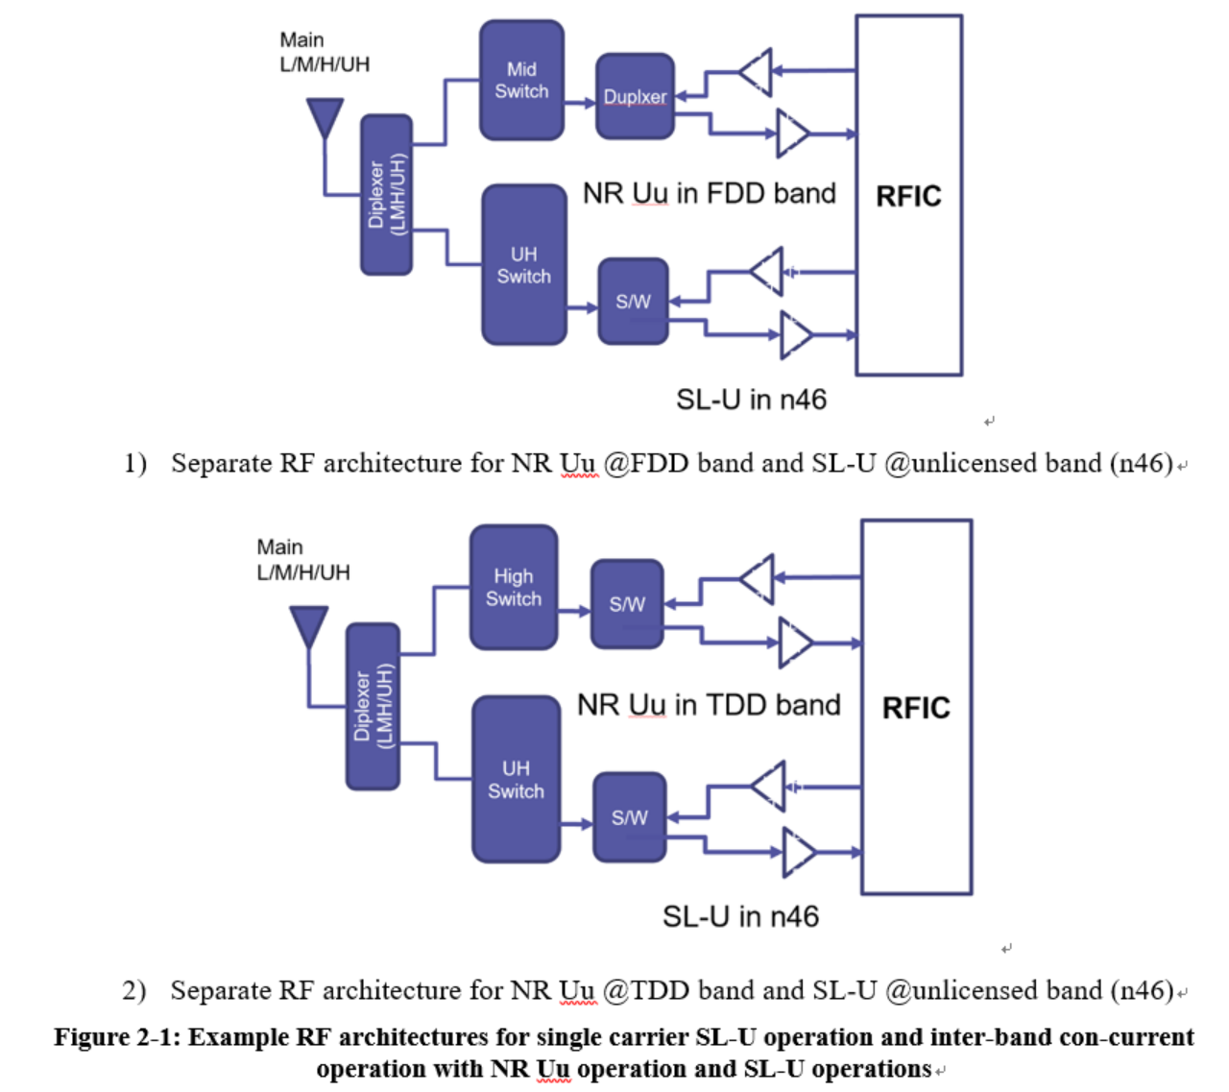  Proposal #1: The above separate RF architectures in Figure 2-1 are baseline to define detailed RF requirements for inter-band con-current operation in Rel-18.  Proposal #2: RAN4 can support the following power classes as total transmitted power for Maximum output Power of inter-band concurrent UE in Rel-18.  - 1st priority  - PC3 Uu@Licensed + PC5 SL@Un-licensed  - PC2 Uu@Licensed + PC5 SL@Un-licensed  - 2nd priority: PC3 SL@ unlicensed combinations will be treated as 2nd priority  - PC3 Uu@Licensed + PC3 SL@Un-licensed  - PC2 Uu@Licensed + PC3 SL@Un-licensed  - RAN4 define MOP per UE as the total transmitted power from each operating band  Proposal #3: RAN4 can define the configured Tx power for inter-band con-current SL-U operation UE as follow.  6.2E.xF.x.x Configured transmitted power for inter-band SL-U concurrent operation  When a UE is configured for simultaneous NR sidelink and NR uplink transmissions for inter-band con-current operation, the UE is allowed to set its configured maximum output power P_{CMAX,c,NR} and P_{CMAX,c,SL} for the configured NR uplink carrier and the configured NR SL carrier, respectively, and its total configured maximum output power P_{CMAX,c}.  The configured maximum output power P_{CMAX c,NR}(p) in slot p for the configured NR uplink carrier shall be set within the bounds:  P_{CMAX_L,c,NR} (p) ≤ P_{CMAX,c,NR} (p) ≤ P_{CMAX_H,c,NR} (p)  where P_{CMAX_L,c,NR} and P_{CMAX_H,c,NR} are the limit as specified in clause 6.2E.4.1.  The configured maximum output power P_{CMAX c,SL} (q) in slot q for the configured NR SL carrier shall be set within the bounds:  P_{CMAX_L,c,SL} (q) ≤ P_{CMAX,c,SL} (q) ≤ P_{CMAX_H,c,SL} (q)  where P_{CMAX_H,c,SL} is the limit as specified in clause 6.2E.4.  The total UE configured maximum output power P_{CMAX} (p,q) in a slot p of NR uplink carrier and a slot q of NR sidelink that overlap in time shall be set within the following bounds for synchronous and asynchronous operation unless stated otherwise:  P_{CMAX_L} (p,q) ≤ P_{CMAX} (p,q) ≤ P_{CMAX_H} (p,q)  with  P_{CMAX_L} (p,q) = MIN {10log₁₀ [p_{CMAX_L,c,NR} (p)+ p_{CMAX_L,c,SL} (q)], P_{PowerClass_CA}, P_{EMAX,CA}}  P_{CMAX_H} (p,q) = MIN {10 log₁₀ [p_{CMAX_H,c,NR} (p) + p_{CMAX_H,c,SL} (q)], P_{PowerClass_CA}, P_{EMAX,CA}}  where p_{CMAX_L,c,NR} and p_{CMAX_L,c,SL} are the respective limits P_{CMAX_L,c,NR} (p) and P_{CMAX_L,c,SL} (q) expressed in linear scale. Also the p_{CMAX_H,c,NR} and p_{CMAX_H,c,SL} are the respective limits P_{CMAX_H,c,NR} (p) and P_{CMAX_H,c,SL} (q) expressed in linear scale.  The measured total maximum output power P_{UMAX} over both the NR uplink and NR SL carriers is  P_{UMAX} = 10 log₁₀ [p_{UMAX,c,NR} + p_{UMAX,c,SL}],  where p_{UMAX,c,NR} denotes the measured output power of serving cell c for the configured NR uplink carrier, and p_{UMAX,c,SL} denotes the measured output power for the configured NR SL carrier expressed in linear scale.  When a UE is configured for synchronous NR sidelink and uplink transmissions,  P_{CMAX_L}(p, q) – T_{LOW} (P_{CMAX_L}(p, q)) ≤ P_{UMAX} ≤ P_{CMAX_H}(p, q) + T_{HIGH} (P_{CMAX_H}(p, q))  where P_{CMAX_L} (p,q) and P_{CMAX_H} (p,q) are the limits for the pair (p,q) and with the tolerances T_{LOW}(P_{CMAX}) and T_{HIGH}(P_{CMAX}) for applicable values of P_{CMAX} specified in Table 6.2E.x.x-1. P_{CMAX_L} may be modified for any overlapping portion of slots (p, q) and (p +1, q+1).  Proposal #4: RAN4 can reuse the UE coexistence requirements of the CA_n46-n78 UE for the UE coexistence requirements of the inter-band con-current SL-U UE with n78@licensed band + n46@Unlicensed band.  Proposal #5: RAN4 do not need to define the additional spurious emission requirements for inter-band con-current SL-U UE with n78@licensed band + n46@Unlicensed band. The individual additional spurious emission limits per each operating band will be applied for the n78 licensed band and n46 unlicensed band, respectively.  Proposal #6: RAN4 can reuse the existing CA_n46-n78 requirements to define REFSENS exception requirements for inter-band con-current SL-U UE with n78@licensed band + n46@Unlicensed band. Also the existing delta Tib/Rib values will be defined for the additional ILs terms for the example SL-U band combinations.
R4-2307479 | LG Electronics | Proposal 1: No need for further discussion on UE RF architecture for con-current operation.  Proposal 2: If there is no input on PC2 Uu@Lincensed in RAN4#107, do not consider PC2 Uu for con-current operation.  Proposal 3: Consider the maximum total transmit power to be used by the UE across all carriers in Uu and SL-U in FR1 which is indicated by NW (e.g, P_{EMAX,con-current}).  Proposal 4: Reuse the spurious emissions for UE co-existence of inter band CA_n46-n78 for con-current operation with Uu@78 + SL@n46.  Proposal 5: Not define the general spurious emission requirement for the con-current operation.  Proposal 6: Not define the additional spurious emission requirement for the con-current operation.  Proposal 7: Reuse MSD requirements of inter band CA_n46-n78 for con-current operation with Uu@78 + SL@n46 with clarification of n46 PC5, and with changing from UL to SL Tx, and from DL to SL Rx for n46.
R4-2307480 | LG Electronics | TP to TR on con-current operation on Uu and sidelink
R4-2308988 | OPPO | Observation 1: For Rel-16/17 NR SL inter-band concurrent operation, only PC3 is supported.  Observation 2: For Rel-16/17 NR SL inter-band concurrent operation, MOP is defined per each operating band.  Observation 3: The general spurious emission and additional spurious emission are not defined for inter-band concurrent operation in lgeacy NR SL.  Proposal 1: Not to consider PC2 for Uu@licensed in Rel-18 for inter-band concurrent operation.  Proposal 2: MOP is defined per each operating band in Rel-18 for inter-band concurrent operation.  Proposal 3: MPR/AMPR of NR uu and NR V2X are reused for uu@licensed + SL-U concurrent transmission.  Proposal 4: The configured transmitted power can follow the same approach as Rel-17 inter-band concurrenet operation.  Proposal 5: Use CA_n46-n78 co-existence reqeuirement as starting point for inter-band concurrent operation Rel-18.  Proposal 6: The general spurious emission and additional spurious emission are not needed for inter-band concurrent operation in Rel-18 SL-U.  Proposal 7: The CA MSD can be considered as the starting point of MSD for inter-band concurrent operation Rel-18.  TP to TR 38.786

Open issues summary
Before Meeting, moderators shall summarize list of open issues, candidate options and possible WF (if applicable) based on companies’ contributions.

Sub-topic 1-1 : General
Sub-topic description:
Open issues and candidate options before meeting:
Issue 1-1-1: RF architecture reference of Uu@Licensed and SL@Un-licensed
- Proposals
  - Option 1: Consider the separate RF architectures in Figure2-1 of R4-2307119 as baseline to define RF requirements for inter-band con-current operation in Rel-18 (Meta)
  - Option 2: No need for further discussion on UE RF architecture for con-current operation (LGE)
- Recommended WF
  - Moderator’s recommendation
  - RAN4 already agreed the basis of con-current operation in the last meeting. Regarding the agreement, further discussion on whether to need to consider the separate UE RF architecture as a baseline seems be not needed
    - Consider the functionality and requirements of single carrier SL-U operation as a basis of SL-U in con-current operation
    - Consider the functionality and requirements of single carrier Uu operation as a basis of Uu in con-current operation
  - Regarding the agreement, further discuss whether to need to consider the separate UE RF architecture as a baseline or not, to define RF requirements for the inter-band con-current operation.

Sub-topic 1-2 : Tx requirements of con-current operation
Sub-topic description
Open issues and candidate options before meeting:
Issue 1-2-1: MOP for Uu@Licensed and SL@Un-licensed
- Proposals
  - Option 1: Define MOP as the total transmitted power from each operating band (LGE, Meta)
  - Option 2: Define MOP per each operating band in Rel-18 (Oppo)
- Recommended WF
  - Make agreement after discussion

Issue 1-2-2: Targeted Power Class combinations for Uu@Licensed and SL@Un-licensed
- Proposals
  - Option 1: Consider PC2 for Uu@licensed along with PC3, and PC3 for SL@Un-license as 2nd priority.
  - 1st priority
    - PC3 Uu@Licensed + PC5 SL@Un-licensed
    - PC2 Uu@Licensed + PC5 SL@Un-licensed
  - 2nd priority: PC3 SL@ unlicensed combinations will be treated as 2nd priority
    - PC3 Uu@Licensed + PC3 SL@Un-licensed
    - PC2 Uu@Licensed + PC3 SL@Un-licensed
  - Option 2: Not consider PC2 for Uu@licensed in Rel-18 for inter-band concurrent operation (Oppo)
  - Option 2a: Not consider PC2 for Uu@licensed in Rel-18 for inter-band concurrent operation if there is no input on PC2 Uu@Lincensed in RAN4#107 (LGE)
- Recommended WF
  - Moderator’s recommendation
  - RAN4 already agreed the basis of con-current operation in the last meeting. Based on the agreement, the points to be discussed are whether to consider or not PC2 for Uu@licensed for inter-band concurrent operation in Rel-18.
    - PC3 Uu@Licensed + PC5 SL@Un-licensed
    - PC3 Uu@Licensed + PC3 SL@Un-licensed can be considered as 2nd priority if PC3 SL is agreed in a single carrier at unlicensed band
  - Recommended proposals
  - Option 1: Consider PC2 for Uu@licensed in Rel-18 for inter-band concurrent operation
  - Option 2: Not consider PC2 for Uu@licensed in Rel-18 for inter-band concurrent operation

Issue 1-2-3: Configured transmitted power for Uu@Licensed and SL@Un-licensed
- Proposals
  - Option 1: Apply the principle of the configured transmitted power of NR inter-band CA for the total UE configured maximum output power P_{CMAX} (p,q) in a slot p of NR uplink carrier and a slot q of NR sidelink (Meta)
  - P_{CMAX_L (p,q)} = MIN {10log10 [p_{CMAX_L,c,NR} (p)+ p_{CMAX_L,c,SL} (q)], P_{PowerClass_CA}, P_{EMAX,CA}}
  - P_{CMAX_H (p,q)} = MIN {10 log10 [p_{CMAX_H,c,NR} (p) + p_{CMAX_H,c,SL} (q)], P_{PowerClass_CA}, P_{EMAX,CA}}
  - Option 2: Consider the maximum total transmit power to be used by the UE across all carriers in Uu and SL-U in FR1 which is indicated by NW (e.g., P_{EMAX,con-current}). (LGE)
  - Option 3: Follow the same approach as Rel-17 inter-band concurrent operation (Oppo)
- Recommended WF
  - Make agreement after discussion

Issue 1-2-4: UE coexistence requirements for Uu@Licensed and SL@Un-licensed
- Proposals
  - Option 1: Reuse the inter band CA_n46-n78 co-existence requirement for con-current operation with Uu@78 + SL@n46 (LGE, Meta).
  - Option 1a: Use the inter band CA_n46-n78 co-existence requirement as starting point for con-current operation with Uu@78 + SL@n46 (Oppo)
- Recommended WF
  - Agreeable with Option 1

Issue 1-2-5: MPR/A-MPR for Uu@Licensed and SL@Un-licensed
- Proposals
  - Option 1: Reuse MPR/AMPR of NR uu and NR V2X for uu@licensed + SL-U concurrent transmission (Oppo).
- Recommended WF
  - Moderator’s recommendation
  - Option 1 is not different from the agreement in the last RAN4 meeting.
  - Agreement in RAN4#106bis-e.
    - Consider the existing requirement of NR V2X con-current operation as baseline with followings
      - Refer to the existing requirement for NR Uu
      - Refer to the SL-U requirement if specified
  - Agreeable with Option1.

Issue 1-2-6: General spurious emission for Uu@Licensed and SL@Un-licensed
- Proposals
  - Option 1: The general spurious emission is not needed for inter-band concurrent operation in Rel-18 (Oppo, LGE,).
- Recommended WF
  - Agreeable with Option1.

Issue 1-2-7: Additional spurious emission for Uu@Licensed and SL@Un-licensed
- Proposals
  - Option 1: The additional spurious emission is not needed for inter-band concurrent operation in Rel-18 (Oppo, LGE, Meta).
- Recommended WF
  - Agreeable with Option1.

Issue 1-2-8: delta Tib for Uu@Licensed and SL@Un-licensed
- Proposals
  - Option 1: Reuse the existing delta Tib of CA_n46-n78 for inter-band concurrent operation in Rel-18. (Meta)
- Recommended WF
  - Agreeable with Option 1

Sub-topic 1-3 : Rx requirements of con-current operation
Sub-topic description
Open issues and candidate options before meeting:
Issue 1-3-1: MSD for Uu@Licensed and SL@Un-licensed
- Proposals
  - Option 1: Reuse the existing CA_n46-n78 MSD requirements for MSD of the inter-band concurrent operation (Meta)
  - Option 2: Reuse the existing CA_n46-n78 MSD requirements for MSD of the inter-band concurrent operation, if power class 5 was assumed for the aggressor band n46 in the existing MSD requirement (LGE)
  - Option 3: Consider the existing CA_n46-n78 MSD requirements as the starting point of MSD for the inter-band concurrent operation (Oppo).
- Recommended WF
  - Consider Option 2 as baseline

Issue 1-3-2: delta Rib for Uu@Licensed and SL@Un-licensed
- Proposals
  - Option 1: Reuse the existing delta Rib of CA_n46-n78 for inter-band concurrent operation in Rel-18. (Meta)
- Recommended WF
  - Agreeable with Option 1

Topic #2: Co-channel coexistence for LTE SL & NR SL
Main technical topic overview. The structure can be done based on sub-agenda basis.

Companies’ contributions summary
T-doc number | Company | Proposals / Observations
R4-2308114 | Nokia, Nokia Shanghai Bell | Proposal 1: No need to consider power imbalance between LTE SL and NR SL simultaneous reception in sidelink co-channel coexistence.  Proposal 2: Tx switching from in-device coexistence from Release 16 can be assumed for sidelink co-channel coexistence.  Proposal 3: RAN4 to wait for RAN1 to conclude on a synchronization framework for sidelink co-channel coexistence before discussing on the synchronization impact to RF requirements.
R4-2308416 | LG Electronics Finland | Proposal 1: RAN4 should analyze if additional functionality or requirements are needed to ensure that NR SL UEs follow the behavior as shown in Figure 3.2 C and/or 3.2D. Is there a need for NR SL / LTE SL co-channel co-existence requirement for 30kHz SCS NR SL UE that ensures that power of the 2nd slot is never higher than the power of the 1st slot (relative requirement)?  In addition, RAN4 should analyze if this beahvior that ensures the co-channel coexistence can impact some other minimum performance requirements. One example here can be the P_{UMAX,f,c}, which shall be within the bounds:  P_{CMAX_L,f,c} – MAX{T_{L,c}, T(P_{CMAX_L,f,c})} ≤ P_{UMAX,f,c} ≤ P_{CMAX_H,f,c} + T(P_{CMAX_H,f,c})  as specified in 6.2.4 in table 6.2.4-1.  In case that clarification in P_{UMAX,f,c} requirement is deemed necessary it could be clarified that P_{UMAX,f,c} tolerances are increased in case of co-channel coexistence or that P_{UMAX.f.c} needs to be measured using the 1st slot only.  Proposal 2: In case that clarification in P_{UMAX,f,c} requirement is deemed necessary it could be clarified that P_{UMAX,f,c} tolerances are increased in case of co-channel coexistence or that P_{UMAX.f.c} needs to be measured usinf the 1st slot only.  Proposal 3: The power imbalance requirement with two links for NR V2X is defined using 30kHz SCS for both interfering and victim UE, but the demodulation requirement is set only for the victim. As interfering signal in this test case is basically acting as strong interfering signal, that impacts the AGC, it is fair to assume that this already defined test case also models the scenarios for co-channel coexistence for NR V2X.
R4-2308608 | Huawei, HiSilicon | Proposal 1: RAN4 need to confirm that we only consider TDM for the transmission manner of co-channel coexistence.  Proposal 2: The Rel-16 ITS time mask defined for LTE SL and NR SL can be reused for Rel-18 co-channel co-existence for NR sidelink and LTE sidelink.  Proposal 3: The AGC adjustment time should be based on the symbol length of LTE. When there is conclusion for AGC adjustment for co-channel coexistence, LS with the information should be sent to RAN1.  Proposal 4: Send RAN1 an LS with the AGC adjustment time for co-channel coexistence, if RAN4 have the conclusion.
R4-2308983 | OPPO | Observation 1: RAN1 agreement is in-line with RAN4 assumption.  Observation 2: The different numerology as LTE SL with 15kHz SCS and NR SL with 30kHz SCS will cause AGC issue.  Observation 3: For 30kHz SCS issue, RAN1 has agreed a power level limitation to solve the issue and it is up to implementation,  Observation 4: The inter-band EN-DC power imbalance requirement is to measure of the receiver’s ability to receive a wanted signal (LTE or NR) in the presence of another carrier signal (NR or LTE) with 25dB power imbalance at a specific frequency offset from the wanted signal.  Observation 5: The LTE SL and NR SL co-existence scenario is similar to the inter-band EN-DC with overlapping DL.  Observation 6: The legacy NR and LTE switching time mask has considered the RRM scheduling restriction requirement.  Proposal 1: To introduce similar RF RX power imbalance requirement for LTE SL and NR SL co-existence.  Proposal 2: To reuse the TX switching time mask, the RRM scheduling restriction should be also agreed for LTE and NR switching in co-existence scenario.

Open issues summary
Before Meeting, moderators shall summarize list of open issues, candidate options and possible WF (if applicable) based on companies’ contributions.

Sub-topic 2-1 : LTE SL and NR SL co-channel coexistence scenarios
Sub-topic description:
Open issues and candidate options before meeting:
Issue 2-1-1: Study on requirements for LTE SL and NR SL co-channel coexistence scenario
- Proposals
  - Option 1: Confirm that only TDM is considered for the transmission manner of co-channel coexistence (Huawei)
- Recommended WF
  - Agreeable with Option 1

Issue 2-1-2: RF on Rx power imbalance for LTE SL and NR SL co-channel coexistence scenario
- Proposals
  - Option 1: Introduce the RF RX power imbalance requirement for LTE SL and NR SL co-existence similar to the inter-band EN-DC with overlapping DL(Oppo)
  - Option 2: No need to consider power imbalance between LTE SL and NR SL simultaneous reception in sidelink co-channel coexistence (Nokia)
- Recommended WF
  - Make agreement after discussion

Issue 2-1-3: Demodulation on Rx power imbalance for LTE SL and NR SL co-channel coexistence scenario
- Proposals
  - Option 1: The power imbalance requirement with two links for NR V2X is defined using 30kHz SCS for both interfering and victim UE, but the demodulation requirement is set only for the victim. As interfering signal in this test case is basically acting as strong interfering signal, that impacts the AGC, it is fair to assume that this already defined test case also models the scenarios for co-channel coexistence for NR V2X (LGE)
  - Option 2: No need to consider power imbalance between LTE SL and NR SL simultaneous reception in sidelink co-channel coexistence (Nokia)
- Recommended WF
  - Make agreement after discussion

Issue 2-1-4: AGC implact due to the different numerology as LTE SL with 15kHz SCS and NR SL with 30kHz SCS for LTE SL and NR SL co-channel coexistence scenario
- Proposals
  - Option 1: The AGC adjustment time should be based on the symbol length of LTE. When there is conclusion for AGC adjustment for co-channel coexistence, LS with the information should be sent to RAN1 (Huawei)
- Recommended WF
  - Make agreement after discussion

Issue 2-1-5: RF requirement impact due to NR 2nd slot power limitation of RAN1 agreement for LTE SL and NR SL co-channel coexistence scenario)
- Proposals
  - Option 1: (LGE)
  - RAN4 should analyze if additional functionality or requirements are needed to ensure that NR SL UEs follow the behavior as RAN1 agreement.
  - RAN4 should analyze if this beahvior that ensures the co-channel coexistence can impact some other minimum performance requirements. One example here can be the P_{UMAX,f,c}.
  - In case that clarification in P_{UMAX,f,c} requirement is deemed necessary it could be clarified that P_{UMAX,f,c} tolerances are increased in case of co-channel coexistence or that P_{UMAX.f.c} needs to be measured usinf the 1st slot only
- Recommended WF
  - For information: RAN1 agreement
Agreement (RAN1#112bis-e)
For NR SL transmissions of 30kHz SCS with dynamic resource pool sharing, the power level of the NR PSCCH/PSSCH transmission in the first of NR SL slots overlapping with an LTE SL subframe is always larger than or equal to the power level(s) of the NR PSCCH/PSSCH transmission in the subsequent NR SL slot overlapping with the LTE SL subframe.
- Note: How to ensure the above condition is up to UE implementation
- FFS on whether same or different frequency allocation may be used in the second overlapping slot

  - Make agreement after discussion

Issue 2-1-6: TX switching between LTE SL and NR SL for co-channel coexistence scenario
- Proposals
  - Option 1: Reuse Rel-16 ITS time mask defined for LTE SL and NR SL (Oppo, Huawei, Nokia)
  - RRM scheduling restriction should be also agreed for LTE and NR switching in co-existence scenario (Oppo)
- Recommended WF
  - Agreeable with Option 1

Issue 2-1-7: Synchronization impact to RF requirement for LTE SL and NR SL co-channel coexistence scenario
- Proposals
  - Option 1: RAN4 to wait for RAN1 to conclude on a synchronization framework for sidelink co-channel coexistence before discussing on the synchronization impact to RF requirements (Nokia)
- Recommended WF
  - Agreeable with Option 1

