3GPP TSG RAN WG4 Meeting #107 *R4-2308925*

**Incheon, KR, May 22 – May 26, 2023**

**Agenda Item:** 8.5.1.3.1

**Source:** MediaTek Inc.

**Title:** Further discussion on low-MSD capability signalling

**Document for:** Discussion

# 1. Introduction

In RAN4 #106-bis-e, WF [1] has been agreed for low MSD study WI. The contribution provides further discussion.

# 2. Discussion

During RAN4#106-bis-e meeting, signalling method for UE supporting low MSD has been discussed but not not concluded yet. Options were left in the WF and are copied below,

### Sub-topic 1-1: Conditions to indicate the lower MSD capability

* Candidate options
* Option 1: For the purpose of MSD improvement, if the minimum requirement for a given REFSENS exception case falls into the interval of MSD ≤ Thi dB, the actual MSD should be at least one-level lower (i.e., actual MSD ≤ Thi-1 dB) in order for the UE to report the low-MSD capability. If the actual MSD is larger than the maximum threshold ThM-1 (i.e. out of range), the UE cannot report low-MSD capability for this REFSENS exception case **(Samsung, Xiaomi, Nokia, AT&T, Skyworks, HW**)
* If UE reports the lower MSD capability, the reported MSD value should be improved at least by TBD dB against a specified MSD
* Option 2: For the purpose of MSD improvement, if the minimum requirement for a given REFSENS exception case falls into the interval of MSD ≤ Thi dB, the actual MSD should be at least one-level lower (i.e., actual MSD ≤ Thi-1 dB) in order for the UE to report the low-MSD capability. If the actual MSD is larger than the maximum threshold ThM-1 (i.e. out of range), the UE cannot report low-MSD capability for this REFSENS exception case (**QC, OPPO, vivo**)
* ~~If UE reports the lower MSD capability, the reported MSD value should be improved at least by TBD dB against a specified MSD~~
* Option 3: Others (**Meta, MediaTek, Apple**)
* WF

Further discuss the listed options.

An LS is also sent to RAN2 to inform on defining one set of absolute multiple thresholds for lower MSD for considering on threshold-based low MSD reporting approach in which respective MSD indication of corresponding threshold(s) are reported with one of the thresholds listed in the set.

**Observation 1: LS[4] is only applicable on threshold-based reporting approach, not for non-threshold based approach**

We can see there are two different approach basically. One is threshold-based lower MSD reporting, the other is directly reported lower MSD values. It has been extensively discussed for threshold-based low-MSD reporting on how to decide values/granularity on the threshold table. Here we provide another thinking on direct reporting low-MSD values approach. In existing specs, MSD due to second or third order harmonic or IMD may have larger values from 20 to 30+ while higher order may have only a few dB (<5~10dB). For some cases with a few dB MSD, even 1dB improvement could be significant. And it is up to network to judge whether the improvement is useful and how it affects network behavior.

As for how to report the lower MSD capability, several promising options for allowing a UE to signal improved lower MSD performance have been discussed[1]. It is also agreed that the MSD mechanisms, orders and values in existing specs shall all be considered as starting point. Considering there are many MSD mechanisms and the power class of aggressor as well as the order of aggressor could be up to 9 in existing specs. The basic low-MSD information shall include terms mentioned above per RAN4 agreement. It is also agreed if new MSD type is identified and specified by RAN4 in the future, the new MSD type can also be considered for indicating lower MSD capability[1]. RAN4 has agreed essential information shall include below information:

* ***Victim band***
* ***MSD type (harmonic; harmonic mixing; cross band isolation; IMD) with orders***
* ***MSD value/thresholds***

**Observation 2: The lower MSD capability signaling can be specified as per victim band per BC as a 2-tuple of < MSD mechanism/Aggressor power class and its order, MSD value > as below examples can save 1-tuple signaling overhead on adaptive network signaling approach.**

Table 1: Information element examples of improved MSD reporting per BC for non-threshold based approach.

|  |  |
| --- | --- |
| MSD in TS 38.101-1 | MSD information unit |
|  | For CA_n1-n3:  Victim n1: <PC3IMD3, 17>  For CA_n1-n78:  Victim n1: <PC3IMD4, 4>  For CA_n3-n78:  Victim n3: <PC3IMD2, 19>  Victim n3: <PC3IMD4, 4>  Victim n3: <PC3IMD7, 0> |
|  | For CA_n1-n3-n78:  Victim n78: <PC3IMD2, 19>  Victim n78: <PC3IMD4, 6>  Victim n3: <PC3IMD2, 19> |
|  | For CA_n3-n78:  Victim n78: <PC3UL2DL1, 17> |
|  | For CA_n1-n3:  Victim n3: <PC3XB, 11> |

Same 2-tuple information can be applicable for threshold-based also as below examples,

Table 2: Information element examples of improved MSD reporting per BC for threshold-based approach.

|  |  |
| --- | --- |
| MSD in TS 38.101-1 | MSD information unit |
|  | For CA_n1-n3:  Victim n1: <PC3IMD3, index 7>  For CA_n1-n78:  Victim n1: <PC3IMD4, index 2>  For CA_n3-n78:  Victim n3: <PC3IMD2, index 7>  Victim n3: <PC3IMD4, index 3>  Victim n3: <PC3IMD7, index 2> |
|  | For CA_n1-n3-n78:  Victim n78: <PC3IMD2, index 7>  Victim n78: <PC3IMD4, index 2>  Victim n3: <PC3IMD2, index 7> |
|  | For CA_n3-n78:  Victim n78: <PC3UL2DL1, index 6> |
|  | For CA_n1-n3:  Victim n3: <PC3XB, index 4> |

where the reported index can be pointed to an agreed MSD values table like example 3-bits index table below. If there is only 2-bits(4 steps) on the MSD threshold, it might be too rough.

Table 3: Actual MSD values

|  |  |
| --- | --- |
| Index | Actual MSD range (dB) |
| 0 | 0 ≤ Actual MSD ≤ 3 |
| 1 | 3 ＜ Actual MSD ≤ 6 |
| 2 | 6 ＜ Actual MSD ≤ 9 |
| 3 | 9 ＜ Actual MSD ≤ 12 |
| 4 | 12 ＜ Actual MSD ≤ 15 |
| 5 | 15 ＜ Actual MSD ≤ 18 |
| 6 | 18 ＜ Actual MSD ≤ 21 |
| 7 | 21 ＜ Actual MSD ≤ 24 |

***Proposal 1: We propose below 3-bits index table for threshold-based low-MSD reporting.***

|  |  |
| --- | --- |
| ***Index*** | ***Actual MSD range (dB)*** |
| ***0*** | ***0 ≤ Actual MSD ≤ 3*** |
| ***1*** | ***3 ＜ Actual MSD ≤ 6*** |
| ***2*** | ***6 ＜ Actual MSD ≤ 9*** |
| ***3*** | ***9 ＜ Actual MSD ≤ 12*** |
| ***4*** | ***12 ＜ Actual MSD ≤ 15*** |
| ***5*** | ***15 ＜ Actual MSD ≤ 18*** |
| ***6*** | ***18 ＜ Actual MSD ≤ 21*** |
| ***7*** | ***21 ＜ Actual MSD*** |

***We also propose low-MSD singling in granularity of 1dB for non-threshold based reporting.***

As for how to report the lower MSD capability, several promising options for allowing a UE to signal improved lower MSD performance have been discussed[1]. It is also agreed that the MSD mechanisms, orders and values in existing specs shall all be considered as starting point. With the introduction of the improved MSD feature, it may bring huge signaling overhead impact and larger memory size for both UE and BS for implementation. How to reduce these signaling overhead become an important topic. From network implementation, it may use pre-planned frequency resources and may be interested in a very limited number of band combinations. Some signaling design on reduction of signaling overhead from network perspective were mentioned in [3]. We also provided some idea on adaptive signaling approach. Network can require UE only to report the top K largest MSD values together with its mechanism indexing and improved MSD values. For example: if K=1, Network scheduling with reference on top largest value of reported lower MSD. The signaling flow is illustrated as below figures:

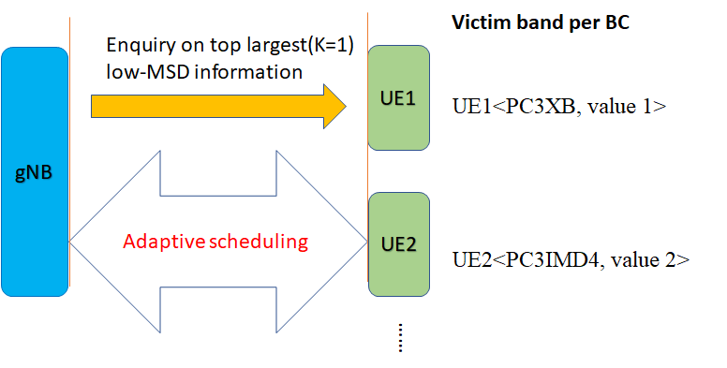

**Figure 1 Example illustration of network query on low-MSD information, K=1**

Or alternative low-MSD signaling expression with index:

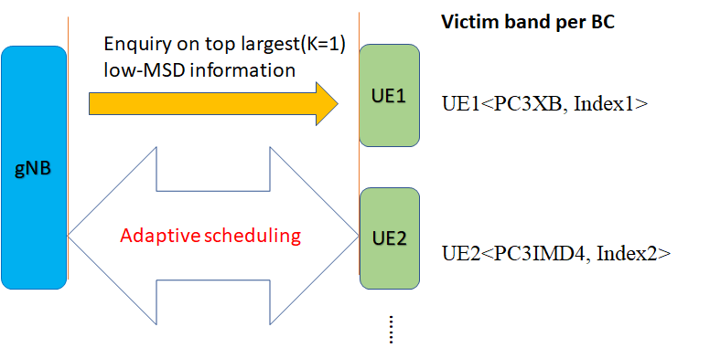

**Figure 2 Example illustration of network query on low-MSD information, K=1**

With such adaptive signalling approach, UE does not need to report all low-MSD information over all supported band combinations. UE may also not need to restore all improved low-MSD points, it only needs to restore top K largest low-MSD information which can save the size of UE memory to smaller one. Network also does not need to restore large amount of low-MSD information that only a few of them are interested band combinations.

**Observation 3: An adaptive signaling approach that network can require UE only to report the top K largest MSD values together with its mechanism indexing and improved MSD values can save large amount of signaling overhead**

***Proposal 2 RAN4 consider both threshold-based approach and non-threshold-based approach to indicate the lower MSD capability***

***Proposal 3 RAN4 down select for each type of approach***

# 3. Conclusion

**Observation 1: LS[4] is only applicable on threshold-based reporting approach, not for non-threshold based approach**

**Observation 2: The lower MSD capability signaling can be specified as per victim band per BC as a 2-tuple of < MSD mechanism/Aggressor power class and its order, MSD value > as below examples can save 1-tuple signaling overhead on adaptive network signaling approach.**

***Proposal 1: We propose below 3-bits index table for threshold-based low-MSD reporting.***

|  |  |
| --- | --- |
| ***Index*** | ***Actual MSD range (dB)*** |
| ***0*** | ***0 ≤ Actual MSD ≤ 3*** |
| ***1*** | ***3 ＜ Actual MSD ≤ 6*** |
| ***2*** | ***6 ＜ Actual MSD ≤ 9*** |
| ***3*** | ***9 ＜ Actual MSD ≤ 12*** |
| ***4*** | ***12 ＜ Actual MSD ≤ 15*** |
| ***5*** | ***15 ＜ Actual MSD ≤ 18*** |
| ***6*** | ***18 ＜ Actual MSD ≤ 21*** |
| ***7*** | ***21 ＜ Actual MSD*** |

***We also propose low-MSD singling in granularity of 1dB for non-threshold based reporting.***

**Observation 3: An adaptive signaling approach that network can require UE only to report the top K largest MSD values together with its mechanism indexing and improved MSD values can save large amount of signaling overhead**

***Proposal 2 RAN4 consider both threshold-based approach and non-threshold-based approach to indicate the lower MSD capability***

***Proposal 3 RAN4 down select for each type of approach***

Reference:

1. R4-2306590 WF on lower MSD, RAN4#106-bis-e
2. R4-2304870 Discussion on possible Lower MSD signalling approaches, RAN4#106-bis-e
3. R4-2306593 TP for TR 38.881 on the signalling design for low-MSD capability, RAN4#106-bis-e
4. R4-2306594 draft LS on lower MSD capability