**3GPP TSG-RAN WG4 Meeting #107 R4-23xxxxx  
Incheon, KR, May 22 – May 26, 2023**

**Agenda item:** 4.7

**Source:** OPPO

**Title:** Summary [107][101] Upto_R16_UERF_maintenance

**Document for:** Information

# Introduction

This is the adhoc summary for Rel-15/16 maintenance under agenda 4.1 which includes 145 papers in total (CAT F+A) and 73 papers with CAT-F.

**List of topics below:**

* Topic #1: dualPA-Architecture capability (1)
* Topic #2: UE co-existence requirement (20)
* Topic #3: PC1.5 for NS_47 (3)
* Topic #4: Power scaling and UL CA Pcmax (3)
* Topic #5: PMPR for PRACH (1)
* Topic #6: EVM measurement for UL MIMO (3)
* Topic #7: EVM for shorter transient period (1)
* CRs for 38.101-1 (21)
* CRs for 38.101-2 (2)
* CRs for 38.101-3 (10)
* CRs for 38.307 (2)
* CRs for 36.101 (2)

# Topic #1: dualPA-Architecture capability (1)

## Contributions summary

|  |  |  |
| --- | --- | --- |
| **T-doc number** | **Company** | **Proposals / Observations** |
| R4-2307044 | Anritsu | Discussion on definition of dualPA-Architecture capability indication for intra-band UL CA  Observation 1: There are currently no cases where TxD or MIMO is used and where dualPA-Architecture capability is reported.  Observation 2: The two cases requiring reporting of dualPA-Architecture capability were introduced in Rel-16, no new case was introduced in Rel-17 and there is no plan in Rel-18 to introduce a new case.  Observation 3: Different sentences for FR1 and FR2 may help understand and avoid confusion.  Proposal 1: The definition in the 38.306 could highlight that “dualPA-Architecture capability is not reported for either intra-band CA + TxD or intra-band CA + UL MIMO as a single LO is used.”  Proposal 2: Have different sentences for FR1 and FR2 to avoid confusion for FR2.  Proposal 3: Send a LS to RAN2 to request a modification of the definition of dualPA-Architecture capability indication for intra-band UL CA in the TS 38.306. |

## Open issues summary

### Sub-topic 1-1

**Issue 1-1-1: Clarification of** ***dualPA-Architecture* capability**

* Proposals: [R4-2307044 Anritsu]
* **Proposal 1:** The definition in the 38.306 could highlight that “*dualPA-Architecture* capability is not reported for either intra-band CA + TxD or intra-band CA + UL MIMO as a single LO is used.”
* **Proposal 2:** Have different sentences for FR1 and FR2 to avoid confusion for FR2.
* **Proposal 3:** Send a LS to RAN2 to request a modification of the definition of dualPA-Architecture capability indication for intra-band UL CA in the TS 38.306.

Moderator note:

Current *dualPA-Architecture* capability in 38.306:

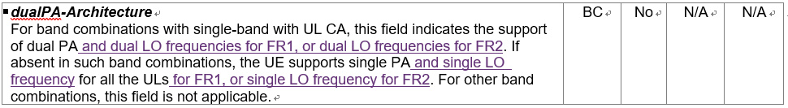

Proposed change to *dualPA-Architecture* capability, especially the yellow highlighted:

| ***dualPA-Architecture***  For NR CA band combinations with two UL CCs in the same band, this field indicates for FR1 that the uplink part is supported by one PA and one LO frequency per CC i.e. dual PAs each with an LO/DC location that can be indicated.  The same field indicates in case of FR2 that the uplink part is supported by one LO frequency per CC i.e. each having an LO/DC location that can be indicated, it does not indicate any specific number of PAs.  If the field is absent for such a band combination, the uplink part is supported by a single PA and one LO/DC location in the case of FR1, and by one LO/DC location in the case of FR2 (no indication of any specific number of PAs). This field does not indicate a specific number of PAs when present or absent in the case of FR2.  DualPA-Architecture capability is not reported for either “intra-band CA + TxD” or “intra-band CA + UL MIMO” as a single LO frequency is used.  For other NR CA band combinations, this field is not applicable. | BC | No | N/A | N/A |
| --- | --- | --- | --- | --- |

**Issue 1-1-2: LS to RAN2 on Clarification of *dualPA-Architecture* capability [R4-2307044 Anritsu]**

|  |  |  |  |  |  |
| --- | --- | --- | --- | --- | --- |
| **1. Overall Description:**  *dualPA-Architecture* capability was originally introduced in Rel-15 to indicate whether UE using one PA or two PAs to support the intra-band UL CA and during the discussion of Rel-16 FR1 RF enhancements RAN4 extended the meaning of this capability to also imply the number of UE LO frequencies in supporting intra-band UL CA is not singular in FR1. During the discussion of Rel-17 FR1 RF enhancements, RAN4 clarified the implication and also applied it to FR2 as well. Therefore, RAN4 would like to respectfully ask RAN2 to extend the meaning of *dualPA-Architecture* capability in TS38.306 from Rel-16 if there is no NBC issue. The proposed changes are as below for consideration:   | ***dualPA-Architecture***  For NR CA band combinations with two UL CCs in the same band, this field indicates for FR1 that the uplink part is supported by one PA and one LO frequency per CC i.e. dual PAs each with an LO/DC location that can be indicated.  The same field indicates in case of FR2 that the uplink part is supported by one LO frequency per CC i.e. each having an LO/DC location that can be indicated, it does not indicate any specific number of PAs.  If the field is absent for such a band combination, the uplink part is supported by a single PA and one LO/DC location in the case of FR1, and by one LO/DC location in the case of FR2 (no indication of any specific number of PAs). This field does not indicate a specific number of PAs when present or absent in the case of FR2.  DualPA-Architecture capability is not reported for either “intra-band CA + TxD” or “intra-band CA + UL MIMO” as a single LO frequency is used.  For other NR CA band combinations, this field is not applicable. | BC | No | N/A | N/A | | --- | --- | --- | --- | --- | |

# Topic #2: UE co-existence requirement (20)

## Contributions summary

|  |  |  |
| --- | --- | --- |
| **T-doc number** | **Company** | **Proposals / Observations** |
| R4-2307117 | CAICT | Discussion on spurious emission for UE co-existence requirement  **Observation 1:** There are quite a lot inconsistencies between Releases in RAN4 specs for requirements of spurious emission for UE co-existence (The reasonable inconsistencies are excluded).  **Observation 2:** For all the single bands included in TS 38.521-1 v17.7.0, the inconsistencies between Releases in RAN4 specs mainly include three scenarios:   1. More protected bands were introduced in later Release, but were not added to previous Releases(e.g., n25, n38, n41, n51, n77...). This is the most common scenario. 2. Some protected bands were removed in later Releases, but were still kept in previous Release(e.g., n50,n78,n74). 3. Protected band was changed from NR band to LTE band in later Release (Note was also changed), but was still kept unchanged in previous Release(e.g., n70).   **Observation 3:** Spurious emission is a regulatory requirement. For regulatory requirements that a UE must meet, RAN4's tradition is to start to update from the earliest Release of spec that a Band has been defined. Some RAN4 delegates followed this tradition (e.g., [4][5][8]), while some RAN4 delegates did not follow this tradition and just updated the latest Release at the time their CRs were submitted (e.g., [6][7][10][11]).  **Proposal 1:** Protected bands shall always be updated from the earliest Release of RAN4 spec that a 3GPP band has been defined to ensure new designed UEs with any Release will not interfere the new co-existent systems.  **Proposal 2:** Spurious emission for UE co-existence requirements in Release 15/16/17 specs of 38.101-1/2/3, Release 17 spec of 38.101-5 and Release 8/9/10/11/12/13/14/15/16/17 specs of 36.101 shall be updated to align with the requirements in Release 18 specs.  **Observation 4:** UE shall consider the spurious emission of all protected bands included in the latest **Version** of spec at the stage of its design. Certification organization has means to ensure the newly introduced protected bands in later **Versions** of specs will not have impact on existing UE implementation.  **Proposal 3:** UE shall consider the spurious emission of all protected bands included in the latest **Version** of spec at the stage of its design. It is up to certification organization to decide which **Version** of spec can be accepted for UE certification.  **Observation 5:** Some inconsistencies between Releases in RAN4 specs for requirements of spurious emission for UE co-existence are not intentional, but consequence of negligence. With more and more Releases coming up, the inconsistencies will be more and more serious as it is too easy to forget to update the specs of all the previous Releases (e.g., It is not easy for delegates to submit 11 LTE correction CRs from Rel-8 to Rel-18 simultaneously).  **Proposal 4:** Requirement for Spurious emission for UE co-existence shall be Release independent. RAN4 shall reach the agreement that the latest Release of RAN4 spec is the reference for the correct requirements of Spurious emission for UE co-existence of all Releases. |
| R4-2307101 | CAICT | Correction of UE co-existence requirement in 36.101 Rel-15 |
| R4-2307102 | CAICT | Correction of UE co-existence requirement in 36.101 Rel-16 |
| R4-2307103 | CAICT | Correction of UE co-existence requirement in 36.101 Rel-17 |
| R4-2307104 | CAICT | Correction of UE co-existence requirement in 38.101-1 Rel-15 |
| R4-2307105 | CAICT | Correction of UE co-existence requirement in 38.101-1 Rel-16 |
| R4-2307106 | CAICT | Correction of UE co-existence requirement in 38.101-1 Rel-17 |
| R4-2307107 | CAICT | Correction of UE co-existence requirement in 38.101-2 Rel-15 |
| R4-2307108 | CAICT | Correction of UE co-existence requirement in 38.101-2 Rel-16 |
| R4-2307109 | CAICT | Correction of UE co-existence requirement in 38.101-3 Rel-15 |
| R4-2307110 | CAICT | Correction of UE co-existence requirement in 38.101-3 Rel-16 |
| R4-2307111 | CAICT | Correction of UE co-existence requirement in 38.101-3 Rel-17 |
| R4-2307112 | CAICT | Correction of UE co-existence requirement in 38.101-5 Rel-17 |
| R4-2307296 (R15)  CAT-A:  R4-2307297 (R16)  R4-2307298 (R17)  R4-2307299 (R18) | NTT DOCOMO | CR for 800MHz frequency range protection from n5 for UE coexistence R15 |
| R4-2307300 (R16)  CAT-A:  R4-2307301 (R17)  R4-2307302 (R18) | NTT DOCOMO | CR for 800MHz frequency range protection from n26 for UE coexistence R16 |
| R4-2308960 | OPPO | R15 clarification of UE coexistence frequency range  Observation 1: In the section of General spurious emission, it clearly says that the spurious emission limits apply for the frequency ranges more than FOOB.  Observation 2: In the section of UE coexistence spurious emissions, NOTE 15 was used to clarify the applicable frequency range. If frequency range within FOOB need to be protected by a band, NOTE 15 need to be added.  Observation 3: To align TE implementations, clarification sentences were proposed in the UE coexistence section.  Observation 4: There were operator concerns on n5 not protecting n26 within FOOB due to without NOTE 15 in the coexistence table, while there is also UE vendor concerns on mandating legacy UE to protect n26 within FOOB.  Proposal: The clarification of UE coexistence applicable frequency ranges, and adding the NOTE 15 for n5, both can be considered from Rel-18, and no changes to the Rel-15/16/17 specs. |
| R4-2308962 (R18) | OPPO | 38101-1 CR on clarification of UE coexistence frequency range (R18) |
| R4-2308963 (R18) | OPPO | 38101-2 CR on clarification of UE coexistence frequency range (R18) |
| R4-2308964 (R18) | OPPO | 38101-3 CR on clarification of UE coexistence frequency range (R18) |
| R4-2309713 (R18) | T-Mobile USA, Skyworks Solutions, Inc., Qualcomm, Qorvo, Murata, Apple | CR for 38.101-1: Foob clarification and n5 and n26 protection for B26/n26 |

## Open issues summary

### Sub-topic 2-1 Inconsistency b/w releases

**Issue 2-1-1: Are the three identified UE co-existence requirement inconsistency scenarios need to corrected?**

* **Scenario 1:** More protected bands were introduced in later Release, but were not added to previous Releases (e.g., n25, n38, n41, n51, n77...). This is the most common scenario.

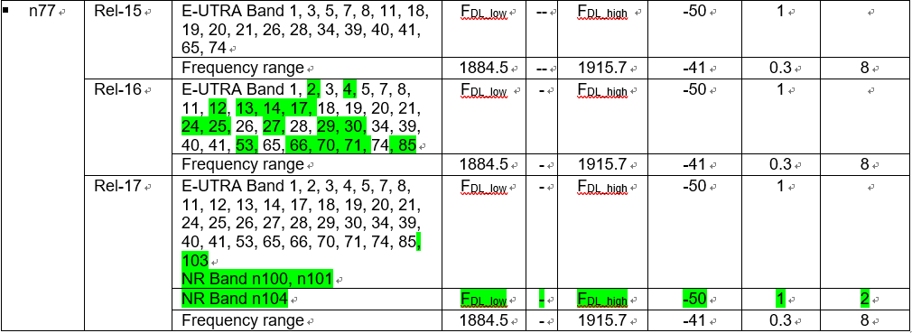

* **Scenario 2:** Some protected bands were removed in later Releases, but were still kept in previous Release (e.g., n50, n78, n74).

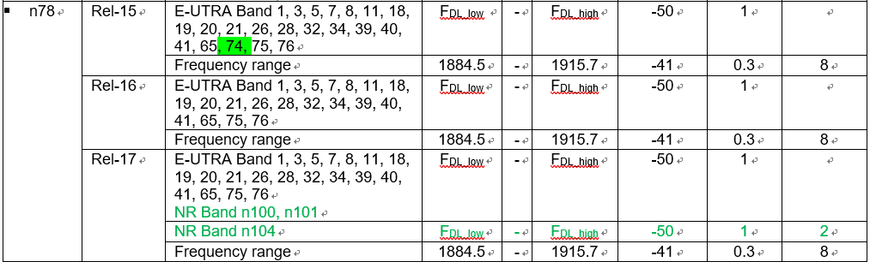

* **Scenario 3:** Protected band was changed from NR band to LTE band in later Release (Note was also changed), but was still kept unchanged in previous Release (e.g., n70).

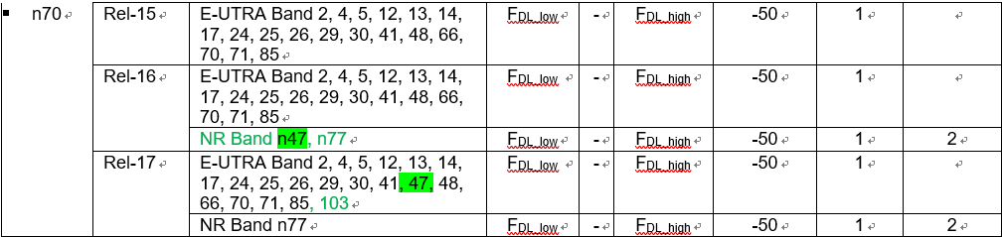

**Issue 2-1-2: UE co-existence requirement applicability**

* Proposals: [R4-2307117 CAICT]
* **Proposal 1: Protected bands shall always be updated from the earliest Release of RAN4 spec that a 3GPP band has been defined** to ensure new designed UEs with any Release will not interfere the new co-existent systems.
* **Proposal 2:** Spurious emission for UE co-existence requirements in **Release 15/16/17 specs of 38.101-1/2/3**, **Release 17 spec of 38.101-5** and **Release 8/9/10/11/12/13/14/15/16/17 specs of 36.101** shall be updated to **align with the requirements in Release 18 specs**.
* **Proposal 3: UE shall consider** the spurious emission of all protected bands included in the **latest Version of spec at the stage of its design.** It is up to certification organization to decide which **Version** of spec can be accepted for UE certification.
* **Proposal 4:** Requirement for Spurious emission for **UE co-existence shall be Release independent**. RAN4 shall reach the agreement that the **latest Release of RAN4 spec is the reference for the correct requirements** of Spurious emission for UE co-existence of all Releases.

*Moderator note:*

* *principles need to be confirmed in these proposals especially the highlighted parts.*
* *For proposal 2, the meaning of “align with requirements in R18 specs” may need clarification, does it mean for the same band the requirements early spec should be consistent with R18?*
* *For proposal 3, how to guarantee UE will apply the “latest version of spec at the stage of its design”? Is it responsibility of RAN4?*
* *For proposal 4, is there possibility that the coexistence requirements are defined differently for different releases by intentionally?*

**Issue 2-1-3: Comments to below CRs**

|  |  |  |  |
| --- | --- | --- | --- |
| **T-doc** | **Company** | **Title/Comments** | **Recommendation** |
| R4-2307101 | CAICT | Correction of UE co-existence requirement in 36.101 Rel-15 |  |
| R4-2307102 | CAICT | Correction of UE co-existence requirement in 36.101 Rel-16 |  |
| R4-2307103 | CAICT | Correction of UE co-existence requirement in 36.101 Rel-17 |  |
| R4-2307104 | CAICT | Correction of UE co-existence requirement in 38.101-1 Rel-15 |  |
| R4-2307105 | CAICT | Correction of UE co-existence requirement in 38.101-1 Rel-16 |  |
| R4-2307106 | CAICT | Correction of UE co-existence requirement in 38.101-1 Rel-17 |  |
| R4-2307107 | CAICT | Correction of UE co-existence requirement in 38.101-2 Rel-15 |  |
| R4-2307108 | CAICT | Correction of UE co-existence requirement in 38.101-2 Rel-16 |  |
| R4-2307109 | CAICT | Correction of UE co-existence requirement in 38.101-3 Rel-15 |  |
| R4-2307110 | CAICT | Correction of UE co-existence requirement in 38.101-3 Rel-16 |  |
| R4-2307111 | CAICT | Correction of UE co-existence requirement in 38.101-3 Rel-17 |  |
| R4-2307112 | CAICT | Correction of UE co-existence requirement in 38.101-5 Rel-17 |  |

### Sub-topic 2-2 FOOB in UE coexistence

*Moderator note: NOTE15 in UE coexistence table is used to indicate whether the freq within FOOB shall comply with the coexistence requirements.*

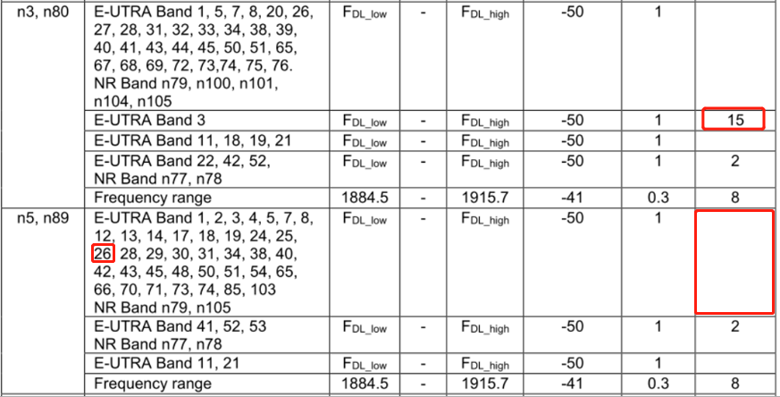



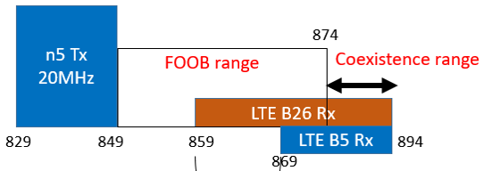

**Issue 2-2-1: Is it ok to introduce the NOTE15 for n5/n26 protect n26/b26 from Rel-18 onwards?**

* **Proposal:** The clarification of UE coexistence applicable frequency ranges, and adding the NOTE 15 for n5, both can be considered from Rel-18, and no changes to the Rel-15/16/17 specs.

**Issue 2-2-2: Comments to below CRs**

*Moderator note: the yellow highlighted 38101-1 CRs can be merged if Issue 2-2-1 is agreeable.*

|  |  |  |  |
| --- | --- | --- | --- |
| **T-doc** | **Company** | **Title/Comments** | **Recommendation** |
| R4-2309713 (R18) | T-Mobile USA, Skyworks Solutions, Inc., Qualcomm, Qorvo, Murata, Apple | CR for 38.101-1: Foob clarification and n5 and n26 protection for B26/n26 |  |
| R4-2307296 (R15)  CAT-A:  R4-2307297 (R16)  R4-2307298 (R17)  R4-2307299 (R18) | NTT DOCOMO | CR for 800MHz frequency range protection from n5 for UE coexistence R15 |  |
| R4-2307300 (R16)  CAT-A:  R4-2307301 (R17)  R4-2307302 (R18) | NTT DOCOMO | CR for 800MHz frequency range protection from n26 for UE coexistence R16 |  |
| R4-2308962 (R18) | OPPO | 38101-1 CR on clarification of UE coexistence frequency range (R18) |  |
| R4-2308963 (R18) | OPPO | 38101-2 CR on clarification of UE coexistence frequency range (R18) |  |
| R4-2308964 (R18) | OPPO | 38101-3 CR on clarification of UE coexistence frequency range (R18) |  |

Recommended WF: Merge the above yellow highlighted CRs for Rel-18. And use R4-2308963/R4-2308964 (R18) as baseline for 101-2/3 and to see whether they are agreeable.

# Topic #3: PC1.5 for NS_47 (3)

## Contributions summary

|  |  |  |
| --- | --- | --- |
| **T-doc number** | **Company** | **Proposals / Observations** |
| R4-2307487 | SoftBank | Updates on PC1.5/NS_47 support of n41 for Japan  [Proposal-1] Final CR(s) are postponed to August meeting.  [Proposal-2] If HP-UE of n3-n41 urgently needs, we try to agree the A-MPR values in this meeting. |
| R4-2309061 | Apple | On PC1.5 for NS_47  **Observation 1**: Region A3 is governed by C-IM3. With defining PC1.5 the A-MPR would require an additional 3dB compared to PC2. The actual impact of rIMD on C-IM3 is unclear and the effect of rIMD might or might not introduce additional power back-off need.  **Proposal 1**: Measurements could be conducted to evaluate whether the rIMD creates additional power back-off need or whether 8dB A-MPR would be sufficient for region A3.  **Proposal 2:** Introduce new A-MPR region to cover certain RBs which require more power back-off than defined by PC1.5 MPR. Decide either for the proposed region 1 or 2.  Proposal 3: Use table 3 as a starting point for further discussion. |
| R4-2309272 | Qualcomm | NS_47 measurements and A-MPR for PC1.5  **Proposal 1:** Adopt A-MPR for NS_47 in n41 with PC1.5 as according to table 3  **Proposal 2:** Make the A-MPR change to the open release. |

## Open issues summary

### Sub-topic 3-1

*Sub-topic description: PC1.5 devices would be allowed in the near future* *in Japan, e.g. June this year. The related additional emission requirements as below.*

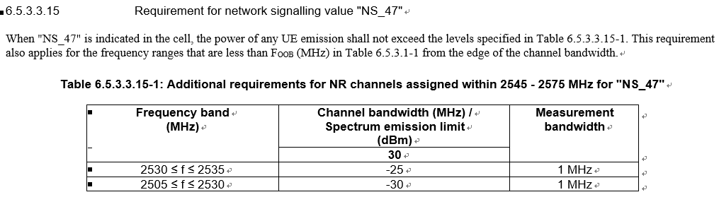

**Issue 3-1-1: Is below proposal acceptable?**

* **[Proposal-1]** Final CR(s) are postponed to August meeting.
* **[Proposal-2]** If HP-UE of n3-n41 urgently needs, we try to agree the A-MPR values in this meeting.

*Moderator note: is the NS_47 requirements be impacted by the Japan regulation status that makes the CR shall wait for the publish of regulation?*

**Issue 3-1-2: Whether the A5 new region is needed?**

* **Option 1:** Introduce new A-MPR region to cover certain RBs which require more power back-off than defined by PC1.5 MPR. Decide either for the proposed Option 1 or 2. (R4-2309061 Apple)

* **Option 2:** Additional A-MPR region is not needed according to the measurements. (R4-2309272 Qualcomm)

**Issue 3-1-3: The AMPR values**

* **Option 1: (R4-2309061 Apple)**

|  |  |  |  |  |  |  |  |  |  |  |  |  |  |
| --- | --- | --- | --- | --- | --- | --- | --- | --- | --- | --- | --- | --- | --- |
| Modulation/Waveform | A1(dB) | | | A2(dB) | | | A3(dB) | | | A4(dB) | | | A5(dB) |
|  | PC3 | PC2 | PC1.5 | PC3 | PC2 | PC1.5 | PC3 | PC2 | PC1.5 | PC3 | PC2 | PC1.5 | PC1.5 |
|  | Outer/ Inner | Outer/ Inner | Outer/ Inner | Outer/ Inner | Outer/ Inner | Outer/ Inner | Outer/ Inner | Outer/ Inner | Outer/ Inner | Outer/ Inner | Outer/ Inner | Outer/ Inner | Outer/ Inner |
| DFT-s-OFDM PI/2 BPSK | ≤ 7 | ≤ 10 | ≤ 13.0 | ≤ 5.5 | ≤ 8.5 | ≤ 11.0 | ≤ 2 | ≤ 5 | ≤ [X] | ≤ 3 | ≤ 6 | ≤ 8.5 | ≤ 3.0 |
| DFT-s-OFDM QPSK | ≤ 7 | ≤ 10 | ≤ 13.0 | ≤ 5.5 | ≤ 8.5 | ≤ 11.0 | ≤ 2 | ≤ 5 | ≤ [X] | ≤ 3 | ≤ 6 | ≤ 8.5 | ≤ 3.0 |
| DFT-s-OFDM 16 QAM | ≤ 7 | ≤ 10 | ≤ 13.0 | ≤ 5.5 | ≤ 8.5 | ≤ 11.0 |  | ≤ 5 | ≤ [X] | ≤ 3 | ≤ 6 | ≤ 8.5 | ≤ 3.0 |
| DFT-s-OFDM 64 QAM | ≤ 7 | ≤ 10 | ≤ 13.0 | ≤ 6 | ≤ 8.5 | ≤ 11.0 |  | ≤ 5 | ≤ [X] | ≤ 3 | ≤ 6 | ≤ 8.5 |  |
| DFT-s-OFDM 256 QAM | ≤ 7 | ≤ 10 | ≤ 13.0 | ≤ 6 | ≤ 8.5 | ≤ 11.0 |  | ≤ 5 | ≤ [X] |  | ≤ 6 | ≤ 8.5 |  |
| CP-OFDM QPSK | ≤ 7 | ≤ 10 | ≤ 13.0 | ≤ 7 | ≤ 10 | ≤ 12.5 |  | ≤ 5 | ≤ [X] | ≤ 4 | ≤ 7 | ≤ 9.5 | ≤ 4.0 |
| CP-OFDM 16 QAM | ≤ 7 | ≤ 10 | ≤ 13.0 | ≤ 7 | ≤ 10 | ≤ 12.5 |  | ≤ 5 | ≤ [X] | ≤ 4 | ≤ 7 | ≤ 9.5 | ≤ 4.0 |
| CP-OFDM 64 QAM | ≤ 7 | ≤ 10 | ≤ 13.0 | ≤ 7 | ≤ 10 | ≤ 12.5 |  | ≤ 5 | ≤ [X] |  | ≤ 7 | ≤ 9.5 |  |
| CP-OFDM 256 QAM | ≤ 7 | ≤ 10 | ≤ 13.0 | ≤ 7 | ≤ 10 | ≤ 12.5 |  |  | ≤ [X] |  | ≤ 7 | ≤ 9.5 |  |

* **Option 2: (R4-2309272 Qualcomm)**

|  |  |  |  |  |  |  |  |  |  |  |  |  |
| --- | --- | --- | --- | --- | --- | --- | --- | --- | --- | --- | --- | --- |
| **Modulation/Waveform** | **A1(dB)** | | | **A2(dB)** | | | **A3(dB)** | | | **A4(dB)** | | |
| **PC3** | **PC2** | **PC1.5** | **PC3** | **PC2** | **PC1.5** | **PC3** | **PC2** | **PC1.5** | **PC3** | **PC2** | **PC1.5** |
| **Outer/** | **Outer/** | **Outer/** | **Outer/** | **Outer/** | **Outer/** | **Outer/** | **Outer/** | **Outer/** | **Outer/** | **Outer/** | **Outer/** |
| **Inner** | **Inner** | **Inner** | **Inner** | **Inner** | **Inner** | **Inner** | **Inner** | **Inner** | **Inner** | **Inner** | **Inner** |
| DFT-s-OFDM PI/2 BPSK | ≤ 7 | ≤ 10 | ≤ 13 | ≤ 5.5 | ≤ 8.5 | ≤ 11 | ≤ 2 | ≤ 5 | ≤8 | ≤ 3 | ≤ 6 | ≤ 8.5 |
| DFT-s-OFDM QPSK | ≤ 7 | ≤ 10 | ≤ 5.5 | ≤ 8.5 | ≤ 2 | ≤ 5 | ≤ 3 | ≤ 6 |
| DFT-s-OFDM 16 QAM | ≤ 7 | ≤ 10 | ≤ 5.5 | ≤ 8.5 |  | ≤ 5 | ≤ 3 | ≤ 6 |
| DFT-s-OFDM 64 QAM | ≤ 7 | ≤ 10 | ≤ 6 | ≤ 8.5 |  | ≤ 5 | ≤ 3 | ≤ 6 |
| DFT-s-OFDM 256 QAM | ≤ 7 | ≤ 10 | ≤ 6 | ≤ 8.5 |  | ≤ 5 |  | ≤ 6 |
| CP-OFDM QPSK | ≤ 7 | ≤ 10 | ≤ 7 | ≤ 10 | ≤ 12.5 |  | ≤ 5 | ≤ 4 | ≤ 7 | ≤ 9.5 |
| CP-OFDM 16 QAM | ≤ 7 | ≤ 10 | ≤ 7 | ≤ 10 |  | ≤ 5 | ≤ 4 | ≤ 7 |
| CP-OFDM 64 QAM | ≤ 7 | ≤ 10 | ≤ 7 | ≤ 10 |  | ≤ 5 |  | ≤ 7 |
| CP-OFDM 256 QAM | ≤ 7 | ≤ 10 | ≤ 7 | ≤ 10 |  |  |  | ≤ 7 |

Recommended WF: Agree on the above cyan highlighted values. And check whether yellow highlighted is agreeable.

# Topic #4: Power scaling and UL CA Pcmax (3)

## Contributions summary

|  |  |  |
| --- | --- | --- |
| **T-doc number** | **Company** | **Proposals / Observations** |
| R4-2307731 | Ericsson | One more on PCMAX for a BC  **Proposal 1:** modify the PCMAX for inter-band UL CA in 38.101-1 consistent with the definition in 38.213. The measured output power PUMAX is verified similar to EN-DC with due account for power prioritization. |
| R4-2308248 | vivo | Discussion on power scaling factor s and impact to RAN4  **Observation 1:** The power scaling in RAN1 is due to RAN1’s understanding of UE implementation restriction and actually not that desirable.  **Observation 2:** The power scaling fact s is applied to ${\hat{P}}_{\text{PUSCH},b,f,c}\left(i,j,q_{d},l\right)$.  **Observation 3:** The power scaling s does not directly change Pcmax or {}.  **Observation 4:** Currently the power scaling factor does not impact power headroom definition and calculation.  **Observation 5:** In case PH is positive, the PH reported would be the same to actual achievable PH even in case of power scaling is not equal to 1.  **Observation 6:** In case PH is negative, the PH reported may haven an offset to actual achievable PH in case of power scaling not equal to 1. However, this may have quite limited impact to the whole system.  **Observation 7:** The PH calculation with no consideration of power scaling factors s, may bring some unclear understandings of PH calculation, though the impact may not be large.  **Observation 8:** The understanding of Pcmax may indeed be impacted by the power scaling factor s.  Based on the observations, the following two proposals are provided:  **Proposal 1:** Send a LS to RAN1 to ask RAN1’s view on this issue.  **Proposal 2:** Not to change RAN4 spec until more feedback from RAN1. Any future revision of Pcmax related concept relating to this feature may also need communication with RAN1 to avoid undesirable impacts to RAN1. |
| R4-2308249 | vivo | [Draft] LS on power scaling factor s and PHR in 38.213 |

## Open issues summary

### Sub-topic 4-1 Pcmax violate 38.213

**Issue 4-1-1: Whether Pcmax in 38.101-1 violates 38.213?**

* **Option 1: (Ericsson)**
  + **In 38.213:** For determining the PCMAX for each transmission occasion, the **UE does not include transmissions starting after this occasion**.

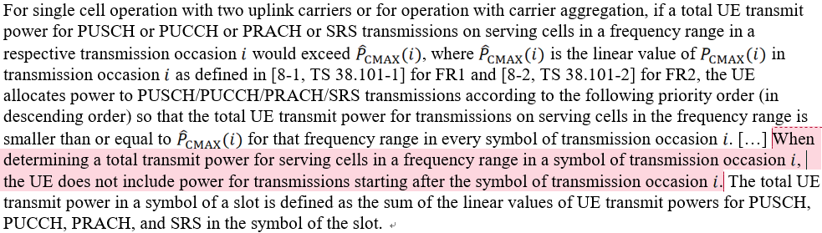

* + **In 38.101-1:** the PCMAX implies that the UE also includes transmissions start after a transmission occasion evaluated.
* the total power for each transmission occasion for scaling during TREF is limited by the lowest pCMAX_L,f,c(i),i (p) + pCMAX_L,f,c(i),j (q) as evaluated for all transmission occasions *j*k overlapping with *i*
* the total power for an **earlier transmission *j*1 is limited by a later non-overlapping transmission *j*3** with an UL grant received at a later instant, which violates the 38.213.

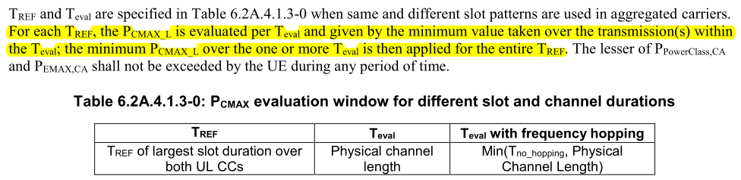

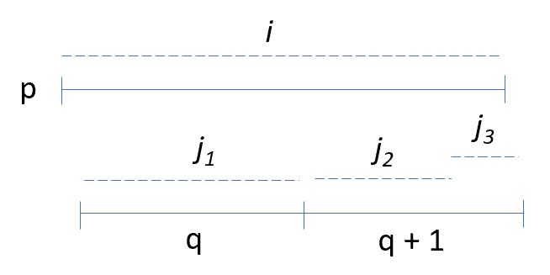

Figure 1: overlapping transmissions occasions on serving cells of different numerologies.

**Issue 4-1-2: Whether below scenarios need to be evaluated in 38.101-1**

* **Option 1: (Ericsson)**
  + The measured total power PUMAX is limited by the pCMAX_L,f,c(i),i (p) + pCMAX_L,f,c(i),j (q) if below the BC power class. Two cases should be included, similarly to inter-band EN-DC:
* **Case 1:** the **total configured power** of all serving cells **is always below the BC power class**, **power prioritization should not occur** and all transmissions be present regardless of priority
* **Case 2:** the **total power exceeds the BC power class**, the UE allowed **scale or drop transmissions of lower priorities**.

**Issue 4-1-3: Whether to change the Pcmax to align with 38.213**

*Moderator note: from which release this change is targeted?*

* **Option 1:** modify the PCMAX for inter-band UL CA in 38.101-1 consistent with the definition in 38.213. The measured output power PUMAX is verified similar to EN-DC with due account for power prioritization. (Ericsson)

### Sub-topic 4-2 Power scaling factor *s* and PHR

*Moderator note: this topic relates to the power scaling factor s which is caused by the non-full power TPMIs. The background is captured in WF R4-2306595 (WF on 4Tx UE RF requirements) as below:*

|  |
| --- |
| *This is not an issue specific for 4Tx, but for all the cases when power scaling is needed for legacy case and also Full Power transmission Mode when the full power cannot be applied for some TPMI configurations. Here are some of the status:*   1. *According to RAN1, there are power scaling Rel-15 and in certain TPMI configurations for ULFPTx modes to reduce the maximum output power;* 2. *The UL-MIMO maximum power requirements do not verify the power scaling behavior;* 3. *The configurated transmitted power definition also do not consider the power scaling;* 4. *The PHR calculation do not consider power scaling.* |

**Issue 4-2-1: Comments to below observations in R4-2308248**

* **Observation 2:** The power scaling fact s is applied to ${\hat{P}}_{\text{PUSCH},b,f,c}\left(i,j,q_{d},l\right)$.
* **Observation 3:** The power scaling s does not directly change Pcmax or {}.
* **Observation 4:** Currently the power scaling factor does not impact power headroom definition and calculation.

**Issue 4-2-2: Whether to change the Pcmax due to power scaling factor s defined in RAN1**

* **Option 1:** Send a LS to RAN1 to ask RAN1’s view on this issue. Not to change RAN4 spec until more feedback from RAN1. Any future revision of Pcmax related concept relating to this feature may also need communication with RAN1 to avoid undesirable impacts to RAN1. (vivo)

**Issue 4-2-3: Comments to below LS**

|  |  |  |  |
| --- | --- | --- | --- |
| **T-doc** | **Company** | **Title/Comments** | **Recommendation** |
| R4-2308249 | vivo | [Draft] LS on power scaling factor s and PHR in 38.213 |  |

# Topic #5: PMPR for PRACH (1)

## Contributions summary

|  |  |  |
| --- | --- | --- |
| **T-doc number** | **Company** | **Proposals / Observations** |
| R4-2309211 | Ericsson | P-MPR for PRACH  Observation 1Percentage of Uplink PRACH symbols could be very low in normal operation.  Observation 1 When maxUplinkDutyCycle-FR2 is present and if the percentage of uplink symbols transmitted including the unscheduled transmission, the P-MPR may apply when percentage of symbols scheduled during 1s is less than the maxUplinkDutyCycle-FR2 reported by UE.  Proposal-1: Clarify UE behaviour of the calculation of percentage of the uplink symbols:  Option 1: the percentage of uplink symbols transmitted does not include any autonomous uplink transmission  Option 2: the percentage of uplink symbols transmitted include the any autonomous uplink transmission which is not scheduled by network. |

## Open issues summary

### Sub-topic 5-1

**Issue 5-1-1: Which option is correct understanding of percentage UL symbols in calculation**

* **Option 1:** the percentage of uplink symbols transmitted **does not include** any autonomous uplink transmission
* **Option 2:** the percentage of uplink symbols transmitted **include** the any autonomous uplink transmission which is not scheduled by network.

**Issue 5-1-2: Is below updates acceptable?**

* **If Option 1 is RAN4 consensus, the specification text in TS 38.101-2 can be improved as below:**

If the field of UE capability *maxUplinkDutyCycle-FR2* is present and the percentage of uplink symbols transmitted excluding any autonomous transmission within any 1 s evaluation period is larger than *maxUplinkDutyCycle-FR2*, the UE follows the uplink scheduling and can apply P-MPRf,c.

* **if Option 2 is RAN4 consensus, the specification text in TS 38.101-2 can be improved as below:**

If the field of UE capability *maxUplinkDutyCycle-FR2* is present and the percentage of uplink symbols transmitted including any autonomous transmission within any 1 s evaluation period is larger than *maxUplinkDutyCycle-FR2*, the UE follows the uplink scheduling and can apply P-MPRf,c.

# Topic #6: EVM measurement for UL MIMO (3)

## Contributions summary

|  |  |  |
| --- | --- | --- |
| **T-doc number** | **Company** | **Proposals / Observations** |
| R4-2309152 | Rohde & Schwarz | Discussion on UL MIMO EVM measurement methodology  **Observation 1:** Current versions of TS 38.101-1 and TS 38.101-2 incorrectly capture the number of DMRS symbols to be used.  **Proposal 1:** Update the specification to use all available DMRS in a RMC.  **Observation 2:** Using all available DMRS symbols greatly improves the performance of Method 1.  **Observation 3:** Method 3 is more complex than Method 1 for 2 layer MIMO. This becomes much worse for 4 layer MIMO.  **Observation 4:** The usage of averaging for improving the channel estimation is an established concept in 3GPP.  **Observation 5:** Method 3 inherently uses a frequency smoothing over 1 CDM group without the option to remove it.  **Observation 6:** Further clarification is needed on the matrix invertibility for Method 3.  **Proposal 2:** RAN4 keeps the current procedure as described in TS 38.101-1 and TS 38.101-2 with the improvement of using all DMRS symbols. |
| R4-2309153 (R15)  CAT-A:  R4-2309154  R4-2309155  R4-2309156 | Rohde & Schwarz | Update of FR1 UL MIMO EVM measurement description |
| R4-2309157 (R15)  CAT-A:  R4-2309158  R4-2309159  R4-2309160 | Rohde & Schwarz | Update of FR2 UL MIMO EVM measurement description |

## Open issues summary

### Sub-topic 6-1

*Sub-topic description: In last meeting, EVM measurement method 3 of UL MIMO was brought out and WF R4-2303653 was approved to further compare the method 3 with method 1.*

* Method 1: (Agreed in previous meeting)
  + MIMO part: DMRS based estimation;

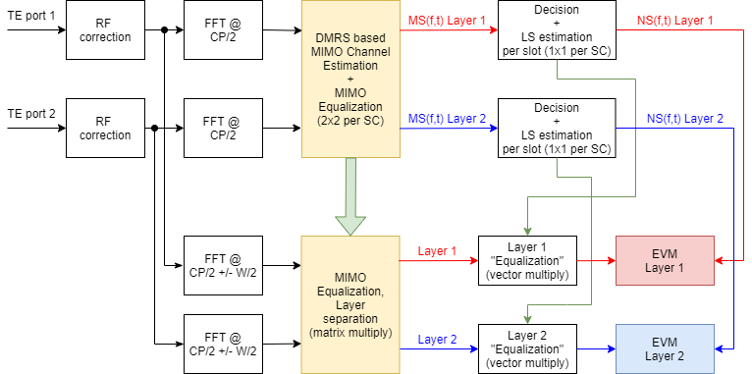

* Method 3:
  + MIMO part: DMRS based estimation, then followed by per CDM group RS + data equalizer building within slot and equalization;

The RS+ data EQ build for MIMO block

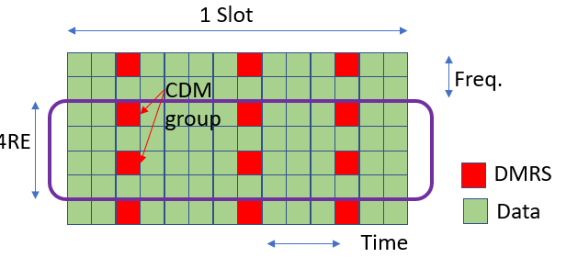

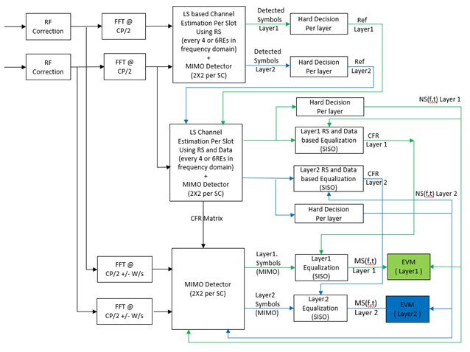

**Issue 6-1-1: Is it acceptable to update the specification to use all available DMRS in a RMC for method 1**

* Yes
* No

*Moderator note: it is stated that current spec incorrectly captures the number of DMRS symbols to be used as 1.*

**Issue 6-1-2: Is it acceptable that RAN4 keeps the current procedure as described in TS 38.101-1 and TS 38.101-2 with the improvement of using all DMRS symbols.**

* Yes
* No

**Issue 6-1-3: Comments to below CRs**

|  |  |  |  |
| --- | --- | --- | --- |
| **T-doc** | **Company** | **Title/Comments** | **Recommendation** |
| R4-2309153 (R15)  CAT-A:  R4-2309154  R4-2309155  R4-2309156 | Rohde & Schwarz | Update of FR1 UL MIMO EVM measurement description |  |
| R4-2309157 (R15)  CAT-A:  R4-2309158  R4-2309159  R4-2309160 | Rohde & Schwarz | Update of FR2 UL MIMO EVM measurement description |  |

# Topic #7: EVM for shorter transient period (1)

## Contributions summary

|  |  |  |
| --- | --- | --- |
| **T-doc number** | **Company** | **Proposals / Observations** |
| R4-2309742 | Skyworks | LS on EVM for shorter transient period capability in FR1 |

## Open issues summary

### Sub-topic 7-1

*Moderator note: In Feb meeting, agreements reached and this is the LS to RAN5:*

*1) Confirm RAN4 assumptions on transient assumptions:*

*a) Transients are verified using the Figure 7.3.3.7-3 ON to ON time mask*

*b) Transient is not triggered by TPC commands, it is triggered by RB allocation change*

*2) RAN4 need a new UL RMC at SCS15kHz with 5ms periodicity to verify the transient according to Figure 6.3.3.7-3 time-mask, i.e. proposal 6 above*

**Issue 7-1-3: Comments to below LS**

|  |  |  |  |
| --- | --- | --- | --- |
| **T-doc** | **Company** | **Title/Comments** | **Recommendation** |
| R4-2309742 | Skyworks | LS on EVM for shorter transient period capability in FR1 |  |

# CRs for 38.101-1 (21)

## K1 and PdschNumOfHarqProcess for DL-CA

|  |  |  |  |
| --- | --- | --- | --- |
| **T-doc** | **Company** | **Title/Comments** | **Recommendation** |
| R4-2307035 (R15)  CAT-A:  R4-2307036 (R16)  R4-2307037 (R17) | Anritsu Limited, Rohde & Schwarz, Keysight Technologies UK Ltd | *CR to K1 and PdschNumOfHarqProcess for DL-CA* |  |
| R4-2307038 (R18) | Anritsu Limited, Rohde & Schwarz, Keysight Technologies UK Ltd | CR to K1 and PdschNumOfHarqProcess for DL-CA |  |

## FR1 OOB requirements correction

|  |  |  |  |
| --- | --- | --- | --- |
| **T-doc** | **Company** | **Title/Comments** | **Recommendation** |
| R4-2307039 (R15)  CAT-A:  R4-2307040 (R16) | Anritsu | FR1 OOB requirements correction  *Moderator note: Align power setting in OOBB, is it possible to reuse either R15 or R17 power setting instead of creating new?* |  |
| R4-2307041 (R17)  CAT-A:  R4-2307042 (R18) | Anritsu | FR1 OOB requirements correction  *Moderator note: Align power setting in OOBB, is it possible to reuse either R15 or R17 power setting instead of creating new?* |  |

## V2X

|  |  |  |  |
| --- | --- | --- | --- |
| **T-doc** | **Company** | **Title/Comments** | **Recommendation** |
| R4-2307094 (R16) | Facebook | CR TS 38.101-1: Correction on NR V2X requirements in Rel-16  *Moderator note: CR was provided to reflect the agreed contents in Rel-16* |  |
| R4-2308990 (R16)  CAT-A:  R4-2308991  R4-2308992 | OPPO | CR for TS 38.101-1 Rel-16: V2X min output power |  |

## Pcmax correction

|  |  |  |  |
| --- | --- | --- | --- |
| **T-doc** | **Company** | **Title/Comments** | **Recommendation** |
| R4-2307732 (R16) | Ericsson | Corrections to configured maximum power for inter-band UL CA  *Moderator note: the Pcmax,f,c is further limited by the min (Ppowerclass, Ppowerclass,CA)* |  |
| R4-2307733 (R17)  CAT-A:  R4-2307734 (R18) | Ericsson | Corrections to configured maximum power for inter-band UL CA |  |
| R4-2308158 (R16)  CAT-A:  R4-2308159  R4-2308160 | ZTE | CR to TS38.101-1: Correction on terms for NR DC Pcmax |  |
| R4-2308367 (R15)  CAT-A:  R4-2308368  R4-2308369  R4-2308370 | MediaTek | CR to 38.101-1 on configured Tx power |  |

## 2UL CA co-existence simplication

|  |  |  |  |
| --- | --- | --- | --- |
| **T-doc** | **Company** | **Title/Comments** | **Recommendation** |
| R4-2308826 | Nokia | NR interband 2UL CA co-ex simplication R16 |  |
| R4-2307862 | Nokia | NR interband 2UL CA co-ex simplication R17 |  |
| R4-2307863 | Nokia | NR interband 2UL CA co-ex simplication R18 |  |

## n28+n78 harmonic mixing MSD

|  |  |  |  |
| --- | --- | --- | --- |
| **T-doc** | **Company** | **Title/Comments** | **Recommendation** |
| R4-2309062 (R16)  CAT-A:  R4-2309063  R4-2309064 | Apple | CR for TS 38.101-1 Rel-16: Introducing missing MSD for harmonic mixing  *Moderator note: n28+n78 harmonic mixing MSD value is different from R4-2309255* |  |
| R4-2309255 (R16)  CAT-A:  R4-2309256  R4-2309257 | Qualcomm | CR to 38.101-1 Rel-16 Cat F, MSD correction  *Moderator note: n28+n78 harmonic mixing MSD value is different from R4-2309062* |  |

## other change

|  |  |  |  |
| --- | --- | --- | --- |
| **T-doc** | **Company** | **Title/Comments** | **Recommendation** |
| R4-2307836 (R17)  CAT-A:  R4-2307837 (R18) | ZTE | CR to TS38.101-1: Correction to out-of-band blocking table |  |
| R4-2307997 (R15)  CAT-A:  R4-2307998 (R16)  R4-2307999 (R17)  R4-2308000 (R18) | ZTE | CR for TS 38.101-1 on corrections to the minimum guardband calculation |  |
| R4-2309068 (R16)  CAT-A:  R4-2309069  R4-2309070 | Apple | CR for TS 38.101-1: Adding missing requirements for NR-U Rel-16 CAT-F |  |
| R4-2309084 (R16) | Apple | CR for 38.101-1: Single SUL CA combination notation modifications |  |
| R4-2309251 (R15)  CAT-A:  R4-2309252  R4-2309253  R4-2309254 | Qualcomm | CR to 38.101-1 Rel-15 Cat F, FRC correction |  |
| R4-2309685 (R15)  CAT-A:  R4-2309688  R4-2309689  R4-2309690 | Qualcomm | CR on correcting n38 UL requirement note 22 |  |

# CRs for 38.101-2 (2)

|  |  |  |  |
| --- | --- | --- | --- |
| **T-doc** | **Company** | **Title/Comments** | **Recommendation** |
| R4-2308001 (R15)  CAT-A:  R4-2308002 (R16)  R4-2308003 (R17)  R4-2308004 (R18) | ZTE | CR for TS 38.101-2 on corrections to the minimum guardband calculation |  |
| R4-2308371 (R15)  CAT-A:  R4-2308372  R4-2308373  R4-2308374 | MediaTek | CR to 38.101-2 on configured Tx power |  |

# CRs for 38.101-3 (10)

## 2UL co-existence simplication

|  |  |  |  |
| --- | --- | --- | --- |
| **T-doc** | **Company** | **Title/Comments** | **Recommendation** |
| R4-2308838 | Nokia | EN-DC interband 2UL co-ex simplication R16 |  |
| R4-2307865 | Nokia | EN-DC interband 2UL co-ex simplication R17 |  |
| R4-2307866 | Nokia | EN-DC interband 2UL co-ex simplication R18 |  |

## Corrections on MOP FR1-FR2

|  |  |  |  |
| --- | --- | --- | --- |
| **T-doc** | **Company** | **Title/Comments** | **Recommendation** |
| R4-2308154 (R15) | ZTE | CR to TS38.101-3: Corrections on MOP FR1-FR2 inter-band NR CA and MOP/MPR for ENDC including FR2/FR1 and FR2 |  |
| R4-2308155 (R16)  CAT-A:  R4-2308156  R4-2308157 | ZTE | CR to TS38.101-3: Corrections on MOP FR1-FR2 inter-band NR CA and MOP/MPR for ENDC including FR2/FR1 and FR2 |  |

## MSD

|  |  |  |  |
| --- | --- | --- | --- |
| **T-doc** | **Company** | **Title/Comments** | **Recommendation** |
| R4-2309261 (R15)  CAT-A:  R4-2309262  R4-2309263  R4-2309264 | Qualcomm | CR to 38.101-3 Rel-15 Cat F, MSD corrections  *Moderator note:8-n77 harmonic mixing MSD* |  |
| R4-2309346 (R15)  CAT-A:  R4-2309347  R4-2309348  R4-2309349 | NTT DOCOMO, INC., Qualcomm Inc., MediaTek Inc. | CR to R15 TS38.101-3 for addition of missing MSD requirements for DC_19_n77 and DC_21_n77 |  |

## others

|  |  |  |  |
| --- | --- | --- | --- |
| **T-doc** | **Company** | **Title/Comments** | **Recommendation** |
| R4-2308129 (R15)  CAT-A:  R4-2308130  R4-2308131  R4-2308132 | Samsung, KT | Rel15 Cat F CR for 38.101-3 Add RI8,8R relaxtion for ENDC with 8 Rx antenas ports for EUTRA bands |  |
| R4-2308812 (R16)  CAT-A:  R4-2308813  R4-2308814 | Xiaomi | CR for Rel-16 38.101-3 to delete the configurations of DC_48A/B/C/D/E_n46E  *Moderator note: reason for change is no the configurations of CA_n46E, so the DC_48_n46E should be deleted* |  |
| R4-2309461 (R15)  CAT-A:  R4-2309463  R4-2309464  R4-2309465 | CHTTL, Samsung, ZTE, SGS Wireless | CR for corrections on EN-DC channel bandwidth section |  |

# CRs for 38.307 (2)

|  |  |  |  |
| --- | --- | --- | --- |
| **T-doc** | **Company** | **Title/Comments** | **Recommendation** |
| R4-2308933 | Nokia | Correction to Frequency arrangement for overlapping operating bands information R16 |  |
| R4-2308919 | Nokia | Correction to Frequency arrangement for overlapping operating bands information R17 |  |

# CRs for 36.101 (2)

|  |  |  |  |
| --- | --- | --- | --- |
| **T-doc** | **Company** | **Title/Comments** | **Recommendation** |
| R4-2307095 (R15)  CAT-A:  R4-2307096 (R16) | Facebook | CR TS 36.101: Correction for REFSENS requirements for LTE-A CA in Rel-15  *Moderator note: how about R17/R18, is CAT-A needed?* |  |
| R4-2308005 (R8)  CAT-A:  R4-2308006  R4-2308007  R4-2308008  R4-2308009  R4-2308010  R4-2308011  R4-2308012  R4-2308013  R4-2308014  R4-2308015 | ZTE Corporation, Samsung | CR to TS 36.101 on relative humidity condition for normal temperature |  |