**3GPP TSG-RAN WG4 Meeting #107 R4-230xxxx  
Incheon, KR, May 22 – May 26, 2023**

**Agenda item:** 4.7

**Source:** OPPO

**Title:** Adhoc summary for [107][101] Upto_R16_UERF_maintenance

**Document for:** Information

# Introduction

This is the adhoc summary for Rel-15/16 maintenance under agenda 4.1 which includes 143 papers in total (CAT F+A) and 73 papers with CAT-F.

**List of topics below:**

* Topic #1: dualPA-Architecture capability (1)
* Topic #2: UE co-existence requirement (20)
* Topic #3: PC1.5 for NS_47 (3)
* Topic #4: Power scaling and UL CA Pcmax (1)
* Topic #5: PMPR for PRACH (1)
* Topic #6: EVM measurement for UL MIMO (3)
* Topic #7: EVM for shorter transient period (1)
* CRs for 38.101-1 (21)
* CRs for 38.101-2 (2)
* CRs for 38.101-3 (10)
* CRs for 38.307 (2)
* CRs for 36.101 (2)

# Topic #1: dualPA-Architecture capability (1)

## Contributions summary

|  |  |  |
| --- | --- | --- |
| **T-doc number** | **Company** | **Proposals / Observations** |
| R4-2307044 | Anritsu | Discussion on definition of dualPA-Architecture capability indication for intra-band UL CA  Observation 1: There are currently no cases where TxD or MIMO is used and where dualPA-Architecture capability is reported.  Observation 2: The two cases requiring reporting of dualPA-Architecture capability were introduced in Rel-16, no new case was introduced in Rel-17 and there is no plan in Rel-18 to introduce a new case.  Observation 3: Different sentences for FR1 and FR2 may help understand and avoid confusion.  Proposal 1: The definition in the 38.306 could highlight that “dualPA-Architecture capability is not reported for either intra-band CA + TxD or intra-band CA + UL MIMO as a single LO is used.”  Proposal 2: Have different sentences for FR1 and FR2 to avoid confusion for FR2.  Proposal 3: Send a LS to RAN2 to request a modification of the definition of dualPA-Architecture capability indication for intra-band UL CA in the TS 38.306. |

## Open issues summary

### Sub-topic 1-1

**Issue 1-1-1: Clarification of** ***dualPA-Architecture* capability**

* Proposals: [R4-2307044 Anritsu]
* **Proposal 1:** The definition in the 38.306 could highlight that “*dualPA-Architecture* capability is not reported for either intra-band CA + TxD or intra-band CA + UL MIMO as a single LO is used.”
* **Proposal 2:** Have different sentences for FR1 and FR2 to avoid confusion for FR2.
* **Proposal 3:** Send a LS to RAN2 to request a modification of the definition of dualPA-Architecture capability indication for intra-band UL CA in the TS 38.306.

Moderator note:

Current *dualPA-Architecture* capability in 38.306:

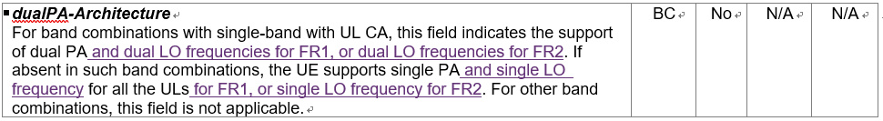

Proposed change to *dualPA-Architecture* capability, especially the yellow highlighted:

| ***dualPA-Architecture***  For NR CA band combinations with two UL CCs in the same band, this field indicates for FR1 that the uplink part is supported by one PA and one LO frequency per CC i.e. dual PAs each with an LO/DC location that can be indicated.  The same field indicates in case of FR2 that the uplink part is supported by one LO frequency per CC i.e. each having an LO/DC location that can be indicated, it does not indicate any specific number of PAs.  If the field is absent for such a band combination, the uplink part is supported by a single PA and one LO/DC location in the case of FR1, and by one LO/DC location in the case of FR2 (no indication of any specific number of PAs). This field does not indicate a specific number of PAs when present or absent in the case of FR2.  DualPA-Architecture capability is not reported for either “intra-band CA + TxD” or “intra-band CA + UL MIMO” as a single LO frequency is used.  For other NR CA band combinations, this field is not applicable. | BC | No | N/A | N/A |
| --- | --- | --- | --- | --- |

Comments:

Samsung: don’t think there is misunderstanding. Not prefer the changes.

Vivo: think current spec wording is fine.

Anritsu: current spec is some misleading. The LS is to align the understanding, but ok with not send LS.

Conclusion: Not send LS to RAN2.

**Issue 1-1-2: LS to RAN2 on Clarification of *dualPA-Architecture* capability [R4-2307044 Anritsu]**

|  |  |  |  |  |  |
| --- | --- | --- | --- | --- | --- |
| **1. Overall Description:**  *dualPA-Architecture* capability was originally introduced in Rel-15 to indicate whether UE using one PA or two PAs to support the intra-band UL CA and during the discussion of Rel-16 FR1 RF enhancements RAN4 extended the meaning of this capability to also imply the number of UE LO frequencies in supporting intra-band UL CA is not singular in FR1. During the discussion of Rel-17 FR1 RF enhancements, RAN4 clarified the implication and also applied it to FR2 as well. Therefore, RAN4 would like to respectfully ask RAN2 to extend the meaning of *dualPA-Architecture* capability in TS38.306 from Rel-16 if there is no NBC issue. The proposed changes are as below for consideration:   | ***dualPA-Architecture***  For NR CA band combinations with two UL CCs in the same band, this field indicates for FR1 that the uplink part is supported by one PA and one LO frequency per CC i.e. dual PAs each with an LO/DC location that can be indicated.  The same field indicates in case of FR2 that the uplink part is supported by one LO frequency per CC i.e. each having an LO/DC location that can be indicated, it does not indicate any specific number of PAs.  If the field is absent for such a band combination, the uplink part is supported by a single PA and one LO/DC location in the case of FR1, and by one LO/DC location in the case of FR2 (no indication of any specific number of PAs). This field does not indicate a specific number of PAs when present or absent in the case of FR2.  DualPA-Architecture capability is not reported for either “intra-band CA + TxD” or “intra-band CA + UL MIMO” as a single LO frequency is used.  For other NR CA band combinations, this field is not applicable. | BC | No | N/A | N/A | | --- | --- | --- | --- | --- | |

# Topic #2: UE co-existence requirement (20)

## Contributions summary

|  |  |  |
| --- | --- | --- |
| **T-doc number** | **Company** | **Proposals / Observations** |
| R4-2307117 | CAICT | Discussion on spurious emission for UE co-existence requirement  **Observation 1:** There are quite a lot inconsistencies between Releases in RAN4 specs for requirements of spurious emission for UE co-existence (The reasonable inconsistencies are excluded).  **Observation 2:** For all the single bands included in TS 38.521-1 v17.7.0, the inconsistencies between Releases in RAN4 specs mainly include three scenarios:   1. More protected bands were introduced in later Release, but were not added to previous Releases(e.g., n25, n38, n41, n51, n77...). This is the most common scenario. 2. Some protected bands were removed in later Releases, but were still kept in previous Release(e.g., n50,n78,n74). 3. Protected band was changed from NR band to LTE band in later Release (Note was also changed), but was still kept unchanged in previous Release(e.g., n70).   **Observation 3:** Spurious emission is a regulatory requirement. For regulatory requirements that a UE must meet, RAN4's tradition is to start to update from the earliest Release of spec that a Band has been defined. Some RAN4 delegates followed this tradition (e.g., [4][5][8]), while some RAN4 delegates did not follow this tradition and just updated the latest Release at the time their CRs were submitted (e.g., [6][7][10][11]).  **Proposal 1:** Protected bands shall always be updated from the earliest Release of RAN4 spec that a 3GPP band has been defined to ensure new designed UEs with any Release will not interfere the new co-existent systems.  **Proposal 2:** Spurious emission for UE co-existence requirements in Release 15/16/17 specs of 38.101-1/2/3, Release 17 spec of 38.101-5 and Release 8/9/10/11/12/13/14/15/16/17 specs of 36.101 shall be updated to align with the requirements in Release 18 specs.  **Observation 4:** UE shall consider the spurious emission of all protected bands included in the latest **Version** of spec at the stage of its design. Certification organization has means to ensure the newly introduced protected bands in later **Versions** of specs will not have impact on existing UE implementation.  **Proposal 3:** UE shall consider the spurious emission of all protected bands included in the latest **Version** of spec at the stage of its design. It is up to certification organization to decide which **Version** of spec can be accepted for UE certification.  **Observation 5:** Some inconsistencies between Releases in RAN4 specs for requirements of spurious emission for UE co-existence are not intentional, but consequence of negligence. With more and more Releases coming up, the inconsistencies will be more and more serious as it is too easy to forget to update the specs of all the previous Releases (e.g., It is not easy for delegates to submit 11 LTE correction CRs from Rel-8 to Rel-18 simultaneously).  **Proposal 4:** Requirement for Spurious emission for UE co-existence shall be Release independent. RAN4 shall reach the agreement that the latest Release of RAN4 spec is the reference for the correct requirements of Spurious emission for UE co-existence of all Releases. |
| R4-2307101 | CAICT | Correction of UE co-existence requirement in 36.101 Rel-15 |
| R4-2307102 | CAICT | Correction of UE co-existence requirement in 36.101 Rel-16 |
| R4-2307103 | CAICT | Correction of UE co-existence requirement in 36.101 Rel-17 |
| R4-2307104 | CAICT | Correction of UE co-existence requirement in 38.101-1 Rel-15 |
| R4-2307105 | CAICT | Correction of UE co-existence requirement in 38.101-1 Rel-16 |
| R4-2307106 | CAICT | Correction of UE co-existence requirement in 38.101-1 Rel-17 |
| R4-2307107 | CAICT | Correction of UE co-existence requirement in 38.101-2 Rel-15 |
| R4-2307108 | CAICT | Correction of UE co-existence requirement in 38.101-2 Rel-16 |
| R4-2307109 | CAICT | Correction of UE co-existence requirement in 38.101-3 Rel-15 |
| R4-2307110 | CAICT | Correction of UE co-existence requirement in 38.101-3 Rel-16 |
| R4-2307111 | CAICT | Correction of UE co-existence requirement in 38.101-3 Rel-17 |
| R4-2307112 | CAICT | Correction of UE co-existence requirement in 38.101-5 Rel-17 |
| R4-2307296 (R15)  CAT-A:  R4-2307297 (R16)  R4-2307298 (R17)  R4-2307299 (R18) | NTT DOCOMO | CR for 800MHz frequency range protection from n5 for UE coexistence R15 |
| R4-2307300 (R16)  CAT-A:  R4-2307301 (R17)  R4-2307302 (R18) | NTT DOCOMO | CR for 800MHz frequency range protection from n26 for UE coexistence R16 |
| R4-2308960 | OPPO | R15 clarification of UE coexistence frequency range  Observation 1: In the section of General spurious emission, it clearly says that the spurious emission limits apply for the frequency ranges more than FOOB.  Observation 2: In the section of UE coexistence spurious emissions, NOTE 15 was used to clarify the applicable frequency range. If frequency range within FOOB need to be protected by a band, NOTE 15 need to be added.  Observation 3: To align TE implementations, clarification sentences were proposed in the UE coexistence section.  Observation 4: There were operator concerns on n5 not protecting n26 within FOOB due to without NOTE 15 in the coexistence table, while there is also UE vendor concerns on mandating legacy UE to protect n26 within FOOB.  Proposal: The clarification of UE coexistence applicable frequency ranges, and adding the NOTE 15 for n5, both can be considered from Rel-18, and no changes to the Rel-15/16/17 specs. |
| R4-2308962 (R18) | OPPO | 38101-1 CR on clarification of UE coexistence frequency range (R18) |
| R4-2308963 (R18) | OPPO | 38101-2 CR on clarification of UE coexistence frequency range (R18) |
| R4-2308964 (R18) | OPPO | 38101-3 CR on clarification of UE coexistence frequency range (R18) |
| R4-2309713 (R18) | T-Mobile USA, Skyworks Solutions, Inc., Qualcomm, Qorvo, Murata, Apple | CR for 38.101-1: Foob clarification and n5 and n26 protection for B26/n26 |

## Open issues summary

### Sub-topic 2-1 Inconsistency b/w releases

**Issue 2-1-1: Are the three identified UE co-existence requirement inconsistency scenarios need to corrected?**

* **Scenario 1:** More protected bands were introduced in later Release, but were not added to previous Releases (e.g., n25, n38, n41, n51, n77...). This is the most common scenario.

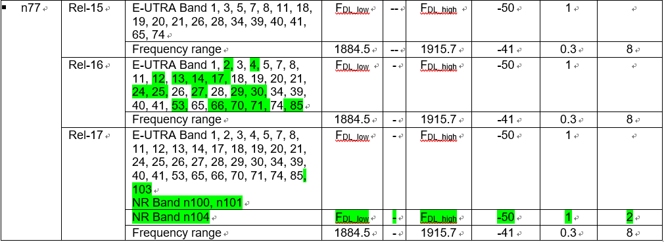

* **Scenario 2:** Some protected bands were removed in later Releases, but were still kept in previous Release (e.g., n50, n78, n74).

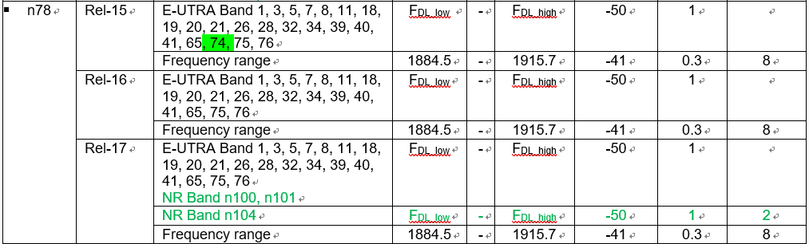

* **Scenario 3:** Protected band was changed from NR band to LTE band in later Release (Note was also changed), but was still kept unchanged in previous Release (e.g., n70).

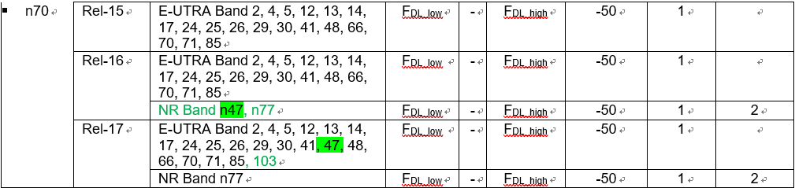

Moderator note:

|  |  |  |
| --- | --- | --- |
|  | Rel-N | Before Rel-N (early release) |
| **Case 1: New band** A introduced in Rel-N | New coexistence requirements defined | Option 1:   * Coexistence table unchanged * Early release “***new UE***” which support band A apply new Rel-N coexistence requirements with release independent manner * Early release “***old UE***” apply old coexistence requirements of early release   Option 2:   * Coexistence table unchanged * Early release UE apply early release coexistence requirements |
| **Case 2: Existing band** but new protected scenario added in Rel-N | New coexistence requirements defined | Option 1:   * Coexistence table updated to add new coexistence requirements * Early release “***new UE***” which support band A apply new coexistence requirements of early release * Early release “***old UE***” which support band A apply old coexistence requirements of early release   Option 2:   * Coexistence table unchanged * Early release UE apply early release coexistence requirements |

Comments:

Nokia: We have flagged the Rel-15 CRs.

Huawei: further check is needed for scenario 2 and 3.

Softbank/Docomo: Scenario 2 is error, but need check scenario 3.

**For Case 1: New band A introduced in Rel-N**

Nokia: Stop update the Rel-15/16 coexistence tables.

Softbank: for example, band 42 in Japan. Option 1 is ok for case 1. Coexistence requirements are regulation requirements.

Apple: Option 2 is the only option. Which is new UE and which is old UE depends on UE vendors.

Vivo: RAN4 only consider the minimum requirements. New UE can consider more coexistence requirements. Option 1 has not been adopted in RAN4, probably RAN5 is better place. Option 2 is safe.

AT&T: Option 1 seems feasible with 38.307 changes.

Huawei: Option 1 and 2 both don’t change RAN4 spec. RAN4 need to leave some flexibility on which requirements apply for some UE.

CAICT: the requirements applied for Legacy UE should be decided by certification bodies.

**For Case 2: Existing band but new protected scenario added in Rel-N**

Softbank: This is what we done to US n77 band. Need to check the regulation.

Apple: the early releases are frozen we need to keep then unchanged, and no new requirements added.

CAICT: If old UE come into new NW where the protection is required, coexistence problem will happen.

Apple: coexistence requirements are not regulation requirements.

Agreement:

* Coexistence table in early releases will not be changed for Case 1.
* Early release “legacy UE” which is on the market apply old coexistence requirements of early release

**Issue 2-1-2: UE co-existence requirement applicability**

* Proposals: [R4-2307117 CAICT]
* **Proposal 1: Protected bands shall always be updated from the earliest Release of RAN4 spec that a 3GPP band has been defined** to ensure new designed UEs with any Release will not interfere the new co-existent systems.
* **Proposal 2:** Spurious emission for UE co-existence requirements in **Release 15/16/17 specs of 38.101-1/2/3**, **Release 17 spec of 38.101-5** and **Release 8/9/10/11/12/13/14/15/16/17 specs of 36.101** shall be updated to **align with the requirements in Release 18 specs**.
* **Proposal 3: UE shall consider** the spurious emission of all protected bands included in the **latest Version of spec at the stage of its design.** It is up to certification organization to decide which **Version** of spec can be accepted for UE certification.
* **Proposal 4:** Requirement for Spurious emission for **UE co-existence shall be Release independent**. RAN4 shall reach the agreement that the **latest Release of RAN4 spec is the reference for the correct requirements** of Spurious emission for UE co-existence of all Releases.

**Issue 2-1-3: Comments to below CRs**

|  |  |  |  |
| --- | --- | --- | --- |
| **T-doc** | **Company** | **Title/Comments** | **Recommendation** |
| R4-2307101 | CAICT | Correction of UE co-existence requirement in 36.101 Rel-15 | Postpone |
| R4-2307102 | CAICT | Correction of UE co-existence requirement in 36.101 Rel-16 | Postpone |
| R4-2307103 | CAICT | Correction of UE co-existence requirement in 36.101 Rel-17 | Postpone |
| R4-2307104 | CAICT | Correction of UE co-existence requirement in 38.101-1 Rel-15 | Postpone |
| R4-2307105 | CAICT | Correction of UE co-existence requirement in 38.101-1 Rel-16 | Postpone |
| R4-2307106 | CAICT | Correction of UE co-existence requirement in 38.101-1 Rel-17 | Postpone |
| R4-2307107 | CAICT | Correction of UE co-existence requirement in 38.101-2 Rel-15 | Postpone |
| R4-2307108 | CAICT | Correction of UE co-existence requirement in 38.101-2 Rel-16 | Postpone |
| R4-2307109 | CAICT | Correction of UE co-existence requirement in 38.101-3 Rel-15 | Postpone |
| R4-2307110 | CAICT | Correction of UE co-existence requirement in 38.101-3 Rel-16 | Postpone |
| R4-2307111 | CAICT | Correction of UE co-existence requirement in 38.101-3 Rel-17 | Postpone |
| R4-2307112 | CAICT | Correction of UE co-existence requirement in 38.101-5 Rel-17 | Postpone |

**NWM flag comments:**

Nokia:

* R4-2307095, R4-2307104, R4-2307109 Is REL15 necessary or can we just do later releases.
* R4-2307105, R4-2307106, R4-2307110, R4-2307111 We would like to see that changes to UL CA/EN-DC are removed as we have CRs in this meeting to simplify these tables

Apple:

Thanks to CAICT for raising the concern and the big efforts on implementing these CRs. Unfortunately, it is not clear to me why the bands introduced in later releases need to be listed in the coexistence table in earlier releases. This does not look be a common exercise in RAN4 in the past when a new band was introduced. In my view, there are three aspects in the proposed CRs.

1. n77 is a unique case that the band in different regions were introduced at different times. For example, n77 in US was introduced in Rel-16. So the protected bands in US were added starting from Rel-16. Though a Rel-15 UE can support US Band n77 via release independent, it will still follow the Rel-16 requirements for this band. Therefore, I do not think US protected bands need to be added to Rel-15 Band n77 requirements.

2. Should new bands introduced in later releases be listed in the protection list in earlier releases? In general, this sounds reasonable for new UEs supporting older releases as any 3GPP bands in the field in principle need to be protected from other 3GPP bands in the same region. However, for UEs already exist in the field, there is no guarantee that these new bands can be protected by UEs which were not verified against these new bands. On this aspect, I think RAN4 needs further discussions and come up with a WF on whether we keep the existing requirements and allow new UE supporting older releases a waiver or we need to make core requirements change in older releases which would impact conformance test requirements as well.

3. Real errors which should always be corrected starting from the earliest release.

Huawei:

1. It may cause some NBC issues for some legacy UEs in the market, which can’t meet the new requirements to protect new bands in later release.

2. In the earlier release spec, there is no new band definition, but to protect them. It sounds contradictory with each other.

3. Comment on observation 3 of 7068. -30dBm/MHz Spurious emission is a regulatory requirement. But -50dBm/MHz specified for UE-to-UE coexistence is not a regulatory requirement. From that perspective, there is no regulatory risk for some inconsistences in spurious emission for UE-to-UE coexistence.

4. Comment on observation 1 of 7068. As spec is being envolved and new features/bands are being introduced, some inconsistency due to technical/release control reasons should be allowed. Otherwise, we can just keep single release spec.

5. As we are approaching the end of Rel-18, it’s more important to keep earlier release spec stable, unless.

Vivo:

The basic question of this issue is whether to treat those UE co-existence requirements as regulatory requirements and whether different releases can have different requirements at a given time.

For usual minimum requirements, there is no such need. However, if treated as regulatory, then different

rules can be considered such as those recommended by the paper.

### Sub-topic 2-2 FOOB in UE coexistence

*Moderator note: NOTE15 in UE coexistence table is used to indicate whether the freq within FOOB shall comply with the coexistence requirements.*

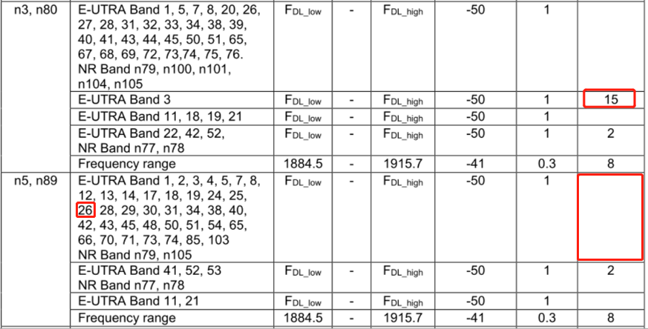



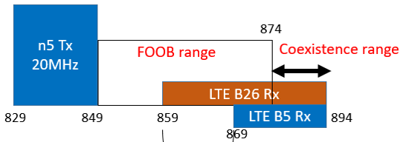

**Issue 2-2-1: Is it ok to introduce the NOTE15 for n5/n26 protect n26/b26 from Rel-18 onwards?**

* **Proposal:** The clarification of UE coexistence applicable frequency ranges, and adding the NOTE 15 for n5, both can be considered from Rel-18, and no changes to the Rel-15/16/17 specs.

Docomo: Rel-18 is ok. CRs from Tmobile are ok.

AT&T: why we delete the last sentence?

Docomo: we have CRs in Rel-15.

Nokia: why you still want to change Rel-15 now we are in Rel-18

Docomo: There is possiblity that new UE comply with Rel-15 will come into market.

Apple: coexistence is not regulatory requirements.

**Issue 2-2-2: Comments to below CRs**

*Moderator note: the yellow highlighted 38101-1 CRs can be merged if Issue 2-2-1 is agreeable.*

|  |  |  |  |
| --- | --- | --- | --- |
| **T-doc** | **Company** | **Title/Comments** | **Recommendation** |
| R4-2309713 (R18) | T-Mobile USA, Skyworks Solutions, Inc., Qualcomm, Qorvo, Murata, Apple | CR for 38.101-1: Foob clarification and n5 and n26 protection for B26/n26  Comment: CAICT flag  QC: FOOB clarification should be introduced in Rel-15/16/17  Tmobile: there is ambiguity in Rel-15/16/17. Our concern is that UE may not protect n26 in later releases. | Return to |
| R4-2307296 (R15)  CAT-A:  R4-2307297 (R16)  R4-2307298 (R17)  R4-2307299 (R18) | NTT DOCOMO | CR for 800MHz frequency range protection from n5 for UE coexistence R15  Comment:  Samsung flag  Skyworks (neither band n5 nor band n26 are allocated in Japan. Only band n18/ and LTE band  19 are operated in Japan. A band n26 UE should not have to protect these ranges. Could it be confirmed that it is sufficient that the protected range only applies to band n18 and band 19 UEs?) | Return to |
| R4-2307300 (R16)  CAT-A:  R4-2307301 (R17)  R4-2307302 (R18) | NTT DOCOMO | CR for 800MHz frequency range protection from n26 for UE coexistence R16  Comment: Samsung flag  Skyworks flag same comment as above. | Return to |
| R4-2308962 (R18) | OPPO | 38101-1 CR on clarification of UE coexistence frequency range (R18)  Comment: CAICT/Samsung/DoCoMo flag | Return to |
| R4-2308963 (R18) | OPPO | 38101-2 CR on clarification of UE coexistence frequency range (R18)  Comment: CAICT flag  Samsung flag (for 38.101-2 currently there is no note in the table) | Return to |
| R4-2308964 (R18) | OPPO | 38101-3 CR on clarification of UE coexistence frequency range (R18)  Comment: CAICT flag  Samsung flag (a general sub-clause 6.5B.3.0 is preferred) | Return to |

# Topic #3: PC1.5 for NS_47 (3)

## Contributions summary

|  |  |  |
| --- | --- | --- |
| **T-doc number** | **Company** | **Proposals / Observations** |
| R4-2307487 | SoftBank | Updates on PC1.5/NS_47 support of n41 for Japan  [Proposal-1] Final CR(s) are postponed to August meeting.  [Proposal-2] If HP-UE of n3-n41 urgently needs, we try to agree the A-MPR values in this meeting. |
| R4-2309061 | Apple | On PC1.5 for NS_47  **Observation 1**: Region A3 is governed by C-IM3. With defining PC1.5 the A-MPR would require an additional 3dB compared to PC2. The actual impact of rIMD on C-IM3 is unclear and the effect of rIMD might or might not introduce additional power back-off need.  **Proposal 1**: Measurements could be conducted to evaluate whether the rIMD creates additional power back-off need or whether 8dB A-MPR would be sufficient for region A3.  **Proposal 2:** Introduce new A-MPR region to cover certain RBs which require more power back-off than defined by PC1.5 MPR. Decide either for the proposed region 1 or 2.  Proposal 3: Use table 3 as a starting point for further discussion. |
| R4-2309272 | Qualcomm | NS_47 measurements and A-MPR for PC1.5  **Proposal 1:** Adopt A-MPR for NS_47 in n41 with PC1.5 as according to table 3  **Proposal 2:** Make the A-MPR change to the open release. |

## Open issues summary

### Sub-topic 3-1

*Sub-topic description: PC1.5 devices would be allowed in the near future* *in Japan, e.g. June this year. The related additional emission requirements as below.*

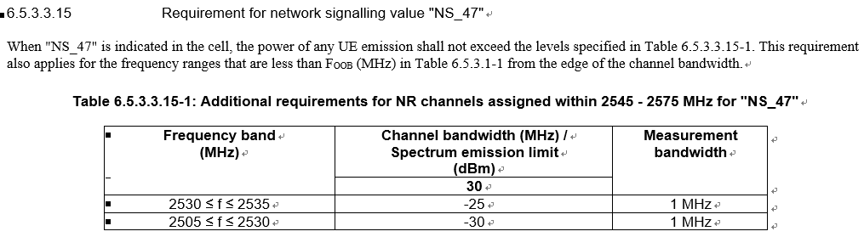

**Issue 3-1-1: Is below proposal acceptable?**

* **[Proposal-1]** Final CR(s) are postponed to August meeting.
* **[Proposal-2]** If HP-UE of n3-n41 urgently needs, we try to agree the A-MPR values in this meeting.

*Moderator note: is the NS_47 requirements be impacted by the Japan regulation status that makes the CR shall wait for the publish of regulation?*

Agreement: Postpone introducing CRs to August meeting.

**Issue 3-1-2: Whether the A5 new region is needed?**

* **Option 1:** Introduce new A-MPR region to cover certain RBs which require more power back-off than defined by PC1.5 MPR. Decide either for the proposed Option 1 or 2. (R4-2309061 Apple)

* **Option 2:** Additional A-MPR region is not needed according to the measurements. (R4-2309272 Qualcomm)

**Issue 3-1-3: The AMPR values**

* **Option 1: (R4-2309061 Apple)**

|  |  |  |  |  |  |  |  |  |  |  |  |  |  |
| --- | --- | --- | --- | --- | --- | --- | --- | --- | --- | --- | --- | --- | --- |
| Modulation/Waveform | A1(dB) | | | A2(dB) | | | A3(dB) | | | A4(dB) | | | A5(dB) |
|  | PC3 | PC2 | PC1.5 | PC3 | PC2 | PC1.5 | PC3 | PC2 | PC1.5 | PC3 | PC2 | PC1.5 | PC1.5 |
|  | Outer/ Inner | Outer/ Inner | Outer/ Inner | Outer/ Inner | Outer/ Inner | Outer/ Inner | Outer/ Inner | Outer/ Inner | Outer/ Inner | Outer/ Inner | Outer/ Inner | Outer/ Inner | Outer/ Inner |
| DFT-s-OFDM PI/2 BPSK | ≤ 7 | ≤ 10 | ≤ 13.0 | ≤ 5.5 | ≤ 8.5 | ≤ 11.0 | ≤ 2 | ≤ 5 | ≤ [X] | ≤ 3 | ≤ 6 | ≤ 8.5 | ≤ 3.0 |
| DFT-s-OFDM QPSK | ≤ 7 | ≤ 10 | ≤ 13.0 | ≤ 5.5 | ≤ 8.5 | ≤ 11.0 | ≤ 2 | ≤ 5 | ≤ [X] | ≤ 3 | ≤ 6 | ≤ 8.5 | ≤ 3.0 |
| DFT-s-OFDM 16 QAM | ≤ 7 | ≤ 10 | ≤ 13.0 | ≤ 5.5 | ≤ 8.5 | ≤ 11.0 |  | ≤ 5 | ≤ [X] | ≤ 3 | ≤ 6 | ≤ 8.5 | ≤ 3.0 |
| DFT-s-OFDM 64 QAM | ≤ 7 | ≤ 10 | ≤ 13.0 | ≤ 6 | ≤ 8.5 | ≤ 11.0 |  | ≤ 5 | ≤ [X] | ≤ 3 | ≤ 6 | ≤ 8.5 |  |
| DFT-s-OFDM 256 QAM | ≤ 7 | ≤ 10 | ≤ 13.0 | ≤ 6 | ≤ 8.5 | ≤ 11.0 |  | ≤ 5 | ≤ [X] |  | ≤ 6 | ≤ 8.5 |  |
| CP-OFDM QPSK | ≤ 7 | ≤ 10 | ≤ 13.0 | ≤ 7 | ≤ 10 | ≤ 12.5 |  | ≤ 5 | ≤ [X] | ≤ 4 | ≤ 7 | ≤ 9.5 | ≤ 4.0 |
| CP-OFDM 16 QAM | ≤ 7 | ≤ 10 | ≤ 13.0 | ≤ 7 | ≤ 10 | ≤ 12.5 |  | ≤ 5 | ≤ [X] | ≤ 4 | ≤ 7 | ≤ 9.5 | ≤ 4.0 |
| CP-OFDM 64 QAM | ≤ 7 | ≤ 10 | ≤ 13.0 | ≤ 7 | ≤ 10 | ≤ 12.5 |  | ≤ 5 | ≤ [X] |  | ≤ 7 | ≤ 9.5 |  |
| CP-OFDM 256 QAM | ≤ 7 | ≤ 10 | ≤ 13.0 | ≤ 7 | ≤ 10 | ≤ 12.5 |  |  | ≤ [X] |  | ≤ 7 | ≤ 9.5 |  |

* **Option 2: (R4-2309272 Qualcomm)**

|  |  |  |  |  |  |  |  |  |  |  |  |  |
| --- | --- | --- | --- | --- | --- | --- | --- | --- | --- | --- | --- | --- |
| **Modulation/Waveform** | **A1(dB)** | | | **A2(dB)** | | | **A3(dB)** | | | **A4(dB)** | | |
| **PC3** | **PC2** | **PC1.5** | **PC3** | **PC2** | **PC1.5** | **PC3** | **PC2** | **PC1.5** | **PC3** | **PC2** | **PC1.5** |
| **Outer/** | **Outer/** | **Outer/** | **Outer/** | **Outer/** | **Outer/** | **Outer/** | **Outer/** | **Outer/** | **Outer/** | **Outer/** | **Outer/** |
| **Inner** | **Inner** | **Inner** | **Inner** | **Inner** | **Inner** | **Inner** | **Inner** | **Inner** | **Inner** | **Inner** | **Inner** |
| DFT-s-OFDM PI/2 BPSK | ≤ 7 | ≤ 10 | ≤ 13 | ≤ 5.5 | ≤ 8.5 | ≤ 11 | ≤ 2 | ≤ 5 | ≤8 | ≤ 3 | ≤ 6 | ≤ 8.5 |
| DFT-s-OFDM QPSK | ≤ 7 | ≤ 10 | ≤ 5.5 | ≤ 8.5 | ≤ 2 | ≤ 5 | ≤ 3 | ≤ 6 |
| DFT-s-OFDM 16 QAM | ≤ 7 | ≤ 10 | ≤ 5.5 | ≤ 8.5 |  | ≤ 5 | ≤ 3 | ≤ 6 |
| DFT-s-OFDM 64 QAM | ≤ 7 | ≤ 10 | ≤ 6 | ≤ 8.5 |  | ≤ 5 | ≤ 3 | ≤ 6 |
| DFT-s-OFDM 256 QAM | ≤ 7 | ≤ 10 | ≤ 6 | ≤ 8.5 |  | ≤ 5 |  | ≤ 6 |
| CP-OFDM QPSK | ≤ 7 | ≤ 10 | ≤ 7 | ≤ 10 | ≤ 12.5 |  | ≤ 5 | ≤ 4 | ≤ 7 | ≤ 9.5 |
| CP-OFDM 16 QAM | ≤ 7 | ≤ 10 | ≤ 7 | ≤ 10 |  | ≤ 5 | ≤ 4 | ≤ 7 |
| CP-OFDM 64 QAM | ≤ 7 | ≤ 10 | ≤ 7 | ≤ 10 |  | ≤ 5 |  | ≤ 7 |
| CP-OFDM 256 QAM | ≤ 7 | ≤ 10 | ≤ 7 | ≤ 10 |  |  |  | ≤ 7 |

Comments:

Agreement:

Postpone to August meeting in the final values, and encourage companies to further check the yellow highlighted values and regions.

# Topic #4: Power scaling and UL CA Pcmax (1)

## Contributions summary

|  |  |  |
| --- | --- | --- |
| **T-doc number** | **Company** | **Proposals / Observations** |
| R4-2307731 | Ericsson | One more on PCMAX for a BC  **Proposal 1:** modify the PCMAX for inter-band UL CA in 38.101-1 consistent with the definition in 38.213. The measured output power PUMAX is verified similar to EN-DC with due account for power prioritization. |

## Open issues summary

### Sub-topic 4-1 Pcmax violate 38.213

**Issue 4-1-1: Whether Pcmax in 38.101-1 violates 38.213?**

* **Option 1: (Ericsson)**
  + **In 38.213:** For determining the PCMAX for each transmission occasion, the **UE does not include transmissions starting after this occasion**.

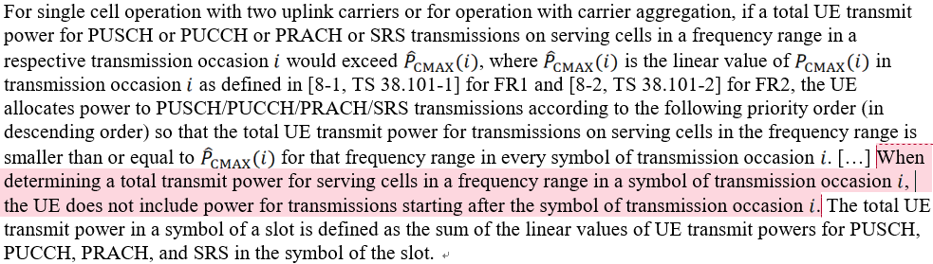

* + **In 38.101-1:** the PCMAX implies that the UE also includes transmissions start after a transmission occasion evaluated.
* the total power for each transmission occasion for scaling during TREF is limited by the lowest pCMAX_L,f,c(i),i (p) + pCMAX_L,f,c(i),j (q) as evaluated for all transmission occasions *j*k overlapping with *i*
* the total power for an **earlier transmission *j*1 is limited by a later non-overlapping transmission *j*3** with an UL grant received at a later instant, which violates the 38.213.

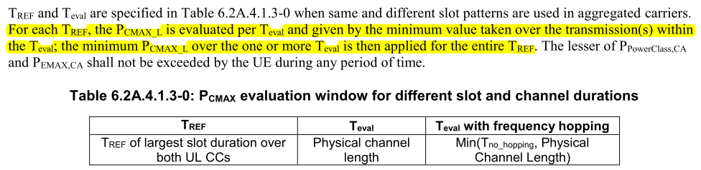

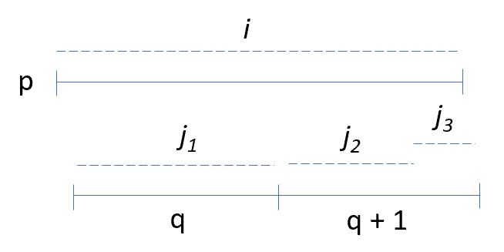

Figure 1: overlapping transmissions occasions on serving cells of different numerologies.

Comments:

Huawei: RAN4 spec doesn’t vialate RAN1.

Ericsson: clearly there are vialation if we look at the yellow highlighted parts. This is real problem.

Huawei: RAN4 case is for overlapping scenario. There is some ambigutiy in the evaluation widow table, and there is no issue in implementation.

**Issue 4-1-2: Whether below scenarios need to be evaluated in 38.101-1**

* **Option 1: (Ericsson)**
  + The measured total power PUMAX is limited by the pCMAX_L,f,c(i),i (p) + pCMAX_L,f,c(i),j (q) if below the BC power class. Two cases should be included, similarly to inter-band EN-DC:
* **Case 1:** the **total configured power** of all serving cells **is always below the BC power class**, **power prioritization should not occur** and all transmissions be present regardless of priority
* **Case 2:** the **total power exceeds the BC power class**, the UE allowed **scale or drop transmissions of lower priorities**.

**Issue 4-1-3: Whether to change the Pcmax to align with 38.213**

*Moderator note: from which release this change is targeted?*

* **Option 1:** modify the PCMAX for inter-band UL CA in 38.101-1 consistent with the definition in 38.213. The measured output power PUMAX is verified similar to EN-DC with due account for power prioritization. (Ericsson)

# Topic #5: PMPR for PRACH (1)

## Contributions summary

|  |  |  |
| --- | --- | --- |
| **T-doc number** | **Company** | **Proposals / Observations** |
| R4-2309211 | Ericsson | P-MPR for PRACH  Observation 1Percentage of Uplink PRACH symbols could be very low in normal operation.  Observation 1 When maxUplinkDutyCycle-FR2 is present and if the percentage of uplink symbols transmitted including the unscheduled transmission, the P-MPR may apply when percentage of symbols scheduled during 1s is less than the maxUplinkDutyCycle-FR2 reported by UE.  Proposal-1: Clarify UE behaviour of the calculation of percentage of the uplink symbols:  Option 1: the percentage of uplink symbols transmitted does not include any autonomous uplink transmission  Option 2: the percentage of uplink symbols transmitted include the any autonomous uplink transmission which is not scheduled by network. |

## Open issues summary

### Sub-topic 5-1

**Issue 5-1-1: Which option is correct understanding of percentage UL symbols in calculation**

* **Option 1:** the percentage of uplink symbols transmitted **does not include** any autonomous uplink transmission
* **Option 2:** the percentage of uplink symbols transmitted **include** the any autonomous uplink transmission which is not scheduled by network.

Ericsson: want to clarify UE behaviour in RAN4 spec related to UE capability defined in 306, and how this capability is calculated. RAN4 spec doesn’t mention about the PRACH like transmission.

Huawei: the percentage of PRACH in Ericsson paper is quite small.

Ericsson: Regulator don’t differentiate channels in SAR/MPE.

Agreement:

* **Option 2:** the percentage of uplink symbols transmitted **include** the any autonomous uplink transmission which is not scheduled by network.

**Issue 5-1-2: Is below updates acceptable?**

* **If Option 1 is RAN4 consensus, the specification text in TS 38.101-2 can be improved as below:**

If the field of UE capability *maxUplinkDutyCycle-FR2* is present and the percentage of uplink symbols transmitted excluding any autonomous transmission within any 1 s evaluation period is larger than *maxUplinkDutyCycle-FR2*, the UE follows the uplink scheduling and can apply P-MPRf,c.

* **if Option 2 is RAN4 consensus, the specification text in TS 38.101-2 can be improved as below:**

If the field of UE capability *maxUplinkDutyCycle-FR2* is present and the percentage of uplink symbols transmitted including any autonomous transmission within any 1 s evaluation period is larger than *maxUplinkDutyCycle-FR2*, the UE follows the uplink scheduling and can apply P-MPRf,c.

**Agreement:**

* **the specification text in TS 38.101-2 can be improved as below:**

If the field of UE capability *maxUplinkDutyCycle-FR2* is present and the percentage of uplink symbols transmitted including any autonomous transmission within any 1 s evaluation period is larger than *maxUplinkDutyCycle-FR2*, the UE follows the uplink scheduling and can apply P-MPRf,c.

# Topic #6: EVM measurement for UL MIMO (3)

## Contributions summary

|  |  |  |
| --- | --- | --- |
| **T-doc number** | **Company** | **Proposals / Observations** |
| R4-2309152 | Rohde & Schwarz | Discussion on UL MIMO EVM measurement methodology  **Observation 1:** Current versions of TS 38.101-1 and TS 38.101-2 incorrectly capture the number of DMRS symbols to be used.  **Proposal 1:** Update the specification to use all available DMRS in a RMC.  **Observation 2:** Using all available DMRS symbols greatly improves the performance of Method 1.  **Observation 3:** Method 3 is more complex than Method 1 for 2 layer MIMO. This becomes much worse for 4 layer MIMO.  **Observation 4:** The usage of averaging for improving the channel estimation is an established concept in 3GPP.  **Observation 5:** Method 3 inherently uses a frequency smoothing over 1 CDM group without the option to remove it.  **Observation 6:** Further clarification is needed on the matrix invertibility for Method 3.  **Proposal 2:** RAN4 keeps the current procedure as described in TS 38.101-1 and TS 38.101-2 with the improvement of using all DMRS symbols. |
| R4-2309153 (R15)  CAT-A:  R4-2309154  R4-2309155  R4-2309156 | Rohde & Schwarz | Update of FR1 UL MIMO EVM measurement description |
| R4-2309157 (R15)  CAT-A:  R4-2309158  R4-2309159  R4-2309160 | Rohde & Schwarz | Update of FR2 UL MIMO EVM measurement description |

## Open issues summary

### Sub-topic 6-1

*Sub-topic description: In last meeting, EVM measurement method 3 of UL MIMO was brought out and WF R4-2303653 was approved to further compare the method 3 with method 1.*

**Issue 6-1-1: Is it acceptable that RAN4 keeps the current procedure as described in TS 38.101-1 and TS 38.101-2 with the improvement of using all DMRS symbols.**

* Yes
* No

Comments:

Keysight: need further discussion.

**Issue 6-1-2: Comments to below CRs**

|  |  |  |  |
| --- | --- | --- | --- |
| **T-doc** | **Company** | **Title/Comments** | **Recommendation** |
| R4-2309153 (R15)  CAT-A:  R4-2309154  R4-2309155  R4-2309156 | Rohde & Schwarz | Update of FR1 UL MIMO EVM measurement description  Comment: R&S flag (CR number on the coversheet is wrong) | Return to |
| R4-2309157 (R15)  CAT-A:  R4-2309158  R4-2309159  R4-2309160 | Rohde & Schwarz | Update of FR2 UL MIMO EVM measurement description | Return to |

# Topic #7: EVM for shorter transient period (1)

## Contributions summary

|  |  |  |
| --- | --- | --- |
| **T-doc number** | **Company** | **Proposals / Observations** |
| R4-2309742 | Skyworks | LS on EVM for shorter transient period capability in FR1 |

## Open issues summary

### Sub-topic 7-1

*Moderator note: In Feb meeting, agreements reached and this is the LS to RAN5:*

*1) Confirm RAN4 assumptions on transient assumptions:*

*a) Transients are verified using the Figure 7.3.3.7-3 ON to ON time mask*

*b) Transient is not triggered by TPC commands, it is triggered by RB allocation change*

*2) RAN4 need a new UL RMC at SCS15kHz with 5ms periodicity to verify the transient according to Figure 6.3.3.7-3 time-mask, i.e. proposal 6 above*

**Issue 7-1-3: Comments to below LS**

|  |  |  |  |
| --- | --- | --- | --- |
| **T-doc** | **Company** | **Title/Comments** | **Recommendation** |
| R4-2309742 | Skyworks | LS on EVM for shorter transient period capability in FR1 | Agreed |

# CRs for 38.101-1 (21)

## K1 and PdschNumOfHarqProcess for DL-CA

|  |  |  |  |
| --- | --- | --- | --- |
| **T-doc** | **Company** | **Title/Comments** | **Recommendation** |
| R4-2307035 (R15)  CAT-A:  R4-2307036 (R16)  R4-2307037 (R17) | Anritsu Limited, Rohde & Schwarz, Keysight Technologies UK Ltd | *CR to K1 and PdschNumOfHarqProcess for DL-CA* | Agreed |
| R4-2307038 (R18) | Anritsu Limited, Rohde & Schwarz, Keysight Technologies UK Ltd | CR to K1 and PdschNumOfHarqProcess for DL-CA | Agreed |

## FR1 OOB requirements correction

|  |  |  |  |
| --- | --- | --- | --- |
| **T-doc** | **Company** | **Title/Comments** | **Recommendation** |
| R4-2307039 (R15)  CAT-A:  R4-2307040 (R16) | Anritsu | FR1 OOB requirements correction | Agreed |
| R4-2307041 (R17)  CAT-A:  R4-2307042 (R18) | Anritsu | FR1 OOB requirements correction | Agreed |

## V2X

|  |  |  |  |
| --- | --- | --- | --- |
| **T-doc** | **Company** | **Title/Comments** | **Recommendation** |
| R4-2307094 (R16) | Facebook | CR TS 38.101-1: Correction on NR V2X requirements in Rel-16  *Moderator note: CR was provided to reflect the agreed contents in Rel-16* | Agreed |
| R4-2308990 (R16)  CAT-A:  R4-2308991  R4-2308992 | OPPO | CR for TS 38.101-1 Rel-16: V2X min output power  Comment:  QC flag (If the minimum power is changed back to -40 dBm then won’t the absolute power tolerance and minimum output power be set back to the original LTE V2X specs that RAN5 indicated would be a problem for IBE measurements in the -40 dBm< output power <-30 dBm range?)  LGE flag (not certain that change in NR V2X operated in band n47 (and then possibly also LT V2X operated in band 47) is necessary as these values have been agreed a long time ago (Rel-16 for NR V2X and Rel-14 for LTE)  Huawei/Meta flag (We don’t agree to change back the minimum output power back to -40dBm.) | Return to |

## Pcmax correction

|  |  |  |  |
| --- | --- | --- | --- |
| **T-doc** | **Company** | **Title/Comments** | **Recommendation** |
| R4-2307732 (R16) | Ericsson | Corrections to configured maximum power for inter-band UL CA  *Moderator note: the Pcmax,f,c is further limited by the min (Ppowerclass, Ppowerclass,CA)*  Comment:  Huawei flag (we disagree the reason for change in the cover sheet. In Rel-16, there’s only PC3 BCs and it’s  hard coded in the spec that PC2 is not applicable for component bands within a BC, i.e. only PC3.)  vivo flag (understand the intention but would like to discuss a bit more on the wording.) | Return to |
| R4-2307733 (R17)  CAT-A:  R4-2307734 (R18) | Ericsson | Corrections to configured maximum power for inter-band UL CA  Comment:  Huawei flag (we have a different approach as proposed in our CR in 9679) | Return to |
| R4-2308158 (R16)  CAT-A:  R4-2308159  R4-2308160 | ZTE | CR to TS38.101-1: Correction on terms for NR DC Pcmax  Comment:  Huawei flag (the motivation is understandable, but would like more time to check the details) | Return to |
| R4-2308367 (R15)  CAT-A:  R4-2308368  R4-2308369  R4-2308370 | MediaTek | CR to 38.101-1 on configured Tx power  Comment:  Nokia flag (Delta Ppowerclass does not alway change power class and associated requirements. For instance, pi/2 BPSK power boosting, even if Delta Ppowerclass is -3 dB, PC must stay PC3, though the reference power  becomes 26 dBm instead 23 dBm.)  Samsung flag (The change might be unnecessary. for single carrier, delta Ppower class is impacted by dutyly cycle IE and p-max, and it clearly mentioned in clause 6.2.1 that if these two factors leads to delta Ppower class, the requirments of which power class applies. Without this clarification, seems it is still clear which MPR  AMPR requirements apply.)  Huawei flag (we share Samsung’s view that the change might not be needed, since Clause 6.2A.1.3 says ”shall apply all requirements for the default power class to the supported power class ”, which should include MPR/A-MPR etc.)  Vivo flag (understand the intention but would like to discuss whether the revision is appropriate or not.)  Qualcomm flag (this change is not needed as it is already covered by 6.2.1 and this seems to result in unintended consequences with pi/2 BPSK power boosting scenario where delta parameter is -3 dB.) | Return to |

## 2UL CA co-existence simplication

|  |  |  |  |
| --- | --- | --- | --- |
| **T-doc** | **Company** | **Title/Comments** | **Recommendation** |
| R4-2308826 | Nokia | NR interband 2UL CA co-ex simplication R16  Comment:  ZTE flag (I didn’t see there are rules/guidances captured in TR38.846, so not sure why some of the protected ’frequency range’ are removed while some are kept?) | Return to |
| R4-2307862 | Nokia | NR interband 2UL CA co-ex simplication R17  Comment: ZTE as above | Return to |
| R4-2307863 | Nokia | NR interband 2UL CA co-ex simplication R18  Comment: ZTE as above | Return to |

## n28+n78 harmonic mixing MSD

|  |  |  |  |
| --- | --- | --- | --- |
| **T-doc** | **Company** | **Title/Comments** | **Recommendation** |
| R4-2309062 (R16)  CAT-A:  R4-2309063  R4-2309064 | Apple | CR for TS 38.101-1 Rel-16: Introducing missing MSD for harmonic mixing  *Moderator note: n28+n78 harmonic mixing MSD value is different from R4-2309255*  QC flag (MSD value applied is approximately 20 dB less than other similar cases. Some middle ground between Qualcomm and Apple proposals is needed.)  CHTTL flag (value too small compare with harmonic requiremens) | Return to |
| R4-2309255 (R16)  CAT-A:  R4-2309256  R4-2309257 | Qualcomm | CR to 38.101-1 Rel-16 Cat F, MSD correction  *Moderator note: n28+n78 harmonic mixing MSD value is different from R4-2309062*  Comment:  Huawei flag (28dB MSD value is too large for 5th harmonic mixing, which is even larger than some 2nd order harmonic MSD. Apple’s CR 2309062 seems more reasonable.) | Return to |

## other change

|  |  |  |  |
| --- | --- | --- | --- |
| **T-doc** | **Company** | **Title/Comments** | **Recommendation** |
| R4-2307836 (R17)  CAT-A:  R4-2307837 (R18) | ZTE | CR to TS38.101-1: Correction to out-of-band blocking table  Comment:  Huawei flag (It’s said “It shall be noted that the corrections were already done in Rel-15 and Rel-16. Therefore, the similar changes should be done for R17 onwards spec to keep the specifications consistency as well.” It is a mirror CR Cat A, isn’t it?) | Agreed |
| R4-2307997 (R15)  CAT-A:  R4-2307998 (R16)  R4-2307999 (R17)  R4-2308000 (R18) | ZTE | CR for TS 38.101-1 on corrections to the minimum guardband calculation | Agreed |
| R4-2309068 (R16)  CAT-A:  R4-2309069  R4-2309070 | Apple | CR for TS 38.101-1: Adding missing requirements for NR-U Rel-16 CAT-F | Agreed |
| R4-2309084 (R16) | Apple | CR for 38.101-1: Single SUL CA combination notation modifications  QC flag (why ”-” instead of agreed ”_” in this case. Cover sheet just says ” it seems it would work”. But how?) | Return to |
| R4-2309251 (R15)  CAT-A:  R4-2309252  R4-2309253  R4-2309254 | Qualcomm | CR to 38.101-1 Rel-15 Cat F, FRC correction | Agreed |
| R4-2309685 (R15)  CAT-A:  R4-2309688  R4-2309689  R4-2309690 | Qualcomm | CR on correcting n38 UL requirement note 22  Huawei flag (It already mentioned in Note 3 that 15 kHz SCS is assumed when RB is mentioned in the note when channel bandwidth is less than or equal to 50MHz. No need to consider corresponding RBs for different SCS.) | Revise to |

# CRs for 38.101-2 (2)

|  |  |  |  |
| --- | --- | --- | --- |
| **T-doc** | **Company** | **Title/Comments** | **Recommendation** |
| R4-2308001 (R15)  CAT-A:  R4-2308002 (R16)  R4-2308003 (R17)  R4-2308004 (R18) | ZTE | CR for TS 38.101-2 on corrections to the minimum guardband calculation | Agreed |
| R4-2308371 (R15)  CAT-A:  R4-2308372  R4-2308373  R4-2308374 | MediaTek | CR to 38.101-2 on configured Tx power  Comment:  Nokia, Huawei, vivo, Samsung, Ericsson flag | Return to |

# CRs for 38.101-3 (10)

## 2UL co-existence simplication

|  |  |  |  |
| --- | --- | --- | --- |
| **T-doc** | **Company** | **Title/Comments** | **Recommendation** |
| R4-2308838 | Nokia | EN-DC interband 2UL co-ex simplication R16  Comment:  ZTE flag (I didn’t see there are rules/guidances captured in TR38.846, so not sure why some of the protected ’frequency range’ are removed while some are kept?)  CHTTL flag | Revised to |
| R4-2307865 | Nokia | EN-DC interband 2UL co-ex simplication R17  Comment: ZTE flag same as above  Samsung flag (The referred clause seems wrong, should refer to correspodning LTE and NR spec, respectively (6.6.3.2 for LTE, 6.6.5.2 for NR)) | Revised to |
| R4-2307866 | Nokia | EN-DC interband 2UL co-ex simplication R18  Comment: ZTE flag same as above | Revised to |

## Corrections on MOP FR1-FR2

|  |  |  |  |
| --- | --- | --- | --- |
| **T-doc** | **Company** | **Title/Comments** | **Recommendation** |
| R4-2308154 (R15) | ZTE | CR to TS38.101-3: Corrections on MOP FR1-FR2 inter-band NR CA and MOP/MPR for ENDC including FR2/FR1 and FR2  Vivo flag (not sure whether this means CA + UL-MIMO requirements for FR2, for clarification.) |  |
| R4-2308155 (R16)  CAT-A:  R4-2308156  R4-2308157 | ZTE | CR to TS38.101-3: Corrections on MOP FR1-FR2 inter-band NR CA and MOP/MPR for ENDC including FR2/FR1 and FR2 |  |

## MSD

|  |  |  |  |
| --- | --- | --- | --- |
| **T-doc** | **Company** | **Title/Comments** | **Recommendation** |
| R4-2309261 (R15)  CAT-A:  R4-2309262  R4-2309263  R4-2309264 | Qualcomm | CR to 38.101-3 Rel-15 Cat F, MSD corrections  *Moderator note:8-n77 harmonic mixing MSD* |  |
| R4-2309346 (R15)  CAT-A:  R4-2309347  R4-2309348  R4-2309349 | NTT DOCOMO, INC., Qualcomm Inc., MediaTek Inc. | CR to R15 TS38.101-3 for addition of missing MSD requirements for DC_19_n77 and DC_21_n77 |  |

## others

|  |  |  |  |
| --- | --- | --- | --- |
| **T-doc** | **Company** | **Title/Comments** | **Recommendation** |
| R4-2308129 (R15)  CAT-A:  R4-2308130  R4-2308131  R4-2308132 | Samsung, KT | Rel15 Cat F CR for 38.101-3 Add RI8,8R relaxtion for ENDC with 8 Rx antenas ports for EUTRA bands |  |
| R4-2308812 (R16)  CAT-A:  R4-2308813  R4-2308814 | Xiaomi | CR for Rel-16 38.101-3 to delete the configurations of DC_48A/B/C/D/E_n46E  *Moderator note: reason for change is no the configurations of CA_n46E, so the DC_48_n46E should be deleted*  Google flag (We propose to add BCS0 for CA_n46E in R4-2309025 and R4-2309027. We would like to keep these 48+n46 inter-band EN-DC configurations.) |  |
| R4-2309461 (R15)  CAT-A:  R4-2309463  R4-2309464  R4-2309465 | CHTTL, Samsung, ZTE, SGS Wireless | CR for corrections on EN-DC channel bandwidth section |  |

# CRs for 38.307 (2)

|  |  |  |  |
| --- | --- | --- | --- |
| **T-doc** | **Company** | **Title/Comments** | **Recommendation** |
| R4-2308933 | Nokia | Correction to Frequency arrangement for overlapping operating bands information R16 |  |
| R4-2308919 | Nokia | Correction to Frequency arrangement for overlapping operating bands information R17 |  |

# CRs for 36.101 (2)

|  |  |  |  |
| --- | --- | --- | --- |
| **T-doc** | **Company** | **Title/Comments** | **Recommendation** |
| R4-2307095 (R15)  CAT-A:  R4-2307096 (R16) | Facebook | CR TS 36.101: Correction for REFSENS requirements for LTE-A CA in Rel-15  *Moderator note: how about R17/R18, is CAT-A needed?* |  |
| R4-2308005 (R8)  CAT-A:  R4-2308006  R4-2308007  R4-2308008  R4-2308009  R4-2308010  R4-2308011  R4-2308012  R4-2308013  R4-2308014  R4-2308015 | ZTE Corporation, Samsung | CR to TS 36.101 on relative humidity condition for normal temperature  Comment:  Nokia flag (REL8 is unacceptable, nothing is broken. REL18 CR with LS to RAN5 to inform applicability would be enough) |  |