# RAN4#106-bis-e Webinar Offline sessions

This is an invitation to RAN4#106-bis-e Webinar Offline sessions on 17 April – 21 2023.  As announced by RAN4 Chairman, there will be a parallel offline session every day, covering multiple topics. This invitation covers BSRF session.

For the **list of topics** covered in each offline session, please check the RAN4#106bis-e meeting GTW **schedule** set by the Chairman and uploaded to /Inbox/Meeting_Arrangement

Please remember that consistent registration format is important for session chairing and hence **use the following format when you register: BriefCompanyName - Firstname, Lastname. An example is shown below**

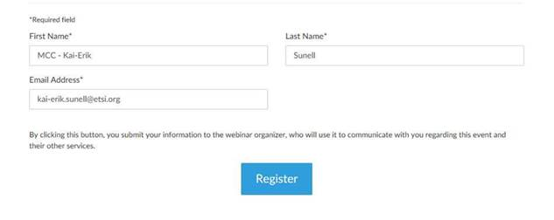

**where BriefCompanyName is ‘MCC’, Firstname is ‘Kai-Erik’ and Lastname is ‘Sunell’.**

Your email address for Webinar registration needs to be the same as for your 3GPP meeting registration.

Registration links are found below and they are session-specific. You may register to all sessions, e.g. if you plan to switch between sessions or if you are able to listen to all sessions at the same time. Once you have registered for a session your registration is valid for the whole week.

**The starting time for Offline session (17 April) is 13:00 UTC** but you can join already 15 minutes earlier, i.e. 12:45 UTC, to check that your speakers and microphones work fine. (Observe, registration links below show time in CET which is UTC + 2 hour.) Webinars are scheduled to stop at 16:00 UTC but there is some extra time reserved for all sessions after 16:00 UTC . The intention is to avoid abrupt termination of the Webinar at 16:00 UTC sharp but, please, try to wrap up your comments latest at 16:00 UTC.

**3GPP TOHRU** will be used in this meeting (previously RAN4 used external TOHRU tool)

Hyperlink:  <https://tohru.3gpp.org/>

Together with the invitation for the GotoWebinar MCC provides you with a "Meeting name" individually after your registration

* The BSRF session meeting TOHRU Meeting ID is listed below:
  + **RAN4_OFFLINE** (TOHRU Meeting ID for Offline)
* This "3GPP TOHRU Meeting ID" has to be entered on the web page and in addition under "Your Name:" you have to provide:  
  **<represented company> - <first name> <family name>**  
  e.g.: XY Telecom - Peter Mustermann

Need to manually push  "Refresh Queue" or use "Automatically refresh queue every 3 seconds", since this is different from the original TOHRU tool.

The other buttons are similar as the previous external TOHRU tool

Instructions on how to join the Webinars will be sent automatically every day.

|  |  |  |
| --- | --- | --- |
| **Offline Sessions for RAN4**  This webinar occurs several times. Please register for the date and time that works best for you.   |  |  | | --- | --- | | |  | | --- | | [Register now!](https://attendee.gotowebinar.com/rt/8356860547598117465) | |   For the schedule and list of topics covered in the offline session of the day, please check the schedule sent out by the Chairman here <https://www.3gpp.org/ftp/tsg_ran/WG4_Radio/TSGR4_106bis-e/Inbox/Meeting_Arrangement>  After registering, you will receive a confirmation email containing information about joining the webinar.  [View System Requirements](https://link.gotowebinar.com/help-system-requirements-attendees) |