3GPP TSG-RAN WG4 Meeting #106 R4-2301765

**Athens, Greece, February 27 – March 3, 2023**

**Title:** [Draft] LS on the UE SRS IL imbalance issue

**Response to:** -

**Release:** Rel-18

**Work Item:** NR_ENDC_ RF_FR1_enh2

**Source:** TSG RAN WG4

**To:** TSG RAN WG1

**Cc:** TSG RAN WG2

**Contact person:**

#### **Name:** Xiang Gao

#### **E-mail Address:** gaoxiang74@huawei.com

**Attachments: None**

# 1 Overall description

SRS IL imbalance has been identified by RAN4. Specifically, the insertion loss for the diversity branch might be different from the main branch. For better explanation, the following example is provided.

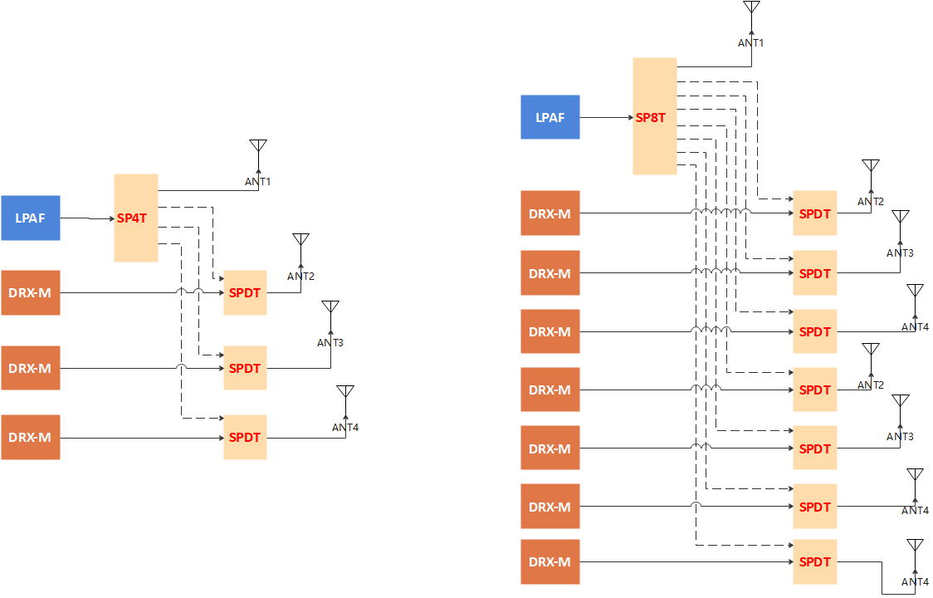

**Fig. Example of possible RF architecture between ‘t1r4’ (left) and ‘t1r8’ (right) AS-SRS capable UE**

As depicted in the above figure, LPAF is the module includes LNA/PA/Filter/switch and is same for different antennas, DRX-M is the diversity receive module which includes the LNA and filters. Apart from the different RF switch (e.g. SPDT/SP4T) that could be applied for different branch, the trace loss, which is due to antenna location, can also contribute to the SRS insertion loss imbalance between the main branch (LPAF branch) and diversity branch (DRX-M branch).

As a result, RAN4 has defined a relaxation for 4Rx as a non-ideal factor in PCMAX_H, f, c, so that the transmission power of any SRS resource from diversity branch would be allowed for a certain reduction. Additionally, such relaxation could be larger in order to deal with 8Rx RF architecture that would increase more implementation complexity, but the discussion on the value is still ongoing. The following definition is excerpted from TS 38.101-1.



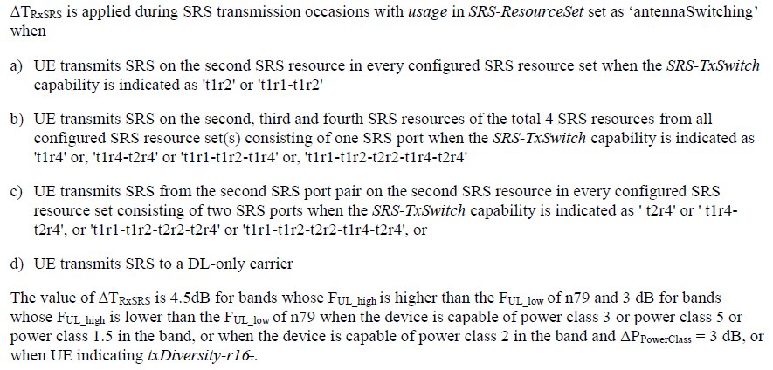

Considering that such imperfection could lead to inaccurate channel estimation at receiver, which could lead to incorrect PMI selection that would degrade overall system performance, RAN4 think it is beneficial to enable UE report on the IL imbalance so network can use this information for AS-SRS based channel estimation accuracy improvement at least for power limited scenario (e.g., cell edge scenario).

For the signaling design, RAN4 have the following discussions and they can be provided to RAN1 for information.

* From the current specification, it can be aware of that PHR type 3 is designed for actual transmission power reporting which is not only consider the aforementioned time-invariant IL imbalance but also other factors e.g., MPR (could be time-variant). While such report is per transmission occasion (for a single SRS resource) so the time duration to cover all SRS resources from one set would be long. Consequently PHR type 3 could be insufficient for gNB to acquire IL imbalance for each diversity branch.

Based on the above analysis for PHR, RAN4 would like to ask RAN1 to further evaluate the possible solutions for enabling UE report on SRS IL imbalance by taking into account the specification impact considering directly reusing PHR (if feasible) as reference. The following characteristics can be considered as initial inputs from RAN4:

* UE can determine whether to report different IL value for different diversity branch.
* The granularity of such report can be per SRS resource and both static and dynamic report can be considered.

# 2 Actions

**To RAN1**

**ACTION:** RAN4 respectfully ask RAN1 to consider above issue for their future study. RAN4 can provide inputs if necessary in the future.

**To RAN2**

**ACTION:** RAN4 respectfully ask RAN2 to consider how to implement the solution which will be determined by RAN1 and/or RAN4 to address the above issue in the future.

# 3 Dates of next TSG RAN WG4 meetings

TSG RAN WG4 Meeting #106bis-e April 17 – April 21, 2023 Electronic meeting

TSG RAN WG4 Meeting #107 May 22 – May 26, 2023 Incheon, Korean