**3GPP TSG-RAN WG4 Meeting #102-e *R4-2207510***

**Electronic Meeting, February 21 – March 3, 2022**

|  |  |  |  |  |  |  |  |  |
| --- | --- | --- | --- | --- | --- | --- | --- | --- |
| *CR-Form-v12.2* | | | | | | | | |
| **CHANGE REQUEST** | | | | | | | | |
|  | | | | | | | | |
|  | **38.827** | **CR** | **xx** | **rev** | **-** | **Current version:** | **16.5.0** |  |
|  | | | | | | | | |
| *For* [***HE******LP***](http://www.3gpp.org/3G_Specs/CRs.htm#_blank)*on using this form: comprehensive instructions can be found at* [*http://www.3gpp.org/Change-Requests*](http://www.3gpp.org/Change-Requests)*.* | | | | | | | | |
|  | | | | | | | | |

|  |  |  |  |  |  |  |  |  |
| --- | --- | --- | --- | --- | --- | --- | --- | --- |
| ***Proposed change affects:*** | UICC apps |  | ME | **X** | Radio Access Network |  | Core Network |  |

|  |  |  |  |  |  |  |  |  |  |  |
| --- | --- | --- | --- | --- | --- | --- | --- | --- | --- | --- |
|  | | | | | | | | | | |
| ***Title:*** | Big CR for TR 38.827 maintenance | | | | | | | | | |
|  |  | | | | | | | | | |
| ***Source to WG:*** | MCC, vivo | | | | | | | | | |
| ***Source to TSG:*** | R4 | | | | | | | | | |
|  |  | | | | | | | | | |
| ***Work item code:*** | FS_NR_MIMO_OTA_test | | | | |  | ***Date:*** | | | 2022-03-4 |
|  |  | | | |  | |  | | |  |
| ***Category:*** | **F** |  | | | | | ***Release:*** | | | Rel-16 |
|  | *Use one of the following categories:* ***F*** *(correction)* ***A*** *(mirror corresponding to a change in an earlier release)* ***B*** *(addition of feature),* ***C*** *(functional modification of feature)* ***D*** *(editorial modification)*  Detailed explanations of the above categories can be found in 3GPP [TR 21.900](http://www.3gpp.org/ftp/Specs/html-info/21900.htm). | | | | | | | | *Use one of the following releases: Rel-8 (Release 8) Rel-9 (Release 9) Rel-10 (Release 10) Rel-11 (Release 11) … Rel-16 (Release 16) Rel-17 (Release 17) Rel-18 (Release 18)*  *Rel-19 (Release 19)* | |
|  |  | | | | | | | | | |
| ***Reason for change:*** | | This big CR merge the endorsed draft CRs R4-2207305 and R4-2204947  In R4-2207305, the maximum downlink power for FR1 and FR2 test procedure is missing;  In R4-2204947, the FR1 power validation for H component with horizontally polarized sleeve dipole is mistakenly descriped as “power sum”, but this should be “average”. | | | | | | | | |
|  | |  | | | | | | | | |
| ***Summary of change:*** | | R4-2207305, update the test procedure with agreed maximum downlink power.  R4-2204947, correct the FR1 power validation procedure with that the power validation for H component using horizontally polarized sleeve dipole is measured by the average of at least 4 orientations. | | | | | | | | |
|  | |  | | | | | | | | |
| ***Consequences if not approved:*** | | FR1 and FR2 MIMO OTA test procedure can not be performed. | | | | | | | | |
|  | |  | | | | | | | | |
| ***Clauses affected:*** | | 6.2.1.2, 6.2.3.2, 7.4.1.5 | | | | | | | | |
|  | |  | | | | | | | | |
|  | | **Y** | **N** |  | | | |  | | |
| ***Other specs*** | |  | **X** | Other core specifications | | | | TS/TR ... CR ... | | |
| ***affected:*** | |  | **X** | Test specifications | | | | TS/TR ... CR ... | | |
| ***(show related CRs)*** | |  | **X** | O&M Specifications | | | | TS/TR ... CR ... | | |
|  | |  | | | | | | | | |
| ***Other comments:*** | |  | | | | | | | | |
|  | |  | | | | | | | | |
| ***This CR's revision history:*** | |  | | | | | | | | |

< start of change 1>

#### 6.2.1.2 Test procedure

Before throughput testing, the initial conditions shall be confirmed to reach the correct measurement state for each test case.

1. Ensure environmental requirements of Annex C are met.

2. Configure the test system according to Clauses 8.2 and 7.2 for the applicable test case.

3. Verify the implementation of the channel model as specified in Clause 7.4.1.

4. Position the UE in the chamber according to Annex A.

5. Power on the UE.

6. Set up the connection.

Note For step 3, the verification of the channel model implementation is usually performed once for each channel model as part of the laboratory accreditation process, and will remain valid as long as the setup and instruments remain unchanged. Otherwise the channel model validation may need to be performed prior to starting each throughput test.

For throughput testing, the following steps shall be followed in order to evaluate NR MIMO OTA performance of the DUT:

1. Measure MIMO OTA throughput from one measurement point, the maximum downlink power is [-80dBm/15kHz (or equivalent -77dBm/30kHz)]. MIMO OTA throughput is the minimum downlink signal power resulting in a pre-defined throughput value (70% and 90%) of the maximum theoretical throughput. The downlink signal power step size shall be no more than 0.5 dB when RF power level is near the NR MIMO sensitivity level.

2. Rotate the UE around vertical axis of the test system by 30 degrees and repeat from step 1 until one complete rotation has been measured i.e. 12 different UE azimuth rotations.

3. Repeat the test from step 1 for each specified device orientation. A list of orientations is given in Annex A.3.

4. The postprocessing method to calculate the average MIMO Throughput is defined in 5.2.

Note: For step 1 of throughput testing, the measurement is not needed to start from maximum downlink power each time. To save testing time, the starting downlink power can be set as a proper value (lower than maximum downlink power supported by test system) as long as all the throughput curve curves at 12 different UE azimuth rotations can reach at least 90% of the maximum theoretical throughput.

< end of change 1>

< start of change 2>

#### 6.2.3.2 Test procedure

Before throughput testing, the initial conditions shall be confirmed to reach the correct measurement state for each test case.

1. Ensure environmental requirements of Annex C are met.

2. Configure the test system according to Clauses 8.2 and 7.2 for the applicable test case.

3. Verify the implementation of the channel model as specified in Clause 7.4.1.

4. Position the UE in the chamber according to Annex D.3.

5. Power on the UE.

6. Set up the connection.

Note: For step 3, the verification of the channel model implementation is usually performed once for each channel model as part of the laboratory accreditation process, and will remain valid as long as the setup and instruments remain unchanged. Otherwise the channel model validation may need to be performed prior to starting each throughput test.

For throughput testing, the following steps shall be followed in order to evaluate NR MIMO OTA performance of the DUT:

1. Position the DUT in the default P0 alignment option (Orientation 1), as defined in Section D.3

2. Measure MIMO OTA throughput, the maximum downlink power is [-79.1dBm/120kHz]. MIMO OTA throughput is the minimum downlink signal power resulting in a pre-defined throughput value (70%) of the maximum theoretical throughput. The downlink signal power step size shall be no more than 0.5 dB when RF power level is near the NR MIMO sensitivity level.

3. Rotate the UE to the next test point. Table 6.2.3.2-1 lists 36 evenly spaced test points determined using the charged particle approach and with test point #1 centred at (0,0).

4. Repeat the test from step 2 for each specified test point. If the re-positioning concept is applied, the device needs to be positioned in P0 Orientation 2 (either option 1 or option 2).

5. he postprocessing method and the performance metric are defined in Clause 5.2.

Note: For step 2 of throughput testing, the measurement is not needed to start from maximum downlink power each time. To save testing time, the starting downlink power can be set as a proper value (lower than maximum downlink power supported by test system) as long as the throughput curve curve can reach at least 70% of the maximum theoretical throughput.

< end of change 2>

< start of change 3>

#### 7.4.1.5 Power validation

**FR1 power validation procedure for MPAC system:**

This measurement checks the total power in the center of the test zone. The power validation is measured with a spectrum analyzer as shown in Figure 7.4.1.5-1.

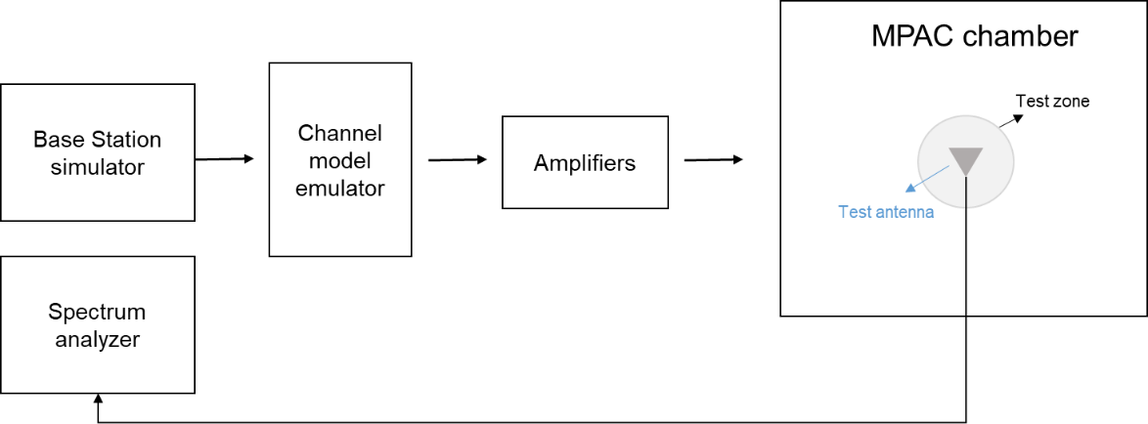

Figure 7.4.1.5-1: Setup for power validation measurements

**Spectrum analyzer settings:**

Table 7.4.1.5-1: Spectrum analyzer settings for Power validation measurements

| Item | Unit | Value |
| --- | --- | --- |
| Center frequency | MHz | Downlink center frequency  in Table 7.4.1-1 |
| Integrated Channel Span | Hz | 20MHz |
| RBW | Hz | 30 kHz |
| VBW | Hz | ≥10MHz |
| Number of points |  | ≥400 |
| Averaging |  | ≥100 |
| Detector |  | RMS |

**Measurement Procedure:**

1. Place a vertical reference dipole in the center of the test zone connected to a spectrum analyzer (or power meter) via a cable.

2. Record the cable and reference dipole gains.

3. Load the target channel model into the channel emulator.

4. Start the NR FR1 signaling in the base station emulator with the required parameter identical to the measurements conditions.

5. Average the power received by the spectrum analyzer for a sufficient amount of time to account for the fading channel – one full channel simulation might be unnecessary.

6. Repeat steps 1 to 4 with a magnetic loop for the horizontal polarization, or a horizontally polarized sleeve dipole measured in at least four orthogonal horizontal positions and average the summed orientations to get the H component.

7. Calculate the total power received at the test area as the sum of the power in the two polarizations.

Note: in step 6, if horizontally polarized sleeve dipole is used, the reference gain correction should be the average of the theta gain pattern cut of the dipole. Besides, more horizontal positions for averaging will improve the measurement accuracy but increase the total measurement time.

The power validation result is considered as systematic offset, which needs to be corrected on the UE final sensitivity value to further reduce measurement uncertainty.

< end of change 3>