TSG-RAN Working Group 4 (Radio) meeting #101-e R4-21XXXX
Electronic meeting, 1 – 12 November 2021

Source: Ericsson
Title: WF on guard period between the SRS resources
Agenda item: 5.1.6.2.1
Document for: Approval

Background
This WF concerns the resolution of a problem for DL CSI acquisition SRS antenna switching (AS) in the field: it is not possible for the network to configure SRS antenna switching in the special slot used in numerous TDD deployments in several regions since there are not enough UL symbols to accommodate the SRS resources and the guard symbol between these. The problematic cases are
- for operations with 2 UL symbols in special slot, AS or AS+FH cannot be used at all (i.e., for any of 1T2R, 2T4R, 1T4R) since there is no room for a guard period G;
- for operations with 3-4 UL symbols in special slot, AS+FH cannot be used at all. AS only (without FH) can be used for 1T2R and 2T4R, 1T4R cannot be used in a single slot
illustrated below for two special slot patterns common in TDD deployments, 10:2:2 and 6:4:4 with 2 and 4 UL symbols (grey) in the special slot, respectively. In the former case (top), the SRS resources R1 and R2 highlighted in red cannot be used for AS due to the guard symbol, while in the latter case (bottom) the SRS resources cannot be configured with FH in combination with AS due to the said guard.
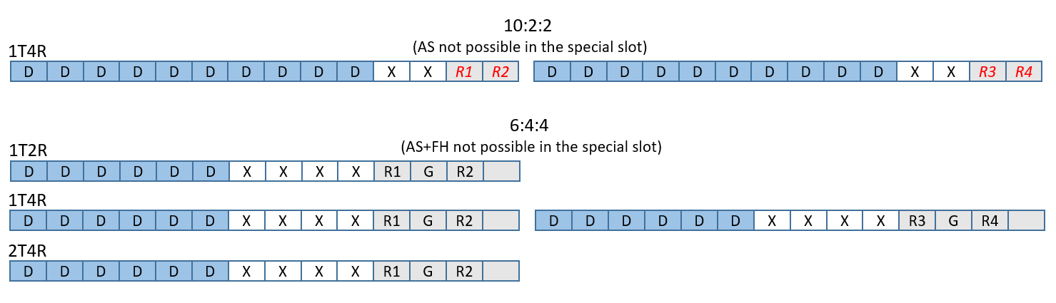
A possible way forward is to remove the guard symbol for 15k and 30k if this is not needed and make this mandatory for Rel-16 (an indication of support is nevertheless needed) at least for UEs supporting the transient time capability. DL CSI acquisition would be improved.
The RAN1 alternative approach to increase the number of SRS sets is optional for Rel-17 and implies that the SRS transmissions are distributed over multiple slots for different UE antennas, the channel sampled in different slots for different UE antennas. For some TDD configurations and deployments, this may lead to a CSI acquisition prone to channel aging and issues with phase coherency in case of DL-UL switching between the said slots, which altogether degrades the MU-MIMO precoding performance for the downlink PDSCH. Alternatively, for resolving the channel aging issue or for UEs not supporting the Rel-17 option, SRS antenna switching must be configured entirely in the UL slot with the UL part of the special slot either unused or granted to transmit an inefficient short mini-slot PUSCH with substantial DMRS overhead. This implies a reduced downlink spectral efficiency.
In the current SRS time mask for antenna switching (Figure 6.3.3.6-5 in 38.101-1)
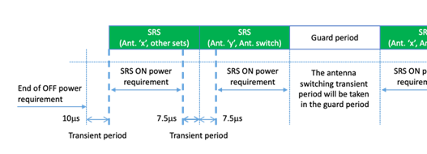
there is no guard symbol between SRS sets despite the antenna switch between resources of different SRS sets. Why is this only needed for switching between resources within the SRS set for AS as specified by RAN1 (guard symbol Y in Table 6.2.1.2-1 in 38.214)? This makes configuration within the special slot of TDD configuration not possible. The reason for the guard period could be clarified with RAN1 – any reason other than UE transients? A draft LS to RAN1 is provided below.
In case the reason for the guard period Y in 38.214 is the UE transients, then RAN4 could further consider the possibility of removing the guard symbol at least for UEs supporting the transient time capabilily (tp < 10 μs) if this would be applicable also for reducing the total transient period for SRS antenna switching. More details can be found in [1]-[3] including the RAN1 scope for Rel-17.

Way forward
To enable configuration of SRS antenna switching in special slots of TDD deployments with 2-4 UL symbols, possibly in combination with FH for reducing SRS interference, the following way forward:
- RAN4 to investigate the possibility of removal of the guard symbol for 15k and 30k between SRS resources in an SRS set with usage ‘antennaSwitching’ (i.e. revert to the mask as specified prior to the 2021-03 version of 38.101-1);
- RAN4 to ask RAN1 on the reason for the need of the guard symbol Y specified in 38.214;
- RAN4 to invstigate using the ON-ON transient time capability for reducing the SRS switching time
for Rel-16 (subject to capability).

References
1. RP-193133, New WID: Further enhancements on MIMO for NR, Samsung, RAN#86, Sitges, Dec. 2019.
2. R4-2118120, Draft LS to RAN1 on the guard period between SRS resources for antenna switching
2. R4-2118121, “Correction to SRS time mask for SRS usage set to antenna switching”, Ericsson

3GPP TSG-RAN WG4 Meeting #100-e R4-21XXXXX
Electronic meeting, 1 – 12 August 2021

Title: [DRAFT] LS to RAN1 on the guard period between SRS resources for antenna switching

Response to:

Release: Rel-16

Work Item: TEI

Source: RAN4
To: RAN1
Cc:

Contact Person:

Name: Christian Bergljung

E-mail Address: Christian.Bergljung@ericsson.com

Send any reply LS to: 3GPP Liaisons Coordinator, mailto:3GPPLiaison@etsi.org

Attachments: None

1. Overall Description:
To enable use of SRS resources for antenna switching together with FH in special slots of TDD deployments with 2-4 UL symbols e.g. 10:2:2 and 6:4:4 used in several countries, RAN4 is discussing the need for and possible removal of the guard symbol between SRS resources for antenna switching in the SRS time mask of 38.101-1 for SCS configurations μ = 0 and μ = 1. This SRS mask was aligned with Table 6.2.1.2-1 of 38.214 in the 2021-03 version of the 38.101-1.

Q1: RAN4 would like ask RAN1 if the only reason for inserting the guard symbol Y was UE transients and possible impacts on SRS transmission quality?

Q2: If the answer to Q1 is yes, would it be possible to remove the guard symbol Y at least for μ = 0 and μ = 1 to enable configuration of the SRS antenna switching in TDD special slots with 2-4 symbols?

RAN4 notes that RAN1 is considering an optional approach for Rel-17 whereby SRS transmissions are distributed over multiple slots for different UE antennas. However, this could make DL CSI acquisition more sensitive to channel aging and phase incorherency as compared to SRS distribution in fewer slots as allowed in the absence of a guard period. Moreover, RAN4 recognises that removal of the guard period would facilitate SRS antenna switching for UEs equipped with more than 4 Rx antennas studied by RAN1.

2. Actions:
To RAN1 group.
ACTION: RAN4 asks RAN1 to consider the above questions.

3. Date of Next RAN WG4 Meetings:
3GPPRAN4#101-bis-e 17 – 25 January 2021 Electronic meeting
3GPPRAN4#102-e 21 February – 3 March 2022 Electronic meeting

