**3GPP TSG-RAN4 WG4 Meeting #** **100-e *R4-2115874***

**Electronic meeting, August 16-27, 2021**

|  |  |  |  |  |  |  |  |  |
| --- | --- | --- | --- | --- | --- | --- | --- | --- |
| *CR-Form-v12.1* | | | | | | | | |
| **CHANGE REQUEST** | | | | | | | | |
|  | | | | | | | | |
|  | **38.827** | **CR** | xxxx | **rev** | **-** | **Current version:** | **16.3.0** |  |
|  | | | | | | | | |
| *For* [***HE******LP***](http://www.3gpp.org/3G_Specs/CRs.htm#_blank)*on using this form: comprehensive instructions can be found at* [*http://www.3gpp.org/Change-Requests*](http://www.3gpp.org/Change-Requests)*.* | | | | | | | | |
|  | | | | | | | | |

|  |  |  |  |  |  |  |  |  |
| --- | --- | --- | --- | --- | --- | --- | --- | --- |
| ***Proposed change affects:*** | UICC apps |  | ME | **x** | Radio Access Network |  | Core Network |  |

|  |  |  |  |  |  |  |  |  |  |  |
| --- | --- | --- | --- | --- | --- | --- | --- | --- | --- | --- |
|  | | | | | | | | | | |
| ***Title:*** | Big CR to TR 38.827 | | | | | | | | | |
|  |  | | | | | | | | | |
| ***Source to WG:*** | MCC, vivo | | | | | | | | | |
| ***Source to TSG*** | R4 | | | | | | | | | |
|  |  | | | | | | | | | |
| ***Work item code:*** | FS_NR_MIMO_OTA_test | | | | |  | ***Date:*** | | | 2021-08-29 |
|  |  | | | |  | |  | | |  |
| ***Category:*** | **F** |  | | | | | ***Release:*** | | | Rel-16 |
|  | *Use one of the following categories:* ***F*** *(correction)* ***A*** *(mirror corresponding to a change in an earlier release)* ***B*** *(addition of feature),* ***C*** *(functional modification of feature)* ***D*** *(editorial modification)*  Detailed explanations of the above categories can be found in 3GPP [TR 21.900](http://www.3gpp.org/ftp/Specs/html-info/21900.htm). | | | | | | | | *Use one of the following releases: Rel-8 (Release 8) Rel-9 (Release 9) Rel-10 (Release 10) Rel-11 (Release 11) … Rel-15 (Release 15) Rel-16 (Release 16)*  *Rel-17 (Release 17) Rel-18 (Release 18)* | |
|  |  | | | | | | | | | |
| ***Reason for change:*** | | This big CRs merge the mutile endorsed draf CRs. The reason for change in each endorsed draft CR is copied below.  R4-2115760 Draft CR to TR38.827:correct Positioning ambiguities  <Reason for change>  In TR 38.827, FR2 MIMO OTA testing is based on 3D multiple probes system, the relative orientations between probes and the DUT have an impact on the measured MIMO OTA metric, the positioning guidance in the current version shows ambiguity issue.  In addition, the BS beam selection and BS antenna element polarizaiton definition are not clearly stated, clarifications are added.  R4-2115761 Draft CR to TR38.827:power validation  <Reason for change>  In TR 38.827, the power validation frequency and test procedure is not correct. | | | | | | | | |
|  | |  | | | | | | | | |
| ***Summary of change:*** | | The summary of change in each each endorsed draft CR is copied below.  R4-2115760 Draft CR to TR38.827:correct Positioning ambiguities  <Summary of change>  Update the positioning guidance to eliminate the ambituities. Update BS beam selection for channel modelling and BS antenna element polarization.  The update is aligned with the content in R4-2115757.  R4-2115761 Draft CR to TR38.827:power validation  <Summary of change>  Update the power validation frequency and test procedure. | | | | | | | | |
|  | |  | | | | | | | | |
| ***Consequences if not approved:*** | | R4-2115760 Draft CR to TR38.827:correct Positioning ambiguities  <Consequences if not approved>  FR2 DUT positioning and rotation would not be aligned in each test lab. Channel modelling procedure would not be clear enough.  R4-2115761 Draft CR to TR38.827:power validation  <Consequences if not approved>  Power validation can not be performed. | | | | | | | | |
|  | |  | | | | | | | | |
| Clauses affected: | | R4-2115760 Draft CR to TR38.827:correct Positioning ambiguities  <Clauses affected>  6.2.3, 7.2, 7.3  R4-2115761 Draft CR to TR38.827:power validation  <Clauses affeacted>  7.4.1, 7.4.1.5 | | | | | | | | |
|  | |  | | | | | | | | |
|  | | **Y** | **N** |  | | | |  | | |
| ***Other specs*** | |  | **x** | Other core specifications | | | | TS/TR … CR … | | |
| ***affected:*** | |  | **x** | Test specifications | | | | TS | | |
| ***(show related CRs)*** | |  | **x** | O&M Specifications | | | | TS/TR … CR … | | |
|  | |  | | | | | | | | |
| ***Other comments:*** | |  | | | | | | | | |

|  |  |
| --- | --- |
| ***This CR’s revision history:*** |  |

< start of change 1>

### 6.2.3 3D Multi-Probe Anechoic Chamber (MPAC) for FR2

The 3D MPAC test method is the reference methodology for FR2 NR MIMO OTA testing. By arranging an array of antennas around the Equipment Under Test (EUT), a spatial distribution of angles of arrival in the 3D MPAC system may be simulated to expose the EUT to a near field environment that appears to have originated from a complex multipath far field environment.

As illustrated schematically in Figure 6.2.3-1, signals propagate from the base station/communication tester to the EUT through a simulated multipath environment known as a spatial channel model, where appropriate channel impairments such as Doppler and fading are applied to each path prior to injecting all of the directional signals into the chamber simultaneously through the probe array. The resulting field distribution in the test zone is then integrated by the EUT antenna(s) and processed by the receiver(s) just as it would do so in any non-simulated multipath environment. The 3D MPAC system with 6 dual-polarized probes (illustrated with black dots in Figure 6.2.3-1) placed on a sector with minimum radius of 0.75m from the centre of the test zone is permitted for NR FR2 MIMO OTA testing.

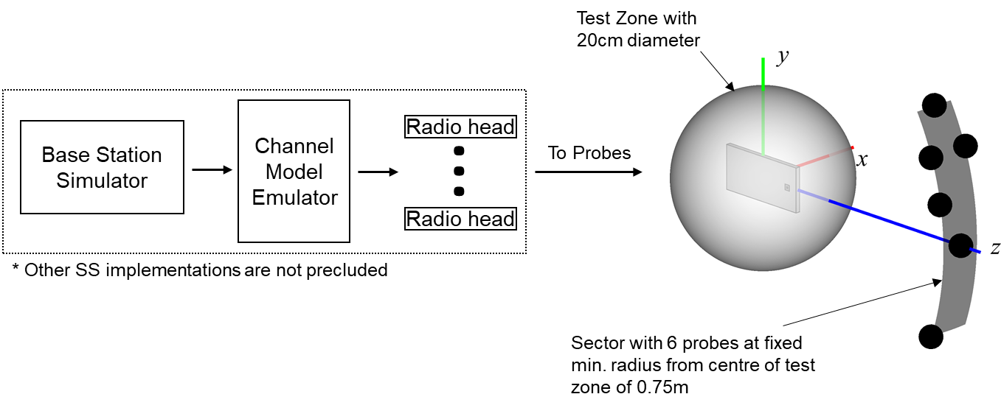

**Figure** **6.2.3-1: 3D MPAC system layout for NR FR2 MIMO OTA testing**

The exact probe locations with respect to the OTA test system coordinate system are tabulated in Table 6.2.3-1.

Table 6.2.3-1. FR2 3D MPAC Probe Locations in OTA test system coordinate system

|  |  |  |
| --- | --- | --- |
| Probe Number | Theta [deg] | Phi  [deg] |
| 1 | 0.0 | 0.0 |
| 2 | 11.2 | 116.7 |
| 3 | 20.6 | -104.3 |
| 4 | 20.6 | 104.3 |
| 5 | 20.6 | 75.7 |
| 6 | 30.0 | 90.0 |

The 3D MPAC probes in Table 6.2.3-1 can be implemented using conventional millimetre-wave probes as well as IFF-based probes as long as the same probe configuration and same number of probes is used.

The channel model parameters and probe locations for channel model implementation are defined in a channel model coordinate system, which is illustrated in figure 6.2.3-2. The channel model coordinate axes *x*CM, *y*CM, and *z*CM correspond to the OTA test system coordinate axes *z*, *y*,and -*x*, respectively.

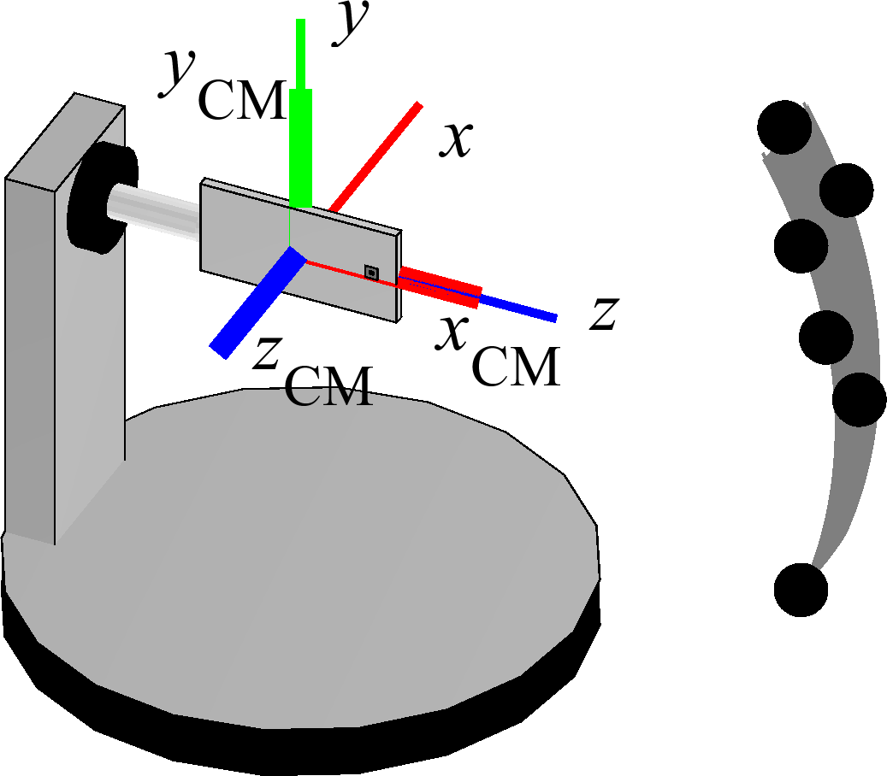

**Figure 6.2.3-2: Channel Model Coordinate Axes**

The probe locations with respect to channel model coordinate axes are tabulated in table 6.2.3-2.

Table 6.2.3-2. FR2 3D MPAC Probe Locations in Channel Model Coordinate System

|  |  |  |
| --- | --- | --- |
| Probe Number | Theta [deg] | Phi [deg] |
| 1 | 90 | 0 |
| 2 | 85 | 10 |
| 3 | 85 | -20 |
| 4 | 85 | 20 |
| 5 | 95 | 20 |
| 6 | 90 | 30 |

The channel model rotations assumed for this probe configuration are tabulated in Table 6.2.3--3.

Table 6.2.3-3. Channel Model Rotations

|  |  |  |  |
| --- | --- | --- | --- |
| InO CDL-A | | UMi CDL-C | |
| Phi [deg] | Theta [deg] | Phi [deg] | Theta [deg] |
| -5 | -2.0 | 32 | 15.0 |

These channel model rotations assume the relative orientations of BS and UE antennas displayed in Figure 6.2.3-3, i.e., the DUT antenna is pointed towards the BS in channel model coordinate system.

In order to avoid positioning ambiguities, the turntable implementing the rotation in  shall match the intended DUT  for P0 Orientation 1 without the re-positioning approach, as defined in Annex A.3, applied. With the re-positioning approach applied, the relative orientation between the DUT and the probes for P0 Orientation 2 shall be the same the relative orientation between DUT and probes as for P0 Orientation 1.

Figure 6.2.3-3: Relative orientations of BS and UE antennas.

Since the test points are uniformly spaced in 3D already, Table 6.2.3.2-1, there is no need to adjust/rotate the DUT rotations by the channel model rotations.

< end of change 1>

< start of change 2>

## 7.2 Channel Models

This section describes amendments to the step-wise procedure of the CDL subclause 7.7.1 in TR 38.901 for generating fast fading radio channel realizations. This channel model methodology considers non-Jakes spectrum with the multi-path fading propagation conditions between the gNB emulator and test chamber probe modelled based on Clustered Delay Line (CDL) methodology.

First, the RMS delay spread values of CDL models are normalized first and they must be scaled in delay so that a desired RMS delay spread can be achieved. The scaled delays can be obtained according to the following equation:

, (7.2-1)

in which

*  is the normalized delay value of the *n*th cluster in a CDL in Tables 7.7.1.1 – 7.7.1.5 of [2]
*  is the new delay value (in [ns]) of the *n*th cluster
*  is the target delay spread (in [ns]).

Values of for FR1/FR2 and for different model scenarios are specified in Table 7.2-1.



Table 7.2-1. Target delay spread values.

|  |  |  |
| --- | --- | --- |
| Frequency | Scenario | DSdesired |
| FR1 | UMi | 100 ns |
| FR1 | UMa | 365 ns |
| FR2 | UMi | 60 ns |
| FR2 | InO | 30 ns |

Subsequently, the departure and arrival angles (based on subclause 7.7.1 step 1 in TR38.901 are generated by combining 7.7-5 and part of step 7 in subclause 7.5. The arrival angles of azimuth using are generated using the following equation

, (7.2-2)

where

*- n,*AOA and *c*ASA are the cluster AOA and the cluster-wise rms azimuth spread of arrival angles (cluster ASA), respectively, in Tables 7.7.1.1 – 7.7.1.5 of TR38.901

*- m* denotes the ray offset angles within a cluster given by Table 7.5-3,

*-*  is the mean angle of the original channel model table in NLOS case (equation is specified in Annex A.2 of TR38.901) and the LOS angle  in LOS case,

- Tables 7.2-2 and 7.2.-3 contain the non-circular angle spread values of the original CDL models of TR38.901 before any angular scaling, ASmodel are the angular spreads derived from the original CDL Tables 7.7.1.1 – 7.7.1.5 of TR38.901. TR25.996 describes :



, (7.2-3)

The values are calculated for the AOD, AOA, ZOD, and ZOA angles after removing the mean angle following the definition of rms angular spread in TR25.996, without finding the minimum over circular shifts. Here, the calculation is performed after removing the mean angle first and subsequently equation A-2 from Annex A of TR38.901

, (7.2-4)

is used to rotate  to zero (and also wrap AOAs within +/-180). Equations A-3

, (7.2-5)

and A-1 of TR 25.996

, (7.2-6)

are used to calculate the ASmodel. Note that equation A-2 of TR 25.996 is not applied to ASmodel calculations, the following equation is used instead

ASdesired is the target angular spread. Table 7.2-4 specifies ASdesired values for CDL-A,B,C,D,E UMi and UMa at FR1 and Table 7.2-5 specifies the corresponding ASdesired values at FR2. These target values are obtained by determining median angular spreads of Table 7.5-6 of TR38.901.

The angular scaling is applied to the ray angles and no further scaling is performed. The generation of AOD (), ZOA (), and ZOD () follows a procedure similar to AOA as described above. Here, the azimuth angles may need to be wrapped around to be within [0, 360] degrees, while the zenith angles may need to be clipped to be within [0, 180] degrees.

Each CDL parameter table of contains two sets of three rows, i.e., three clusters, with exactly same angular parameters. This is harmful for the statistical properties of the models as they become non-WSS across the ensemble of model realizations. Instead of making the angular parameters non-equal by introducing small offsets to angles of the three rows, the problematic clusters are treated as midpaths as intended when the CDLs where drawn from statistical distributions which works across all frequency ranges. For the clusters that look like midpaths, e.g., Cluster 2-4 and 5-7 for CDL-A and Cluster 2-4 and 6-8 for CDL-C, the powers for each of the three clusters are added and using the regular midpath power distribution of 0.5, 0.3, and 0.2 specified in Table 7.5-5 of TR38.901, the powers for the each of the midpaths are calculated. Notice that the intra cluster delay spread in Table 7.5-5 of TR38.901 is not followed, and the same delays as the original CDL are followed for the midpaths (aka Sub-Cluster). This helps keeping the rms DS of the modified CDL to 1s.

Table 7.2-2: Original (non-circular) angle spreads of CDL models UMi and UMa (K-factor 9 dB)

|  |  |  |  |  |
| --- | --- | --- | --- | --- |
| Model | ASmodel [deg] | | | |
| ASD | ASA | ZSD | ZSA |
| CDL-A | 73.6985 | 85.2676 | 28.5575 | 21.0831 |
| CDL-B | 41.5917 | 59.3326 | 5.9633 | 10.3818 |
| CDL-C | 39.0949 | 71.1175 | 4.0666 | 10.4245 |
| CDL-D | 15.6771 | 17.3604 | 2.4462 | 1.5362 |
| CDL-E | 13.1544 | 37.5640 | 1.4577 | 2.4601 |

Table 7.2-3: Original (non-circular) angle spreads of CDL-D and CDL-E models InO (K-factor 7 dB)

|  |  |  |  |  |
| --- | --- | --- | --- | --- |
| Model | ASmodel [deg] | | | |
| ASD | ASA | ZSD | ZSA |
| CDL-D | 18.9859 | 21.0747 | 2.9629 | 1.8735 |
| CDL-E | 15.7784 | 45.3434 | 1.7692 | 2.9982 |

Table 7.2-4: Desired AS for UMi and UMa at 3.5 GHz (FR1)

|  |  |  |  |  |
| --- | --- | --- | --- | --- |
| Model | ASdesired [deg] | | | |
| ASD | ASA | ZSD | ZSA |
| UMi NLOS (CDL-A, B, C) | 23.9751 | 57.2457 | 0.7762 | 7.8320 |
| UMi LOS (CDL-D, E) | 15.0432 | 47.6149 | 0.6166 | 4.6204 |
| UMa NLOS (CDL-A, B, C) | 25.7620 | 74.1138 | 4.8978 | 18.2050 |
| UMa LOS (CDL-D, E) | 14.0180 | 64.5654 | 3.4674 | 8.9125 |
| Note: For UMa frequency fc = 6 as stated in [2], and other parameters hUMa = 25, hUMi = 10, hUT = 1.5, and D2D = 100. | | | | |

Table 7.2-5: Desired AS for UMi and InO at 28 GHz (FR2)

|  |  |  |  |  |
| --- | --- | --- | --- | --- |
| Model | ASdesired [deg] | | | |
| ASD | ASA | ZSD | ZSA |
| UMi NLOS (CDL-A, B, C) | 15.6188 | 49.3183 | 0.7762 | 7.2695 |
| UMi LOS (CDL-D, E) | 13.7050 | 41.0212 | 0.6166 | 3.8350 |
| InO NLOS (CDL-A, B, C) | 41.6869 | 50.3659 | 12.0226 | 14.7109 |
| InO LOS (CDL-D, E) | 39.8107 | 31.8526 | 1.3702 | 11.4756 |

Subsequently, the AOD angles are coupled to AOA angles within a cluster *n*. Instead of random procedure, the coupling is performed using the fixed coupling pattern specified in Table 7.2-6. The same fixed coupling pattern is applied for all clusters *n.*

Table 7.2-6: Fixed coupling pattern of ray angles to be applied for each cluster

|  |  |  |  |  |  |  |  |  |  |  |  |  |  |  |  |  |  |  |  |  |
| --- | --- | --- | --- | --- | --- | --- | --- | --- | --- | --- | --- | --- | --- | --- | --- | --- | --- | --- | --- | --- |
|  | m | | | | | | | | | | | | | | | | | | | |
|  | 6 | 12 | 5 | 10 | 8 | 11 | 16 | 14 | 18 | 9 | 20 | 4 | 2 | 15 | 7 | 13 | 19 | 17 | 3 | 1 |
|  | 20 | 9 | 12 | 1 | 13 | 18 | 10 | 4 | 8 | 2 | 6 | 14 | 11 | 19 | 7 | 3 | 17 | 5 | 15 | 16 |
|  | 2 | 16 | 3 | 11 | 18 | 9 | 5 | 17 | 4 | 19 | 15 | 20 | 13 | 7 | 10 | 1 | 8 | 12 | 6 | 14 |
|  | 15 | 18 | 13 | 1 | 12 | 9 | 6 | 7 | 5 | 3 | 2 | 8 | 14 | 17 | 19 | 16 | 11 | 20 | 10 | 4 |

In the next steps, the linear cross polarization power ratios (XPR) **  are calculated for each ray *m* of each cluster *n* as

, (7.2-7)

where *X* is the per-cluster XPR in dB from Tables 7.7.1.1 – 7.7.1.5 of TR38.901.

The gNB beam pattern including the assumptions for gNB antenna for definitions and symbols of subclause 7.3 of TR38.901 for FR1 and FR2 are summarized in Table 7.2-7.

Table 7.2-7: BS Antenna Parameters

|  |  |  |  |  |
| --- | --- | --- | --- | --- |
| Parameter description | Symbol | Parameter value | | |
| FR1 ≤2.5GHz | FR1 >2.5GHz | FR2 |
| Antenna panels in vertical dimension | *Mg* | 1 | 1 | 1 |
| Antenna panels in horizontal dimension | *Ng* | 1 | 1 | 1 |
| Elements per panel in vertical dimension | *Me* | 4 | 8 | 8 |
| Elements per panel in horizontal dimension | *Ne* | 8 | 8 | 16 |
| Number of polarizations per panel | *P* | 2 | 2 | 2 |
| Element spacing in horizontal dimension (λ) | *dH* | 0.5 | 0.5 | 0.5 |
| Element spacing in vertical dimension (λ) | *dV* | 0.5 | 0.5 | 0.5 |

Antenna element radiation patterns, including orientation of the element main polarization components as well as orientation of the antenna array for both FR1 and FR2 are as in the example pattern in Table 7.3-1 of TR38.901. The antenna element has ±45 polarization components and the radiation pattern parameters are θ3dB = 65°, 3dB = 65°, Amax = 30dB,SLAv = 30dB, *GE,max* =8 dBi.

It is assumed the co-polarized elements of the array are combined to a single RF port, i.e. they compose an antenna array that can form beams by setting certain weights per element. Weight vector for the first polarization and for the second polarization is

, (7.2-8)



where is the location vector of transmit antenna element and , and is a spherical unit vector denoting the target beam direction. Determination of beam directions is



described in section 7.3..

Random initial phase  are not used for the different polarization combinations (*θθ, θϕ, ϕθ, ϕϕ*). Instead, a fixed and pre-defined set of initial phases of Table 7.2-8 and a scalar random initial phase term is used for each ray *m* of each cluster *n*.



The set of fixed initial phases can be same for all clusters, i.e. etc. for all four polarization combinations. These 20×4 initial phase values can be specified either by a table of values or by setting a random number generator and a fixed seed number. The distribution of scalar initial phases is uniform within . Its purpose is to enable generation of different fading sequences on different uses of the model, but still maintaining the power angular distribution of the model. The scalar initial phases can be fixed (or removed) if completely deterministic process, i.e. exactly same fading sequences at each model use, is aimed at.



Table 7.2-8: Fixed initial phases for 2x2 polarization matrices. These values are drawn from uniform distribution

|  |  |  |  |  |
| --- | --- | --- | --- | --- |
| *m* | [rad] | [rad] | [rad] | [rad] |
| 1 | 1.7609 | -0.6928 | -1.6230 | -0.6037 |
| 2 | -2.5356 | -2.3124 | 2.7775 | 2.8660 |
| 3 | 0.4725 | -2.7660 | -1.6664 | -0.9226 |
| 4 | 2.0181 | -3.0448 | -2.8713 | -2.0798 |
| 5 | 0.9369 | 1.4560 | 0.9283 | -0.3084 |
| 6 | 0.2954 | -1.2798 | 1.5375 | -1.9544 |
| 7 | 1.1735 | -1.9886 | -0.8263 | 0.7893 |
| 8 | 1.7607 | -2.6319 | 2.6979 | 1.7324 |
| 9 | -0.0830 | -0.4030 | -0.3344 | -1.2167 |
| 10 | 0.0535 | 0.0677 | 1.9957 | 1.8525 |
| 11 | 0.9068 | -0.7627 | 1.9577 | 0.2062 |
| 12 | -0.9379 | 2.7583 | 2.3621 | 0.3151 |
| 13 | 0.7695 | 0.5469 | -1.8363 | -1.2488 |
| 14 | -0.1827 | -1.6934 | 2.1634 | -1.9179 |
| 15 | -1.7221 | -2.0690 | -1.7111 | -0.4040 |
| 16 | -1.1869 | 2.6602 | -0.4385 | -1.9804 |
| 17 | 2.5439 | 3.0143 | -0.3841 | -2.4434 |
| 18 | -1.5201 | -0.5735 | 0.5962 | -1.4941 |
| 19 | 0.6462 | 1.3271 | -1.7483 | -2.4038 |
| 20 | -1.2775 | -1.1386 | -0.4765 | 0.0494 |

To determine the channel all clusters are treated as "weaker cluster", i.e., no further sub-clusters in delay should be generated. The BS beamforming weights defined in Equation 7.2-8for antenna elements are used and the BS antenna signals are summed for BS beamforming. The BS transmits downlink signals with *S* beams. Index denotes the formed beam index. Each beam may have different and thus the beamforming weight of eq. (7.2-8) becomes specific for index *s* as ; it should be noted though that there are always two orthogonally polarized beams to the same direction. Here, the random initial phases are used for sub-paths, but not for the different polarization combinations (*θθ*, *θϕ,* *ϕθ,* *ϕϕ*). The channel coefficient for time instant *t*, Rx antenna/beam *u*, Tx beam *s*, and cluster *n* is defined by the following equations. They apply for the NLOS clusters and the LOS path, respectively:



, (7.2-9)



, (7.2-10)



where , , and are the theta and phi polarized radiation patterns and the position vector of the BS antenna element of sub-array *s*, respectively.Symbols *Frx,u,θ* , *Frx,u,ϕ*, , , and , are determined as in TR 38.901. UE velocity vector is determined as



 (7.2-11)

UE velocity *v* is defined as follows: 30km/h for FR1 vs 3 km/h (Indoor Office) and 12 km/h (UMi) for FR2. The UE travelling direction (**v, **v) are as follows for FR1:

* (135°,90o) for UMi CDL A channel model
* ([127.0455°],90o) for UMi CDL C channel model
* ([182.1659°],90o) for UMa CDL A channel model
* (65°,90o) for UMa CDL C channel model

The UE travelling direction (**v, **v) are as follows for FR2:

* (112.51°,90°) for InO CDL-A channel model
* (74.11°,90°) for UMi CDL-C channel model

< end of change 2>

< start of change 3>

### 7.3 Channel Model emulation of the Base Station beamforming configuration

The basic parameters of NR BS antenna is specified in table 7.2-7. The propagation environment generated in the test zone is channel model defined in section 7.2 with base station antenna filtering effect. For the channel model emulation in the chamber, the beamforming characteristic of the BS pattern is defined as follow:

* For FR1: A code book of 60 fixed beams is constructed to a grid of five elevation angles from –20° to +20° with 10° steps and 12 azimuth angles from –80° to +80° with ~15° steps；
* For FR2: A code book of 128 fixed beams is constructed to a grid of eight elevation angles from –25° to +25° with ~7.1° step size and 16° azimuth angles from –60° to +60° with 8° step size；

For FR1 4x4 MIMO OTA, two strongest transmitting beams are selected from the pre-defined beam grid based on their proximity to the strong clusters of each FR1 channel model. These beams should have different azimuth directions and can provide the highest receive power for UE.

For FR1 2x2 MIMO OTA, 1 strongest transmitting beam is selected from the pre-defined beam grid which provides the highest received power for UE based on the FR1 channel model.

- In detail, beam directions for channels model given in Clause 7.2.1 are

* For UMa CDL-C, the beam directions are:
  + Strongest beam: AoD: -7.27°, ZoD: 100°
  + 2nd strongest beam: AoD: -21.82°, ZoD: 100°
* For UMi CDL-C, the strongest beam direction is: AoD: -7.27°, ZoD: 100°.

For NR FR2 MIMO OTA, 1 strongest transmitting beam is generated from BS, the direction of this beam towards the strongest cluster of each FR2 channel model. In detail, the directions in CDL-A InO and CDL-C UMi models are (-4.0°, 93.6°) and (-12.0°, 100.7°), respectively.

< end of change 3>

*< start of change 4>*

7.4 Verification of Channel Model implementation

7.4.1 Channel Models validation

This clause describe the MIMO OTA validation measurements, in order to ensure that the channel models are correctly implemented and hence capable of generating the propagation environment, as described by the model, within the test zone.

The following measurements shall be done for FR1 channel model validation:

Power Delay Profile (PDP)

Doppler/Temporal correlation

Spatial correlation

Cross-polarization

Power validation

The following measurements shall be done for FR2 channel model validation:

Power Delay Profile (PDP)

Doppler/Temporal correlation

PAS similarity percentage (PSP)

Cross-polarization

Power validation

Frequencies to be used to test for channel model validation and quality of quiet zone validation:

Table 7.4.1-1: Frequencies for PDP, Doppler, Spatial correlation, Cross-polarization validation, and Quality of Quiet Zone validation

|  |  |  |
| --- | --- | --- |
| NR FR1 Bands | Range | Test frequency (MHz) |
| n71 | Low | 617MHz |
| n12, n17, n29, n14, n28 | 722MHz |
| n5, n8, n18, n20 | 836.5MHz |
| n50, n51, n74 | Mid | 1575.42MHz |
| n3, n2, n25, n39 | 1880MHz |
| n1, n34, n65 | 2132.5MHz |
| n7, n30, n41, n40, n38, [n90] | 2450MHz |
| n77,n78 | High | 3600MHz |
| n79 | [4700MHz] |

Table 7.4.1-2: Channel model validation and Quality of Quiet Zone validation frequencies

|  |  |  |
| --- | --- | --- |
| NR FR2 Bands | Range | Test Frequency (MHz) |
| n257 | Low | 27750 |
| n260 | High | 38500 |
| n258 | Low | 25875 |
| n261 | Low | 27925 |

Table 7.4.1-3: Frequencies for FR1 power validation

|  |  |  |
| --- | --- | --- |
| NR FR1 Bands | Range | Test frequency (center frequency of each band) |
| n71 | Low | n71 |
| n12, n17, n29, n14, n28 | n28 |
| n5, n8, n18, n20 | n8 |
| n50, n51, n74 | Mid | n51 |
| n3, n2, n25, n39 | n3 |
| n1, n34, n65 | n1 |
| n7, n30, n41, n40, n38, [n90] | n41 |
| n77, n78 | High | n78 |
| n79 | n79 |

< end of change 4>

< start of change 5>

#### 7.4.1.5 Power validation

**FR1 power validation procedure for MPAC system:**

This measurement checks the total power in the center of the test zone. The power validation is measured with a spectrum analyzer as shown in Figure 7.4.1.5-1.

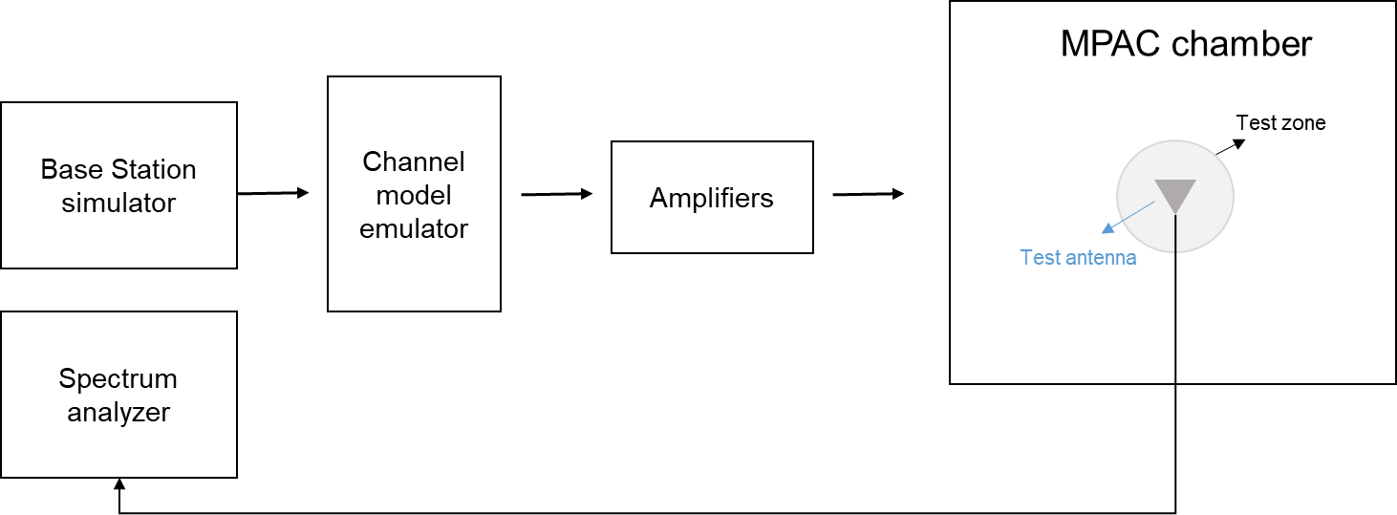

Figure 7.4.1.5-1: Setup for power validation measurements

**Spectrum analyzer settings:**

Table 7.4.1.5-1: Spectrum analyzer settings for Power validation measurements

| Item | Unit | Value |
| --- | --- | --- |
| Center frequency | MHz | Downlink center frequency  in Table 7.4.1-3 |
| Integrated Channel Span | Hz | 20MHz |
| RBW | Hz | 30 kHz |
| VBW | Hz | ≥10MHz |
| Number of points |  | ≥400 |
| Averaging |  | ≥100 |
| Detector |  | RMS |

**Measurement Procedure:**

1. Place a vertical reference dipole in the center of the test zone connected to a spectrum analyzer (or power meter) via a cable.

2. Record the cable and reference dipole gains.

3. Load the target channel model into the channel emulator.

4. Start the NR FR1 signaling in the base station emulator with the required parameter identical to the measurements conditions.

5. Average the power received by the spectrum analyzer for a sufficient amount of time to account for the fading channel – one full channel simulation might be unnecessary.

6. Repeat steps 1 to 4 with a magnetic loop for the horizontal polarization, or a horizontally polarized sleeve dipole measured in at least four orthogonal horizontal positions and summed to measure the H component.

7. Calculate the total power received at the test area as the sum of the power in the two polarizations.

Note: in step 6, if horizontally polarized sleeve dipole is used, the reference gain correction should be the average of the theta gain pattern cut of the dipole. Besides, more horizontal positions for averaging will improve the measurement accuracy but increase the total measurement time.

The power validation result is considered as systematic offset, which needs to be corrected on the UE final sensitivity value to further reduce measurement uncertainty.

< end of change 5>