3GPP TSG-RAN WG4 Meeting # 100-e Revision of R4-2114499

Electronic Meeting, 16 – 27 August 2021

**Agenda item:** 10.1.4

**Source:** Keysight Technologies

**Title:** On Non-Uniform TRP grids for PC1

**Document for:** Approval

# Introduction

This contribution outlines a test time reduction approach for PC1 TRP measurements using non-uniform grids.

# Non-Uniform TRP Measurement Grids

This section provides a brief overview how the test time of TRP measurements can be reduced without an increase in MU by utilizing non-uniform measurement grids, i.e., a fine step size is used within a conical region around the FF beam peak and a coarse step size outside that region. This approach is of primary interest for PC1 devices where the number of unique grid points is generally 1106 (Dq=Df=7.5o) with a constant step-size measurement grid [3]. For PC3 devices, the number of unique grid points is 192 (Dq=16.3o; Df=18.8o) [3], i.e., the number of grid points and test time is manageable.

Given the large number of PC1 TRP grid points, additional test time reduction techniques based on non-uniform grids were investigated for NF in [2] and FF here. The idea here is to apply a fine grid around the FF beam peak direction to capture the main portion of the very directive beam while a coarse grid around the remaining portion of the sphere is applied. This is further illustrated in Figure 1 with the following non-uniform TRP grid assumptions:

* The known FF beam is shown with the large grey dot. On top, the FF beam peak is assumed at (0o,0o) while the FF beam peak on the bottom is assumed at (45o,45o).
* The red grid points are within a ±20o cone centred around the NF beam peak with Dq=Df=7.5o.
* The cyan grid points are outside a ±20o cone centred around the NF beam peak with Dq=Df=15o.

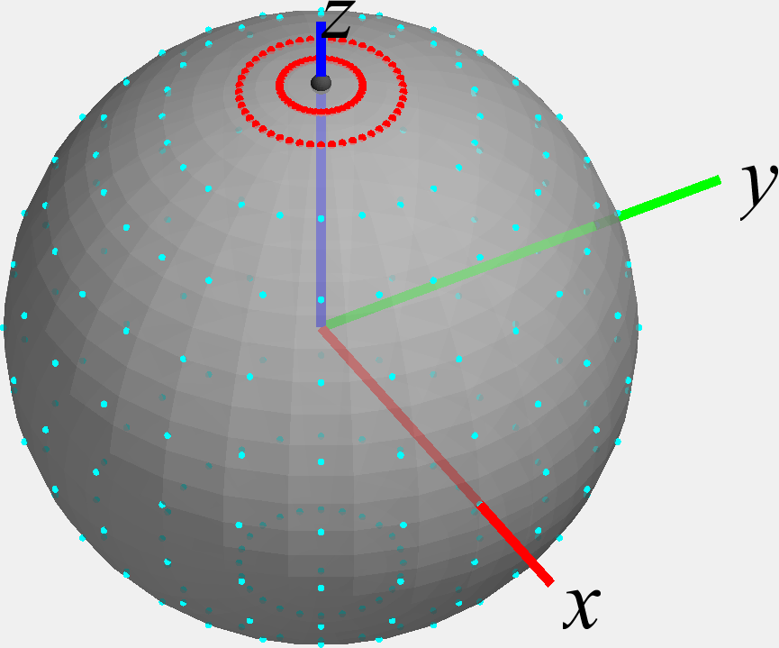 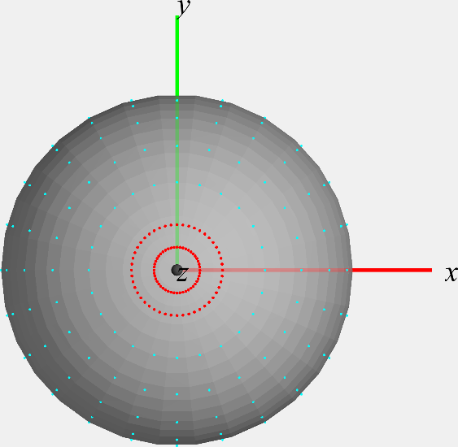

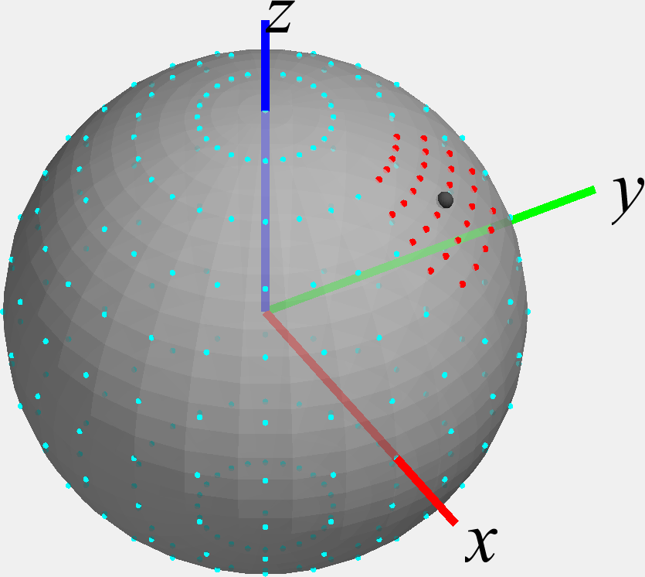 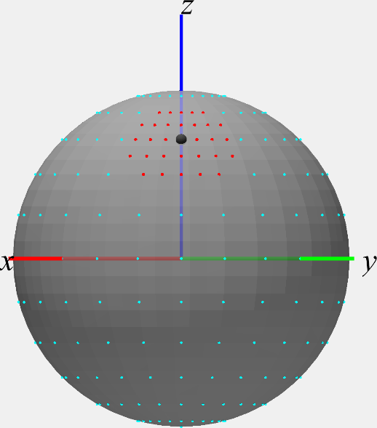

Figure 1: Visualization of non-uniform TRP grids for NF beam at (0o,0o) on top and at (45o,45o) on bottom. Grid points in cyan (red) are outside (inside) the conical NF beam peak region.

Simulations with 2000 random permutations of the beam peak direction (rotation in q, f, and twist a as outlined in Clause G.1 of [4]) were performed for a FF range length of 20m; only the Clenshaw-Curtis quadrature was considered here. Table 1 shows the simulation results for the non-uniform measurement grids considered suitable for PC1 devices; the grid with step size of 7.5o within ±20o of the FF beam peak and step size of 15o outside ±20o of the FF beam peak is meeting the same MUs are the current measurement grid. The average number of unique grid points based on all simulations investigated is ~300 which shows a significant test time reduction compared to the current standard TRP grid with 1106 grid points while maintaining the same MU as the grid with uniform step sizes in q and f.

Table 1: CFFDNF TRP simulation results (using Clenshaw-Curtis quadrature) for PC1 devices (12x12 antenna configuration) using non-uniform measurement grids.

|  |  |  |  |  |  |  |
| --- | --- | --- | --- | --- | --- | --- |
| **Antenna Configuration** | **Cone width (±) [o]** | **Constant Step-Size Grid Step Size outside cone Dq=Df [o]** | **Constant Step-Size Grid Step Size within cone Dq=Df [o]** | **Average number of unique grid points** | **|Mean TRP Error| [dB]** | **TRP Std. Dev. [dB]** |
| **12x12** | 15 | 10 | 5 | 648 | 0.1 | 0.1 |
| 20 | 15 | 5 | 338 | 0.1 | 0.1 |
| 15 | 7.5 | 293 | 0.1 | 0.1 |

The comparison of the TRP measurement grid parameters and the min. number of grid points are tabulated in Table 2 with angular grid spacings placed uniformly and non-uniformly in q and f. Clearly, the non-uniform TRP measurement grid approach is beneficial in terms of test time reduction.

Table 2: Comparison of the TRP measurement grid parameters for PC3 and PC1 including potential test time improvement.

|  |  |  |  |  |  |  |  |
| --- | --- | --- | --- | --- | --- | --- | --- |
| **Antenna Config.** | **Non-uniform angular spacing** | | | | **Uniform angular spacing** | | **Potential Test Time Improvement with non-uniform angular spacing in q and f (factor)** |
| **Cone width (±) [o]** | **Constant Step-Size Grid Step Size outside cone Dq=Df [o]** | **Constant Step-Size Grid Step Size within cone Dq=Df [o]** | **Average Number of unique grid points** | **Constant Step-Size Grid Step Size Dq=Df [o]** | **Number of unique grid points** |
| **12x12** | 20 | 15 | 7.5 | 293 | 7.5 | 1106 | 3.8 |

Observation 1: Non-uniform TRP measurement grids for PC1 devices can significantly reduce the number of unique grid points.

Proposal 1: Include the augmented constant step-size TRP measurement grid for PC1 in TR38.884 [5].

A similar TRP test time reduction approach based on the constant density grid type could eventually be adopted for PC1 as well.

# Conclusion

The following observations and proposals were made in this contribution

**Observation 1: Non-uniform TRP measurement grids for PC1 devices can significantly reduce the number of unique grid points.**

**Proposal 1: Include the augmented constant step-size TRP measurement grid for PC1 in TR38.884 [5].**

# References

1. R5-211189, PC1 MUs based on the revised antenna array assumptions, Keysight Technologies, 3GPP TSG-RAN5 Meeting #90-e, March 2021
2. R4-2114384, On CFFNF and CFFDNF test methodologies for high DL power and low UL power test cases, Keysight Technologies, 3GPP TSG-RAN WG4 Meeting # 100-e, August 2021
3. TS 38.521-2, User Equipment (UE) conformance specification; Radio transmission and reception; Part 2: Range 2 Standalone, V16.8.0 (2021-06)
4. TR38.810, Study on test methods, V16.6.1 (2020-09)
5. TR 38.884, Study on enhanced test methods for FR2 NR UEs, V0.4.0 (2021-05)