**3GPP TSG-RAN WG4 Meeting # 100-e draft R4-2115664**

**Electronic Meeting, August 16-27, 2021**

**Title:** WF on the gap between regulation concern and current UE EMC specification

**Source:** Xiaomi

**Agenda item:** 5.1.3

**Document for:** Approval

# Background

* The UE EMC regulation has been updated in recent years to cover 5G in different regulatory bodies such as ETSI 301 489-52 [1] for Europe and YD/T 2583.18[2] for China as introduced by [3].
* An LS [4] has been received from CCSA TC9 WG1 about UE EMC test configurations and future work plan. LS content has been captured below:

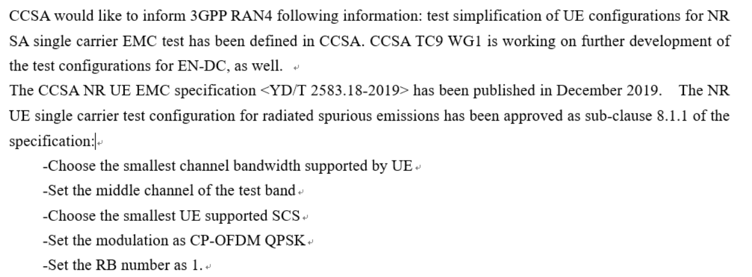

* There are gaps between current UE EMC TS 38.124 and regulations. It is recommended to capture the gap in the WF as for information for further develop 3GPP UE EMC specification for potential Rel-18 WID.
* A WF on UE EMC requirements extensions [5] has been agreed and further an umbrella WID for EMC enhancement [6] has been proposed and has been stable enough with many supporting companies while it is postponed due to RAN4 time budget issue.

# WF

The below table captures the status of current regulation and 3GPP specification.

|  |  |  |  |
| --- | --- | --- | --- |
|  | CCSA YD/T 2583.18 | ETSI 301 489-52 | TS 38.124 |
| Latest version | 2019 | V1.1.2 (2020-12) | V15.6.0 (2021-07)  V16.3.0 (2021-07) |
| Newly updated part for test configuration and core requirements as well as test methods. | 5G UE with newest NR UE single carrier test configuration simplification for radiated emission test.  EMC core requirements and test method corresponding to IEC 61000 series. | The arrangement for test signals for NR SA and NSA has been clearly stated in sub-clause 4.2.3 with the parameters settings referred to TS 38.508-1 while the UL/DL signal setups referred to TS 38.521-1 for NR FR1.  For LTE, the TS 36.508 and TS 36.521 are referred.  EMC core requirements and test method corresponding to IEC 61000 series. | EMC test configurations keep unchanged with TS 36.124 with less information about specific test configurations. Even the TS 38.508 and TS 38.521 is not referred.  EMC core requirements and test method corresponding to IEC 61000 series. |
| Future work plan | A work plan has been agreed to further develop the test configuration for EN-DC cases as stated in the LS [4]. | Current version is in EC decision to be finalized. | Potential Rel-18 EMC umbrella WID. |

From the above table, couple of observations can be concluded as:

**1, TCs for UE EMC tests are the most popular topic that both China and Europe regulations are working on.**

**-The EU regulation has defined test signal configurations referring to 3GPP RF test specification.**

**-The CCSA regulation has defined specific test configuration simplification for EMC radiated spurious emission and the future work on EN-DC test configuration is also planned.**

**2, Current TS 38.124 doesn’t give enough information on specific test configurations for EMC tests.**

**-Current TS 38.124, sub-clause 4, the test configurations are still lack of specific descriptions and are not aligned to the request of regulations.**

With the above observations of the gap between regulation and concern and current EMC specifications, we see the urgency of 3GPP to research on the test configurations to give further recommendations to regulation groups. With the timeline considered, Rel-18 is suitable for these EMC enhancement work.

# Reference

1. ETSI 301 489-52 V1.1.2
2. YD/T 2583.18-2019
3. R4-2112609 on LS from CCSA on UE EMC, Xiaomi
4. R4-2111718 Liaison Statement on CCSA progress on UE EMC, CCSA TC9 WG1
5. R4-2012575 WF on UE EMC requirements extensions, Xiaomi
6. RP-202792 New WID on BS UE EMC enhancements, Ericcson, Xiaomi