3GPP TSG-RAN WG4 Meeting # 100-e DRAFT R4-2115667

Electronic Meeting, August 16-27, 2021

|  |  |  |  |  |  |  |  |  |
| --- | --- | --- | --- | --- | --- | --- | --- | --- |
| *CR-Form-v12.1* | | | | | | | | |
| **CHANGE REQUEST** | | | | | | | | |
|  | | | | | | | | |
|  | **38.175** | **CR** | **-** | **rev** | **1** | **Current version:** | **16.2.0** |  |
|  | | | | | | | | |
| *For* [***HE******LP***](http://www.3gpp.org/3G_Specs/CRs.htm#_blank)*on using this form: comprehensive instructions can be found at* [*http://www.3gpp.org/Change-Requests*](http://www.3gpp.org/Change-Requests)*.* | | | | | | | | |
|  | | | | | | | | |

|  |  |  |  |  |  |  |  |  |
| --- | --- | --- | --- | --- | --- | --- | --- | --- |
| ***Proposed change affects:*** | UICC apps |  | ME |  | Radio Access Network | **x** | Core Network |  |

|  |  |  |  |  |  |  |  |  |  |  |
| --- | --- | --- | --- | --- | --- | --- | --- | --- | --- | --- |
|  | | | | | | | | | | |
| ***Title:*** | draft CR to TS 38.175: further extension of spatial exclusion considerations for EMC RI test for IAB, Rel-16 | | | | | | | | | |
|  |  | | | | | | | | | |
| ***Source to WG:*** | Huawei | | | | | | | | | |
| ***Source to TSG:*** | R4 | | | | | | | | | |
|  |  | | | | | | | | | |
| ***Work item code:*** | NR_IAB-Perf | | | | |  | ***Date:*** | | | 2021-08-06 |
|  |  | | | |  | |  | | |  |
| ***Category:*** | **F** |  | | | | | ***Release:*** | | | Rel-16 |
|  | *Use one of the following categories:* ***F*** *(correction)* ***A*** *(mirror corresponding to a change in an earlier release)* ***B*** *(addition of feature),* ***C*** *(functional modification of feature)* ***D*** *(editorial modification)*  Detailed explanations of the above categories can be found in 3GPP [TR 21.900](http://www.3gpp.org/ftp/Specs/html-info/21900.htm). | | | | | | | | *Use one of the following releases: Rel-8 (Release 8) Rel-9 (Release 9) Rel-10 (Release 10) Rel-11 (Release 11) … Rel-15 (Release 15) Rel-16 (Release 16) Rel-17 (Release 17) Rel-18 (Release 18)* | |
|  |  | | | | | | | | | |
| ***Reason for change:*** | | Based on previous discussions, it was found that the text on the spatial exclusion application for the RI test of the IAB node may not be clear enough. Therefore, more clarifications were provided, together with the examples figures (in order not to limit any IAB implementations). | | | | | | | | |
|  | |  | | | | | | | | |
| ***Summary of change:*** | | Text on the spatial exclusion extended to improve readability of the spatial exclusion applications for IAB.  Missing definition added. | | | | | | | | |
|  | |  | | | | | | | | |
| ***Consequences if not approved:*** | | Application of the spatial exclusion for the IAB node may not be clear. | | | | | | | | |
|  | |  | | | | | | | | |
| ***Clauses affected:*** | | 3.1, 9.2.2 | | | | | | | | |
|  | |  | | | | | | | | |
|  | | **Y** | **N** |  | | | |  | | |
| ***Other specs*** | |  | **x** | Other core specifications | | | |  | | |
| ***affected:*** | |  | **X** | Test specifications | | | |  | | |
| ***(show related CRs)*** | |  | **x** | O&M Specifications | | | |  | | |
|  | |  | | | | | | | | |
| ***Other comments:*** | |  | | | | | | | | |
|  | |  | | | | | | | | |
| ***This CR's revision history:*** | |  | | | | | | | | |

*------------------------------ Modified section ------------------------------*

## 3.1 Definitions

For the purposes of the present document, the terms and definitions given in TR 21.905 [1] and the following apply. A term defined in the present document takes precedence over the definition of the same term, if any, in TR 21.905 [1].

**channel bandwidth:** the RF bandwidth supporting a single NR RF carrier with the transmission bandwidth configured in the uplink or downlink of a cell. The *channel bandwidth* is measured in MHz and is used as a reference for transmitter and receiver RF requirements.

**continuous phenomena:** electromagnetic disturbance, the effects of which on a particular device or equipment cannot be resolved into a succession of distinct effects (IEC 60050-161 [7]).

**enclosure port:** physical boundary of the equipment through which electromagnetic fields may radiate or impinge.

NOTE: In the case of *integral antenna* equipment, this port is inseparable from the antenna port.

**exclusion band:** frequency range(s) not subject to test or assessment.

**IAB-node**: RAN node that supports wireless access to UEs and wirelessly backhauls the access traffic.

**IAB type 1-H:** IAB-MT and IAB-DU operating at FR1 with a requirement set holding requirements defined at the respective TAB and OTA requirements defined at the respective RIB

**IAB type 1-O:** IAB-MT and IAB-DU operating at FR1 with a requirement set consisting only of OTA requirements defined at the respective RIB.

**IAB type 2-O:** IAB-MT and IAB-DU operating at FR2 with a requirement set consisting only of OTA requirements defined at the respective RIB

**integral antenna:** antenna designed for permanent connection to the equipment and considered part of the enclosure port.

NOTE: An *integral antenna* may be fitted internally or externally.

**operating band:** frequency range in which NR operates (paired or unpaired), that is defined with a specific set of technical requirements.

**port:** particular interface of EUT used for EMC requirements testing purposes.

NOTE: Any connection point on EUT intended for connection of cables to or from EUT during the EMC testing is considered as a port.

EXAMPLE 1: Examples of ports for *IAB type 1-H* are as presented in figure 3.1‑1:



Figure 3.1-1: Examples of *port*s for *IAB type 1-H*

EXAMPLE 2: Examples of ports for *IAB type 1-O* and *IAB type 2-O* (i.e. with no *antenna ports*) are as presented in figure 3.1-2:



Figure 3.1-2: Examples of *port*s for *IAB type 1-O* and *IAB type 2-O*

**receiver exclusion band:** band of frequencies over which no tests of radiated immunity of a receiver are made, and expressed relative to the IAB receive band.

**signal port:** portintended for the interconnection of components of an EUT, or between an EUT and associated equipment and used in accordance with relevant functional specifications (for example for the maximum length of cable connected to it).

**spatial exclusion zone:** range of angles where no tests of radiated immunity are made for *IAB type 1-O* or *IAB type 2-O* (i.e. half sphere around the EUT's radiating direction).

*------------------------------ Unchanged part omitted ------------------------------*

*------------------------------ Next modified section ------------------------------*

## 9.1 Test configurations

This clause defines the configurations for immunity tests as follows:

- the equipment shall be tested under normal test conditions as specified in the functional standards;

- during the test, the RF output power may be reduced to a power level sufficient for establishing and maintaining the required communication link;

- the test configuration shall be as close to normal intended use as possible;

- if the equipment is part of a system, or can be connected to *ancillary equipment*, then it shall be acceptable to test the equipment while connected to the minimum configuration of *ancillary equipment* necessary to exercise the ports;

- if the equipment has a large number of ports, then a sufficient number shall be selected to simulate actual operation conditions and to ensure that all the different types of termination are tested;

- the test conditions, test configuration and mode of operation shall be recorded in the test report;

- ports which in normal operation are connected shall be connected to an *ancillary equipment* or to a representative piece of cable correctly terminated to simulate the input/output characteristics of the *ancillary equipment*. In case of *IAB type 1-H*, *antenna ports* shall be correctly terminated;

- ports which are not connected to cables during normal operation, e.g. service connectors, programming connectors, temporary connectors etc. shall not be connected to any cables for the purpose of EMC testing. Where cables have to be connected to these ports, or interconnecting cables have to be extended in length in order to exercise the EUT, precautions shall be taken to ensure that the evaluation of the EUT is not affected by the addition or extension of these cables;

- immunity tests on the entire IAB Node shall be performed by establishing communication links at the radio interface (e.g. with the mobile simulator) and the NG interface (e.g. with an NGC simulator) and evaluating the throughput;

- immunity tests shall be performed on both the uplink and downlink paths. The tests shall also include both the radio interface and the NG interface. Throughput evaluation may be carried out at either interface, where appropriate, and the measurements for the uplink and downlink paths may be carried out as a single path looped at either the radio interface or NG interface. In case of looping is used care have to be taken that the throughput information doesn't change due to looping;

- for IAB node capable of multi-band operation, communication links shall be established in such a way that all *operating band*(s) are activated during the test according to the applicable test configurations in clause 4.5. Performance assessment may be done separately for each *operating band*.

## 9.2 RF electromagnetic field (80 MHz - 6000 MHz)

The test shall be performed on a representative configuration of the equipment, the associated ancillary equipment, or representative configuration of the combination of radio and ancillary equipment.

### 9.2.1 Definition

This test assesses the ability of radio equipment and *ancillary equipment* to operate as intended in the presence of a radio frequency electromagnetic field disturbance at the enclosure.

### 9.2.2 Test method and level

The test method shall be in accordance with IEC 61000‑4‑3 [13].The use of reverberation chamber test method according to IEC 61000-4-21 [18], clause 6.1 and Annex D as alternative method is allowed.

- For transmitters, receivers and transceivers the following requirements shall apply:

- The test level shall be 3 V/m amplitude modulated to a depth of 80 % by a sinusoidal audio signal of 1 kHz;

- The stepped frequency increments shall be 1 % of the momentary frequency;

- The test shall be performed over the frequency range 80 MHz - 6000 MHz; with the exception of the exclusion band for receivers (see clause 4.4);

- Responses in stand-alone receivers or receivers which are part of transceivers occurring at discrete frequencies which are narrow band responses, shall be disregarded, see clause 4.3;

- The frequencies selected during the test shall be recorded in the test report. - For the test method in accordance with IEC 61000-4-3[13], the *spatial exclusion zone* can be chosen to protect the IAB node receiver(s). For the frequency arrange above 690 MHz (according to the test method in ETSI EN 301 489-50 [28]), the EMC RF electromagnetic field immunity requirement applies on the non-radiating faces of the *IAB type 1-O*, or *IAB type 2-O,* as depicted on figures 9.2.2-1 and 9.2.2‑2.

NOTE: Depending on the IAB implementation, application of the spatial exclusion to all radiating faces of the IAB may not allow proper execution of the RI testing. In such cases, to protect the IAB node receiver(s), exclusion bands shall be considered, as in table 4.4.1-1.

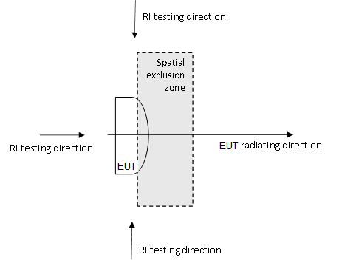

Figure 9.2.2-1: Example of the spatial exclusion application in case of a single instance of the IAB radiating face (horizontal plane depicted)

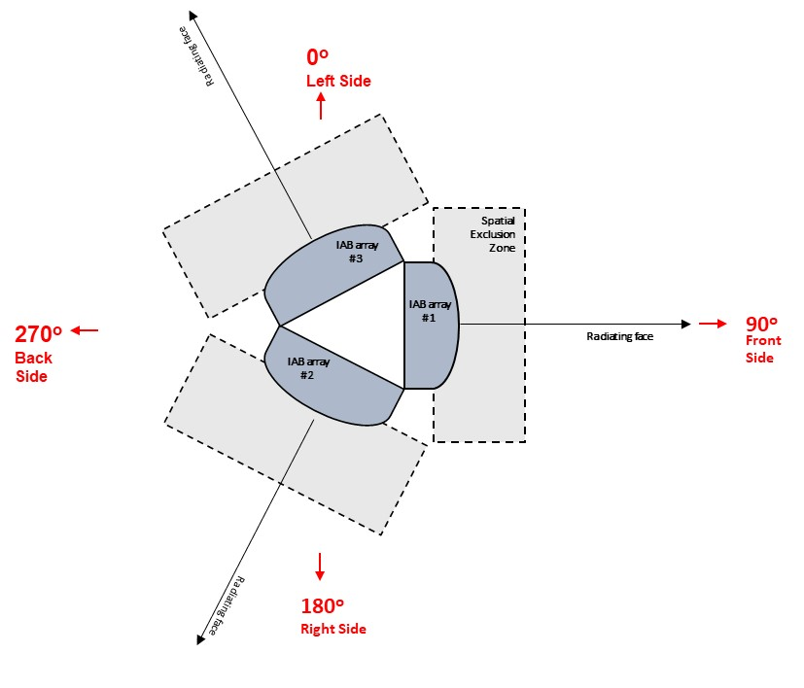

Figure 9.2.2-2: Example of the spatial exclusion application in case of a 3-panel IAB node (horizontal plane depicted) – proper execution of the RI test may not be feasible

*------------------------------ End of modified section ------------------------------*