3GPP TSG-RAN WG4 #100-e R4-211xxxx

August 16th ‒ 27th, 2021

Electronic Meeting

**Agenda item:** 8.2.3

**Source:** Qualcomm Incorporated

**Title:** TP for TR 38.849 on A-MPR for VLP

**Document for:** Approval

# Introduction

The technical requirements for unlicensed operation in the range 5945 – 6425 MHz for Europe were published by ECC in November 2020 [1]. The ECC decision accommodate both low power indoor (LPI) and very low power (VLP) usage of unlicensed spectrum. It was also agreed in [2] to include VLP into the 3GPP specifications based on [1], but possible regulatory issues may need to be considered. This TP provides the A-MPR for VLP.

# Reference

1. ECC Decision (20)01, “On the harmonised use of the frequency band 5945-6425 MHz for Wireless Access Systems including Radio Local Area Networks (WAS/RLAN),” 20 November 2020.
2. R4-2108020, “WF on introduction of lower 6GHz NR unlicensed operation for Europe,” Nokia

**<<< Start of TP for TR 38.849 >>>**

6.1.1 Transmitter characteristics

This section details specific transmitter characteristics for a UE operating in the lower 6 GHz NR unlicensed range in Europe.

#### 6.1.1.1 A-MPR for a NS(s) for lower 6GHz NR unlicensed operation in Europe.

Additional emission requirements can be signalled by the network. Each additional emission requirement is associated with a unique network signalling (NS) value indicated in RRC signalling by an NR frequency band number of the applicable operating band as detailed in TS 38.101-1*.*

To meet the additional requirements applicable in EU as given in EN 303 687, additional maximum power reduction (A-MPR) is allowed for the maximum output power as specified in Table 6.1.1.1-1 for low power indoor (LPI).

Table 6.1.1.1-1: A-MPR for PC5 LPI

|  |  |  |  |
| --- | --- | --- | --- |
| Pre-coding | Modulation | RB Allocation | |
|  |  | Full2 (dB) | Partial3 (dB) |
| DFT-s-ODFM | Pi/2 BPSK4 | ≤ 1.5 | ≤ 2.5 |
|  | QPSK | ≤ 2.0 | ≤ 3.5 |
|  | 16 QAM | ≤ 2.5 | ≤ 4.0 |
|  | 64 QAM | ≤ 3.5 | ≤ 4.5 |
|  | 256 QAM | ≤ 5.0 | ≤ 5.5 |
| CP-OFDM | QPSK | ≤ 3.5 | ≤ 4.5 |
|  | 16 QAM | ≤ 4.0 | ≤ 4.5 |
|  | 64 QAM | ≤ 5.5 | ≤ 5.5 |
|  | 256 QAM | ≤ 7.0 | ≤ 7.0 |
| NOTE 1: The A-MPR shall apply to all SCS in all active 20 MHz sub-bands contiguously allocated in the channel. The MPR applies to interlaced allocations with uplink resource allocation type 2 as specified in TS 38.214 [10].  NOTE 2: Full RB allocation A-MPR applies when all RB’s in a 20 MHz channel or all RB’s in all sub-bands for wideband operation are fully allocated and sub-bands are transmitted according to configuration A in Table 6.2F.2-2.  NOTE 3: Partial RB allocation A-MPR applies when one or more RB’s in one or more sub-bands are not allocated or when the transmitted sub-bands for wideband operation are transmitted according to configuration B in Table 6.2F.2-2.  NOTE 4: Applicable to Pi/2-BPSK modulation when IE powerBoostPi2BPSK is set to 0.  NOTE 5: The A-MPR applies instead of MPR for 20 MHz channel centered at the nearest NR-ARFCN corresponding to 5955 MHz, 40 MHz channel at the nearest NR-ARFCN corresponding to 5965 MHz, 60 MHz channel at the nearest NR-ARFCN corresponding to 5975 MHz, and 80 MHz channel at the nearest NR-ARFCN corresponding to 5985 MHz. For all other channels, A-MPR is zero and MPR as specified in Table 6.2F.2-1 applies. | | | |

For very low power (VLP) operation the out-of-band emissions and in-band power spectral density requirements are much more restrictive than for LPI. A set of A-MPR simulation results is provided below for 20, 40, 60, and 80 MHz channels assuming that NR-U PC5 power class is used.

NOTE: FFS whether NR-U PC5 power class will be used for VLP or a new power class is needed.

In Figure 6.1.1.1-1 all channels in the band are represented while in Figure 6.1.1.1-2 lower edge channels are not illustrated since those are most impacted by the additional spurious emission requirement of -45 dBm/MHz. The lower edge channels found to be impacted were the ones centered at 5955 MHz for 20 MHz channels, 5965 MHz for 40 MHz channels, 5975 MHz and 5995 MHz for 60 MHz channels, and 5985 MHz for 80 MHz channels.

Table 6.1.1.1-2. Simulation scenarios for all CBW/SCS

|  |  |  |  |
| --- | --- | --- | --- |
| Scenario | Modulation | DFT/CP | Allocation |
| 1 | QPSK | CP | Interlace_0 |
| 2 | QPSK | DFT-S | Interlace_0 |
| 3 | QPSK | CP | Full |
| 4 | QPSK | DFT-S | Full |
| 5 | 16QAM | CP | Interlace_0 |
| 6 | 16QAM | DFT-S | Interlace_0 |
| 7 | 16QAM | CP | Full |
| 8 | 16QAM | DFT-S | Full |
| 9 | 64QAM | CP | Interlace_0 |
| 10 | 64QAM | DFT-S | Interlace_0 |
| 11 | 64QAM | CP | Full |
| 12 | 64QAM | DFT-S | Full |
| 13 | 256QAM | CP | Interlace_0 |
| 14 | 256QAM | DFT-S | Interlace_0 |
| 15 | 256QAM | CP | Full |
| 16 | 256QAM | DFT-S | Full |

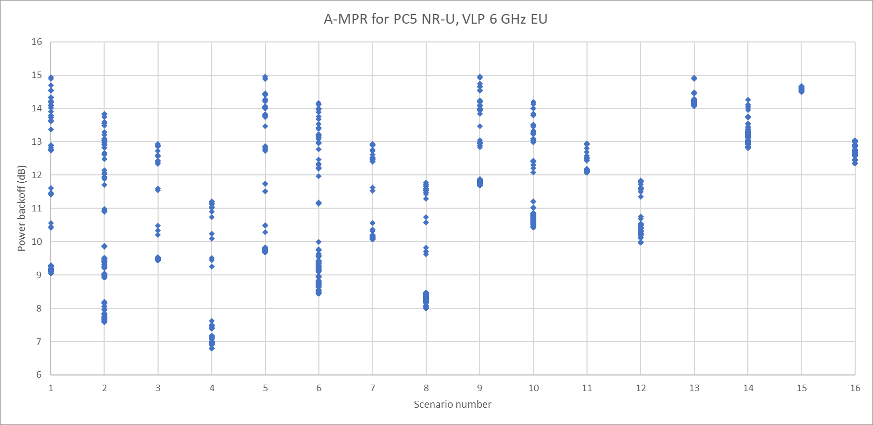

Figure 6.1.1.1-1. Power backoff for 20, 40, 60, and 80 MHz channels

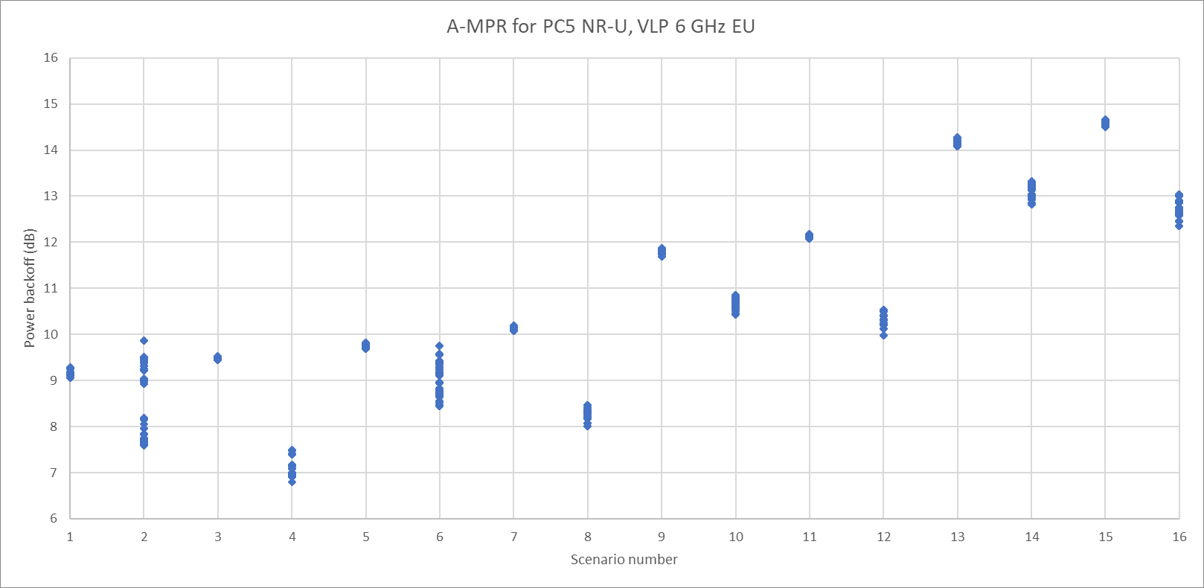

Figure 6.1.1.1-2. Power backoff with lower edge channels excluded

Based on these simulation results, the A-MPR table for VLP is provided below in Table 6.1.1.1-3.

Table 6.1.1.1-3. PC5 A-MPR table for VLP

|  |  |  |  |  |  |
| --- | --- | --- | --- | --- | --- |
| Pre-coding | Modulation | RB Allocation (Note 2) | | RB Allocation (Note 3) | |
|  |  | Full (dB) | Partial (dB) | Full (dB) | Partial (dB) |
| DFT-s-ODFM | QPSK | ≤ [12] | ≤ [14] | ≤ [8] | ≤ [10] |
|  | 16 QAM | ≤ [12] | ≤ [15] | ≤ [9] | ≤ [10] |
|  | 64 QAM | ≤ [12] | ≤ [15] | ≤ [11] | ≤ [11] |
|  | 256 QAM | ≤ [13] | ≤ [15] | ≤ [13] | ≤ [14] |
| CP-OFDM | QPSK | ≤ [13] | ≤ [15] | ≤ [10] | ≤ [10] |
|  | 16 QAM | ≤ [13] | ≤ [15] | ≤ [11] | ≤ [10] |
|  | 64 QAM | ≤ [13] | ≤ [15] | ≤ [13] | ≤ [12] |
|  | 256 QAM | ≤ [15] | ≤ [15] | ≤ [15] | ≤ [15] |
| NOTE 1: Full allocation A-MPR applies when all RB’s in a 20 MHz channel or all RB’s in all sub-bands for wideband operation are fully allocated and all sub-bands are transmitted. Partial allocation A-MPR applies when one or more RB’s in one or more sub-bands are not allocated or when not all transmitted sub-bands for wideband operation are transmitted.  NOTE 2: Applicable for 20 MHz channels centered at the nearest NR-ARFCN corresponding to 5955 MHz, 40 MHz channels centered at the nearest NR-ARFCN corresponding to 5965 MHz, 60 MHz channels centered at the nearest NR-ARFCN corresponding to 5975 and 5995 MHz and 80 MHz channels centered at the nearest NR-ARFCN corresponding to 5985 MHz.  NOTE 3: Applicable for all valid channels other than those enumerated under NOTE 2. | | | | | |

**<<< End of TP >>>**