3GPP TSG-RAN WG3 #123bis R3-24xxxxx

Changsha, 15 – 19 Apr. 2024

Agenda Item: 12.1

Source: NTTDOCOMO (moderator)

Title: Summary of Offline Discussion on additional topological enhancement

Document for: Approval

# Introduction

This document provides a summary of the offline discussion on additional topological enhancements.

# Discussion

## 2.1 WAB

* WAB architecture and general requirements

**the WAB-node includes a gNB component (WAB-gNB) and a MT component (WAB-MT));**

**the WAB-gNB is based on the gNB functionality specified in TS 38.300 [4] and TS 38.401 [5]; CU-DU split is not considered in this study.**

**WAB-MT needs to support the subset of UE functionality.**

**NR Uu is used for the radio link between an WAB-gNB and served UEs. The NR Uu radio link between the WAB-gNB and served UE does not use NTN;**

**In-band scenario is no precluded to be studied.**

**The study precludes the scenario where the access and backhaul is in-band and backhaul use NTN.**

**This study focus on the using PDU session backhaul. Other non-NR uu (including non 3GPP radio technology) for the backhaul is not precluded. (but not part of the study)**

**The R19 WAB only supports single hop, which means a WAB-node does not allow any descendant WAB-node to access it.**

**WAB study include a scenario where the WAB-gNB and the WAB-MT belong(connected) to the same or different PLMN.**

**the WAB-MT may connect to a PLMN or an SNPN;**

**the WAB-gNB may connect to a PLMN or an SNPN;**

**TR to include the requirement that legacy UEs can connect to the WAB-node, and that there are no WAB-specific enhancements to Rel-19 UEs.**

**Agree to capture the following WAB architecture in the TR**

**Update the figure to align with the previous agreements.**

**For terminology:**

**WAB-UE->WAB-MT**

**MWAB->WAB**

**N2/3-> NG-C, NG-U**

**5GC serving UE**

**BH gNB-> NG-RAN node serving WAB-MT**

**BH 5GC-> WAB-MT’s 5GC**

**For the figure:**

**Attempt to include Xn interface between WAB-gNB and backhaul gNB over PDU session (if Xn is supported)**

**Add a note for non-3GPP backhaul**





**WAB architecture**

**Agree to capture the following protocol stack for WAB in TP**

**Align the name of the figure with previous agreements.**

Remove the DN in the right side of UPF for U-plane protocol stack





**User Plane Protocol Stack**



**Control Plane Protocol Stack**

* WAB integration procedure

**Agree the following WAB integration procedure**



WAB-MT needs to establish a default PDU session for transmitting the OAM/NG-C/Xn-C traffic after it accesses the network.

The WAB-node can use the default PDU session of the WAB-MT or establish another PDU session of the WAB-MT for transmiting the user-plane traffic of the UE served by the WAB-gNB.

* WAB authorization

**RAN3 to consider WAB architecture solutions identified by SA2 that have RAN impact**

**Authorization of WAB-nodes pertains to service authorization, i.e., the right to serve UEs.**

**WAB-node service authorization status pertains to the WAB-gNB.**

**OAM can provide the WAB-gNB with the policies for controlling its service authorization status.**

**The UEs served by a WAB-node whose authorization status changes from “authorized” to “not authorized” can either be handed over to other RAN nodes or released.**

**The NG connection(s) of a WAB-gNB whose authorization status changes from “authorized” to “not authorized” can be removed or suspended.**

**In all scenarios, including roaming scenarios, the WAB-gNB connected to the HPLMN is service-authorized by the home network.**

* WAB PDU session

**in the uplink direction, WAB can perform the traffic mapping based on the QoS of the UL packet, and the QoS of the QoS flow of its BH PDU session.**

**for downlink N2/N3 traffic, the WAB-UE’s UPF performs the traffic mapping based on the IP header of the N2/N3 traffic.**

**for downlink traffic mapping, the WAB-gNB need to know the TNL information for the further DL NG-U packet during the UE’s PDU Session Resource Setup/Modification procedure.**

**RAN3 to discuss the following alternatives for CP traffic transfer between WAB-MT and donor:**

* **Alt 1: CP traffic transfer via legacy PDU session**
* **Alt 2: CP traffic transfer via backhaul PDU session/DRB without GTP-U tunnel**
* **Alt 3: CP traffic transfer via SRB**
* WAB mobility

**Support NG connection removal for WAB-nodes.**

**Discuss whether to support NG connection suspension for WAB-nodes.**

**A WAB-gNB can establish an Xn connection at least with the BH-gNB.**

**A WAB-gNB can establish Xn connections with the surrounding gNBs.**

**No need to support Xn interface between two WAB-gNBs.**

**WAB-gNB’s Xn interface can be transferred over the WAB-MT’s PDU session. RAN3 to discuss whether other enhancement is needed.**

**Support co-location discovery of WAB-MT and WAB-gNB at the BH-gNB.**

**WAB-gNB can reuse existing Xn-C TNL address discovery procedure to know the Xn-C TNL address of donor gNB, then setup Xn with Donor gNB.**

**WAB-gNB can use the neighboring cell information received from the donor gNB to update its NCRT, or initiate the Xn-C TNL address discovery procedure towards the neighboring gNB for further TNL/Xn Setup with the neighboring gNB.**

**donor gNB detects the co-location of the WAB-gNB and WAB-UE during the Xn Setup procedure initiated by the WAB-gNB.**

**existing Xn/NG-handover procedure can be reused for the migration of WAB-UE.**

**the relocation of the UE’s AMF can be performed by using two logical gNBs in the WAB.**

**Support the following scenarios for intra-PLMN WAB-node mobility:**

**• WAB-node connects to the same AMF(s)/UPF(s) as it moves inside a PLMN.**

**• WAB-node connects to different AMF(s)/UPF(s) as it moves inside a PLMN.**

**Support the roaming scenario where the WAB-MT connects to a VPLMN, and the WAB-gNB remains connected to the HPLMN.**

* WAB configuration

**Many configuration parameters of the WAB-node are location-dependent, WAB-node configuration needs to be updated as the node moves.**

**A WAB-node can be pre-configured with the parameters pertinent to different potential locations of the WAB-node.**

**The OAM can provide configuration parameters to the WAB-node based on the location of the node.**

**WAB-node should be provided with the information enabling it to connect to different OAM systems at different locations.**

**In non-roaming scenarios and in the roaming scenarios where the WAB-gNB remains connected to the HPLMN, the WAB-gNB is configured by the OAM system in the HPLMN.**

**For roaming scenarios where the WAB-gNB connects to the VPLMN, if any, the WAB-gNB may connect to the OAM system in the VPLMN. How the WAB-gNB is redirected to connect to the OAM system in the VPLMN, is up to implementation.**

* WAB resource multiplexing

**WAB radio resource configuration and coordination can be considered as deployment and implementation issues. RAN3 may discuss whether or to what degree Xn signalling specified for (m)IAB should be made applicable to WAB.**

* WAB access control

**RAN3 not to consider aspects related to control of UE access to the MWAB-node unless explicitly requested by SA2.**

* WAB location service

**RAN3 not to consider aspects related to location services unless explicitly requested by SA2.**

* WAB backhaul degradation

**The WAB-gNB and the WAB-5GC should be aware of backhaul wireless link degradation.**

* WAB PDB handling

**Calculation of the WAB-gNB PDB (i.e., the WAB counterpart of the 5G-AN PDB specified in TS 23.501) considers the PDB of the backhaul network.**

## 5G Femto

* 5G Femto architecture

**RAN3 should consider the following options for 5G femto architecture:**

**1) HgNB directly connected to the 5GC;**

**2) The HgNB GW (concentration for the CP application layer);**

**3) The SCTP concentrator (concentration for the transport layer);**

**4) The CU-DU split (femto as gNB-DU, GW as gNB-CU).**

**RAN3 should discuss the above advantages and disadvantages for the proposed architecture options for HgNBs.**

*1) HgNBs directly connected to 5GC*

ADVANTAGE:

* likely less CP latency and no processing delay due to absence of a concentration stage
* Already supported since Rel-17

DISADVANTAGE:

* Increased number of CP connections to AMFs, so in theory less capable AMFs might potentially have issues (but, as mentioned above, this should be checked against current network capabilities)

*2) The HgNB GW*

ADVANTAGES:

* Assuming concentration is a requirement, provides concentration of NG
* Maintains existing investment for operators that have already deployed a HeNB GW, assuming it isfeasible to upgrade existing nodes.

DISADVANTAGES

* Likely increased CP latency and additional processing delay
* Possible performance constraints w.r.t. mobility to/from surrounding macro (it took several releases to fully specify it for E-UTRAN)
* Possible constraints due to Xn termination (horizontal peer-to-peer interface) toward neighbor gNBs
* Requires specific, dedicated additions to NGAP, XnAP protocols.
* May put additional constraints on TAI space partitioning by operators if messages for femtos under the HgNB GW are routed according to TAI like for the HeNB GW

*3) The SCTP concentrator*

ADVANTAGES

* Assuming concentration is a requirement, provides concentration of NG, Xn
* Transparent to the application protocols and to the NG-RAN architecture

DISADVANTAGES

* May require changes to SCTP layer *implementation* (e.g. consistent handling of SCTP streams in the concentrator and in the AMF). It should be noted that most of the issues studied in [13] may be superseded due to the evolved SCTP handling in NG-RAN.
* Does not maintain existing investment for operators that have already deployed a HeNB GW.

*4) The CU-DU split*

ADVANTAGES

* Assuming concentration is a requirement, provides concentration of NG, Xn (and optionally UP, leveraging the gNB-CU-UP)
* Native part of NG-RAN architecture: little or no standards impact
* A femto is a gNB-DU: slightly less complex to build than a gNB.
* A gNB-CU may be less complex to build than a femto GW.
* Fully supports mobility to/from macro.

DISADVANTAGES

* Does not maintain existing investment for operators that have already deployed a HeNB GW.

**RAN3 should discuss whether for NG-RAN we should still apply the same requirements for UP and CP concentration toward the core network for femto deployments as for E-UTRAN and UTRAN.**

**The solutions for NG concentration in principle may also apply for Xn concentration toward other gNBs, performed by a separate logical node; due to the different topology of Xn and the limited number of neighbor gNBs, Xn concentration seems much less useful.**

**The necessary security aspects for HgNBs are out of RAN3 scope.**

**Agree the following architecture for 5G femto.**

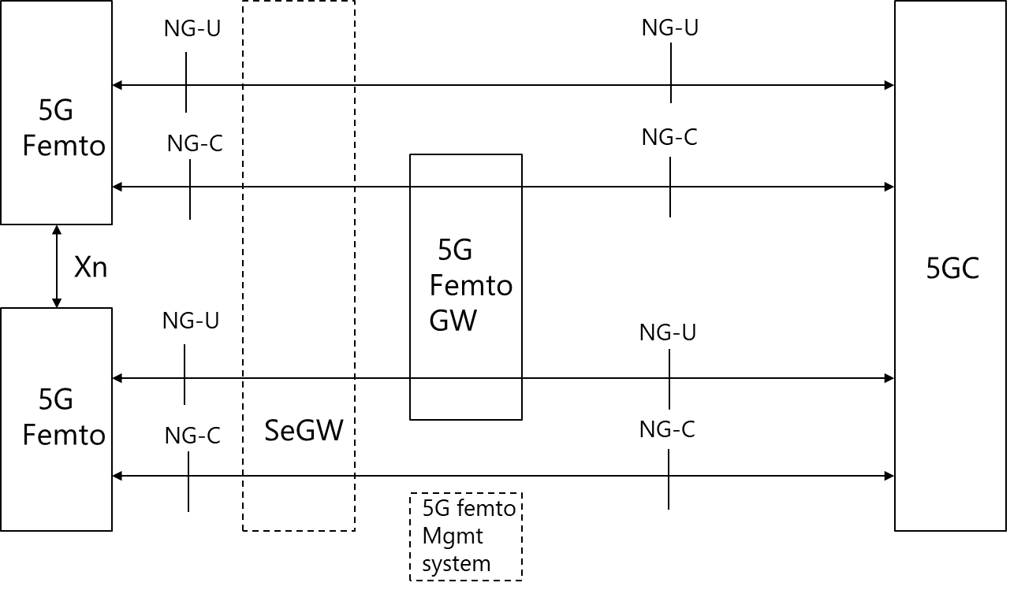

**Agree the following protocol stack for 5G femto.**

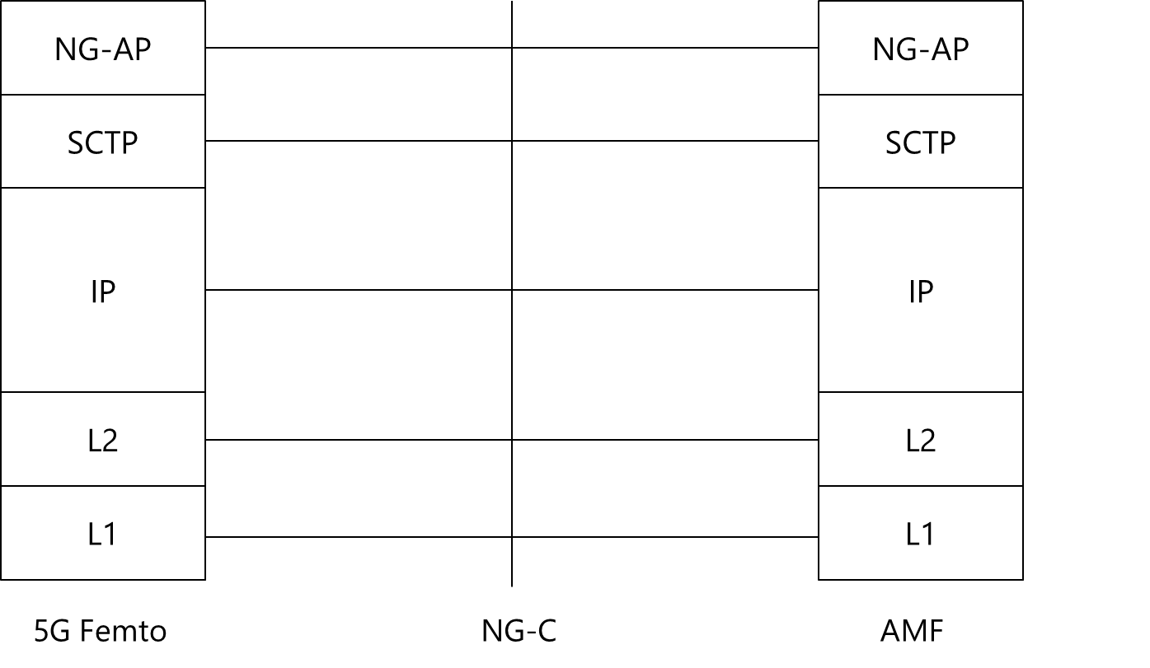

**Control plane for NG-C interface for 5G Femto to AMF without the 5G Femto GW**

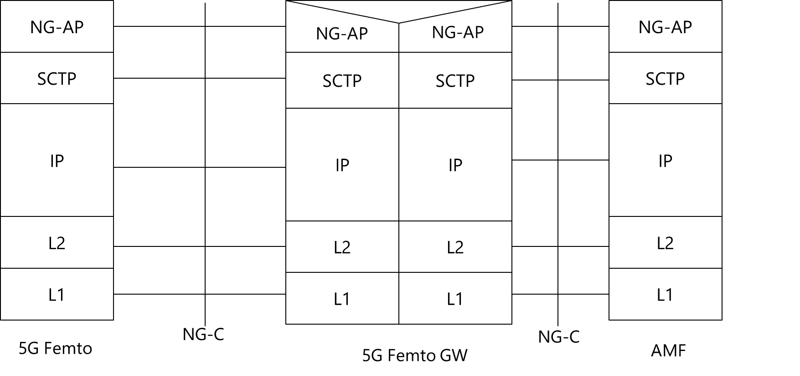

**Control plane for NG-C interface for 5G Femto to AMF with the 5G Femto GW**

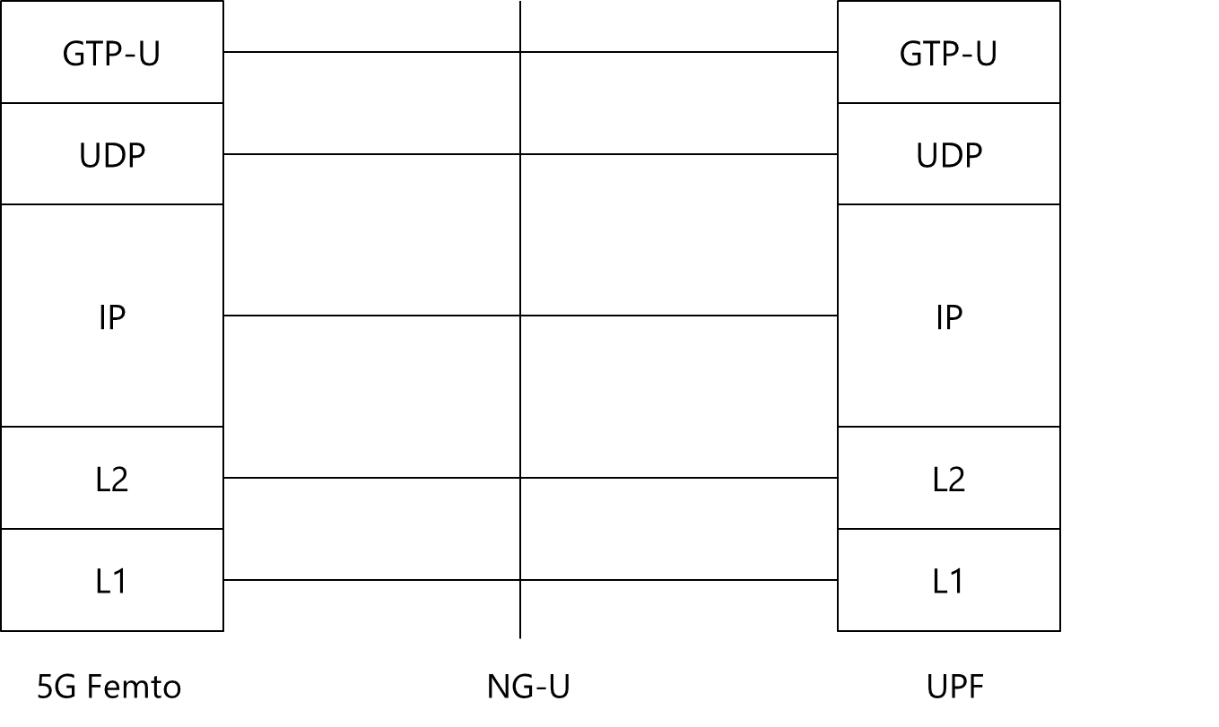

**User plane for NG-U interface for 5G Femto to UPF without the 5G Femto GW**

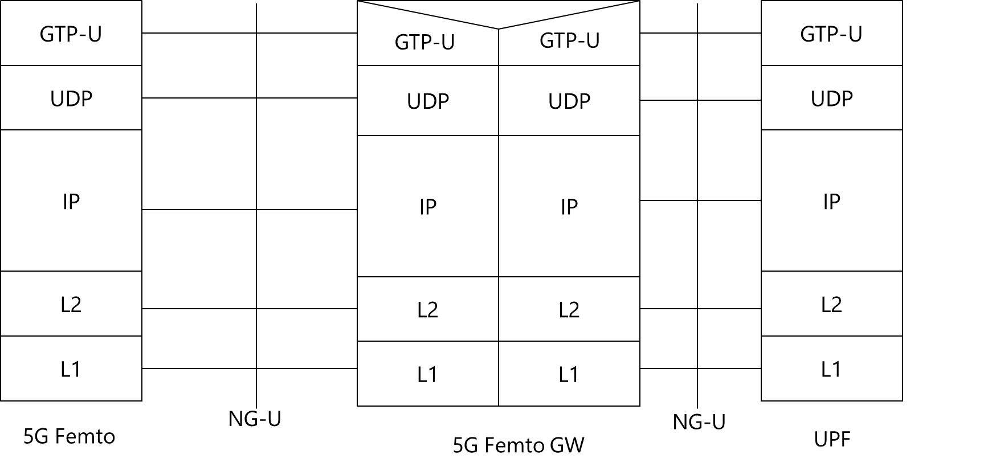

**User plane for NG-U interface for 5G Femto to UPF with the 5G Femto GW**

* 5G femto access control

**perform initial access control on 5G Femto in the AMF.**

**RAN3 to decide at stage 3 level whether to reuse the *NPN Access Information* IE in the Initial UE Message or introduce an equivalent new *5G Femto Access Information* IE.**

**A HgNB cell may be a CAG Cell (a CAG Member cell or a CAG-only cell)**

**RAN3 should assume the same CAG configuration and mobility behavior for UEs as in current PNI-NPN functionality is also applicable for femto deployments.**

**The same RAN behavior, signaling and procedures for PNI-NPN is also applicable for femto deployments.**

**The same RAN behavior for access control for PNI-NPN is also applicable for femto deployments.**

* 5G femto local service

**In order to access local services through a local breakout, a HgNB may connect to a local UPF (co-located or stand-alone) providing the necessary functionality and terminating N9 toward the central UPF and N6 toward the local data network.**

**If desired, when accessing local services according to 5GC UP architecture for femto deployments, support for Session and Service Continuity should follow current specified behavior by SA2.**

# Conclusion, Recommendations [if needed]

If needed

# References

|  |  |
| --- | --- |
| R3-241554 | (TP to TR 38.799) Aspects related to WAB architecture (Qualcomm Inc.) |
| R3-241926 | (pCR for TR 38.799) Functional Aspects of WAB-Nodes (Ericsson) |
| R3-241717 | Consideration on integration procedure and resource multiplexing for WAB (Huawei) |
| R3-241997 | Discussion on WAB architecture and high level aspects (Nokia, Nokia Shanghai Bell) |
| R3-241540 | (TP to TR 38.799) Architecture and protocol stack for WAB (CATT) |
| R3-241541 | Discussion on impact of WAB mobility (CATT) |
| R3-241542 | Discusson on operation and signling for supporting WAB (CATT) |
| R3-241549 | Discussion on Network Selection for WAB (Fraunhofer IIS, Fraunhofer HHI) |
| R3-241552 | Aspects related to WAB mobility and resource multiplexing (Qualcomm Inc.) |
| R3-241553 | (TP to TR 38.799) Discussion on requirements for WAB (Qualcomm Inc.) |
| R3-241601 | Discussion on the enhancements for WAB (NEC) |
| R3-241625 | Discussion on Wireless Access Backhaul (NTT DOCOMO INC.) |
| R3-241715 | Consideration on the architecture design for WAB (Huawei) |
| R3-241716 | Consideration on the QoS support and mobility for WAB (Huawei) |
| R3-241743 | Discussion on architecture and protocol stack for WAB (Samsung) |
| R3-241744 | Discussion on architecture requirement and deployment scenarios for WAB (Samsung) |
| R3-241751 | (TP for TR 38.799) Architecture and protocol stack of MWAB (Xiaomi) |
| R3-241752 | (TP for TR 38.799) Stage 2 procedures of MWAB (Xiaomi) |
| R3-241781 | Architecture and Signalling Enhancements for Wireless Access Backhaul (China Telecom) |
| R3-241797 | Architecture and protocol stacks of WAB node (Lenovo) |
| R3-241798 | Discussion on integration and migration procedures for WAB node (Lenovo) |
| R3-241799 | Discussion on resource multiplexing for WAB node (Lenovo) |
| R3-241893 | Discussion on architecture and protocol stack for R19 WAB (ZTE) |
| R3-241894 | Discussion on WAB mobility (ZTE) |
| R3-241895 | Discussion on resource multiplexing and location service in WAB (ZTE) |
| R3-241925 | (pCR for TR 38.799) WAB Architecture and Scenarios (Ericsson) |
| R3-241927 | (pCR for TR 38.799): Handling of Reliability, Latency and Resource Multiplexing for WAB (Ericsson) |
| R3-241979 | Discussion on support of WAB (LG Electronics) |
| R3-241998 | Discussion on WAB mobility and XnAP/NGAP impact (Nokia, Nokia Shanghai Bell) |
| R3-241999 | Resource Multiplexing for WAB (Nokia, Nokia Shanghai Bell) |

|  |  |  |
| --- | --- | --- |
| R3-241624 | Discussion on 5G Femto (NTT DOCOMO INC.) | discussion |
| R3-241555 | (TP to TR 38.799) Discussion on requirements for 5G Femto (Qualcomm Inc.) | other |
| R3-241556 | Architecture, access control and local services for 5G Femto (Qualcomm Inc.) | discussion |
| R3-241543 | (TP to TR 38.799) Discussion on 5G Femto architecture (CATT) | other |
| R3-241980 | Discussion on support of 5G Femto (LG Electronics) | discussion |
| R3-241896 | Discussion on RAN architecture and required functional for 5G femto (ZTE) | discussion |
| R3-241831 | Solution for 5G Femto Architecture (Nokia, TMO US, AT&T, Verizon Wireless, BT, NTT Docomo, KDDI) | discussion |
| R3-241832 | [TP for TR 38.799] Solution for 5G Femto architecture (Nokia, TMO US, AT&T, Verizon Wireless, BT, NTT Docomo, KDDI) | other |
| R3-241598 | Considerations on 5G femto (NEC) | discussion |
| R3-241800 | Architecture and protocal stacks of 5G femto (Lenovo) | discussion |
| R3-241565 | On 5G Femto Support (China Telecommunication) | discussion |
| R3-241745 | Discussion on architecture and functional impact for Femto (Samsung) | discussion |
| R3-241718 | Discussion on the architecture design for 5G femto (Huawei) | pCR |
| R3-242040 | Femto Architecture and NG-RAN (Ericsson LM) | pCR |
| **Access Control, CAG** | | |
| R3-241897 | Discussion on access control for 5G femto (ZTE) | discussion |
| R3-241545 | Discussion on 5G Femto access control mechanism (CATT) | discussion |
| R3-241801 | Access control and handover for 5G Femto with CAG (Lenovo) | discussion |
| R3-241833 | [TP for TR 38.799] Initial Access Control of 5G Femtos (Nokia ) | other |
| R3-241834 | [TP for TR 38.799] Access Control of 5G Femtos for Mobility (Nokia ) | other |
| R3-241835 | LS on security aspect for handover to target 5G Femto (Nokia) | LS out To: SA3 CC: |
| R3-241719 | Discussion on the access control for 5G femto (Huawei) | pCR |
| R3-242041 | Access Control with CAG (Ericsson LM) | pCR |
| **Access to Local Services, Local UPF** | | |
| R3-241898 | Discussion on local services for 5G femto (ZTE) | discussion |
| R3-241544 | Discussion on 5G Femto local service access (CATT) | discussion |
| R3-241684 | Access to local services from the 5G Femto via collocated local UPF (Huawei) | pCR |
| R3-242042 | Access to Local Services via Local UPF (Ericsson LM) | pCR |