3GPP TSG-RAN WG2 Meeting #123 Tdoc R2-23xxxxx
Toulouse, France, August 21st - 25th, 2023

Agenda: 7.25.4
Source: Ericsson
Title: CP/UP latency assumptions
Document for: Discussion, Decision

1 Introduction
ITU-R has defined requirements for the satellite component of IMT-2020 [1]. The set of requirements and the corresponding evaluation guidelines are based on the terrestrial procedure, to which 3GPP has submitted TR 37.910 [2]. Similar to the terrestrial case, the requirements include a CP and UP latency targets which have been set to 40 ms and 10 ms, respectively [1], to take into account the longer propagation delay inherent to satellite communications.

2 Summary of remaining issues

2.1 Propagation delay (RTD)
The most significant difference with respect to the terrestrial evaluation documented in TR 37.910 [2] is the addition of the satellite’s long propagation delay, i.e., round trip delay (RTD). During RAN2#122, the topic was briefly discussed, and the following agreement was reached:
- For RTD we consider the same scenario as considered by RAN1

RAN1 has already made some progress in their parameter and scenario selection for IMT-2020 simulations. During RAN1#112bis-e and RAN1#113, the following relevant agreement were made [3]:
- The evaluation performed by RAN1 will consider at least the following scenario:
  - Transparent payload without ISL
  - S-band (2<GHz)
  - LEO-600
  - Handheld UEs
- For peak spectral efficiency and peak data rate parameters:
  - The parameters are chosen based on “ideal conditions”: 90degree elevation angle, 0dB atmospheric loss, 0dB shadow fading margin, 0dB scintillation loss, 0dB polarization loss, 0dB additional losses.
  - Companies to provide in RAN1#113 realistic parameters, declaring the assumptions and evaluations leading to those parameters.

Even though there seems to be an overall consensus for the baseline scenario, submissions to RAN2#123 reflect a variety of views:
- For the feeder and service link delay consider LEO at 600 km with both UE and GW/gNB at nadir.[6]
- The propagation delay (RTD) due to service and feeder links is 8 ms for both control and user plane in the LEO-600 scenario (corresponding to 90° elevation angle).[4]
- RAN2 agrees to consider RTD of LEO 600km in user plane/control plane latency evaluation.[8]
- In LEO-600, with a minimum elevation angle for both feeder link and service link, i.e., 10° for service link and 10° for feeder link. [5]
- The propagation delay is also calculated based on LEO satellite orbit altitude of 600km. For evaluation purpose, 79° elevation angle for both gNB and UE are assumed. [11]

Q1. To calculate the round-trip delay, can “ideal conditions” be assumed for the evaluation of UP and CP latency? From RAN2 perspective, “ideal conditions” refer to the case where both UE and gNB are located at the satellite’s nadir, i.e., elevation angles are 90 degrees.
Company | Yes/No | Comments
OPPO | Yes

Summary:
Proposal

Once the baseline scenario is settled, the next issue relates to whether feeder and/or service link propagation delays are used to calculate the overall propagation delay. There are two opposing views on the topic:
- Feeder and service links propagation delays are not included in the time budget to satisfy the user plane and control plane latency requirement.[1]
- Feeder and service link delays need to be taken into account in the user and control plane latency analysis for NTN.[3]

Q2. Do feeder and service link delays need to be included in the propagation delay computation?
Company | Yes/No | Comments
OPPO | Yes

Summary:
Proposal

2.2 Mobility interruption time
According to the definition, mobility interruption time is the shortest time duration supported by the system during which a user terminal cannot exchange user plane packets with any base station during mobility transitions. This parameter was already discussed in RAN2#123-bis reaching the following agreement:
- Confirm 0ms mobility interruption time is achieved by NR in beam mobility.

Even though this was already discussed in the previous meeting and there seems to be an overall consensus, there are submissions to RAN2#123 which reflect a variety of views:
- The inter cell level mobility interruption time is not evaluated for the IMT-2020 Satellite self-evaluation.[4]
- It is sufficient to consider beam-based mobility to achieve 0ms mobility interruption and other scenarios (e.g., service link and feeder link switch) will not be considered for mobility interruption time evaluation.[7]
- The interruption time during mobility across cell should also be evaluated. [5]

Q3. Given mobility interruption time refer to the shortest time duration supported by the system, does RAN2 need to consider the inter-cell/inter-satellite scenario?
Company | Yes/No | Comments
OPPO | No

Summary:
Proposal

2.3 Satellite processing delay
In addition to longer propagation delays, NTN introduces a satellite payload which is transparent to the UE-BS communication, i.e., it forwards the signal without perform any processing on it. The processing delay related to the satellite corresponds to the routing of the signal from the feeder receiving antenna to the service link transceiver and inversely and its amplification [4]. Again, there are two opposing views:
- The satellite on-board processing delay in transparent mode can be considered negligible (i.e. << 1ms).[1]
- The value may be non-negligible and RAN1 needs to provide it [2].

Q4. Can the satellite on-board processing delay in transparent architecture be considered negligible?
Company | Yes/No | Comments
OPPO | Yes

Summary
Proposal

2.3 Control Plane procedure
As defined in Report ITU-R M.2410, control plane latency refers to the transition time from a most “battery efficient” state (e.g., Idle state) to the start of continuous data transfer (e.g. Active state). In RAN2#122, the following relevant agreements were made:
- Evaluate the control plane latency from RRC_INACTIVE to RRC_CONNECTED.
- Evaluate the control plane latency based on the 2-step RACH.

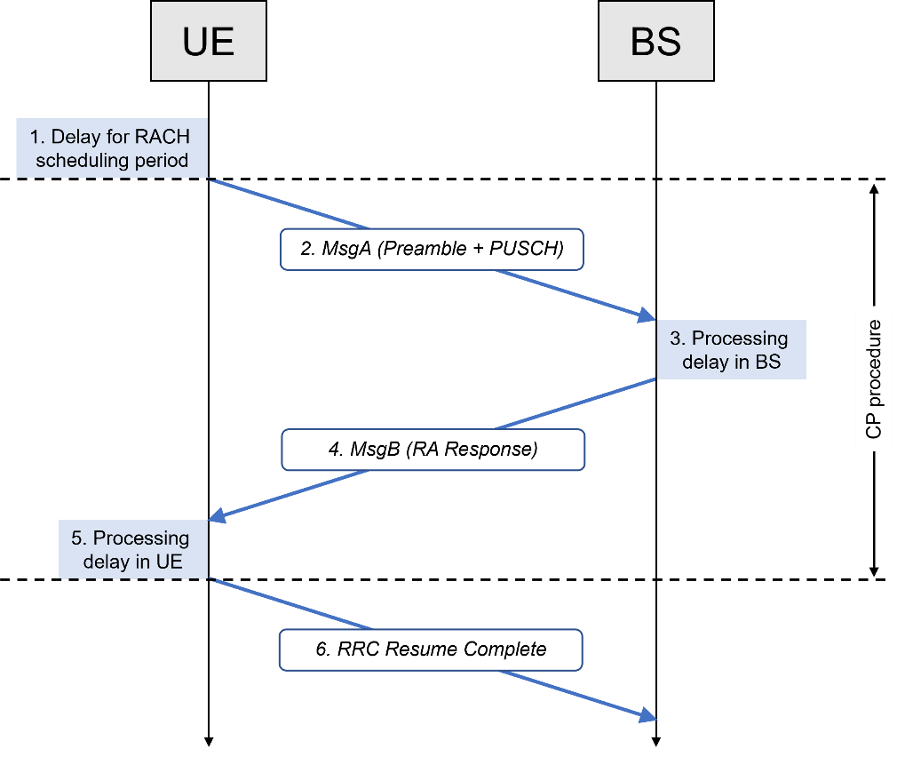
Figure 1. Illustration of CP signalling during transition from RRC_INACTIVE to RRC_CONNECTED mode.

Q5. Can the following high-level control plane procedure be used for NR NTN?
Company | Yes/No | Comments
OPPO | Yes

Summary
Proposal

Q6. Provide company input about the detailed procedure and delay assumptions.
Step | Description | CP latency for UL data transfer | Company comments
1 | Delay due to RACH scheduling period (1TTI) | 0
2.1 | Transmission of MsgA (RACH Preamble + PUSCH) | Ts (the length of 1 slot / non-slot)
2.2 | Propagation delay UE -> BS | RTD/2
3 | Preamble detection and processing in gNB | 3 ms (Same as for reception of Msg3 in NR TN)
4.1 | Transmission of MsgB (RA response) | Ts (the length of 1 slot / non-slot)
4.2 | Propagation delay BS -> UE | RTD/2
5 | UE Processing Delay | 7 ms (Same as for reception of Msg4 in NR TN)
6 | Transmission of RRC Resume Complete and data | 0

2.4 User Plane procedure
As defined in Report ITU-R M.2410, user plane latency is the contribution of the radio network to the time from when the source sends a packet to when the destination receives it (in ms). In RAN2#122, the following relevant agreement was made:
- For user plane latency evaluation, HARQ disabling should be assumed.

Given HARQ mechanism is disabled, the rapporteur has noticed that some contributions assume the radio interface to be error-free (p=0), while other believe blind retransmissions can be considered without impact in the time budget calculation [5]. In [4], it is proposed to consider a realistic (p=0.1) and its effect on the RLC ARQ mechanism. In this case, the RLC ARQ latency for loss recovery should be included in the user plane latency.

Q7. Which of the following should be included the total user plane latency calculation to account for a realistic error rate (p=0.1) in the radio interface?
a RLC ARQ.
b Blind retransmissions.
c None.

Company | Option | Comments
OPPO | B

Summary
Proposal

2.4.1 DL latency
Given the assumption to disable HARQ feedback, the delay due to retransmission does not need to be considered.

Q8. Provide company input about the detailed procedure and delay assumptions.
ID | Component | Notations | Value | Company comments
1 | BS processing delay | t_{BS,tx}  The time interval between data arrival and packet generation. | T_{proc,2}/2, with d_{2,1} = d_{2,2} = 0.  T_{proc,2} is defined in Section 6.4 of TS 38.214.
2 | DL frame alignment (transmission alignment) | t_{FA,DL}  The time interval between packet generation and the next Tx opportunity. | T_{FA}  Length of one slot, since T_{FA} is bounded by the slot duration.
3 | TTI for DL data packet transmission | t_{DL_duration} | Length of one slot (14 OFDM symbol length) or non-slot (4/7 OFDM symbol length), depending on slot or non-slot selected in evaluation.
4 | One-way propagation time BS -> satellite -> UE | t_{prop} | RTD/2
5 | UE processing delay | t_{UE,rx}  The time interval between PDSCH reception and decoding of the data. | T_{proc,1}/2, with d_{1,1} = 0.  T_{proc,1} is defined in Section 5.3 of TS 38.214.
 | Total UP latency for DL | T_{DL} = (t_{BS,tx} + t_{FA,DL})  + (t_{DL_duration} + t_{prop})+ t_{UE,rx}

2.4.2 UL latency
Given the agreement to disable HARQ feedback, the rapporteur sees different interpretations in several contributions. Some assumed that this only applies to the DL [10], while others have assumed it also applies to the UL thanks to HARQ mode B [5,7].

Q9. HARQ mode B (no retransmissions) is assumed to calculate the UP uplink latency.
Company | Yes/No | Comments
OPPO | Yes

Summary
Proposal

Q10. Provide company input about the detailed procedure and delay assumptions.
ID | Component | Notations | Value | Company input
1.1 | UE processing delay | t_{UE,tx}  The time interval between data arrival and packet generation. | T_{proc,2}/2, with d_{2,1} = d_{2,2} = 0.  T_{proc,2} is defined in Section 6.4 of TS 38.214.
1.2 | UL frame alignment (transmission alignment) | t_{FA,UL}  The time interval between packet generation and the next Tx opportunity. | T_{FA}  Length of one slot, since T_{FA} is bounded by the slot duration.
1.3 | TTI for UL data packet transmission | t_{UL_duration} | Length of one slot (14 OFDM symbol length) or non-slot (4/7 OFDM symbol length), depending on slot or non-slot selected in evaluation.
1.4 | One-way propagation time UE -> satellite -> BS | t_{prop} | RTD/2
1.5 | BS processing delay | t_{BS,rx}  The time interval between PUSCH reception and decoding of the data. | T_{proc,1}/2, with d_{1,1} = 0.  T_{proc,1} is defined in Section 5.3 of TS 38.214.
 | UL data transfer | T₁  The sum of steps 1.1 to 1.5. | T₁ = (t_{UE,tx} + t_{FA,UL})  + (t_{UL_duration} + t_{prop}) + t_{BS,rx}

3 References
- R1-2304123, Feature lead summary #4 on evaluation methodology for IMT-2020 Satellite, RAN1.
- ITU-R M.2514, "Vision, requirements and evaluation guidelines for satellite radio interface(s) of IMT-2020".
- R1-2306083,
- R2-2307322, Discussion on IMT-2020 Satellite self-evaluation for Latency and Mobility, THALES, RAN2#123, Toulouse, France, August 2023
- R2-2307496, Self-Evaluation for NR NTN, Huawei, HiSilicon, RAN2#123, Toulouse, France, August 2023
- R2-2307586, On CP and UP Latency for IMT-2020 NTN Self Evaluation, Nokia, Nokia Shanghai Bell, RAN2#123, Toulouse, France, August 2023
- R2-2307624, RAN2 aspects on evaluation methodology for IMT-2020 Satellite, Qualcomm Incorporated, RAN2#123, Toulouse, France, August 2023
- R2-2308508, Self-Evaluation towards the 3GPP submission of a IMT-2020 Satellite Radio Interface Technology, ZTE Corporation, Sanechips, RAN2#123, Toulouse, France, August 2023
- R2-2308903, Satellite IMT-2020 self-evaluation: CP latency, Ericsson, RAN2#123, Toulouse, France, August 2023
- R2-2308905, Satellite IMT-2020 self-evaluation: UP latency, Ericsson, RAN2#123, Toulouse, France, August 2023
- R1-2307551, Discussion on self-evaluation methodology for IMT-2020 satellite radio interface, OPPO, RAN1#114, Toulouse, France.

