3GPP TSG-RAN WG2 Meeting #121-bis-e R2-230XXXX

Online, 17 – 26 April, 2023
Agenda item: 6.5.3
Source: Samsung
Title: Summary of Relay-17 relay UP CR (Samsung)
Document for: Discussion & Decision

Introduction
This is the report of the offline discussion.
- [AT121bis-e][426][Relay] Rel-17 relay UP CR (Samsung)
Scope: Check the CR in R2-2304036 and determine whether/how to integrate the TP from P4 of R2-2304191
Intended outcome: Agreed CR (without CB if possible)
Deadline: Monday 2023-04-24 2359 UTC

Discussion
As per the summary in [1], this is to check companies view on the CR in R2-2304036[2] and the TP for DL data transfer which is associated with the change for UL data transfer in R2-2304036[2].

2.1 TP for UL data transfer
R2-2304036[2] | Corrections on SRAP for SL relay | NEC | - In clause 5.3.1.2,  - clarify how to determine the egress PC5 relay RLC channel for sending SRB1 via default SL-RLC1  - else if the SRAP Data PDU is for SRB1 and if there is not an entry in sl-SRAP-ConfigRemote, whose sl-RemoteUE-RB-Identity matches the SRB identity of the SRAP Data PDU, or if there is an entry in sl-SRAP-ConfigRemote without the corresponding sl-EgressRLC-ChannelPC5:  - Determine the egress PC5 Relay RLC channel in the link with U2N Relay UE corresponding to logicalChannelIdentity for SL-RLC1 as specified in TS 38.331 [3];
Q1. Do companies agree the CR in R2-2304036?
Companies | Agree or Disagree | Comments
OPPO | Agree
Apple | Agree | There is one additional issue with the coversheet of 4036, The clause number 5.3.3.2 in summary of change is wrong.  [Rapp] Thanks for spotting this. It is corrected in the draft CR.
China Telecom | Agree
CATT | Agree
vivo | Agree
Xiaomi | Agree
NEC | Agree | Thanks Apple for pointing out the mistake.
ZTE | Agree | Not sure if the CR also affects “Radio Access Network”. If not, the corresponding square should be unticked.  [Rapp] Thanks for the comment. I think that this CR does not affect RAN.
LG | Agree
Intel | Agree
Futurewei | Agree
MediaTek | Agree
Huawei, HiSilicon | Agree

2.2 TP for DL data transfer
The TP (underlined red text) is to be added in clause 5.2.2.2 in TS 38.351. Rapporteur would like to check the views of companies on the TP and if it is agreeable then the TP can be merged into the CR in R2-2304036[2] or a separate CR.

5.2.2.2 Egress RLC channel determination
For a SRAP Data PDU to be transmitted, the SRAP entity shall:
- if the SRAP Data PDU is for SRB0 (the BEARER ID field is 0 and the bearer is identified as SRB based on sl-RemoteUE-RB-Identity associated with the entry containing the sl-EgressRLC-ChannelUu which matches the LCID of the Uu Relay RLC Channel from which the SRAP Data PDU is received):
- Determine the egress PC5 Relay RLC channel in the determined egress link corresponding to logicalChannelIdentity for SL-RLC0 as specified in TS 38.331 [3];
- else if the SRAP Data PDU is for SRB1 and if there is not an entry in sl-SRAP-ConfigRelay, whose sl-RemoteUE-RB-Identity matches the SRB identity of the SRAP Data PDU, or if there is an entry in sl-SRAP-ConfigRelay without the corresponding sl-EgressRLC-ChannelPC5:
- Determine the egress PC5 Relay RLC channel in the determined egress link corresponding to logicalChannelIdentity for SL-RLC1 as specified in TS 38.331 [3];
- else if there is an entry in sl-SRAP-ConfigRelay, whose sl-LocalIdentity matches the UE ID field in SRAP Data PDU, which includes an sl-RemoteUE-RB-Identity that matches the SRB identity or DRB identity of the SRAP Data PDU determined by the BEARER ID field (For the BEARER ID shared by both SRB and DRB, SRB and DRB are differentiated based on sl-RemoteUE-RB-Identity associated with the entry containing the sl-EgressRLC-ChannelUu which matches the LCID of the Uu Relay RLC Channel from which the SRAP Data PDU is received):
- Determine the egress PC5 Relay RLC channel in the determined egress link corresponding to sl-EgressRLC-ChannelPC5 configured for the concerned sl-LocalIdentity and concerned sl-RemoteUE-RB-Identity as specified in TS 38.331 [3].
Q2.1 Do companies agree the TP for clause 5.2.2.2 in 38.351?
Companies | Agree or Disagree | Comments
OPPO | Agree
China Telecom | Agree
vivo | Agree
Xiaomi | Agree
NEC | Agree
ZTE |  | - For relay UE, “if there is not an entry in sl-SRAP-ConfigRelay” for SRB1, how to configure the Uu RLC channel of SRB1 for relay UE? How does the relay UE identify a DL SRAP data PDU is for SRB1?  [Rapp] As specified in 38.331, it is configured with SL-L2RelayUE-Config IE. BEARER ID field is set to 1 for SRB1 in the received DL SRAP data PDU but SRB1 is not included in sl-MappingToAddModList, or SRB1 is included in sl-MappingToAddModList, but sl-EgressRLC-ChannelPC5 is not configured.  - Whether the following sentence should also be copied for SRB1 identification?  For the BEARER ID shared by both SRB and DRB, SRB and DRB are differentiated based on sl-RemoteUE-RB-Identity associated with the entry containing the sl-EgressRLC-ChannelUu which matches the LCID of the Uu Relay RLC Channel from which the SRAP Data PDU is received  [Rapp] Thanks for the comment. I think that just adding ‘(the BEARER ID field is 1)’ after ‘SRB1’ should be fine.
LG | Agree
Intel | Agree
Futurewei | Agree
Huawei, HiSilicon | Agree
Apple | Agree with comment | To address ZTE concern, we think to put the change under “else if” part:  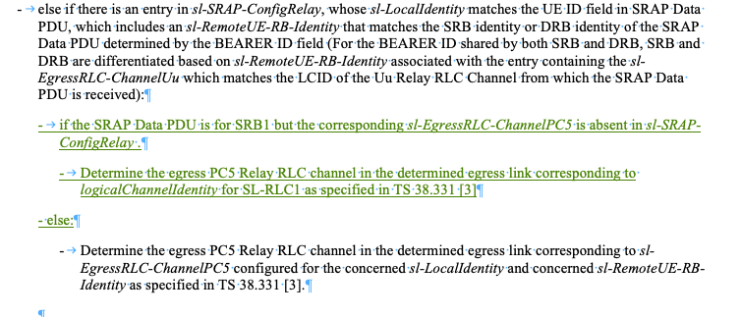  [Rapp2] Thanks for the suggestion. It looks okay. The draft CR is updated with this change.

Q2.2 If agreed in Q2.1, which option do companies support for the TP?
option 1: merge the TP into the CR in R2-2304036[2]
option 2: a separate CR
Companies | Option 1/Option 2 | Comments
vivo | No strong view
Xiaomi | Option 1 | Same issue on relay/remote. Single CR is enough.
NEC | Comments | Can accept the majority views.
LG | No strong view
Huawei, HiSilicon | No strong view
Apple | Option 1

Summary: Based on companies input on the questionnaires above, the proposed TPs for Remote UE and Relay UE are agreeable. The CR in R2-2304036 should be revised to incorporate the TP for Relay UE operation and to fix some error in the cover sheet. So Rapporteur proposes to agree the CR in R2-230XXXX (the revision of R2-2304036).
Proposal 1. The 38.351 CR in R2-230XXXX is agreeable.

Conclusion
We have the following proposal.

References
[1] R2-2304191, Summary of agenda item 6.5.3, Samsung (Rapporteur)
[2] R2-2304036, Corrections on SRAP for SL relay, NEC

