3GPP TSG-RAN WG2 Meeting #121 R2-2302024
Athens, Greece, 27th Feb.– 3rd Mar., 2023

Agenda item: 5.2.2
Source: Huawei, HiSilicon
Title: Summary of [AT121][502][V2X/SL] R16 RRC corrections (Huawei)
Document for: Discussion and Decision

Introduction
This document summarizes the below offline discussion.
- [AT121][502][V2X/SL] R16 RRC corrections (Huawei)
Scope: Discuss corrections in R2-2300485/R2-2300486, R2-2300836/R2-2300837, R2-2301021/R2-2301022, and R2-2301377/R2-2301378. Merge agreeable corrections.
Intended outcome: 38.331 CR in R2-2302022/R2-2302023 and discussion summary in R2-2302024 (if needed).
Deadline: Comeback at 3/2 CB session
Contact list
Name | Company | email
Tao Cai | Huawei, HiSilicon | tao.cai@huawei.com
Qianxi Lu | OPPO | qianxi.lu@oppo.com
Giwon Park | LG | giwon.park@lge.com
Xiao, XIAO | vivo | xiao.xiao@vivo.com
Li Zhao | Xiaomi | zhaoli6@xiaomi.com
Ansab Ali | Intel Corp | ansab.ali@intel.com
Hyunjeong Kang | Samsung | hyunjeong.kang@samsung.com

First/second change in R2-2300485/R2-2300486
Rapporteur realized, since NR discovery is introduced in Rel-17, the first and second changes are not needed for Rel-16 as in R2-2300485. Rapporteur propose to discuss first and second changes in R2-2300486 instead. If agreed, they will be added into R17 Misc CR (i.e. not mirror changes)

1. In 6.3.5 Sidelink information elements, in the current field description of sl-TxPoolExceptional, it is stated that the resource in the pool is used for NR sidelink communication. Actually, the resource in the pool can also be applied to transmit NR sidelink discovery, which is not included in the current description.  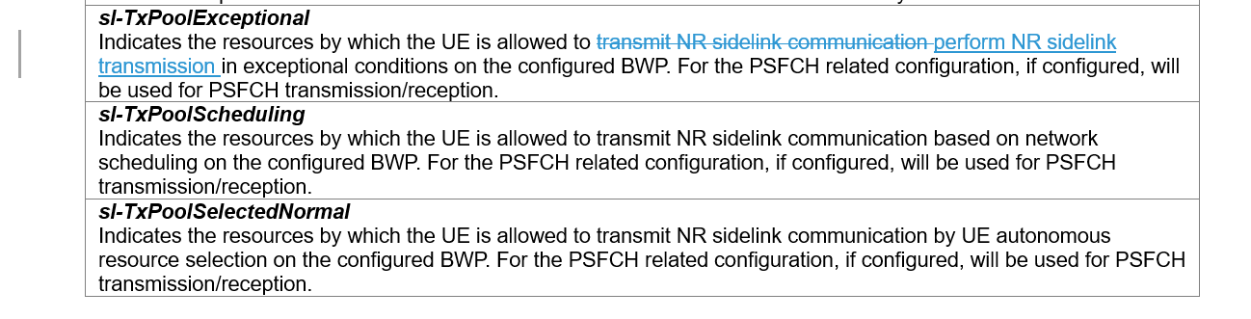  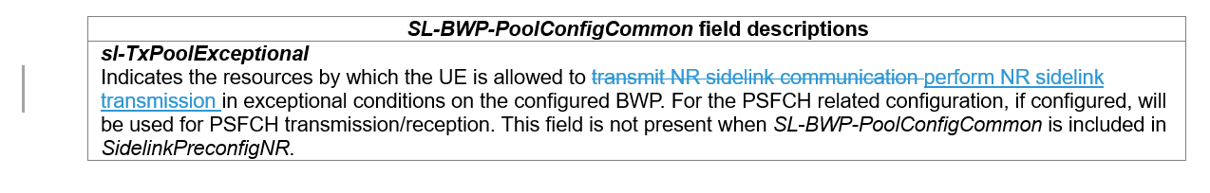 | The first second change are to cover the missing case of "sidelink discovery transmission" which should be reasonable.
Q1: Would your company agree the above two changes for Rel-17?

Company | Agree/Disagree | Further comments
OPPO | Agree for R17 | Intention OK, and as Rapp said, it should be Rel-17 CR only.
LG | Agree for R17
vivo | Agree
Xiaomi | Agree for R17
Intel | Agree
Samsung | Agree for R17

Last change in R2-2300485/R2-2300486, change in R2-2301021/R2-2301022
The last change in 485/486 and the change in 1021/1022 are on the same issue that the IEs refer to field sl-MaxTxTransNumPSSCH as for the maximum retransmission number while the FD of sl-MaxTxTransNumPSSCH states that it is for total transmission number including new transmission. We can discuss whether to adopt one of the changes or other alternatives.

Tdoc | Summary of changes/proposals | Rapp’s remark
R2-2300485 | All IEs refer to SL-PSSCH-TxConfigList for the configuration of “retransmission number”. However, the field description of sl-MaxTxTransNumPSSCH in SL-PSSCH-TxConfigList is that “Indicates the maximum transmission number (including new transmission and retransmission) for PSSCH”. So it is unclear on what sl-MaxTxTransNumPSSCH is really used for, the maximum transmission number or the maximum retransmission number. | This change is to solve the same issue as vivo CR in R2-2301021, without causing any impacts on already implemented products, according to discussion of last meeting.
R2-2301021 | According to current MAC specification in clause 5.22.1.1 as below, the UE will select a “retransmission number” from the “the allowed numbers”, where the “the allowed numbers” is defined by overlapped values within sl-MaxTxTransNumPSSCH included in sl-PSSCH-TxConfigList and sl-MaxTxTransNumPSSCH indicated in sl-CBR-PriorityTxConfigList.  - select the number of HARQ retransmissions from the allowed numbers, if configured by RRC, in sl-MaxTxTransNumPSSCH included in sl-PSSCH-TxConfigList and, if configured by RRC, overlapped in sl-MaxTxTransNumPSSCH indicated in sl-CBR-PriorityTxConfigList for the highest priority of the logical channel(s) allowed on the carrier and the CBR measured by lower layers according to clause 5.1.27 of TS 38.215 [24] if CBR measurement results are available or the corresponding sl-defaultTxConfigIndex configured by RRC if CBR measurement results are not available;  On the other hand, in current RRC, the field of sl-MaxTxTransNumPSSCH is described as “the maximum transmission number (including new transmission and retransmission)”.  Based on above observations, a potential issue is how UE understands the “the allowed numbers” in MAC, given that they are implicitly derived by the value of sl-MaxTxTransNumPSSCH in RRC, other than directly apply the value of sl-MaxTxTransNumPSSCH. Therefore, some clarifications are made on the description of sl-MaxTxTransNumPSSCH. | Technically this change would solve the issue as in Rapp's Misc CR. However, there might be "circular reference" that the new FD points to MAC spec clause 5.22.1.1 which depends on RRC configuration. Strictly speaking, "value of this field minus 1" is not specified in MAC spec.  Essentially, new transmission (one time) should be always allowed, i.e. this field sl-MaxTxTransNumPSSCH is only to control the maxi number of retransmissions.
Q2: Which option would your company support?
Option 1: last change in R2-2300485/R2-2300486.
Option 2: change in R2-2301021/R2-2301022.
Option 3: No change
Option 4: Other change alterative, please elaborate.
Company | Option | Further comments
OPPO | 3 | For both CRs: intention OK, yet the existing text (‘including new transmission and retransmission’) already aligns with the proposed change, so no need to change.
LG | 3 | The existing text is clear. No need to change.
vivo | Option 2 | We are Proponent of Option 2.  To reply to rapporteur comment on there might be "circular reference", we don’t think there is a circular issue. The CR only said that the allowed number for HARQ retransmission in MAC spec is defined by RRC signalling.
Xiaomi | 3 | Agree with other companies the existing text is clear enough.
Intel | 3 | Same view as LG and Xiaomi
Samsung | 3 | The intention is shared but we think that current specification text is fine.

Correction in R2-2300836/R2-2300837
The changes are be included into two types:

Summary of changes/proposals | Rapp’s remark
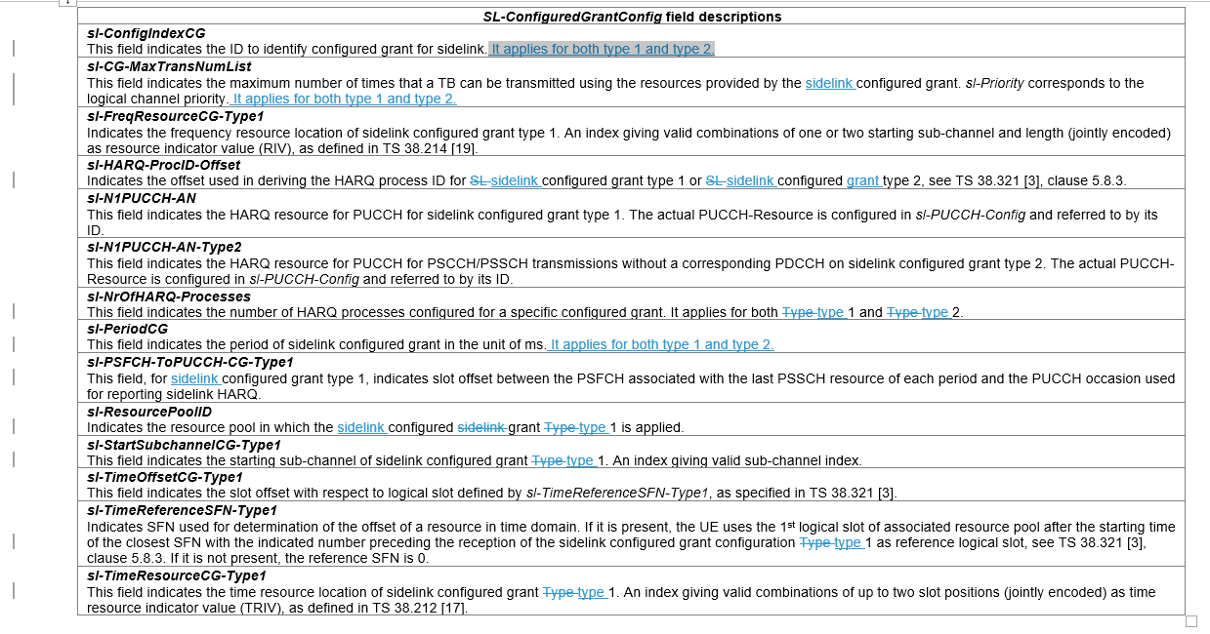 | Editorial changes (configured sidelink grant->sidelink configured grant, Type->type) can be accepted. Changing SL to sidelink may be unnecessary as SL is used "pervasively" in RRC spec without ambiguity. On adding "it applies for both type 1 and type 2", it can be discussed whether this addition is critically needed, as for those attributes of SL CG (ID, period, max number of transmission), the implication is that they are applicable for both CG types.
Q3: Would your company agree to add the description "It applies for both type 1 and type2" for field sl-ConfigindexCG, sl-CG-MaxTransNumList, sl-PeriodCG?
Company | Agree/Disagree | Further comments
OPPO | Disagree | Do not see critical issue behind this change.
LG | Agree
vivo | Agree
Xiaomi | Agree | Proponent  All these parameters are located in the same level as sl-NrOfHARQ-Processes for which there is clear description that both type 1 and type 2 applies. So better to have consistent handling.
Intel | Disagree | We share the view with OPPO that the changes seem a bit cosmetic and not essential at this stage
Samsung | Disagree | We do not think that it is essential. With the field names and field descriptions, the current specification looks clear.
For other more of editorial issues, rapporteur suggest to adopt, as proposed, to consistently use "sidelink configured grant" not "SL configured grant", and "type" not "Type" as in 836/837. Please comment if disagree.
Company | Comments
OPPO | We are bit reluctant to do a R16 CR for cosmetic reasons.. (normally, R16 (or earlier) CR should be motivated by critical issues in our view).  Yet we can follow majority view here

Change in R2-2301377/R2-2301378

Summary of changes/proposals | Rapp’s remark
In the RAN4 LS, RAN4 agreed not to define P_{EMAX,c} for S-SSB configured Tx Power in TS38.101-1. The related parameter sl-MaxTransPower which is used for configuring P_{EMAX,c} should be updated to reflect RAN4’s agreement.  And in TS 38.101-1, it is clear the this parameters can be used for PSSCH, PSCCH and PSFCH respectively | This change can be agreeable, based on the related RAN4 agreement on a resource pool.
Q4: Would your company agree the change in 1377/1378?
Company | Agree/Disagree | Further comments
OPPO | See comment | Given one can refer to RAN4 spec to know further details if needed, we do not think current RAN2 spec broken on this issue.
LG | Follow majority view
vivo |  | Proponent, but no strong view.  OPPO’s comments can be one way out as well; also, some offline comments were received by us that S-SSB occasions are not per resource pool config, so no necessity to be reflected in this per pool parameters.
Xiaomi | Disagree | Agree with OPPO to refer to RAN4 spec.
Intel | Follow majority view
Samsung | No strong view

Conclusions

