3GPP TSG-RAN WG2 Meeting #121 R2-2300xxx
Athens, Greece, Feb 27 – Mar 03, 2023

Title: Draft LS to SA2 on Sidelink positioning procedure
Response to:
Release: Rel-18
Work Items: NR_pos_enh2

Source: Intel (To be RAN2)
To: SA2
CC: SA3

Contact Person:

Name: Yi Guo

E-mail Address: yi.guo@Intel.com
Attachment:

1. Overall Description:
RAN2 discussed the overall signaling procedure for PC5-only positioning (including at least in coverage (IC) and out of coverage (OOC); FFS if there are differences for partial coverage (PC)), and made following agreements:
Agreement:
The sidelink positioning procedure comprises the following series of steps as a baseline, between the LMF/positioning server UE/NG-RAN/candidate Anchor UE(s) and Target UE(s):
- Triggering event
- Sidelink positioning capability exchange
3. Sidelink positioning assistance data transfer
4. SL Positioning Request Location Information
5. Measurement of SL-PRS
6. Location calculation
7. SL Positioning Provide Location Information
Some steps may have dependencies on SA2 and can be revisited in this light. The order is subject to further discussion. FFS if discovery and selection of anchor UEs and/or server UE are part of the positioning layer in RAN2 scope.

During RAN2 discussion, following questions were raised:
Question 1:Does SA2 have any comments on RAN2 agreed PC5-only positioning procedure?

Question 2: Regarding the step 1 trigger event, RAN2 would like to understand whether SA2 will specify the triggering event for an SLPP session?

Question 3: Whether SA2 intends to specify anchor/server UE selection (if yes, whether the anchor/server UE selection is related to the discovery procedure?), or whether this should be handled by positioning (SLPP) layer? ?

2. Actions:
To SA2
ACTION:
- RAN2 respectfully asks SA2 to take the above into account in their future work and provide feedback to RAN2.

3. Date of Next RAN WG2 Meetings:
RAN2 #121bis 17-26 April 2023 Electronic Meeting
RAN2 #122 22-26 May 2023 Incheon

4. Contact information
Respondents to the email discussion are kindly asked to fill in the following table.
Company | Contact: Name (E-mail)
Huawei, HiSiclion | Yinghao Guo
Ericsson | Ritesh.shreevastav@ericsson.com
LG | Jonggil Nam (jonggil.nam@lge.com)
Fraunhofer | birendra.ghimire@iis.fraunhofer.de
CATT | lijianxiang@catt.cn
Nokia | Stepan.kucera@nokia.com
Philips | rob.j.davies@philips.com
CMCC | tangxiaoxuan@chinamobile.com

5. Discussion

Rapporteur would like to check companies’ view .
Q1: Do companies agree the content above?
.
Company | Yes/No | Remark
Huawei, HiSiclion |  | LCS already means location service. So, “LCS service request” should be “LCS request”  [Rapporteur] Thanks  Not sure why SLPP session should be invoked by LPP layer.  [Rapporteur] See Ericsson’s clarification. I added SLPP/LPP.  From this perspective, we prefer to leave the question more open, since it is up to SA2 to discuss. We can reword the question as: “We would like to understand how the SLPP session is triggered?”  [Rapporteur] I will add this sentence.  For the 3rd question, we can ask, whether and how the anchor UE selection is related to the discovery procedure and UE capability exchange.  [Rapporteur] refer to OPPO’s question.
OPPO |  | The SA2 could only decide whether or not the discovery procedure could be used as part of the anchor UE selection procedure. Regarding the capability transfer, it is in AS level, so we think that SA2 cannot give any suggestion on if capability transfer is also part of the UE selection procedure.  We suggest the 3rd question should be modified like: whether and how the anchor UE selection is related to the discovery procedure?  [Rapporteur] Ok.
Ericsson |  | Regarding LCS or LPP invoke; the main issue is that:  Do we deviate from legacy MT-LR procedure where LPP (positioning procedure) is triggered after AMF selects LMF?  In legacy MT-LR (23.273)  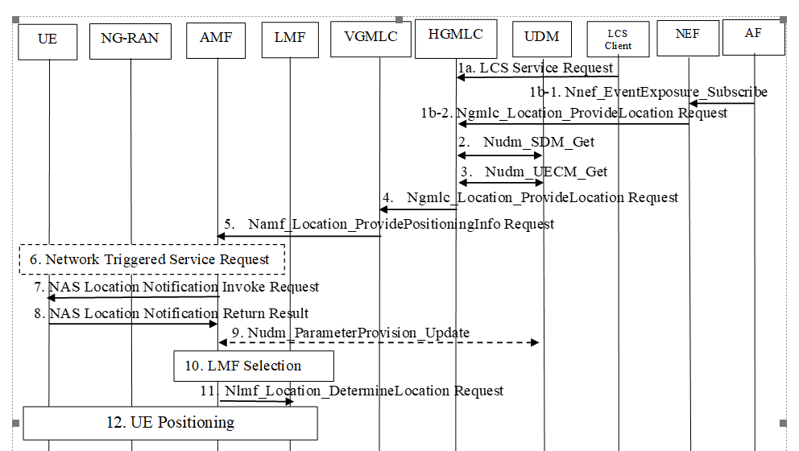  The question is whether the step 12 above which would be “SLPP/LPP UE positioning/ranging procedure” should include the selection of anchor carrier based upon radio conditions etc: OR;  Should it be part of supplementary service as suggested by QC in SA2:  https://www.3gpp.org/ftp/tsg_sa/WG2_Arch/TSGS2_155_Athens_2023-02/Docs/S2-2303026.zip  e.g: step 14:  14. UE1 returns a supplementary services SL-MT-LR response to the serving AMF in an UL NAS TRANSPORT message and includes the Routing ID received in step 11. The SL-MT-LR response indicates if the SL-MT-LR request can be supported and which of UEs 2 to n have been discovered and are available for positioning.  In our view, how discovery is performed is an application layer procedure but when it is triggered can be part of SLPP/LPP Positioning/Ranging Procedure.  At least the LMF; during the Uu positioning procedure; should be able to invoke also ranging procedure; that is hybrid positioning procedure (Uu+PC-5)
Qualcomm | partly | Question 2: The significance/meaning of LCS and LPP layer in the SL positioning context is unclear. We can ask if SA2 has any input on Step 1 of the draft procedure. E.g., will SA2 specify the triggering event for an SLPP session.  [Rapporteur] If they specify, we still need to understand how, right? Updated it a bit.  Similar for question 3: If tis is really needed, we can ask whether SA2 intents to specify anchor/server UE selection, or whether this should be handled by positioning (SLPP) layer, and hence, would be in RAN2 scope. I.e., the FFS in the RAN2 agreement.  However, we think anchor/server UE selection is a "positioning function", e.g., depends on selected positioning method, capabilities, etc.  [Rapp] updated a bit.
Lenovo |  | Question1: Considering saying “sidelink” is ambiguous and asking whether SA2 has “concern” does not look appropriate. We suggest the 1st question can be updated as:“Does SA2 have any comments on RAN2 agreed PC5-only positioning procedure?”  [Rapp] Updated.  Question2: For the step1 on triggering event, we understand it is also fall in SA2 scope,  we can also check SA2’s views on the location service request triggering in the 2nd question.  [Rapp] Updated based on QC’s comments.  Question3: SA2 cannot determine how the anchor UE selection procedure is performed since it may involve both upper layer and AS layer impacts. We share the same view with Huawei that the 3rd question can be updated: “whether and how the anchor UE selection is related to the discovery procedure and UE capability exchange? ”.  [Rapp] Updated based on QC and Huawei’s comments.
LG |  | Q2: According to SA2 TR 23.700-86, legacy functionality specified in TS 23.273 for location services shall be reused including MO-LR, MT-LR. So, SL positioning can be triggered by LCS client resided on network side or UE side. For example, in OOC, LCS client may reside in the UE, but, in IC and PC, LCS client can reside in network or UE, regardless of PC5-only and PC5+Uu positioning. In case of PC5+Uu, for example, SL positioning can be added to Uu positioning on a triggered location service by LCS, which means SLPP session can be invoked by LPP session, not location request.  [Rapp] Thanks for the clarification. I assume no harm to ask SA2 again on this.  Q3: SA2 considers and discusses discovery procedure only, not SLPP procedure. From my understanding, anchor UE selection (including server UE selection) can be conducted in both discovery procedure (SA2) and SLPP procedure (RAN2). Discovery is necessary for sidelink communication, but, if anchor UE selection relies on discovery only, UE capability is not visible on SLPP layer. But for session-less operation, anchor UE selection can be performed only on discovery. RAN2 therefore consider anchor UE selection can be performed on both discovery and SLPP procedure (ex, capability exchange procedure).  [Rapp] Thanks for the clarification. I assume no harm to ask SA2 again on this.
Fraunhofer |  | Regarding Q3: Anchor UE selection depends on information such as los condition, dop and so on. These information are not available at LCS layer. The anchor UE selection from the higher layer could at best provide a list of UEs that are available in a “certain area” and may be at a “certain time” (since anchors can be moving). But it cannot do a selection of anchor UEs that will be used for ranging.  [Rapp]Let’s check SA2’s view first.
CATT |  | Comments on Question 2:  “LPP Layer” is not accurate. SLPP session is not clear for SA2 as well. Q2 can be polished as below:  Question 2: What a Sidelink positioning session is invoked by? If it is LCS, how a single SLPP session is invoked by the service request for sidelink positioning?  [Rapp] see updated version.  Comments on Question 3:  We don't think anchor UE is the scope of SA2 since anchor UE depends on the positioning methods deeply. Server UE selection may be decided by SA2 according to the LMF selection in legacy. If we really need some feedback from SA2, then Q3 can be updated as:  Question 3: Is anchor UE (defined in TR 38.859) selection incorporated as part of the upper layer discovery procedure? And is server UE selection incorporated as part of the upper layer discovery procedure?  [Rapp] see updated version.
Nokia |  | Q2: To our understanding, the question of triggering SLPP falls rather into SA2 scope so we would like to actually ask SA2 if they have views on this.  [Rapp] see updated version.  Q3: We believe that the selection of both anchor and server UEs should happen within the SLPP domain and thus decided by RAN2. To select anchor UEs suitable for positioning (eg multi-lateration), AS information such as radio propagation must be considered, while when selecting the server UE, capability knowledge is also relevant. If SA2 is to be questioned in this context, we would prefer SA2 to rather confirm that the design of anchor / server UE selection is in RAN2 scope.  [Rapp] Companies have different view on this. Hope updated version can be acceptable.
vivo |  | For Q1, agree with Lenovo.  [Rapp] see updated version.  For Q2, the step 1 in the procedure is not clear, we could clarify it in Q2. i.e., “How SLPP session is triggered in the step 1. Who is responsible for the management of SLPP session?”  [Rapp] see updated version.  For Q3, we think Q3 should include the discovery of server UE. In addition to the version of CATT, we would add “how positioning server UE/LMF get the information of candidate anchor UE?”.  [Rapp] see updated version.
Philips |  | Q1: We like Lenovo's proposed revision.  [Rapp] see updated version.  Q2: If we would like to understand SA2's view on the triggering event, better to ask an open question like the one proposed by vivo.  [Rapp] see updated version.  Q3: The selection criteria available at upper layer and SLPP will be different and final selection of Anchor UEs (and also, in our view, Server UE) has to be done at SLPP for the reasons pointed out by, for example, Fraunhofer. We might ask whether SA2 intends to perform some selection as part of discovery and, if so, which criteria will be applied.  [Rapp] see updated version.
ZTE |  | Q1: ok  Q2: Agree with HW’s response of 2nd question.  [Rapp] see updated version.  Q3: For the 3rd question, we think anchor UE selection and session establishment(management) procedure are tightly associated. So we can just ask SA2 whether anchor UE selection is within SA2’s scope, as the agreement indicates ‘FFS if discovery and selection of anchor UEs and/or server UE are part of the positioning layer in RAN2 scope’  [Rapp] see updated version.
CMCC |  | For Q2: We are not sure if we should list the two options for triggering a SLPP session. We can just state the general question as:  “Question 2: What a Sidelink positioning session is invoked by? “  [Rapp] see updated version.  For Q3: We think the discovery procedure of SA2 is for the first-step selection. The anchor UE is selected among the discovered UEs based on SLPP procedures like capability exchange. The second step for the anchor UE selection is within the scope of RAN2. Thus, we share the same view with oppo, the question 3 should be updated as  “Question 3: Whether and how the anchor UE selection is related to the discovery procedure?”  [Rapp] see updated version.

Rapporteur would like to check companies’ view .
Q2: Do companies agree the questions above? Or any additional questions?
.
Company | Yes/No | Remark
vivo |  | New question for clarification: RAN2 assumes LMF or positioning server UE will receive the LCS service request in step 1 and then determines to perform the positioning procedure based on required positioning QoS. Ask SA2 to confirm.  [Rapp] I assume SA2 can discuss the whole procedure triggered by RAN2 LS. Hopefully they will provide something to us.
Philips |  | The (revised) Q1 could also be put to SA3.  [Rapp] I think SA3 is looking for the procedure for broadcast/group cast. But ok to CC SA3.

