3GPP TSG-RAN WG2 Meeting #121 R2-2300xxx
Athens, Greece, Feb 27 – Mar 03, 2023

Title: Draft LS to SA2 on Sidelink positioning procedure
Response to:
Release: Rel-18
Work Items: NR_pos_enh2

Source: Intel (To be RAN2)
To: SA2
CC:

Contact Person:

Name: Yi Guo

E-mail Address: yi.guo@Intel.com
Attachment:

1. Overall Description:
RAN2 discussed the overall signaling procedure for PC5-only positioning (including at least in coverage (IC) and out of coverage (OOC); FFS if there are differences for partial coverage (PC)), and made following agreements:
Agreement:
The sidelink positioning procedure comprises the following series of steps as a baseline, between the LMF/positioning server UE/NG-RAN/candidate Anchor UE(s) and Target UE(s):
- Triggering event
- Sidelink positioning capability exchange
3. Sidelink positioning assistance data transfer
4. SL Positioning Request Location Information
5. Measurement of SL-PRS
6. Location calculation
7. SL Positioning Provide Location Information
Some steps may have dependencies on SA2 and can be revisited in this light. The order is subject to further discussion. FFS if discovery and selection of anchor UEs and/or server UE are part of the positioning layer in RAN2 scope.

During RAN2 discussion, following questions were raised:
Question 1:Does SA2 have any concern on RAN2 agreed sidelink positioning procedure?

Question 2: Whether a SLPP session is invoked by LCS or LPP layer. If it is LCS, how a single SLPP session is invoked by the LCS service request for sidelink positioning?

Question 3: Is anchor UE selection incorporated as part of the upper layer discovery procedure or SLPP capability exchange procedure?

2. Actions:
To SA2
ACTION:
- RAN2 respectfully asks SA2 to take the above into account in their future work and provide feedback to RAN2.

3. Date of Next RAN WG2 Meetings:
RAN2 #121bis 17-26 April 2023 Electronic Meeting
RAN2 #122 22-26 May 2023 Incheon

4. Contact information
Respondents to the email discussion are kindly asked to fill in the following table.
Company | Contact: Name (E-mail)
Huawei, HiSiclion | Yinghao Guo
Ericsson | Ritesh.shreevastav@ericsson.com

5. Discussion

Rapporteur would like to check companies’ view .
Q1: Do companies agree the content above?
.
Company | Yes/No | Remark
Huawei, HiSiclion |  | LCS already means location service. So, “LCS service request” should be “LCS request”  Not sure why SLPP session should be invoked by LPP layer.  From this perspective, we prefer to leave the question more open, since it is up to SA2 to discuss. We can reword the question as: “We would like to understand how the SLPP session is triggered?”  For the 3rd question, we can ask, whether and how the anchor UE selection is related to the discovery procedure and UE capability exchange.
OPPO |  | The SA2 could only decide whether or not the discovery procedure could be used as part of the anchor UE selection procedure. Regarding the capability transfer, it is in AS level, so we think that SA2 cannot give any suggestion on if capability transfer is also part of the UE selection procedure.  We suggest the 3rd question should be modified like: whether and how the anchor UE selection is related to the discovery procedure?
Ericsson |  | Regarding LCS or LPP invoke; the main issue is that:  Do we deviate from legacy MT-LR procedure where LPP (positioning procedure) is triggered after AMF selects LMF?  In legacy MT-LR (23.273)  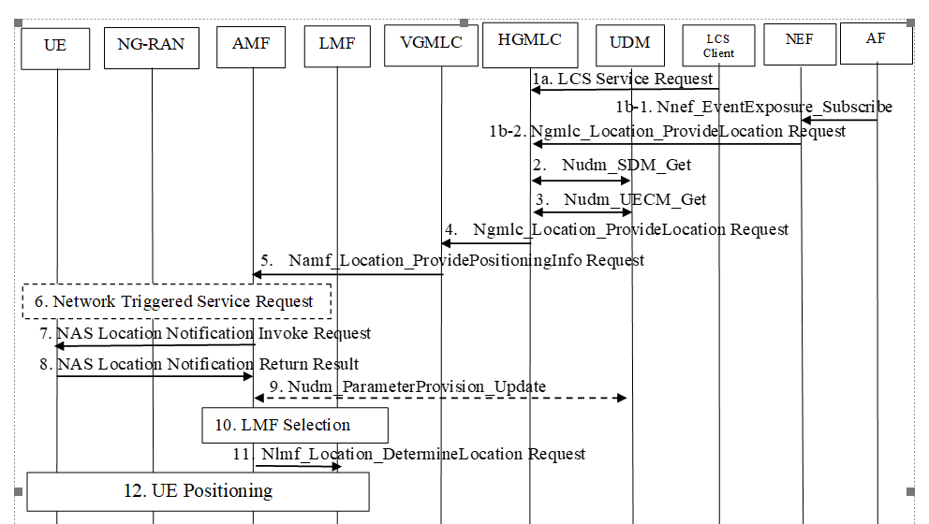  The question is whether the step 12 above which would be “SLPP/LPP UE positioning/ranging procedure” should include the selection of anchor carrier based upon radio conditions etc: OR;  Should it be part of supplementary service as suggested by QC in SA2:  https://www.3gpp.org/ftp/tsg_sa/WG2_Arch/TSGS2_155_Athens_2023-02/Docs/S2-2303026.zip  e.g: step 14:  14. UE1 returns a supplementary services SL-MT-LR response to the serving AMF in an UL NAS TRANSPORT message and includes the Routing ID received in step 11. The SL-MT-LR response indicates if the SL-MT-LR request can be supported and which of UEs 2 to n have been discovered and are available for positioning.  In our view, how discovery is performed is an application layer procedure but when it is triggered can be part of SLPP/LPP Positioning/Ranging Procedure.  At least the LMF; during the Uu positioning procedure; should be able to invoke also ranging procedure; that is hybrid positioning procedure (Uu+PC-5)
Qualcomm | partly | Question 2: The significance/meaning of LCS and LPP layer in the SL positioning context is unclear. We can ask if SA2 has any input on Step 1 of the draft procedure. E.g., will SA2 specify the triggering event for an SLPP session.  Similar for question 3: If tis is really needed, we can ask whether SA2 intents to specify anchor/server UE selection, or whether this should be handled by positioning (SLPP) layer, and hence, would be in RAN2 scope. I.e., the FFS in the RAN2 agreement.  However, we think anchor/server UE selection is a "positioning function", e.g., depends on selected positioning method, capabilities, etc.

Rapporteur would like to check companies’ view .
Q2: Do companies agree the questions above? Or any additional questions?
.
Company | Yes/No | Remark

