**3GPP TSG-RAN2 Meeting #121 *R2-230XXXX***

**Athens, Greece, 27th Feb 2023 - 3rd Mar 2023**

**Agenda item: 4.1**

**Source: CEWiT, Samsung (offline email discussion rapporteur)**

**Title: Report of [AT121][203][LTE] CIO for Inter-RAT HO from LTE to NR**

**Document for: Report**

# 1 Scope of the offline email discussion

This document contains the summary of the offline discussion *[AT121][203][LTE] CIO for Inter-RAT HO from LTE to NR* as indicated below:

* [AT121][203][LTE] CIO for Inter-RAT HO from LTE to NR

**Status:** Started

**Scope:** Discuss the topic and aim for consensus

**Intended Outcome:** Discussion summary and CRs (if aggregable)

**Deadline:** Friday 2023-03-03 CB Session

**Table of contact:**

* *Please consider entering contact info below:*

|  |  |  |
| --- | --- | --- |
| **Company** | **Point of contact** | **Email address** |
| Saankhya Labs | Anindya Saha | anindya@saankhyalabs.com |
| Tejas Networks | Jishnu Aravindakshan | jishnu@tejasnetworks.com |
| Ericsson | Håkan Palm | Hakan.l.palm@ericsson.com |
|  |  |  |
|  |  |  |
|  |  |  |
|  |  |  |
|  |  |  |
|  |  |  |
|  |  |  |
|  |  |  |
|  |  |  |
|  |  |  |

# 2 Ping-pong inter-RAT HO: scenario and solution proposal

Reliance Jio has a greenfield national LTE network deployment in India. Reliance Jio has recently started rolling out a 5G (SA) network in C-band. The 5G NR deployment is a heterogeneous network composed of different classes of 5G cells (including macro, outdoor small cells, and indoor small cells) from multiple vendors. However, each class of 5G NR base station has different thresholds for 5G-to-4G handovers.

As the current LTE specifications do not support cell-specific offsets for inter-RAT (NR) measurements, many cases of ping-pong handovers between LTE and NR cells have been reported during the 5G network deployment. The ping-pong handover (HO) in LTE is one of the most crucial problems that can decrease the performance of the handover.

To illustrate this issue, consider the following scenario consisting of an LTE macro cell, an NR macro cell, and an NR outdoor small cell (ODSC).

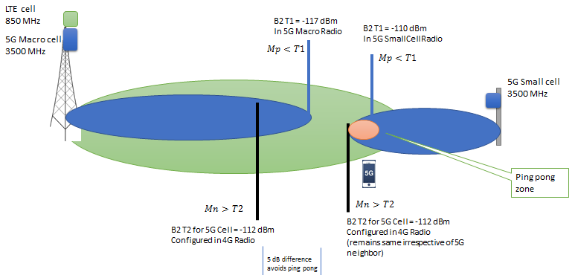

Figure 1. Different classes of 5G HetNet Cells with differing thresholds for 5G to 4G HO

Figure 1 illustrates that the Threshold 2 (B2 T2) is a common configuration in LTE base stations for all 5G cells. The value is selected to enable a 5dB difference with Threshold 1 (B2 T1) for one of the most common classes of 5G NR base stations, providing a sufficient margin to avoid successive ping-pong handovers between LTE and NR cells. This is demonstrated using the LTE and NR macro cells in Figure 1.

However, another class of 5G base station exists, shown as the 5G small cell in Figure 1. The threshold 1 (B2 T1) for 5G small cells is higher than the threshold 2 (B2 T2) configured for NR in LTE base stations. Therefore, when a multi-RAT UE moves out of the 5G small cell coverage, it enters a zone where the measurement quality of its primary cell drops below the threshold (B2 T1), resulting in a handover initiated to the LTE macro cell for connected UEs in this zone.

However, the LTE base station observes that the measurement quality of the inter-RAT neighbour NR cell is still better than the common threshold 2 (B2 T2) value and thus initiates a handover back to the 5G small cell. This creates a perpetual set of inter-RAT HOs between LTE macro & NR small cell.

The 5G – 4G Interworking measurement configurations configured are as follows in 5G Macro and Vendor-A 4G Macros. There is a 5 dB offset to avoid ping-pong between 5G and 4G cells.

|  |  |  |  |
| --- | --- | --- | --- |
| **Sr.** | **Parameter** | **Configured at** | **Value** |
| 1 | 5G to 4G: B2 T1  5G serving cell becomes worse than this threshold when phone is connected on 5G cell | 5G Macro | -117 dBm |
| 2 | 4G to 5G: B2 T2  5G target cells becomes better than this threshold when phone is connected on 4G cell | 4G Macro | -112 dBm |

As Jio ODSC is a different category of product, the above values for Jio ODSC as Serving Cell and Target Cell are as follows:

|  |  |  |  |
| --- | --- | --- | --- |
| **Sr.** | **Parameter** | **Configured at** | **Value** |
| 1 | 5G to 4G: B2 T1  5G serving cell becomes worse than this threshold when phone is connected on 5G cell | 5G Macro | -110 dBm |
| 2 | 4G to 5G: B2 T2  5G target cells becomes better than this threshold when phone is connected on 4G cell | 4G Macro | -105 dBm |

The configuration of B2 T1 at 5G cell can be taken care by the 5G node provider. However, the configuration of Target Cell B2 T2 needs to be done differently at Vendor-A 4G for different neighbours.

This above illustrated inter-RAT ping-pong HO between LTE & NR cells can be handled correctly at LTE base station by configuring different Cell Individual Offset (CIO) for different types of 5G neighbours as shown in Figure 2. It should be noted that the Cell Individual Offset (CIO) for LTE measurement objects is already specified in NR RRC specifications.

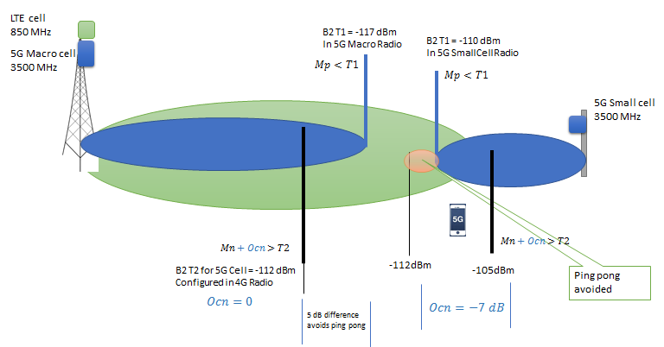

Figure 2. Different classes of 5G HetNet Cells with Cell Individual offset configuration

# 3 Offline email discussion

The discussion would be based upon following CR 4911 rev1 as presented in following Tdoc -

**R2-2301928 “Introduction of cell-specific offset for inter-RAT measurement in LTE for NR neighbours”,**

- Added Cell specific offset support in NR measurement object for LTE

1. Intent of proposed update: Companies are requested to provide comments in the table below (one row for each new comment to better keep track of the discussion – please don’t edit the previous comments).

|  |  |  |
| --- | --- | --- |
| **Company** | **Do you agree with the intent of the CR?** | **Detailed comments** |
| Saankhya Labs | **YES** | The reported network issue is an essential reason to introduce CIO for Inter-RAT HO from LTE to NR |
| Tejas Networks | **Yes** | This is an important update and needs to be taken up in RAN2#121 |
| Ericsson | **Yes** |  |
|  |  |  |

Conclusion: TBC

Proposal: TBC

2. UE capability-based approach: Companies are requested to provide comments in the table below (one row for each new comment to better keep track of the discussion – please don’t edit the previous comments).

The IMs may suggest applicable CR updates towards the same.

|  |  |  |
| --- | --- | --- |
| **Company** | **Do you agree the proposed changes to be based upon a new UE capability to ensure backward compatibility?** | **Detailed comments** |
| Saankhya Labs | **YES** | UE capability-based approach to ensure backward compatibility. |
| Tejas Networks | **Yes** | This will ensure backward compatibility |
| Ericsson | **Yes** | Main reason for new capability is to make Nw aware of that UE supports the new feature, and NW can avoid other work-around (e.g. defensive settings of other per-frequency thresholds). |
|  |  |  |

Conclusion: TBC

Proposal: TBC

3. Release 16 applicability: Companies are requested to provide comments in the table below (one row for each new comment to better keep track of the discussion – please don’t edit the previous comments).

|  |  |  |
| --- | --- | --- |
| **Company** | **Do you agree that Release 16 should be considered to accommodate proposed LTE TEI ?** | **Detailed comments** |
| Saankhya Labs | **YES** | CR updates should be agreed for Release 16 |
| Tejas Networks | **Yes** | This is needed as operators are seeing the issue with Rel 16 handset. |
| Ericsson | **See comments** | Prefer to have CR from Rel-17, but Rel-16 acceptable. |
|  |  |  |

Conclusion: TBC

Proposal: TBC

# 3 Conclusions

**Conclusions:**

TBC

**Agreed CRs:**

TBC – agreed Rel-16 CRs (with Tdoc numbers).

# 4 List of referenced documents

[1] R2-[2301928](http://10.10.10.10/ftp/RAN/RAN2/Inbox/R2-2301928.zip) “Introduction of cell-specific offset for inter-RAT measurement in LTE for NR neighbors”, Reliance Jio, CEWiT, Saankhya Lab, IIT M, IIT H CR Rel-16 36.311 16.11.0 4911 - B LTE-TEI16.