3GPP TSG-RAN WG2 Meeting #116 electronic R2-2111392
Electronic Meeting, Nov 1 – 12, 2021

Agenda item: 7.3
Source: CMCC
Title: Offline discussion on the issue for Random Access on multicarrier for NB-IoT
Document for: Discussion and Decision

Introduction
 [AT116-e][302][NBIOT R16] Random access on multiCarrier in NB-IoT (CMCC)
Scope: Discuss issues in R2-2110240. Agreement of CRs in R2-2110241 and R2-2110762.
Intended outcome: Phase 1: Poll for support and comments with report in R2-2111392. Phase 2: Agreed CRs (TBD)
Deadline: Phase 1: Wed 3 Nov, 1200 UTC, Phase 2: TBD depending on comments.
Status: started

Contact list
Company and Name | Email
Qualcomm - Mungal Dhanda) | mdhanda@qti.qualcomm.com
CMCC – Ningyu Chen | chenningyu@chinamobile.com

Discussion
Deployment scenario:
In contribution [1], Figure 1 shows a typical deployment scenario for multi-carrier NB-IoT in real network. In order to reduce intra-frequency interference on the anchor carrier, the neighbouring anchor carriers are deployed on different frequencies. And the downlink narrowband reference-signal EPRE (Energy Per Resource Element) of the non-anchor carriers is generally lower than EPRE of the intra-frequency anchor carrier, in order to reduce the intra-frequency interference to anchor carrier of neighbour cells. This results to the downlink coverage of non-anchor carriers smaller than anchor carrier.
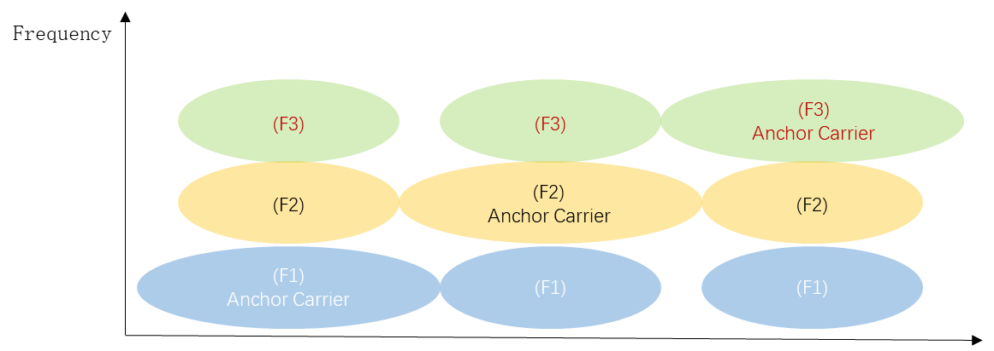
Figure 1 The deployment of NB-IoT multi-carrier
Issue description:
There is the overlapping area that the CE levels is different between the anchor carrier and non-anchor carriers, and CE level of the non-anchor carriers is usually worse than the CE level of the anchor carrier. Take CE0 coverage area as an example shown as Figure 2.
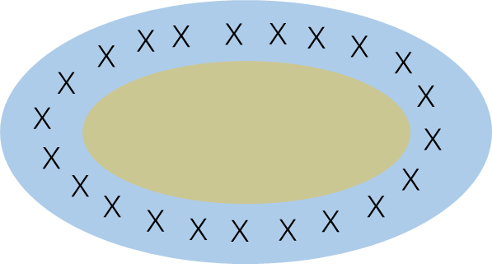
CE0 coverage area of the non-anchor carriers
CE0 coverage area of the anchor carriers
X
The overlapping annular area that the anchor carrier is CE0 and the non-anchor carriers is CE 1
Figure 2 the coverage area of the anchor carrier and the non-anchor carriers
In the overlapping annular area, due to lower RSRP on non-anchor carrier, the actual CE level of the non-anchor carriers is worse than the CE level of the anchor carrier, which results to random access issue.
But, according to the specification, the NPRACH CE level for the non-anchor carriers is determined by the RSRP on anchor carrier and RSRP threshold. For UEs in the overlapping annular area and performing RA to non-anchor carrier, due to repetition for NPDCCH in current CE level is not suitable for the UE, the UE suffered from longer RA time or even RACH failure.
Q1: Do you agree the following two issues may happen in scenario of different EPRE for anchor and non-anchor carriers, as shown in figure 1&2?
Issue 1: UEs may select the inappropriate nprach resource (such as number of nprach repetitions) and fail to access the cell on the non-anchor carriers if the UEs utilize the same NPRACH CE level of the anchor carrier in the overlapping annular area that the actual CE level determined by RSRP measurement of the non-anchor carrier is worse than the CE level of the anchor carrier.
Issue 2: The UE may select the carrier with worse CE level by the legacy selection probability for anchor nprach resource when the CE levels are different between the anchor carrier and the non-anchor carriers. It may increase network traffic and more resource consumption, and affect UEs’ service experience.
Company | Yes/No | Comment
Qualcomm | No | To compensate for the lower power used on the downlink non-anchor carrier, the NPDCCH repetitions (see npdcch-NumRepetitions-RA-r14 in SIB22-NB) can be configured with a higher value.  Only in the extreme case where anchor carrier is configured with a maximum repetitions of 2048 this issue may arise if downlink non-anchor carrier is also uses lower power but we don’t think this a very realistic situation.
CMCC | Yes | Firstly, if the NPDCCH repetitions(npdcch-NumRepetitions-RA-r14) is configured with a higher value to compensate for the lower power used on the downlink non-anchor carrier, it may cause extra network resource consumption for the users close to the eNB which could access to the non-anchor carrier cell with the original lower NPDCCH repetitions value shown as figure2 yellow area. In simple terms, if the NPDCCH repetitions is double, the resource consumption is almost double. Service time delay and terminal power consumption of the users close to the eNB may be increased by configured with a higher NPDCCH repetitions value.  Secondly, the uplink interference of anchor carrier and non-anchor carrier may be different, which is caused by uplink service from neighbour cell and background noise. If the uplink interference of the non-anchor carrier is stronger than the anchor carrier, the nprach repetitions (see maxNumPreambleAttemptCE, numRepetitionsPerPreambleAttempt in NPRACH-Parameters-NB-r13) should be configured with a high value to make sure that the users can access to the non-anchor carrier cell. But there is also extra network resource consumption for the users which could access to the anchor carrier cell with original lower nprach repetitions value shown as figure2 blue area and the users which could access to the anchor carrier cell with original lower nprach repetitions value shown as figure2 yellow area. Service time delay and terminal power consumption of the users may be increased by configured with a higher nprach repetitions value. On the other hand, if RSRP threshold of the anchor carrier is shrunk, part of the users in the shrunk area will access to the anchor carrier with a higher CE level which could access to the anchor carrier cell with original CE level shown as figure2 blue area with ‘x’, and the part of the users will also cause additional resource consumption and service time delay. Otherwise, if introduce a new nprach repetitions for the non-anchor carrier and the nprach repetitions is configured with a higher value, it may lead to extra network resource consumption for the non-anchor carrier users close to the eNB shown as figure2 yellow area, which could access to the non-anchor carrier cell with original lower nprach repetitions value.  We see these 2 issues happen in the field and the current specification may lead to extra network resource consumption and increase service time delay and terminal power consumption.

To address the issue 1&2, the following solutions are proposed, companies are invited to share views on which one would you prefer?
Q2: Which solution is preferred to address issue 1 & 2?
Solution 1a and 1b are provided to address issue 1:
Solution 1a：introduce a new RSRP Threshold list for each non-anchor carrier. The NPRACH CE level on the non-anchor carrier is determined based on comparison between NRSRP measurement results and the RSRP threshold of the non-anchor carrier.
Solution 1b: The CE level of the non-anchor carrier is estimated by UE with the NRSRP measurment results, the RSRP threshold of the anchor carrier, and the downlink narrowband reference-signal EPRE offset of the non-anchor carrier relative to the downlink narrowband reference-signal EPRE of the anchor carrier.
Solution 1c: Other solutions
Solution 2a and 2b are provided to address issue 2:
Solution 2a：Introduce a new selection probability for the anchor carrier NPRACH resource, which the UE should apply when the CE level of the non-anchor carriers is different from that of the anchor carrier in the IE SystemInformationBlockType22-NB.
Solution 2b: The UE appropriately raises the selction probability for the anchor carrier, if the CE level of the non-anchor carrier is worse than that of the anchor carrier.
Solution 2c: Other solutions
Company | Which solution to address issue 1? | Which solution to address issue 2? | Comments
Qualcomm | See reply to Q1 | See reply to Q1 | While we recognise the scenerio described but we think the existing specification caters for such a scenerio.
CMCC | 1a or 1b | 2a | We kindly ask RAN2 to discuss on how to address the issues. We share candidate solutions in our contributions, one is to introduce the RSRP thresholds of the non-anchor carrier. The RSRP thresholds can be adjusted, if EPRE for anchor and non-anchor carriers is different, or the intra interference and uplink interference for anchor and non-anchor carriers is different. The users can choose appropriate NPRACH resources by the CE level determined by the non-carrier RSRP measurements and RSRP threshold when the users access to the non-anchor carrier. It will not lead to extra network resource consumption and affect users’ service experience which may be caused by only configured a higher npdcch or nprach repetitions for non-anchor carrier.  If the users access to the non-anchor carrier with a worse CE level, high probability for the better CE level carrier (anchor carrier) is important for more efficiently utilization of network resources and the principle is more probably to select the carrier with better CE level to save network resources when the CE level of the non-anchor carrier is worse than the CE level of the anchor carrier. If the legacy selection probability for the anchor carrier nprach resource is configured with a high value, the effect of network load balancing may not be realized. In addition, if the users select the worse CE level non-anchor carrier, the users should access to the non-anchor carrier with the mapping CE level nprach resource detemined by the non-anchor carrier to avoid failing to access to the non-anchor carrier or trying more times to access to the non-anchor carrier by utilizing the anchor carrier CE level.

Conclusions
TBD

Reference
[1] R2-2110240 Discussion on the issue for Random Access on multicarrier for NB-IoT CMCC discussion
[2] R2-2110241 Solving the issue for random access on multiCarrier in NB-IoT CMCC draftCR Rel-16 36.331 16.6.0 B NB_IOTenh3-Core
[3] R2-2110762 Solving the issue for random access on multiCarrier in NB-IoT CMCC draftCR Rel-16 36.321 16.6.0 F NB_IOTenh3-Core Late

